A Sari’s Journey through Time: British Perceptions of the Indian Woman
Keywords: orientalism; sari; colonial; gender; post-war; Britain; migrant; commonwealth

In today’s diverse and multicultural society, the sari is a commonly accepted as a mode of cultural attire for South Asian women in Britain. It can be seen worn by women in public spaces, whether this is on a daily basis or for more special occasions such as weddings and religious festivals. Not only this, but it is visible nationally, on public platforms, as an expression of culture and diversity: from acting as a medium for cultural exchange, to being celebrated as a cultural fashion icon on the red carpet and in high fashion (as illustrated in the images below).
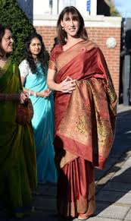
Samantha Cameron’s cultural attire on a visit to a local Hindu temple, for Diwali in 2013.

Actress Sonam Kapoor’s ensemble on the red carpet of Cannes Film Festival, 2013.

Despite the sense of normality we may now feel, in regards to the placement of cultural garb within multicultural Britain, the sari has had a tumultuous journey through history; subsequently, the average Briton’s perceptions of the Indian woman have closely followed this historical trajectory.

The construction of the South Asian woman within Western discourses of the modern era was driven by the predominant colonial orientalist narrative. Orientalism, as defined by Edward Said (a pioneer in postcolonial studies), had long perpetuated the Western myth of ‘the East’ as a faraway land of forbidden fruit and exotic practices. It dictated British colonial perceptions of Indian women as being sexually promiscuous- as mysterious creatures, of erotic fantasies, that held the secrets to sexual pleasure. Examples of such sensualised, orientalist influence can be found in the literature and culture of the era, with common artistic representations of Indian women wearing loosely draped saris and veils. For example, the Indian art of Kalighat painting symbolises and reflects the orientalist demands of the foreign travellers that it often appealed to. The illustrations were often bought by Europeans as souvenirs of their travels to ‘exotic’ places.
Nibaran Chandra Ghosh, A woman putting a rose in her hair, c. 1900, Victoria and Albert Museum, London.
More examples of such orientalist art can be viewed in the V&A collection (the largest in the world) of Kalighat paintings.

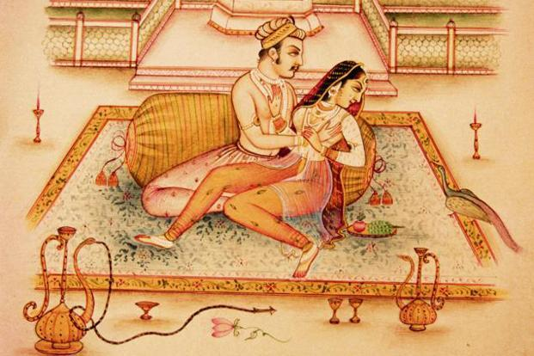
An illustration from the much circulated Kamasutra: an ancient Sanskrit text discussing themes of sexuality and emotional and spiritual fulfilment. Its first English translation was publicised in 1883, and yet was almost immediately made illegal. Nevertheless, Victorian audiences and successive generations remained avid consumers of the banned document and its seemingly ‘exotic’ eroticised imagery.

Moving on to the next epoch marked on the historical timeline of the sari, we find ourselves in post-war Britain- more specifically, following the partition and subsequent independence of India in 1947. The British Nationality Act of 1948 encouragingly brought new waves of migrants from across the Commonwealth into the central heart of the empire: the metropole. This new era of commonwealth migration, and the Windrush generation, brought the colonial ‘other’ home to the British streets and public spaces. With it, it brought new people, food, dress, and numerous other elements of religious and cultural diversity. Inevitably, hostilities and anxieties inclined within the public and political sphere, creating new prejudices towards migrant newcomers. Amongst such views, emerged the stereotypical image of the sari-donning Indian woman as a primitive feature of a backward culture. Represented Indian women in a negative light. For Britons, the sari here epitomised the broader refusal of migrant groups to assimilate into the cultural norms of British society. Saris were thus viewed as markers of Indian women as unsuitable candidates of ‘Britishness’, a word that was synonymous with ideas of citizenship.

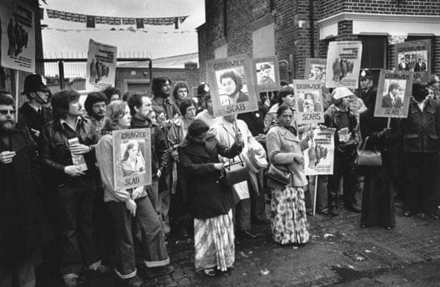
However a significant event between 1976 and 1978, that held an important role in the broader narrative of changing British perceptions of the Indian woman: the Grunwick dispute. The strike was in protest of what Grunwick factory workers viewed as abysmal working conditions. The issues raised were distinctly characterised by gender and race, with the majority of the strikers being South Asian women with their complaints ranging from receiving the lowest paid wages in comparison to their white colleagues, to the degraded treatment they were subjected to by their management. Despite the failure of the strike itself, the depiction of these ‘strikers in saris’ across national newspapers and debates was a major step forward in the reimagining of the docile South Asian woman.
Workers on the picket line hold posters of peers that continue to work, 1977, photograph, Evening Standard/Hulton Archive.
The next and final moment of historical significance has its fundamental roots in the 60s, but only really had lasting impact from the 90s onwards. It directly relates to the development and reinterpretation of the sari and Indian beauty on a global platform, through the framework provided by international beauty pageants. The very first Indian female to be awarded the title of Miss World was Reita Faria, in 1966. She succeeded in inspiring reactions of awe and adoration from audiences and even receiving ‘Best in Evening Wear’ award for wearing a red sari. However, it was not until the 90s, that Indian women in saris accumulated international recognition as fashion and beauty icons, with numerous wins. This was perhaps more attributed to the contextual relevance of the 80s and 90s in supporting a more multi-culturalist approach towards perceptions of beauty and fashion across the international market. During the final decades of the twentieth century, British society witnessed the emergence of cultural movements within the British South Asian diaspora: with the rise of British Asian music and South Asian fashion. This social and political framework had simply not been present within Britain during the decade of Faria’s win; the post-war influx of Commonwealth migration. and the initial developments in the process of decolonisation, had perpetuated a contentious climate that had left little space for appreciation of cultural diversity and beauty.
So far, we have followed a historical timeline, that portrays different stages of development in the perception of the sari, and the woman that wore it. Today, multiculturalism within British society allows us to celebrate cultural diversity: from food, language, music and indeed dress. However, how far is this true? On the one hand, we can readily agree that British society is now much more accepting of cultural expressions through clothing, and the perception of Indian women has come a long way from the initial stages of stigmatisation. However, there are very recent examples of the eroticisation of the sari, echoing aspects of the very first phase within the sari’s journey.
The Pussycat Dolls promote their hit soundtrack ‘Jai Ho’ for the film Slumdog Millionaire, in 2009. It emanates the familiar trope of orientalism that has often determined British perceptions of empire; in this case, it demonstrates the lasting influence of a colonial discourse that consistently eroticised the sari, and the women that wore them.

Does colonial-era orientalism still pervade present-day British society in its perceptions of Indian women? These are crucial questions we must ask ourselves. In order to actively progress as a tolerant and truly multicultural society, it is imperative that we address elements of continuity in more controversial attitudes of our past, and not solely celebrate today’s society as being distinctly changed and apart from the society of yesterday. In order to address this long-standing problem, we must demand more diverse representation of minority groups within popular media, in order to depict and celebrate culture in a more respectable and considerate manner. Furthermore, it is vital to facilitate the creation of platforms and new spaces in which Indian women can dictate and open up their own dialogue, that addresses and reconstructs their contemporary and historical representation.

Further links and sources: if you wish to know more about the origins and cultural meanings of the sari, and historical perceptions of Indian women over time.
Cynthia Green, ‘Why Saris are Indian Material Culture’, JSTOR Daily, February 23 2018. https://daily.jstor.org/why-saris-are-indian-material-culture/
‘Dressing the Indian woman through history’, BBC News Magazine, 6 December 2014.
https://www.bbc.co.uk/news/magazine-30330693
Jyoti Puri, ‘Concerning “Kamasutras”: Challenging Narratives of History and Sexuality’, Signs, 27 (2002), 603-639. doi:10.1086/337937

More about the author:
U1719817 is a third-year history student at the University of Warwick, and is currently studying a module focussed upon migration in the modern world.

Word Count: 1360
University ID: u1719817
Project Audience: broader public (age range 16+), from A-level history students to casual readers with a slight interest in history.

Bibliography:
Bhachu, Parminder, Dangerous Designs: Asian Women Fashion the Diaspora Economies (New York: Routledge, 2004)
Doniger, Wendy, On Hinduism (Oxford: Oxford University Press, 2014)
Hansen, Randall, Citizenship and Immigration in Post-war Britain: The Institutional Origins of a Multicultural Nation (Oxford: Oxford University Press, 2000)
Maynard, Margaret, Dress and Globalisation (Manchester: Manchester University Press, 2004)
Nagle, John, Multiculturalism’s Double Bind: Creating Inclusivity, Cosmopolitanism and Difference (Abingdon: Routledge, 2009)
Said, Edward, Orientalism (New York: Pantheon, 1978)
Thompson, Andrew, ed., Britain’s Experience of Empire in the Twentieth Century (Oxford: Oxford University Press, 2012)
Wilson, Amrit, Finding a Voice: Asian Women in Britain (London: Virago, 1978)
Webster, Wendy, Englishness and Empire 1929-1965 (Oxford: Oxford University Press, 2005)

