UNIVERSITY OF WARWICK
Mock Exam

Empire and Oil: BP and the Building of the Global Oil Industry in Iran

(i) For candidates who are offering a whole-unit paper:
Time allowed: 3 hours, plus 15 minutes reading time during which notes may be made (on the question paper) but no answers may be begun.

Students sitting the three hour paper must answer:
Section A
One question from Section B
One question from Section C

(ii) For candidates who are offering a half-unit paper:
Time allowed: 2 hours, plus 15 minutes reading time during which notes may be made (on the question paper) but no answers may be begun.

Students sitting the two hour paper must answer:
Section A
One question from Section B or Section C

The answers should not include any significant amount of material already presented in ANY assessed essays.

Read carefully the instructions on the answer book and make sure that the particulars required are entered in each answer book.

SECTION A

Comment on FOUR of the following:

- ‘he [the Arab]’ recognized that ‘land has value it never had before as he has seen what can be achieved with irrigation….[i]f then it be Arab apathy which renders the ground waste, it will be Arab avarice which will prevent you getting it at the price you quote.’
Reynolds to Messrs. Concessions Syndicate, April 17, 1909, 71994, BP

- The Company undertakes to send, at its own expense and within a reasonable time, to the [Iranian] Ministry of Finance whenever the representative of the [Iranian] Government shall request it, accurate copies of all plans, maps, sections and any other data whether topographical, geological or of drilling relating to the territory of the Concession, which are in its possession.
Article 13, 1933 Concession, BP

- On one hand we are able to see splendidly built modern houses with air-conditioning, ice-boxes, etc., passing through a variety of stages right down to small individually built shacks in some cases the only roof being empty paper cement bags and old pieces of matting which some of the Persian labor had tried to create shelter from. Never in the whole of my experience indeed in any other country which I have had the privilege of visiting, did I see so close together such extremes in Housing Accommodation.
Report on MP’s (J. Jones) visit to Persia,” June 1946, 16256, BP
d)
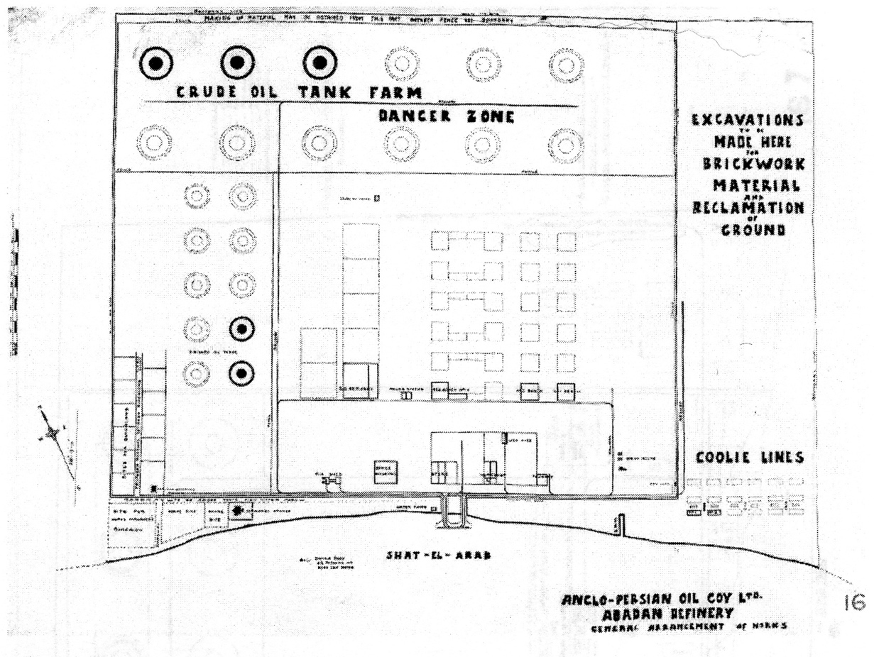

Map of Abadan Refinery of 1910, BP Archive

SECTION B

- What is the relation between race and technology? Discuss using the sources.

- In what ways did oil shape the history of property relations in Khuzestan? Discuss using the sources.

- The 1932-33 concession dispute set a leg precedent for oil producing countries. Discuss using the sources.

SECTION C

- What are the properties of oil that get overlooked in conventional accounts?

- ‘The major oil companies,’ such as the Anglo-Iranian Oil Company, ‘which were the first and the largest of the new transnational corporations of the twentieth century, established their global presence at the historical moment when the old system of empire, built up originally through colonizing corporations, was finally disintegrating.’ Discuss.

- Why is it harder to build with oil an enduring mechanism for advancing democratic political claims, as compared with coal?

END

