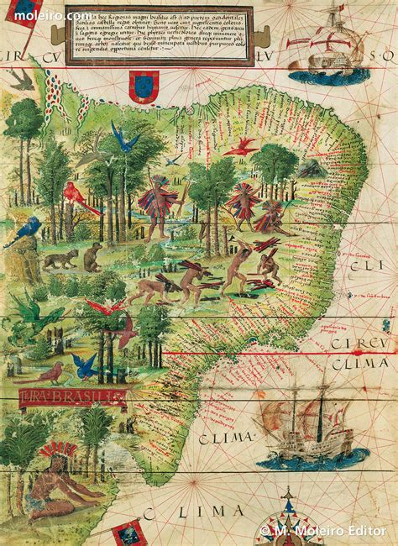 | 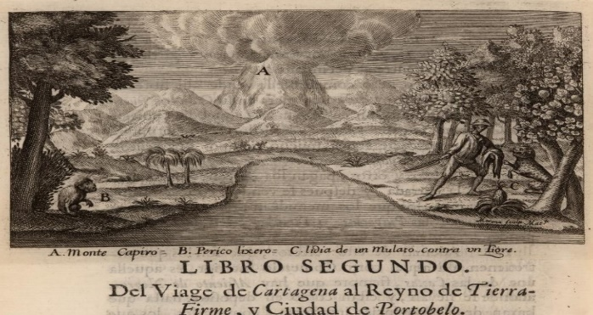
 | 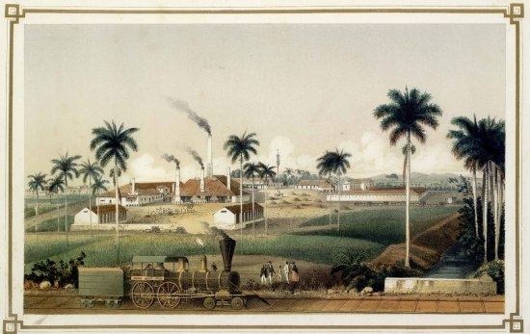
Paths of Enslavement, Routes to Freedom:
Slavery and Mobility in the Iberian Atlantic World
11.45am-5.30pm, Monday 29 April 2024, FAB5.01, Faculty of Arts Building
This workshop connects the rich historiography of slavery and emancipation in the Iberian Atlantic world to the fields of spatial and mobilities history. Paths of Enslavement reveals enslaved people’s ability to harness mobilities in creative, resistive ways, and considers how Latin American archive sources on this topic can be used for teaching in schools and universities.
José Lingna Nafafé, University of Bristol: “Evidence that Demands a Verdict and the Verdict that Demands Freedom: Prince Lourenço da Silva Mendonça and the Black Atlantic Abolitionists’ Case in Rome and the Vatican Response for Universal Justice, 1684-1686”
Selina Patel Nascimento, University of Lancaster: “Space Invaders? Slavery, Gender and the Remapping of Eighteenth-Century Portuguese Imperial Geographies”
Bethan Fisk, Department of Hispanic Studies, University of Bristol: “In the Interstices: Religious Geographies of Eighteenth-Century Afro-Colombia”
Oscar de la Torre, UNC Charlotte, US: “Secluding and Exhibiting: The Double Inscription of Planter Power in the Urban Space of Matanzas, Cuba 1818-1886”
Camillia Cowling, Department of History, University of Warwick: “Captura: Policing and Defining Enslaved Movements in Mid-Nineteenth-Century Cuba”
Roundtable: Teaching person-centred histories of slavery in schools and universities:
Rosie Doyle, Department of History, University of Warwick; Bethan Fisk, Department of Hispanic, Portuguese & Latin American Studies, University of Bristol; José Lingna Nafafé, Department of Hispanic, Portuguese & Latin American Studies, University of Bristol; Simon Peplow, Department of History, University of Warwick; David Rawlings, School of Education, University of Bristol
