Yesu Persaud Centre for Caribbean Studies

'Revolutions and Counter-Revolutions:

The Eastern Caribbean in the 1790s'.

Tuesday 27 January, 1pm - 3pm
Location: FAB 5.30
A round table event with Dr Angus Martin, an independent scholar and heritage consultant, who is the visiting fellow in the Centre for Caribbean Studies.
With presentations by Dr Martin as well as Professor David Lambert (History), Professor Katherine Astbury (French Studies), Abigail Coppins (French Studies / English Heritage).
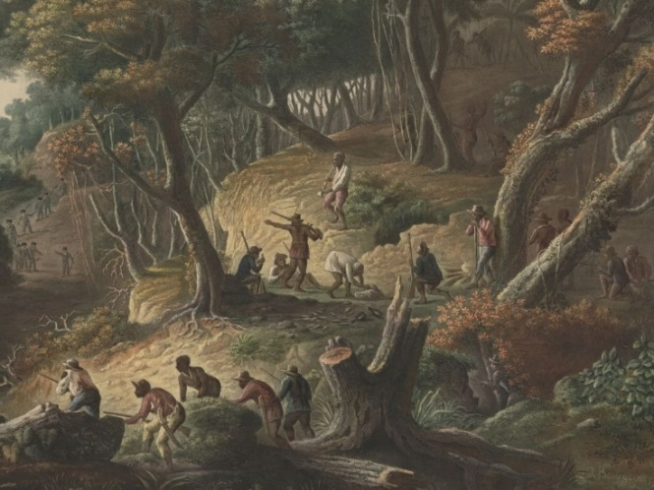

John Angus Martin is an historian, archivist and museum curator from Grenada who attained a PhD from the Faculty of Archaeology, Leiden University in October 2023. He has been based in Grenada since 2022, when he returned to serve as the director of the Grenada National Museum, but is currently engaged as an independent scholar and heritage consultant. He has been readying his dissertation, titled ‘“We Navel-String Bury Here”: Finding Identity in the Grenada Islandscape,’ for publication.


