Yesu Persaud Centre for Caribbean Studies

Professor Thomas Glave (SUNY Binghamton)

En Pointe, Off Kilter: Essays by Thomas Glave

Book launch for Black History Month 2026

Tuesday 13 October, S0.09 (Social Sciences Building), 4pm – 5.30pm

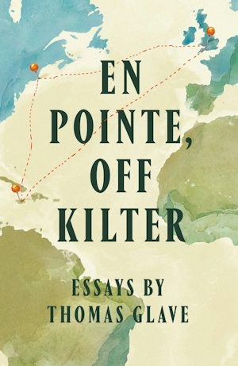

Professor Thomas Glave is the author of four books and the editor of Our Caribbean: A Gathering of Lesbian and Gay Writing from the Antilles. A two-time Fulbright Scholar and two-time Lambda Literary Award winner, he is an honorary visiting professor at the University of Liverpool, and has been the Martin Luther King Jr Visiting Professorship at MIT and a Leverhulme Visiting Professor at the University of Warwick. Glave serves on the editorial board of Wasafiri, and is a trustee of Writing West Midlands and Peepal Tree Press.

