ESSAY PLAN: A comparative analysis of state institutions for the feeble minded in late nineteenth century America.

The above statement will be explored in depth in a 4500-word essay. The essay will use Michel Foucault’s theoretical approach of biopower to analyse a sample of annual reports from US state institutions in the late nineteenth century. Biopower was learnt and practiced in these institutions, and this essay will be important in understanding how the late nineteenth century was fundamental in shaping and constructing bio-politics in states across America. In many of these same institutions, states later sterilized inmates as a means of eugenic population control. Therefore, the essay will contribute to the understanding of biopower beyond the institution, and even to its contemporary use in the world today.

Structuring the essay
The first section of the essay will be an introduction stating its aim – to compare the annual reports of state institutions for the feeble minded across different US states in the late nineteenth century. The introduction will also include some essential context, such as an explanation of the problematic and demeaning term ‘feeble minded.’ It will also briefly cover some highlights in the historiography, including the edited volume Mental Retardation in the United States: A historical reader, and James Trent’s Inventing the feeble mind. The essay will contribute to this historiography by taking an original comparative approach and by explicitly examining the mechanisms of biopower implemented in state institutions. Finally, the introduction will make clear the essay’s argument – that all American states used biopower in institutions for the feeble minded, but to different degrees.

The main body of the essay will draw upon annual reports available on the HaithiTrust database. The reports include those published by the following institutions: Michigan Home for the Feeble Minded and Epileptic at Lapeer; Indiana School for Feeble-Minded Youth; California Home for the Care and Training of Feeble-Minded Children, and the Wisconsin Home for the Feeble-Minded. The essay will also examine the reports available on the Digital Library of Georgia database for the Georgia State Sanitarium near Milledgeville. These institutions were selected because they all later adopted sterilization policies. Michael Robinson explained annual reports are able to “provide essential detail as to the power structure within institutions” and information about “wider mental health policy.” Therefore, biopower is both a relevant and useful theoretical approach to adopt in analysing these documents. Rather than moving through each institution separately, the essay will be separated into paragraphs that each explore a different feature of the institution that allowed the use of biopower. This approach will be the most appropriate as it keeps the mechanisms of power at the centre of analysis whilst also allowing the direct comparison of institutions.

These paragraphs will include:
- The construction of the institution: How does the layout/building work create a power dynamic in the institution?
- The programs of education or training: What were the institution’s long-term goals for the people in the institution?
- The medical care offered to inmates: How did lack of medical care/invasive medical care allow the state to have power over the body?
- Staff in institutions: Did the ideologies of institutional superintendents align with the state’s agendas?
- Population reports: Who was being admitted into the institution? Who were the state targeting in these programs of biopower?
- Institutional expenditure: How much money were states investing in these institutions as sites of political power?

The final part of this essay will draw together the features of the institution that have been analysed and argue that they reveal a use of biopower in state institutions for the feeble minded. It will also argue that state’s used these mechanisms to different extents dependent on political agendas. The conclusion will make clear the broader significance of the essay, arguing that appreciating the institution’s role in the establishment of biopower is fundamental to understanding the more invasive bio-politics later in the twentieth century.

Annotated Bibliography
Trent, James W. Jr, Inventing the feeble mind: a history of mental retardation in the United States (London, Berkeley, California: University of California Press, 1994).
James Trent’s text has been influential for many historians writing about state institutions; therefore, the essay will draw considerable contextual information from his work. Trent examines the history of the term ‘feeble minded’ from the nineteenth century, through to the late twentieth and its eventual demise. He takes great care in tracking the progression of state initiatives concerning the ‘feeble minded,’ including the founding of state institutions. He discusses developments in these institutions that were endorsed by the state, for example the growth of the cottage system. He draws upon evidence from several institutions when needed for examples, but he does not explicitly compare the state’s employment of power within these institutions. The comparative approach taken by this essay will not only set it apart from the work of Trent, but also enable it to make an original contribution to the historiography as a whole.

Rafter, Nicole, ‘The Criminalization of Mental Retardation,’ in Mental Retardation in America: a historical reader, ed. by Steven Noll and James W. Jr Trent (New York: New York University Press, 2004), pp. 232-257.
The essay will take inspiration from Nicole Rafter’s work in this edited volume. This chapter focuses on a figure named Josephine Shaw Lowell, and it “follows the steps Lowell took to establish the Newark (New York) Custodial Asylum for Feeble-Minded women.” Rafter examines the way Lowell worked with New York state officials in founding the institution. She links this institution to the state’s use of biopower, stating that “Newark’s creation signified a new stage in governmental management of bodies.” Rafter crucially asserts that the existence of an institution in itself was an act of biopower. This essay will expand on this notion, by exploring the ways the practices within the institution further consolidated biopower.

Michel Foucault established the term biopower, thus his ideas will be central to the essays analytical approach. Two of his texts are particularly relevant to the institutional reports under examination.
Foucault, Michel, The Birth of Biopolitics: Lectures at the College de France, 1978-1979, trans. by Graham Burchell (Basingstoke: Palgrave Macmillan, 2008).
In this text, which includes passages from Foucault’s lectures, Foucault explores the idea of American neo-liberalism. Foucault argues American neo-liberals aimed “to extend the rationality of the market … to domains which are not exclusively or not primarily economic: the family and birth rate, for example, or delinquency and penal policy.” According to Foucault, neo-liberals sought to influence and control “traditionally non-economic social behaviour in economic terms.” The essay will use this idea to demonstrate how US states used economic analysis to ‘justify’ their power of bodies in the institutional setting.

Foucault, Michel, The History of Sexuality: The Will to Knowledge (London: Penguin Books, 2019).
In this second influential text, Foucault identifies the key features of his biopower concept. He theorises that since the eighteenth century there has been a “profound transformation of these mechanisms of power” that are used by the state. Foucault argues “the ancient right to take life or to let live was replaced by a power to foster life or disallow it to the point of death.” This notion will be used to analyse how annual reports demonstrate the state had power over the lives of institutional inmates. Foucault states that “power over life evolved in two basic forms,” one being “centred on the body as a machine: its disciplining, the optimization of its capabilities.” This will be particularly relevant when analysing the programs of education and training in the different state institutions. The “second … focused on the species body … propagation, births and mortality.” This notion will be pivotal when considering the segregation of the ‘feeble minded’ away from their communities; evidence of the state enacting power over reproduction. It will also inevitably be relevant when considering the later policies of forced sterilization in all of these institutions.
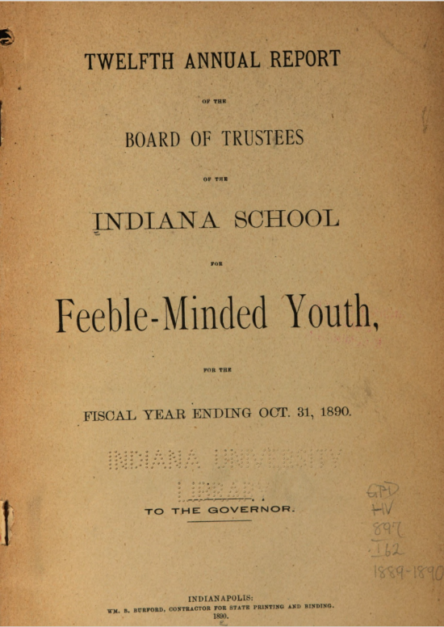

Figure i: An annual report published by the Indiana School for Feeble-Minded Youth
Indiana School for Feeble-Minded Youth, Twelfth Annual Report of the Board of Trustees of the Indiana School for Feeble-Minded Youth for the Fiscal Year ending Oct. 31, 1890 (Indianapolis: WM. B. Burdford, Contractor for State Printing and Binding, 1890), digital resource, HaithiTrust <https://catalog.hathitrust.org/Record/011801459> [accessed 19 October 2022].

The essay will use primary sources such as this annual report from The Board of Trustees of the Indiana School for Feeble-Minded Youth. This report features a list of staff members which will be further researched to examine how their employment demonstrated Indiana’s use of politics in the institution. It also includes a page on intended building work, this will be examined to demonstrate how the structure of the institution was used to create a power dynamic between staff and patients. The detailed accounts on expenditure will assist in analysing the state’s endorsement of the institution as a site of political power. The plans for schooling and training of inmates will also indicate the state’s power over the body through “the optimization of its capabilities.” The essay may also find that much of this training was centred around the economy of the state. Finally, this primary source includes a doctor’s report, this will allow examination of the states “fostering of life” through the institutions commitment to the health of its inmates – the ultimate act of biopower.

1487 words

Bibliography

Digital Library of Georgia <https://dlg.usg.edu/> [accessed 19 October 2022].

Eugenics: Compulsory Sterilization in 50 states <https://www.uvm.edu/~lkaelber/eugenics/> [accessed 19 October 2022].

Foucault, Michel, The Birth of Biopolitics: Lectures at the College de France, 1978-1979, trans. by Graham Burchell (Basingstoke: Palgrave Macmillan, 2008).

Foucault, Michel, The History of Sexuality: The Will to Knowledge (London: Penguin Books, 2019).

HaithiTrust Digital Library <https://www.hathitrust.org/> [accessed 19 October 2022].

Indiana School for Feeble-Minded Youth, Twelfth Annual Report of the Board of Trustees of the Indiana School for Feeble-Minded Youth for the Fiscal Year ending Oct. 31, 1890 (Indianapolis: WM. B. Burdford, Contractor for State Printing and Binding, 1890), digital resource, HaithiTrust <https://catalog.hathitrust.org/Record/011801459> [accessed 19 October 2022].

Rafter, Nicole, ‘The Criminalization of Mental Retardation,’ in Mental Retardation in America: a historical reader, ed. by Steven Noll and James W. Jr Trent (New York: New York University Press, 2004), pp. 232-257.

Robinson, Michael, ‘Mental Health,’ Liverpool University Press Digital Collaboration Hub, March 2019 <https://liverpooluniversitypress.manifoldapp.org/projects/using-primary-sources> [accessed 19 October 2022].

Trent, James W. Jr, Inventing the feeble mind: a history of mental retardation in the United States (London, Berkeley, California: University of California Press, 1994).

Mental Retardation in America: a historical reader, ed. by Steven Noll and James W. Jr Trent (New York: New York University Press, 2004), and, James W. Jr Trent, Inventing the feeble mind: a history of mental retardation in the United States (London, Berkeley, California: University of California Press, 1994).
HaithiTrust Digital Library <https://www.hathitrust.org/> [accessed 19 October 2022].
Digital Library of Georgia <https://dlg.usg.edu/> [accessed 19 October 2022].
See state pages on Eugenics: Compulsory Sterilization in 50 states <https://www.uvm.edu/~lkaelber/eugenics/> [accessed 19 October 2022].
Michael Robinson, ‘Mental Health,’ Liverpool University Press Digital Collaboration Hub, March 2019 <https://liverpooluniversitypress.manifoldapp.org/projects/using-primary-sources> [accessed 19 October 2022].
James W. Jr Trent, Inventing the feeble mind: a history of mental retardation in the United States, pp. 79-80.
Nicole Rafter, ‘The Criminalization of Mental Retardation,’ in Mental Retardation in America: a historical reader, ed. by Steven Noll and James W. Jr Trent, pp. 232-257 (p. 232).
Ibid, p. 241.
Ibid, p. 248.
Michel Foucault, The Birth of Biopolitics: Lectures at the College de France, 1978-1979, trans. by Graham Burchell (Basingstoke: Palgrave Macmillan, 2008), p. 322.
Ibid, 246.
Michel Foucault, The History of Sexuality: The Will to Knowledge (London: Penguin Books, 2019) p. 136.
Ibid, p. 138.
Ibid, p. 139.
Ibid, p. 139.
Indiana School for Feeble-Minded Youth, Twelfth Annual Report of the Board of Trustees of the Indiana School for Feeble-Minded Youth for the Fiscal Year ending Oct. 31, 1890 (Indianapolis: WM. B. Burford, Contractor for State Printing and Binding, 1890), digital resource, HaithiTrust <https://catalog.hathitrust.org/Record/011801459> [accessed 19 October 2022].
Ibid, pp. 5-6.
Ibid, p. 7.
Ibid, pp. 11-19.
Foucault, The History of Sexuality: The Will to Knowledge, p. 139.
Ibid, p. 138.

