Extracts sheet
Proclamation of 1590 [Hughes and Larkin, no. 716, p. 46]
the sayd Bayliffes, Constables, Thyrdboroughs, Tithingmen, Churchwardens, and all other inferior officers, and euery of them, doe euery Sunday, and festiuall day, make diligent viewe and search in all Churches, Chappels, and all other places within the circuites and compasses of their offices and authorities, for all and singular breakers and offendors of the saide statute, and without delay cause the names of all such offendours, and of the parents, gardians, gouernours, and masters of euery childe, seruant, and warde, so offending, together with the day and place of the offence committed, to be then written, and to be lawfully and orderly presented, at such Assises, Sessions, or Courts (next after such offences) as haue authoritie to enquire or determine the sayd offences.

Edward Hext, JP for Somerset, writing to William Cecil, Lord Burghley, September 1596
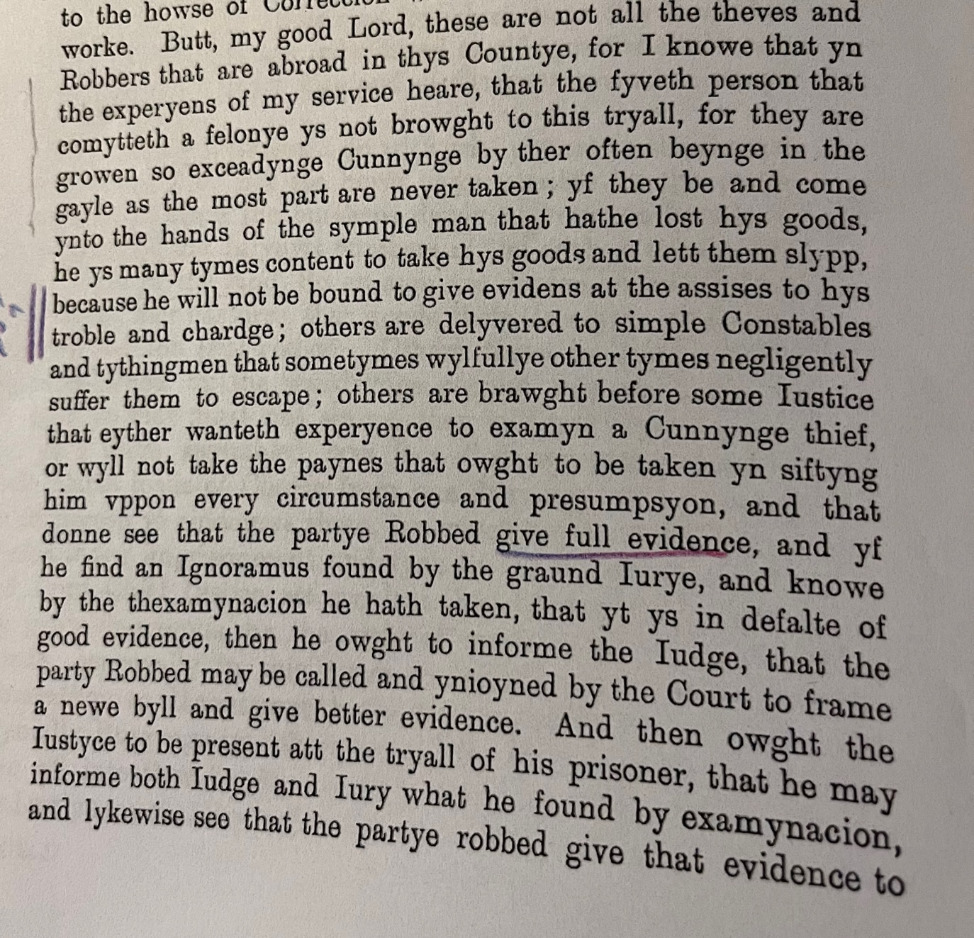
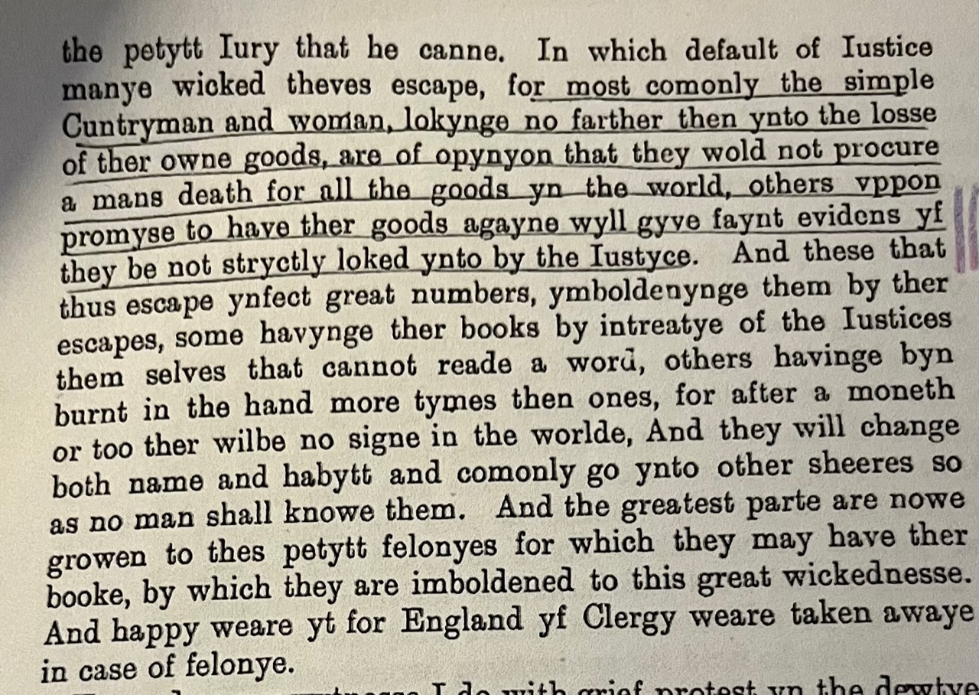
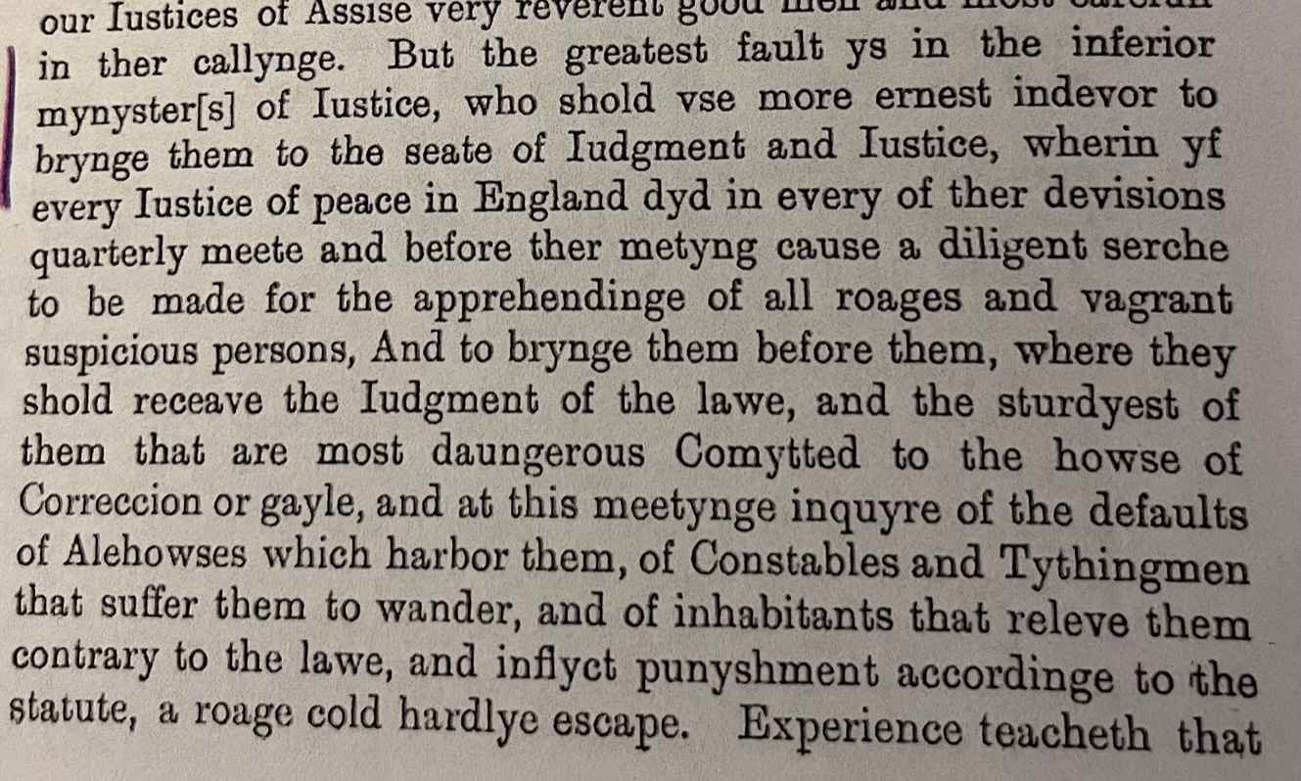
Lord Keeper’s speech to Justices in Star Chamber, 1608 (quoted in Hawarde’s Reportes del Cases in Camera Stellata)
Yt is allso as daungerous to geve waye to the popular sorte to take the sworde of Justice into there handes, they must not be there owne Judges; & especiallye the offence ys greate to execute busynesses in the nighte, albeit thinges lawful, & theise small begynninges would be nypped in the budde, which, yf they were well looked into by the Justices of the peace, in time they woulde be stayed, or else they will growe in little time to the popular rebellyons of Northamptonshire; & the number of the Justices of the Peace ys to greate, they trust so muche one to another that they doe nothinge, they lurke in the towne all the winter, and goe downe to take the pleasure of the Cuntrye and to receave presentes of there Freindes and neighbours.

Lord Chancellor Ellesmere’s letter to Earl of Worcester, EL MS 2718
After our verie harty commendacons to your lordship. Theis are to advertise you, that on Thursday last in thafternoone we being both togither for some service given us in charge by his Majestie, and having ben before informed of the disorderly course holden by the Lord Stafford in bailing one Bradshawe, who was committed for a notorious murder and burglarie, we sent for his Lordship to come to us, and he therupon returned us aunswer that he could not come to us. Which we much misliking, I the Chancellor tooke order presentlyt o putt him out of the Commission of the peace in that countie, which is don accordingly. And this daie after dynner we receyved your Lordships Letter, signifying unto us his Majesties gracious pleasure for our proceeding in this matter: Wherupon we presently sent a pursuyvant for the Lord Stafford who brought h9im before us. We have taken theis severall examinacons, ^which of himself, and of one Henry Roldhuns His servaunt the coppies wherof we send to your Lordship herenclosed. By which may appear, that he hath dealt in this matter verie unduely, and otherwise then the Lawe doth warrant. His offence is in the nature of misprision, and punishable by grievous fyne to his Majesty, either by the Justice of Assise and Gaiole Delyvery, or in the Starchamber. If any suite be for Bradshawe pardon, I the Chancelor will stay it as the great Seale, and will moove my Lord vicount Cranbourne to doe the like as the privy Seale: And it is good that warning be given to such of the Masters of the Requestes, and Clerke of the Signet, as attend his majesty, that they doe not present any bill to his highnes signature for any such pardon.
Fynding the offence to be of this nature, in example so dangerous (Especially in a Nobleman) and doubling it mayf all owt woorse then yet appeareth, We thought good to command him to keep his Lodging, and have taken order for further examinacion of the matter in Staffordshir, where Bradshawe was bailed.
Thus your Lordship hath an accompt what we have doon in this matter, which if it please you to make known to his Majesty, we will attend his gracious pleasure, and alwaies pray to goe to preserve his sacred Majesty in health and all happynes. And so we take our Leave of your Lordship and rest
Your Lordships assured loving frendes
At York-house 25te Februarii 1604
TEllesmere Canc
William Lambarde, The Dueties of Constables
if men be fighting together in a house (the dores being shut) yet may such Officer [a constable] break open the doores to cause the peace to be kept, though none of the parties have taken hurt,

Francis Bacon, Cases of Treason
If any man will lay murder or felony to anothers charge, or do suspect him of murder or felony, hee may declare it to th constable, and the constable ought upon such declaration or complaint, carry him before a Justice.

