THE FOOTNOTE
  - Community news from the department of history
As the days begin to shorten and the festivities of Halloween enter full swing, we approach the half way stage of the Autumn Term. For many first-year students this will be marked by the submission of their first university assignment (Making of the Modern World deadline noon on 31st October). Meanwhile, the more seasoned students amongst you are probably all too aware of your own impending deadlines, as often awaits you upon return from reading week (specific deadlines can be found on Tabula or module webpages).

As you immerse yourself in your assessments, it’s good to be aware that there is a range of support and assistance available to help you through the process (see featured article). However, it’s also important to remember that being a History student at Warwick is not just about assessments and there are certainly plenty of community events taking place throughout November.

If your keen to explore new areas of history or hear more about the latest historical research then check out the department’s extensive research seminar programme (see History Research Events feature). Likewise, if your keen to engage with the discipline in new ways then the History on Film Evening would be great place to start. Dr. Simon Peplow, author of Race and Riots in Thatcher’s Britain, presents our first film ‘Pressure’ this Thursday Evening. The film explores the experiences of a teenager negotiating his way between his life in Britain and his Caribbean heritage and is a very fitting way to mark the end of Black History Month.

In addition, you can also have your say or just keep-up-to-date with what’s going on through a variety of department platforms, from SSLC drop-in sessions to undergraduate blogs authored by students in both Warwick and Venice. So, however you wish to stay in touch with the History community and whatever your interests there is plenty going on as the term marches forward.

Best wishes,

Carys

Stay Connected…  Facebook: @warwickhistory  Twitter: @warwickhistory | Stay up-to-date…  Undergraduate Community Calendar:  https://warwick.ac.uk/fac/arts/history/students/undergraduate/calendar/ |  | Stay Informed…  History Department Handbook:  https://warwick.ac.uk/fac/arts/history/students/handbooks
  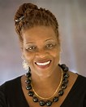  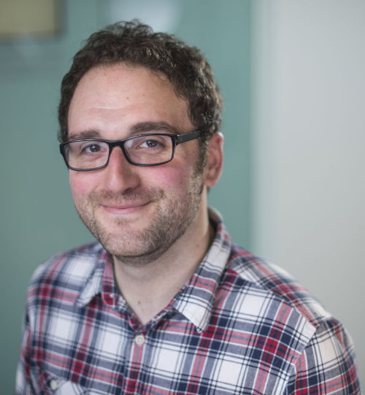 |  | Department of History Research Seminar Series.  History Dept. 3rd and 4th year undergrads (including joint degrees) are welcome to attend the various research seminar series within the History Dept. You may find them of interest, particularly if you are thinking of doing a postgraduate degree. To save you from being bombarded with emails about them, please look instead at the events pages for the Dept and the research centres, and see the posters around Humanities, especially the History Research Events noticeboard opposite H3.43.  _{History Dept Research Seminars} Global History and Culture Centre events  Centre for the History of Medicine events Early Modern and Eighteenth Century Centre events  European History Research Centre events  There may also be other events for Comparative American Studies, Feminist History Group etc. https://www2.warwick.ac.uk/fac/arts/history/research/seminars_readinggroups  NB. some other events advertised may be restricted to postgrads/staff. Please ask one of the research coordinators if in doubt:  · Sheilagh Holmes (CHM, EMECC): Sheilagh.Holmes@warwick.ac.uk  · Amy Evans (GHCC): Amy.Evans@warwick.ac.uk  · Rowan MacGregor (History Dept, EHRC, CAS, FHG): _{PGHistoryOffice@warwick.ac.uk}  Upcomming Events  - The Annual Walter Rodney Lecture ‘Re-Grounding the Intellectual Activist Model of Walter Rodney’ (Prof. Carole Boyce-Davies): Tuesday 30th October at 5.15pm, Room OC1.09, Oculus. Please contact  - History on Film Evening (Dr. Simon Peplow): Thursday 1st November at 5pm, L5, Sciences (over bridge from Library).  - Africa Book and Film Series (Dr. Sasha Hepburn): Monday 12th November at 6pm, H052, Humanities.  - For full list of events see UG Community calendar.
Study skills and assessment support.
With essay deadlines looming it’s important to remember that support and guidance is always close at hand…
- The History Department’s Undergraduate Handbook is an invaluable source of guidance on assessment writing. Everything you need to know from referencing to marking scales is included and a lot more besides! It can be accessed online: https://warwick.ac.uk/fac/arts/history/students/handbooks
- Module webpages are another treasure trove of information offering a wealth of information and often useful links to both primary and secondary material. Taking time to familiarize yourself with each of your module websites is strongly advised.
- Module tutors are a key point of contact for your assessment related queries both via email and during office hours. Signing up for feedback surgeries is also a great idea for those seeking to both maintain and improve academic performance.
- For more general non-module specific academic queries your personal tutor is another useful point of contact.
- Many workshops are held throughout the year by the Skills and Student Development department. They tackle a broad range of study-related issues such as effective note taking and speed-reading. A full list of workshop provisions can be accessed at: warwick.ac.uk/services/skills/events/ugworkshops. Places are often limited so advanced booking is usually necessary.
- Wellbeing Services, The Library’s subject support page and Disability Services are also key points of contact depending on the nature of the guidance and support required. If you’re unsure who to contact, speak to your personal tutor.
  - https://warwick.ac.uk/services/studentsupport
  - warwick.ac.uk/services/library/subjects/arts/history
  - https://warwick.ac.uk/services/disability/howwecanhelp

Notices: Year Abroad Opportunities
Year abroad applications open on Monday 29th October 2018 and close on Monday 19th November. Please see webpage for further information:
https://warwick.ac.uk/fac/arts/history/students/international/yearabroad/.

Department News:
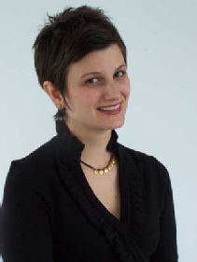
Sarah Hodges has been awarded a Wellcome Trust-funded 5-year Collaborative Award. Hodges leads this major research award. In her team are two anthropologists from the University of Amsterdam and the University of the Witwatersrand, respectively. The project is called "What’s at Stake in the Fake? Indian Pharmaceuticals, African Markets and Global Health". It focuses on the social lives of pharmaceuticals in India, South Africa and Tanzania from 1970-present.
What's at stake in the fake? Today, the idea that fake drugs threaten global health has become almost common-sensical. Often, these concerns are voiced in relation to how, for example, Africans’ already poor health is further imperiled by fake Indian drugs. Yet looked at closely the scientific literature backing up these claims, we found that they were based on unexpectedly weak evidence. This project responds to this puzzle by critically re-examining our collective common-sense about fake drugs and global health. Initial research suggests that, addition to the world of pharmacology, worries about fake drugs may be based in social worlds. When the world’s supply of live-saving drugs is beset by worries about safety, governments and citizens face difficult decisions about how to allocate scarce resources. The project’s historical and ethnographic enquiries seek to understand the emergence and circulation of worries about fake drugs for global health, as well as to understand these worries’ effects.
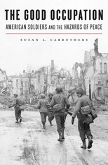
Professor Susan Carruthers has been discussing her latest publication, The Good Occupation: American Soldiers and the Hazards of Peace (Harvard University Press, 2016), with New Books Network’s Craig Sorvillo. The Good Occupation chronicles America’s transition from wartime combatant to postwar occupier, by exploring the intimate thoughts and feelings of the ordinary servicemen and women who participated—often reluctantly—in the difficult project of rebuilding nations they had so recently worked to destroy.
When the war ended, most of the seven million Americans in uniform longed to return to civilian life. Yet many remained on active duty, becoming the “after-army” tasked with bringing order and justice to societies ravaged by war. Susan Carruthers shows how American soldiers struggled to deal with unprecedented catastrophe among millions of displaced refugees and concentration camp survivors, while negotiating the inevitable tensions that arose between victors and the defeated enemy. To hear Professor Carruthers’ interview, the podcast can be accessed at https://newbooksnetwork.com/susan-carruthers-the-good-occupation-american-soldiers-and-the-hazards-of-peace-harvard-up-2016/. You can also read more on The Good Occupation by visiting https://www.susanlcarruthers.com.
Notices: New Undergraduate Blogs.
Follow third year students, Charlotte Wilson and Samantha Haynes during their term in Venice. This month Charlotte discusses her experiences of settling in to a new city while Samantha provides a review of Venice’s culinary delights.
http://blogs.warwick.ac.uk/charlottewilson/
http://blogs.warwick.ac.uk/samanthahaynes/

Student Voice
SSLC course Reps election results can now be accessed online via warwicksu/sslc.
Look out for information on Staff-Student Liaison Committee drop-in sessions and townhalls via Social Media and Community Calendar!

Other Notices:
Skills Festival, Monday 5th November, The Oculus Buiding
FREE sessions to help you: think about where you want to be in a year’s time and develop key skills for your academic, personal and/or professional life. To register please visit: www.warwick.ac.uk/skillsfestival.

Women’s Debating Weekend, 3rd/4th November.
The day will consist of several workshops, practical sessions and key notes speeches. For more information contact the Warwick Debating Society or email Najma Ahmed at n.ahmad.2@warwick.ac.uk . Places are limited and are allocated on a first-come. Sign-up: https://docs.google.com/forms/d/1eIK9lqr7NeXjxKzvWkSHQOt3oXt0iG1jKPdboE8hHw0/edit

