1968 | 2018: Protest, Performance and the Public Sphere

In June 2018 the Department of Theatre & Performance Studies (TPS) hosted a successful three-day symposium on the subject of ‘1968 | 2018: Protest, Performance and the Public Sphere’. The event was strikingly interdisciplinary, attracting 71 presenters and 13 non-presenters from Architecture, Art History, Dance, Economics, Education, English, Film, History, International Relations, Media, Modern Languages, Music, Politics, Sociology, and Theatre and Performance Studies. The event was also international in scope, with attendees joining from Catalonia, France, India, Ireland, Mexico, Sweden, Taiwan, Turkey, the UK, and the USA.

Strategically this symposium was significant for the School, as it aimed to strengthen old relationships and forge new partnerships. The event was hosted at Warwick Arts Centre on the University of Warwick’s campus, and was programmed to coincide with the world premiere of Trying it On – a new work written and performed by the playwright David Edgar. In this piece Edgar celebrates his 70th birthday by looking back over 50 years to confront his 20-year-old self in 1968. TPS Professor Emeritus Janelle Reinelt hosted a Q&A with Edgar as part of the symposium, and Warwick Arts Centre hosted a post-show drinks reception for the conference delegates.

The symposium was directed by Andy Lavender, Head of TPS, and administered by David Coates, a former PhD student in the Department and now an IAS Early Career Fellow at Warwick. It was run in collaboration with the Cultures of the Left: Manifestations and Performances project, funded by the British Academy and led by Dr Silvija Jestrovic (TPS), which enabled partner colleagues from Jawaharlal Nehru University in Delhi, India, to attend. During the symposium the Cultures of the Left project leaders made an important connection with Professor Fabrizio Tonello from the University of Padua, with whom they are discussing a planned Cultures of the Left conference at Warwick’s palazzo in Venice in Spring 2019.

In addition, the symposium allowed the School to develop links with the Martin E. Segal Theatre Center at the Graduate Center, CUNY, from which a keynote speaker, Peter Eckersall, was invited. He was joined by CUNY colleague Frank Hentschker, Director of the Martin E. Segal Theatre Center, CUNY, in performing How it All Began – the premiere staged reading of the personal testimony of Michael ‘Bommi’ Baumann, a member of one of the most spectacular urban guerrilla organizations in West Berlin – the June 2nd Movement. The V&A Theatre and Performance Collections were also linked to the event, presenting a panel on the exhibition and documentary film You Say You Want a Revolution? Records and Rebels 1966-70.

The proceedings of the ‘1968 | 2018: Protest, Performance and the Public Sphere’ symposium can be traced by using the hashtag #Warwick68to18 on Twitter. It is also likely that some of the papers from the conference will be published in a special issue of the journal Performance Research, titled On Protest, which will be edited by the conference organisers, following a proposal to this end by PR General Editor Richard Gough.

Volunteers were recruited to assist with the event from the undergraduate cohort of the Department of Theatre and Performance Studies. The event enabled these undergraduates to participate in the conference, and has inspired them to consider curating their own conference.

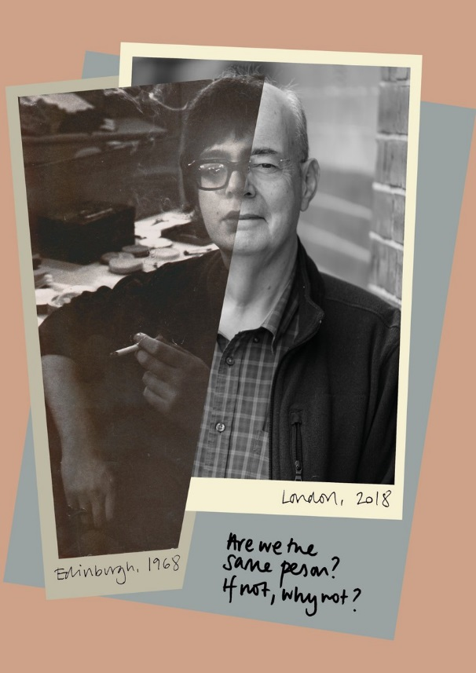

Lucia Bensasson, Director of ARTA, Research Association of Traditions of the Actor gave a keynote considering the work and history of the celebrated French theatre company Théâtre du Soleil, founded by Ariane Mnouchkine and colleagues directly in response to the cultural upheaval of the 1960s. David Edgar performed the world premiere of his new piece, Trying it On, at Warwick Arts Centre as part of the symposium.

Peter Eckersall, Professor of Theatre and Performance and Executive Officer of the PhD Program in Theatre and Performance at the Graduate Centre, City University of New York, gave a keynote entitled ‘Politics and approaches to time: reflections on Japan’s 1960s from the age of freeter time’. He also participated in a Roundtable discussion with Janelle Reinelt, David Edgar and Andy Lavender to close the conference.

