Eighteenth Warwick Symposium on Parish Research, ‘Remembering the Parish’
Saturday, 7 November 2020
Report by Maria Tauber (History)
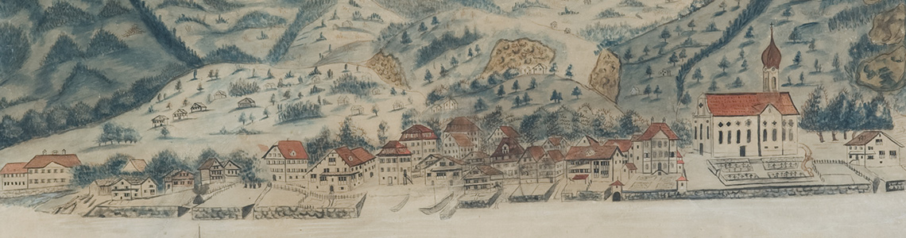
Damian Camenzind, ‘Prospect of Gersau’ (1813). By kind permission of Gersau District Council.
For the first time since its inception in 2003, the Parish Symposium took place as a virtual gathering on Blackboard Collaborate, attracting nearly 100 researchers. BEAT KÜMIN (Warwick) welcomed speakers and participants and thanked the university’s Humanities Research Centre for their continuing support. This year’s conference theme, Remembering the Parish, was explored in five panels dedicated to 'Buildings', 'Communities', 'Records', 'Revolution' and 'Environments'. Speakers from four countries explored a variety of written and material sources relating to parishes from the Middle Ages to the present.
NICOLA WHYTE (Exeter) delivered a keynote address in which she highlighted the social, spiritual, and economic importance of ancient boundaries and landmark features for both parish communities and individual households. Drawing on a rich and fascinating body of sources from Norfolk, including material traces in the landscape, maps, court records, and forged documents, she portrayed the making and unmaking of boundaries as a complex intergenerational social process in which memories were often tightly linked to space. Whyte noted that the number of post-Reformation court cases dealing with boundary disputes show that the preservation and formation of boundaries remained a significant part of local identities and parish policies. Addressing recent historiography and its focus on the creation of new boundaries (enclosure) in the early modern period, Whyte pointed out prevailing aspects of continuity, observing ancient patterns of boundary divisions, and revealing a complex network of jurisdictions inherited from medieval times.
The following twelve contributions centred around acts and objects of memorialisation, collective and individual parishioners’ recollections of past events and their role in shaping and imagining the parish’s present and future. The question of who was in charge of remembering shed light on contested memories, identity formation processes and the overall significance of collective memory in the parish community. The contributions complemented each other very well, and a rich variety of methodologies (e.g. material culture studies, historical anthropology, and archaeology) and sources (places, buildings, maps, letter, diaries etc.) enabled a fruitful and in-depth discussion.
On the whole, the Symposium highlighted the crucial role of parish communities in local memory, however, with the caveats that regional disparities need to be taken into account and that, in terms of the British Isles, more work needs to be done on the larger parishes with multiple chapelries in northern England. Finally, we were once again reminded of the fluidity, complexity, and different layers of parishes, which must be envisioned as both physical and imagined places.
In terms of ‘conference experience’, the virtual format brought tangible benefits (such as greater involvement of overseas network members and the chance to easily record proceedings) as well as certain disadvantages (especially a lack of informal interaction). Looking ahead, participants expressed a preference for ‘blended’ provision, i.e. a mixture of face-to-face and online activities. The 19th Symposium on ‘Parish Politics’ will take place on 15 May 2021.

An extended report and supporting materials can be found on the My-Parish site: https://warwick.ac.uk/fac/cross_fac/myparish/parishsymposia/2020remembering

