Adaptation and the Stage in the Nineteenth Century

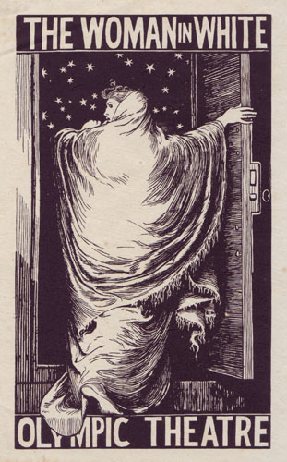
This one-day colloqium was held at Millburn House on Saturday 28 March 2014 and drew new and established scholars from North America and the United Kingdom to present papers related to adaptation and the nineteenth-century stage. Scholars of the nineteenth century have long been interested in the cultural, economic and aesthetic contexts and practices of adaptation. The adaptation of fiction, poetry, and painting into plays to feed hungry theatre managers and audiences was an important part of the overall cultural economy of the nineteenth century. Adaptation from the nineteenth-century novel to film has long been the subject of discussion, debate, and theorization, while more recently exchanges between visual culture, the novel, and the theatre in the period have gained increasing attention. The colloqium aimed to draw on the lively discourses and discussions currently centering on adaptation in the period.
The keynote was delivered by Professor Jacky Bratton (Royal Holloway, University of London) and focussed on W. T. Moncrieff, the dramatist who particularly offended Dickens when he adapted Nicholas Nickleby. Papers ranged across the work of Don Boucicault, Hall Caine, Henry James, Wilkie Collins and Mary Elizabeth Braddon, but also considered adaptation in the broadest sense, including the adaptation of text to performance text and the adaptation of pictorial art into dramatic form. The symposium was organised by Jim Davis and Patricia Smyth, co-editors of the refereed journal Nineteenth Century Theatre and Film, in order to generate articles for a special issue on stage adaptation in the nineteenth century.
The volume on adaptation will appear in 2016. In the meantime we hope to develop the symposium as an annual event to bring together nineteenth-century theatre scholars and to generate new work on other topics.

