HRC event report for 29th and 30th September 2023: ‘Afterlives of an Essay’ conference
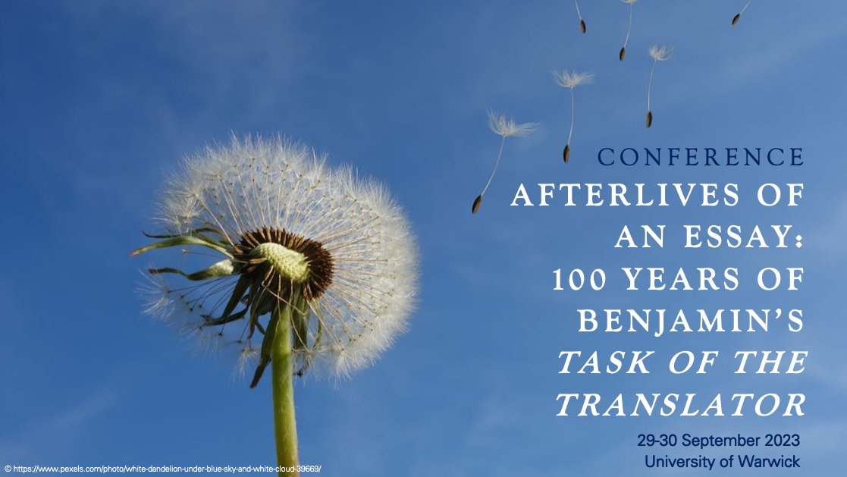
Conference organised by: Dr Caroline Summers (University of Warwick), Dr Ian Ellison (University of Kent, Goethe-Universität Frankfurt am Main), and Dr Arianna Autieri (Goldsmiths, University of London).
HRC money was secured to help cover keynote travel costs. Other funding was received from the ILCS, MHRA, Goldsmiths University of London and Warwick SMLC.

Conference report
The conference took place on 29th and 30th September 2023 and was hosted at the University of Warwick .

The main objective of the conference was to invite critical engagement with Benjamin’s seminal essay on ‘The Task of the Translator’ [‘Die Aufgabe des Übersetzers]. Our intention was to invite papers from across a range of disciplinary perspectives, and to engage both younger and more experienced scholars in the discussion of a key text in the discipline of Translation Studies.

Due to UCU industrial action, the original conference programme of papers and panels across 2 days was adjusted to fit all academic papers into the second day of the schedule. The first day therefore presented an opportunity for delegates to engage with the conference theme off-campus through planned activities, as follows:
- A visit to the Migrating Dreams and Nightmares exhibit at Common Ground (Fargo Village, Coventry), including a discussion with curators Nirmal Puwar and Kate Rosslin on the experience of putting together this narrative of the linguistic and physical translation of migrants between spaces;
- A visit and tour of Coventry Cathedral as a space that embodies concepts of afterlife and rebirth, with Nirmal Puwar (BA Fellow at Coventry Cathedral);
- Screening and discussion of Nirmal Puwar’s film Unravelling (2008) in the Chapter House (Coventry Cathedral);
- The opportunity to visit the Herbert Gallery with its various holdings, including more information on the history of Coventry Cathedral and the city itself;
- Conference dinner at Bistrot Pierre in Coventry, attended by almost all delegates.

The academic focus of the conference was on Saturday 30th September, which is also celebrated as International Translation Day since it is the feast day of St Jerome. The conference programme consisted of 4 standard panels, 2 keynote papers and a dialogue between two established scholars and translators. Delegates commented favourably on the range of papers and the quality of the keynotes. Since panels ran consecutively, the audience for the various papers was not divided: while this made for a long day, it ensured that discussions from the panel sessions could flow naturally into conversations in the scheduled breaks and helped to establish a feeling of continuity throughout the day.

There were 35 official delegates, including PhD researchers, Early Career Academics, established scholars and retired members of the academic community. Participants came from across the UK and Ireland, as well as from mainland Europe, Turkey, the USA and Hong Kong. This diversity was also reflected in the range of presenters.

Traditional keynotes were delivered by Dr Julia Ng (Goldsmiths) and Professor Duncan Large (BCLT, UEA). Their different perspectives on Benjamin, from Philosophy and from Comparative Literature/Translation Studies respectively, initiated some very interesting questions in the subsequent discussion, looking across disciplinary boundaries to explore the impact of the essay. Participants were very engaged by both papers.

The ‘In Conversation’ session with Dr Chantal Wright (ZHAW) and Professor Douglas Robinson (CUHK, Shenzhen) was chaired by Dr Arianna Autieri and ranged from discussion of the text itself to a broader dialogue about the experience of translating Benjamin, or translating in the spirit of Benjamin. This was a very valuable opportunity for delegates to hear two international scholars in Translation Studies sharing their extensive expertise on the conference topic. We are grateful to all four keynote speakers for their willingness to adapt to challenging circumstances, and for their generosity and supportive reflections on papers throughout the conference.

The standard of papers and presentations was very high throughout the conference. Panel sessions centred on the following topics:
- Theoretical readings of Benjamin;
- Contemporary perspectives;
- ‘The task’ as a literary lens;
- Reading ‘the task’ through Benjamin and his translators.
Particular strands that emerged from the panel discussions included the materiality of language and text, translation as a performance, critical engagement with binaries such as un/translatability and the im/possible, and the importance of reading texts and theories in context.

The broad and engaged conversations that continued throughout the day meant that the conference objectives were easily met. Benjamin’s essay was read and reframed from a number of different angles, and the discussions that followed panels and keynotes provided ample opportunity to develop these ideas. There was a relaxed, engaged and supportive atmosphere throughout the day, for all papers. We were delighted to be able to welcome ten students from the Warwick MA in Translation and Cultures to the keynote sessions: these students have had a unique opportunity to be part of a landmark event at the start of their postgraduate careers in Translation Studies, and we were pleased that so many of them chose to attend.

Following prior contact with Routledge, we were able to secure a discount for conference delegates on Douglas Robinson and Chantal Wright’s publications on the Benjamin essay, valid for a month after the conference. We are grateful to Routledge for their generosity in this, and for sending us the sample copies.

Keynotes, presenters and attendees commented positively on their experience, describing it as stimulating, entertaining and enriching. One delegate commented: Congratulations … for putting on such a wonderful event under challenging circumstances and with several contingencies! It was of course a long day but the I felt the format really did encourage conversations, and all the talks were excellent. It was wonderful to have so many great scholars together and to have a chance to discuss. Thank you once again for all your efforts in organising.’

Our intention is to publish proceedings from the conference as a ‘Talking Points’ volume with the Forum for Modern Language Studies. This is a format that invites a dialogic, open format and a narrow focus and would work well as a publication of the ideas and conversations featured at the conference. We are in touch with delegates about this and are in the process of putting together a Call for Papers. In the longer term, the co-organisers also hope to apply for funding to support a future research project exploring literary afterlives and modernism.

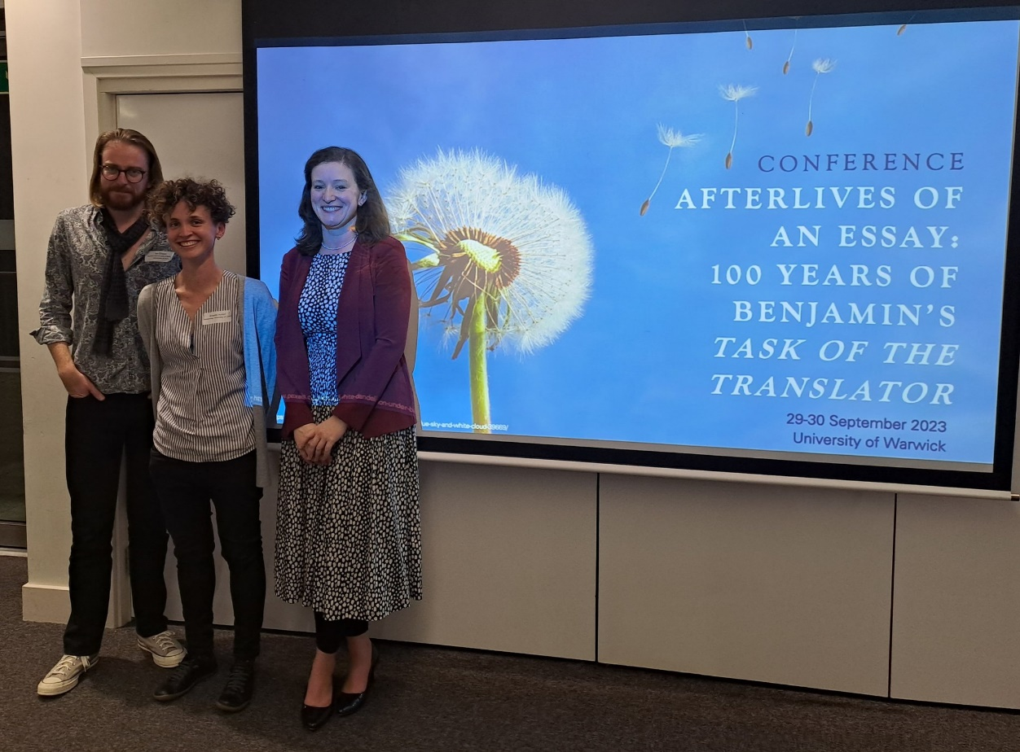
Conference organisers: Dr Ian Ellison, Dr Arianna Autieri, Dr Caroline Summers (L-R)

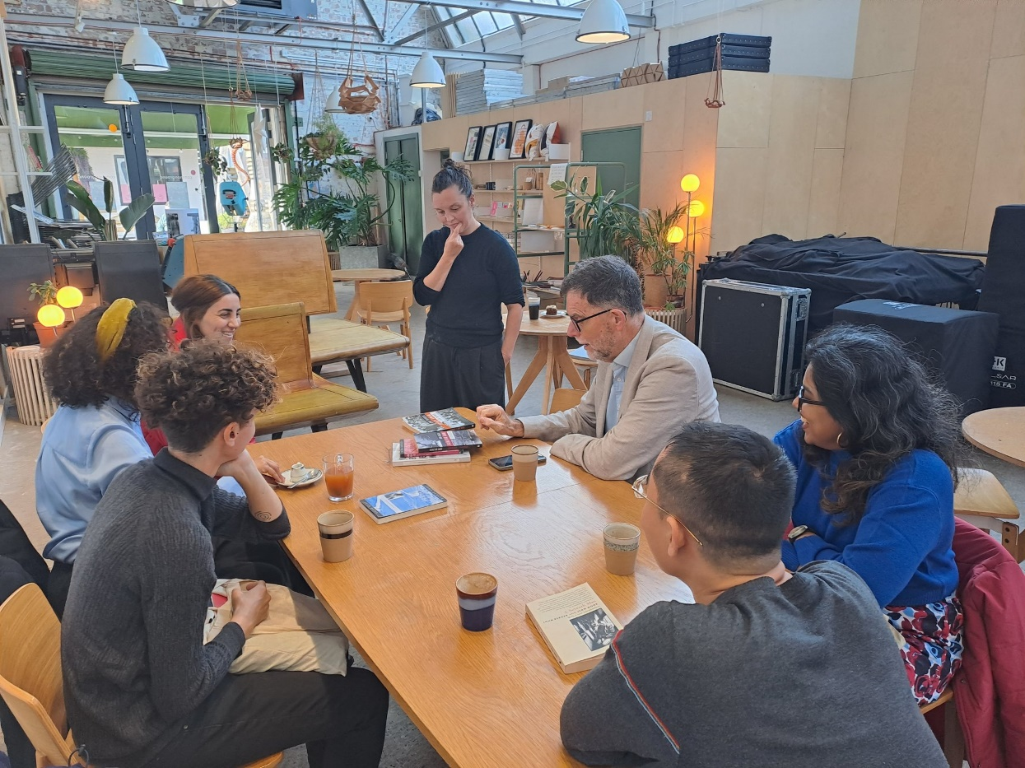
Conference delegates engaging with the Migrating Dreams and Nightmares exhibition at Fargo, Coventry
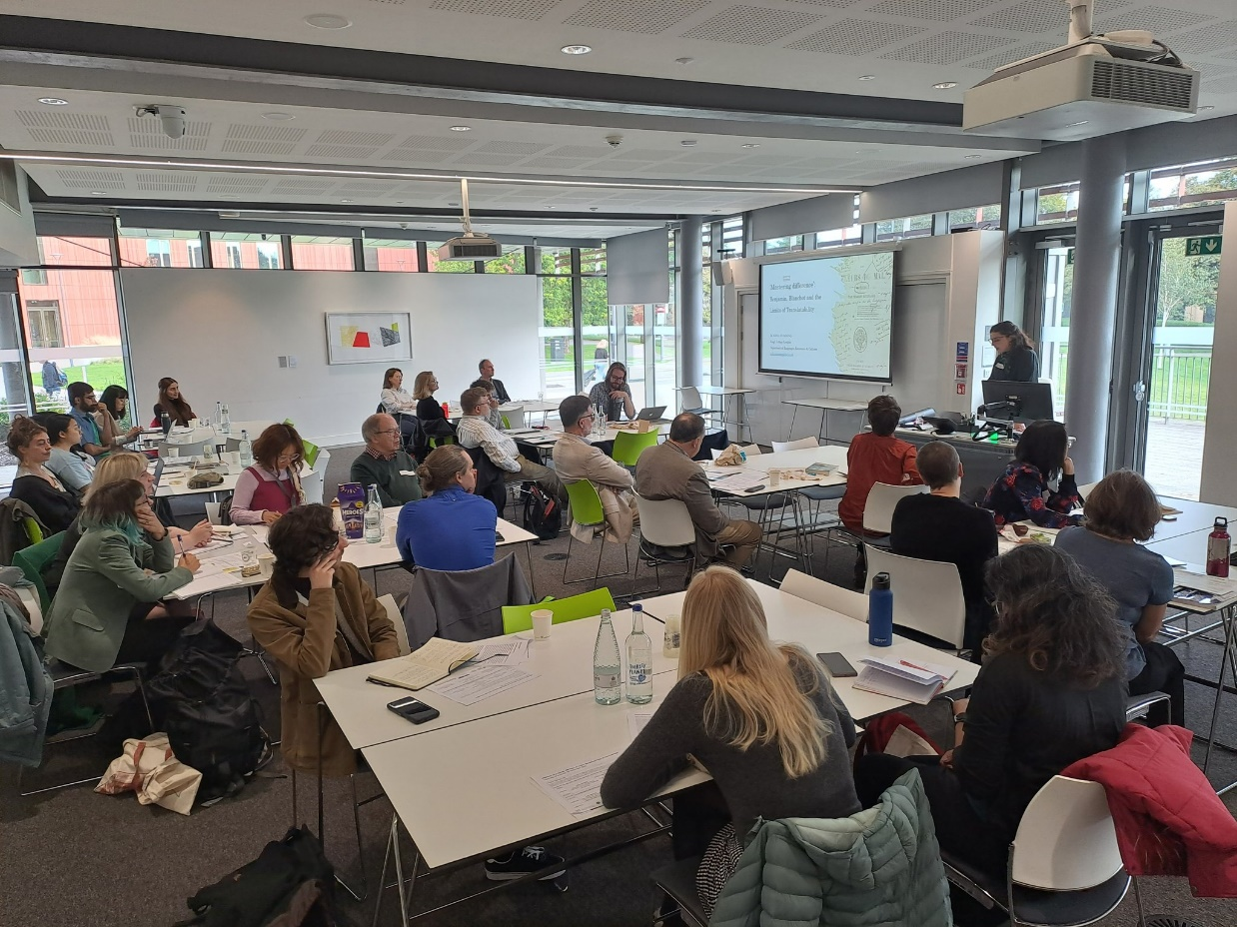
Opening panel: Dr Sofia Cumming presents her work

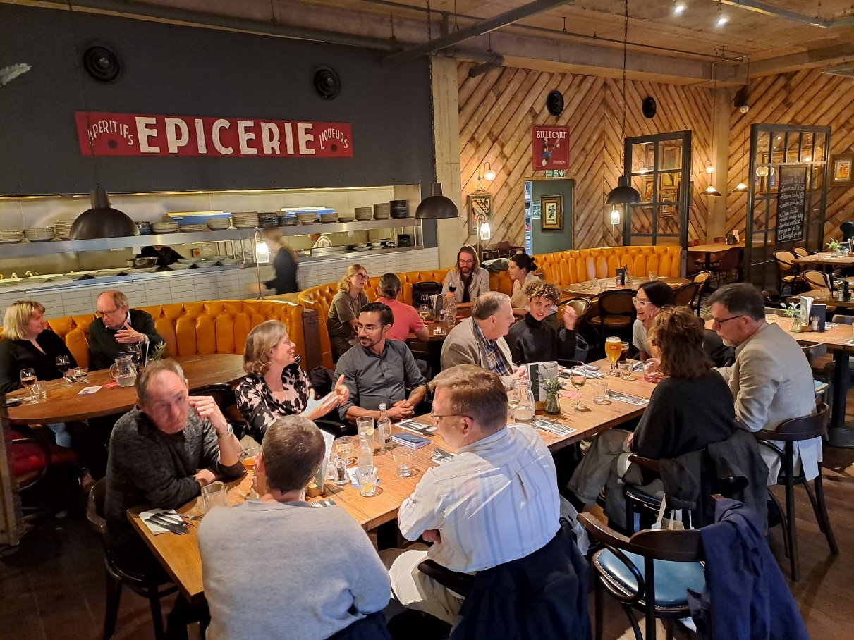
Conference dinner
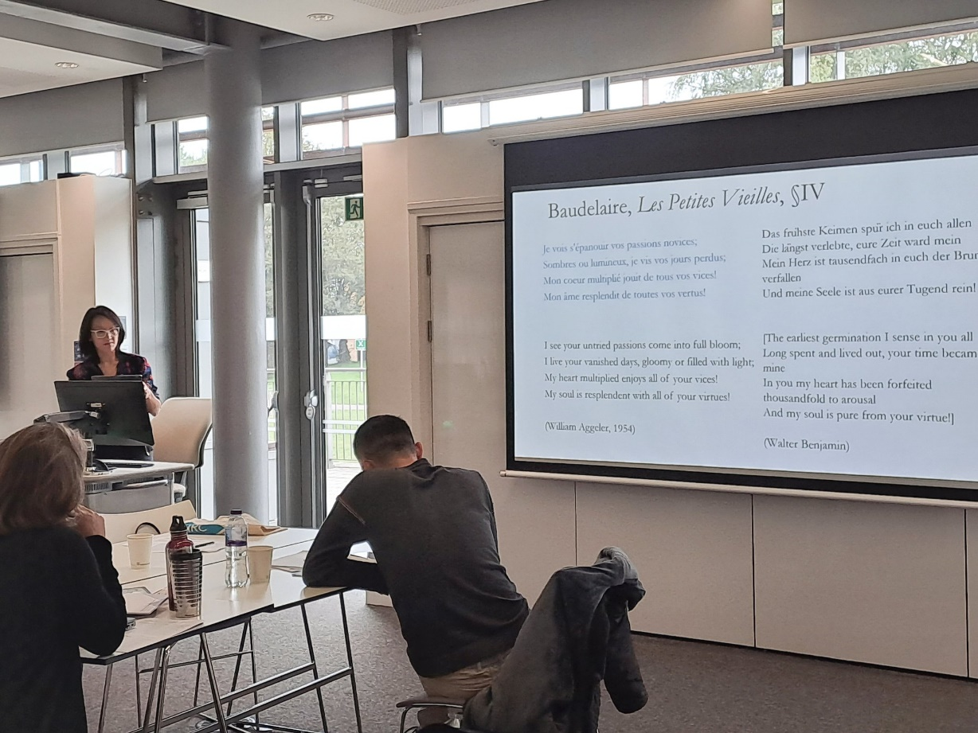
Keynote 1: Dr Julia Ng

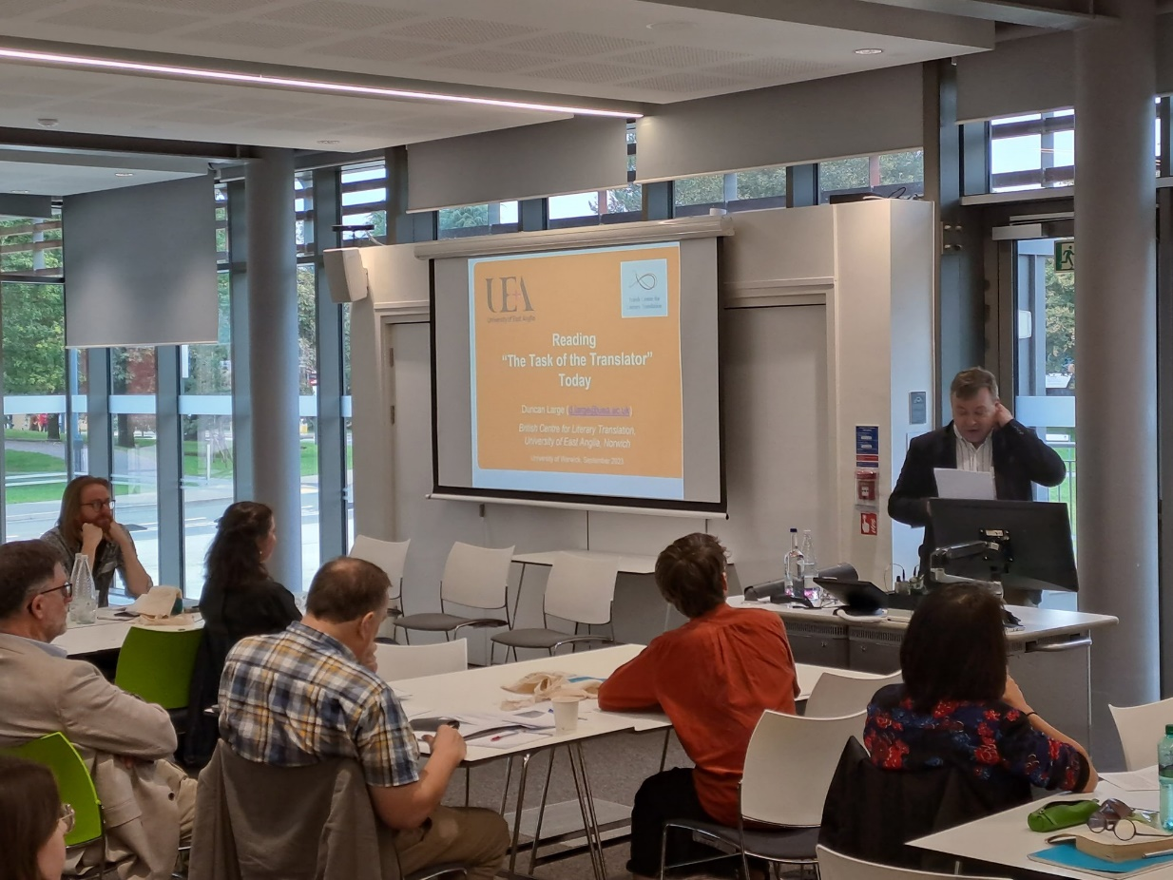
Keynote 2: Professor Duncan Large

