Being Human: Individualism and the Self from the Renaissance to the 21st Century
Mia Edwards, Himesh Mehta, and Anna Pravdica (History)
https://warwick.ac.uk/fac/arts/hrc/confs/bh/

Firstly, we would like to thank the Humanities Research Centre at the University of Warwick for their gracious funding of our conference, Being Human: Individualism and the Self from the Renaissance to the 21st Century which took place on the 22 February 2025. It was a fruitful day, which wouldn’t have taken place without their generous support.

What was the aim of this conference?
What does it mean to be human? Our one-day interdisciplinary conference aimed to both define the parameters of this question, and to suggest some potential answers. The definitions and meanings assigned to the conception of the self, or being human more generally, are numerous and contentious depending upon discipline, time, and place. Moreover, the contingency of such definitions often remains unaddressed. Therefore, this conference acted as a way to bring together a range of scholars, who worked across time, geography, and academic discipline, to suggest different ways in which their research might bring us closer to understanding some of the multitudinous ways in which human nature, and ideas of the self have been understood throughout history.

In particular, this conference focused upon ideas regarding what it means to be human, and the self, from the Early Modern period to the present day. This felt like a good level of historical scope, which would allow for us to discuss continuities and changes over time, while also allowing for the approaches provided by disciplines and scholars outside of history. In the end, the conference drew participants from disciplines including economics and philosophy, thus allowing Q&As to explore often-unaddressed disciplinary and methodological collisions.

Some of the initial suggested topics for conference participants to consider included:
- Religion, human nature, and the self
- Self-control and the law
- Capitalism and the rise of individualism
- Collectivism within individualistic societies
- The role of Philosophy in shaping conceptions of the self
- The role of emotion in identity formation
- Historical perceptions of autonomy, self-determinism, and control
However, we also had a range of discussions and presentations which broadened this scope, such as considering anthropomorphism in relation to artificial intelligence, and the influence of the individualism and choice upon the economic outcomes of a person’s life.

Outline of the Conference
The conference included two keynote addresses, and we finished with a fascinating roundtable discussion which both summed up the main themes of the day while also bringing the two speakers into discussion with each other. The first keynote was given by Roger Smith, entitled ‘Ensoulment in a Time of Embodiment’ which focused on the importance of the soul as a historical and personal category of analysis. While modern scholarship, and the more general cultural lexicon, perhaps prioritises ideas of selfhood, Smith’s keynote made a case for considering the soul as a distinct, historicised and connected notion that can act as both a personal and political instrument. The second keynote was delivered by Roger Cooter, entitled ‘Eating Cats and Finding Rats: A Singular Search for “Identity”’ which charted the experiences of an eighteenth-century French man, as he worked through a range of job titles, familial relations, and geographical locations. This keynote critically contrasted a unique and isolated example of eighteenth century identify formation with the role of identity in contemporary Western culture. Together, the keynotes defended the value of history to the critical engagement with the present.

The conference was split into three panels, which explored a range of themes such as the methodological and historiographical approaches that we use to explore these questions and notions of human nature, philosophical meaning, technology, the body, race, and colonialism. The papers presented during these panels included a range of topics and methodological approaches to our overall theme. There were a range of topic areas, such as the consideration of humanism as a decolonial construct, the sexual self within the context of Postwar British Universities and understanding the birth of modern individualism within Renaissance historiography. The range of topics and methodological approaches presented allowed for wide-ranging discussions, in which both speakers and audience members could learn from those far outside their personal topic area. This open, collective, and inclusive discussion was a main aim for the conference, and we are happy that it appeared to be achieved through the papers given, Q&As, and in more informal discussions.

Outcomes
We are very thankful to all presenters and attendees for their excellent work, presentations, and general enthusiasm throughout the day. We felt that many generative discussions were had, and we hope that attendees continue to think about the themes discussed within their own work going forward.

We hope that the conference will lead to an edited collection in the Warwick Series in the Humanities, as published by Routledge. We will release a call for papers, contacting presenters to ask about their interest in turning their presentations into a larger, article length piece. Any continued support from the HRC towards this end would be greatly appreciated.

See some pictures from the event below!
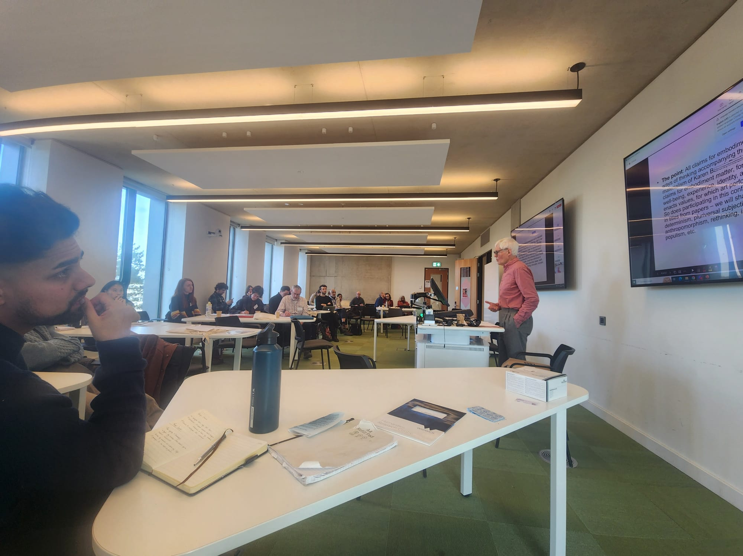
Figure 1. Roger Smith keynote address
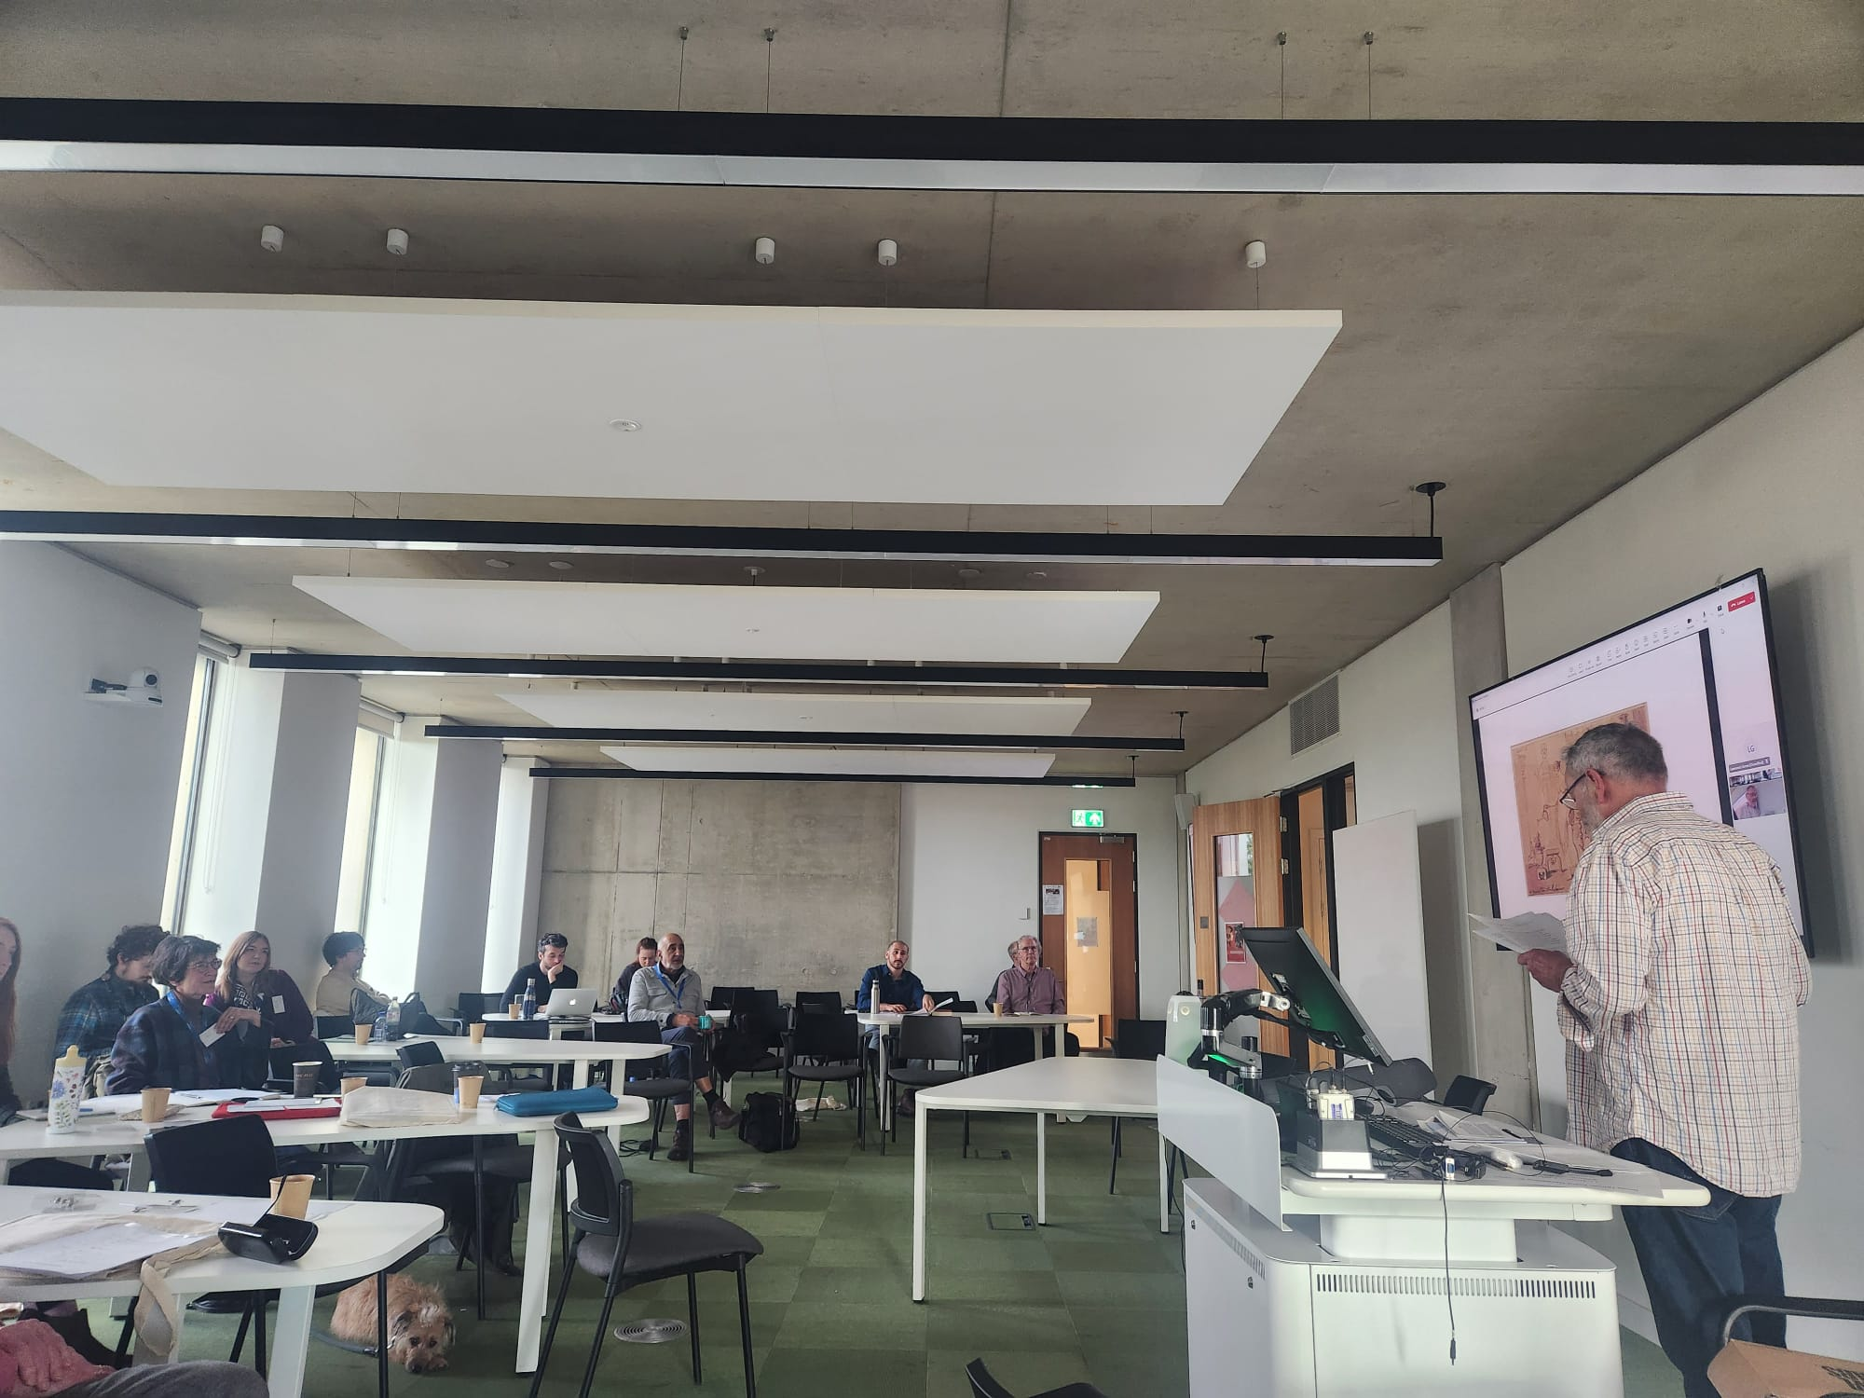
Figure 2. Roger Cooter keynote address
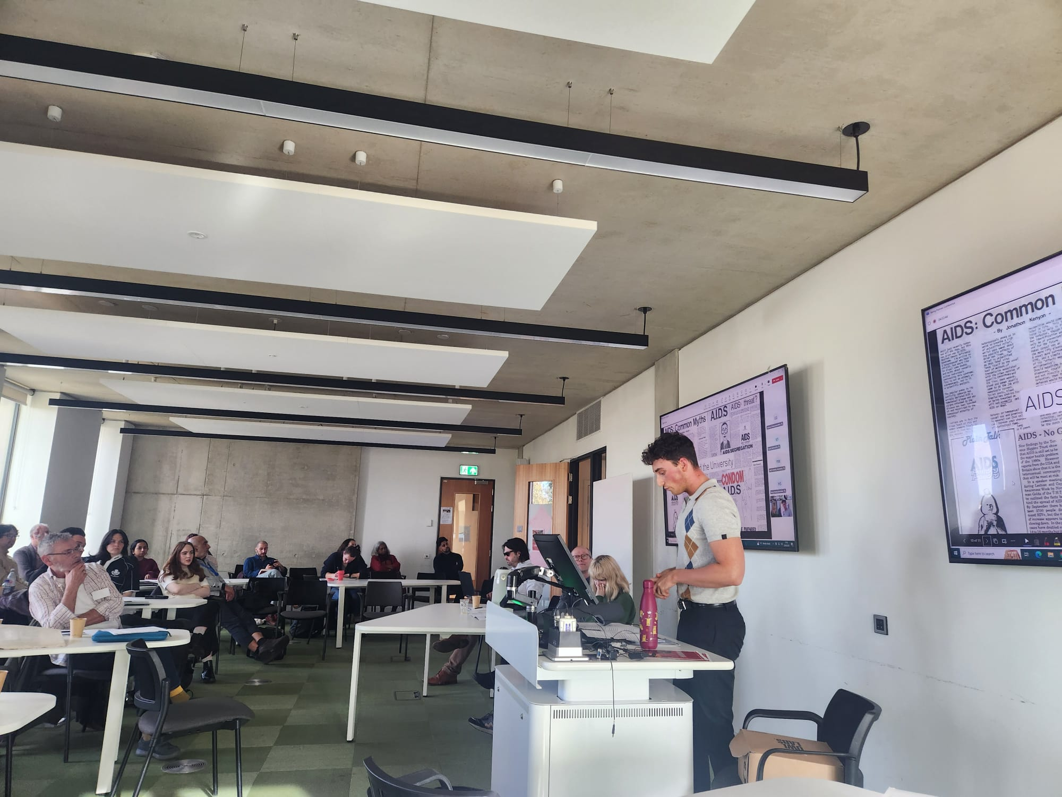
Figure 3. Joseph Price presentation
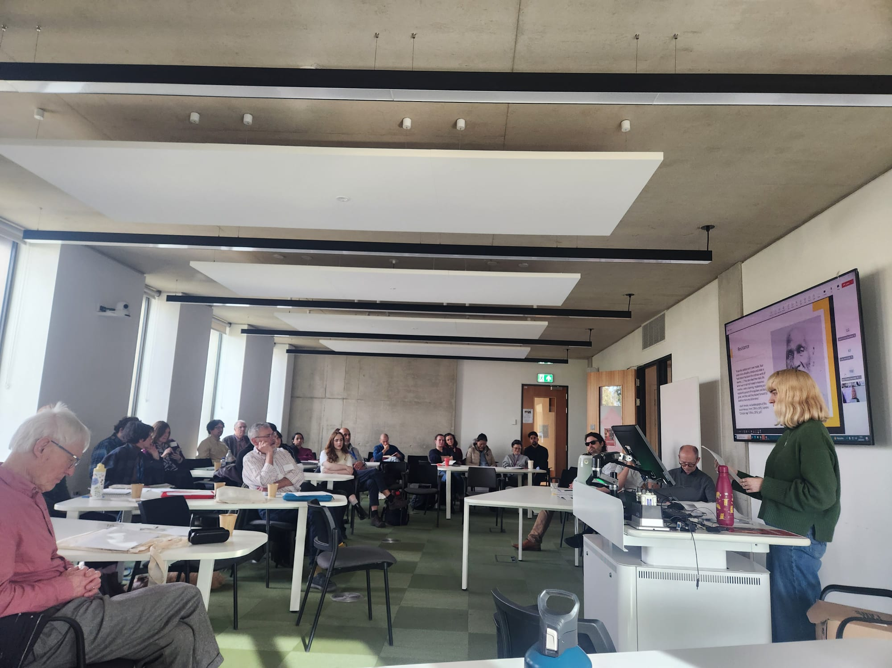
Figure 4. Mia Edwards presentation
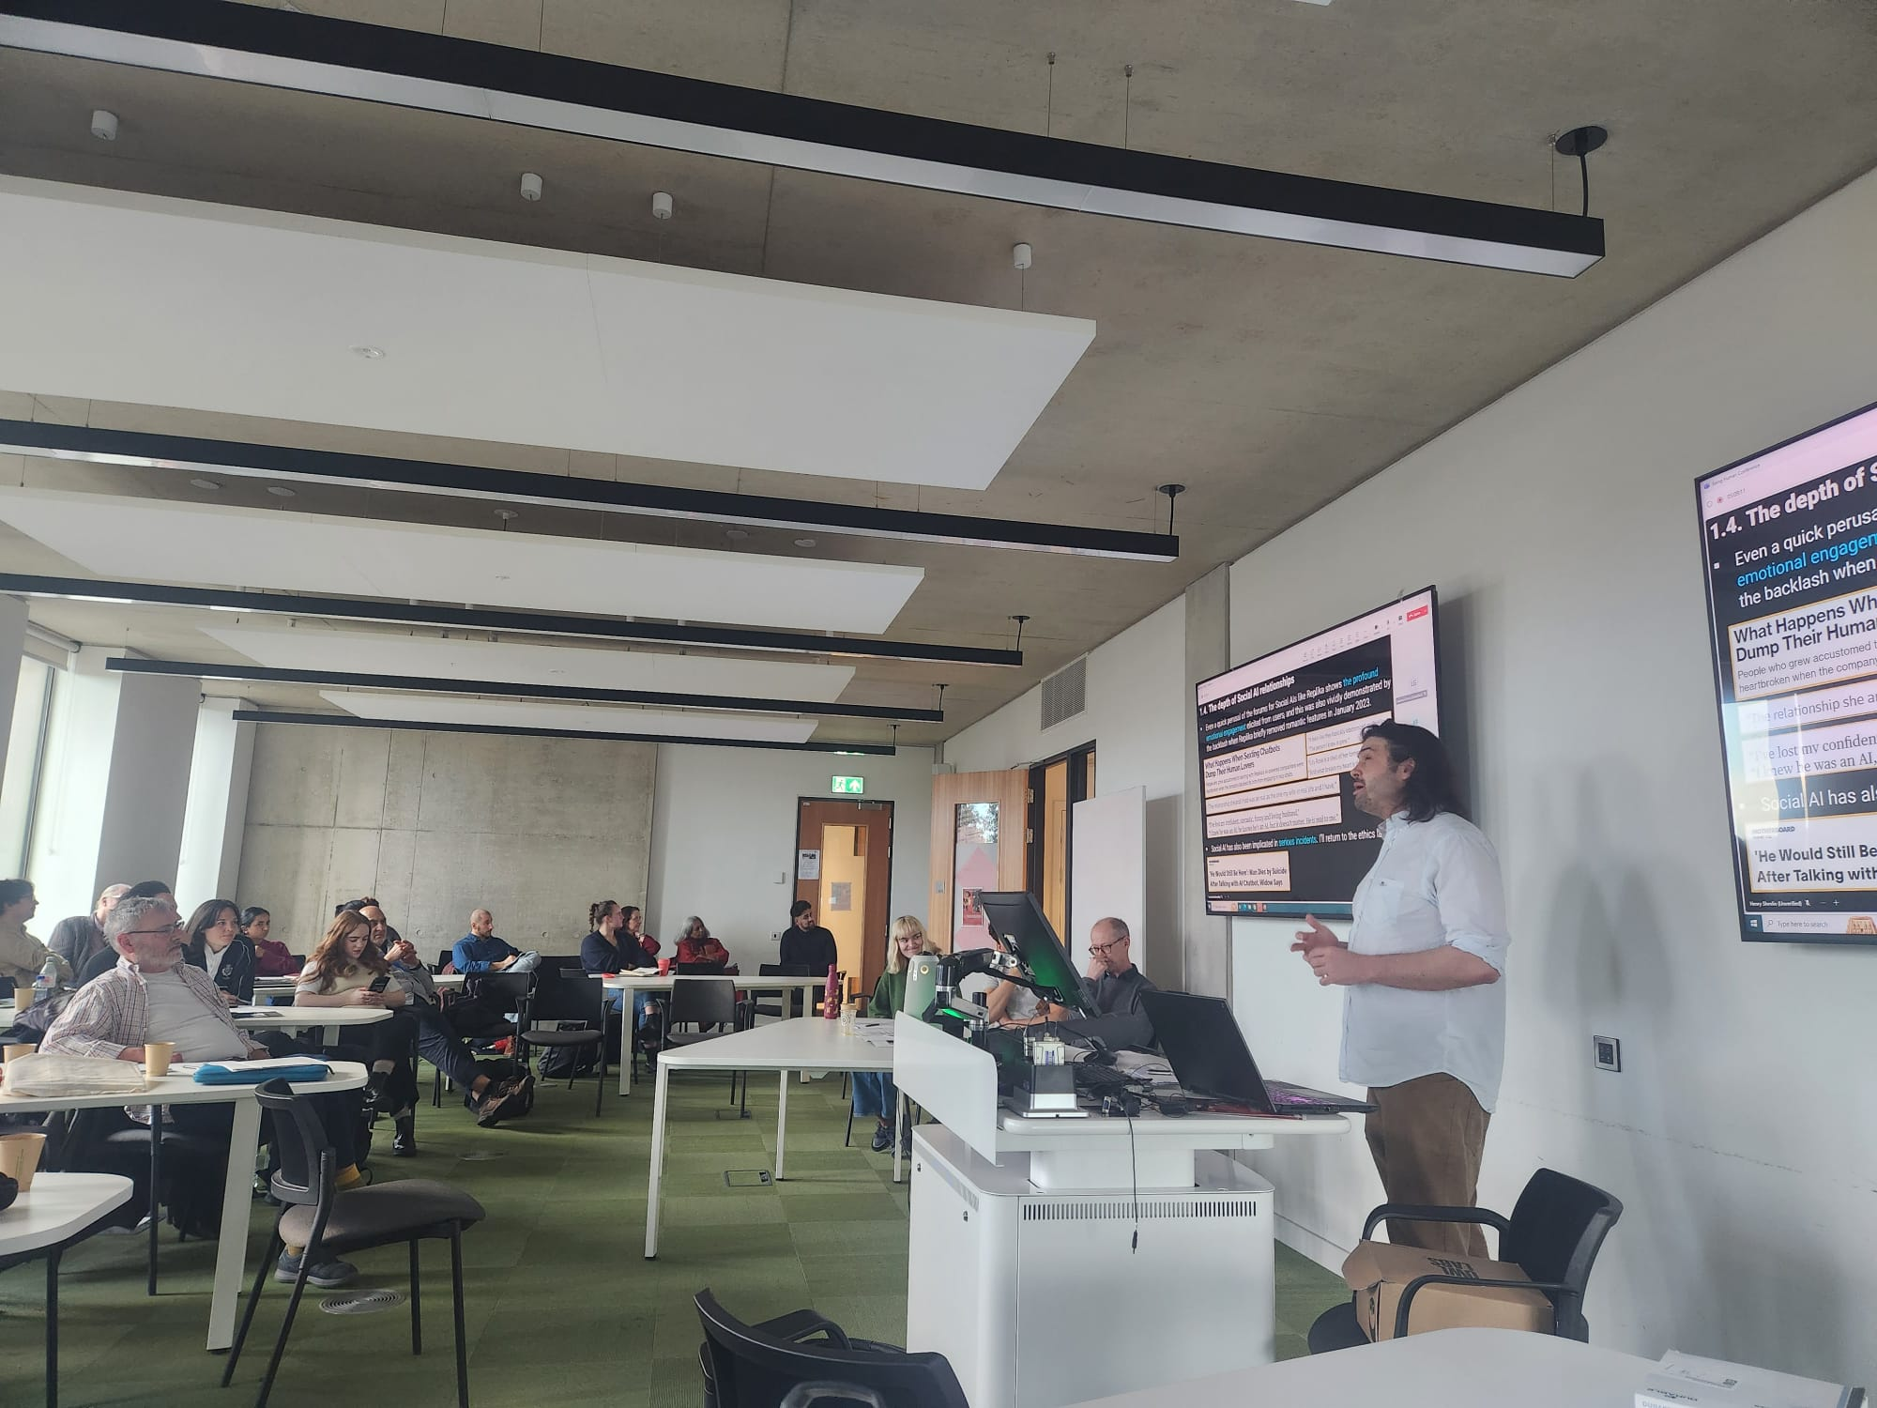
Figure 5. Henry Shevlin presentation
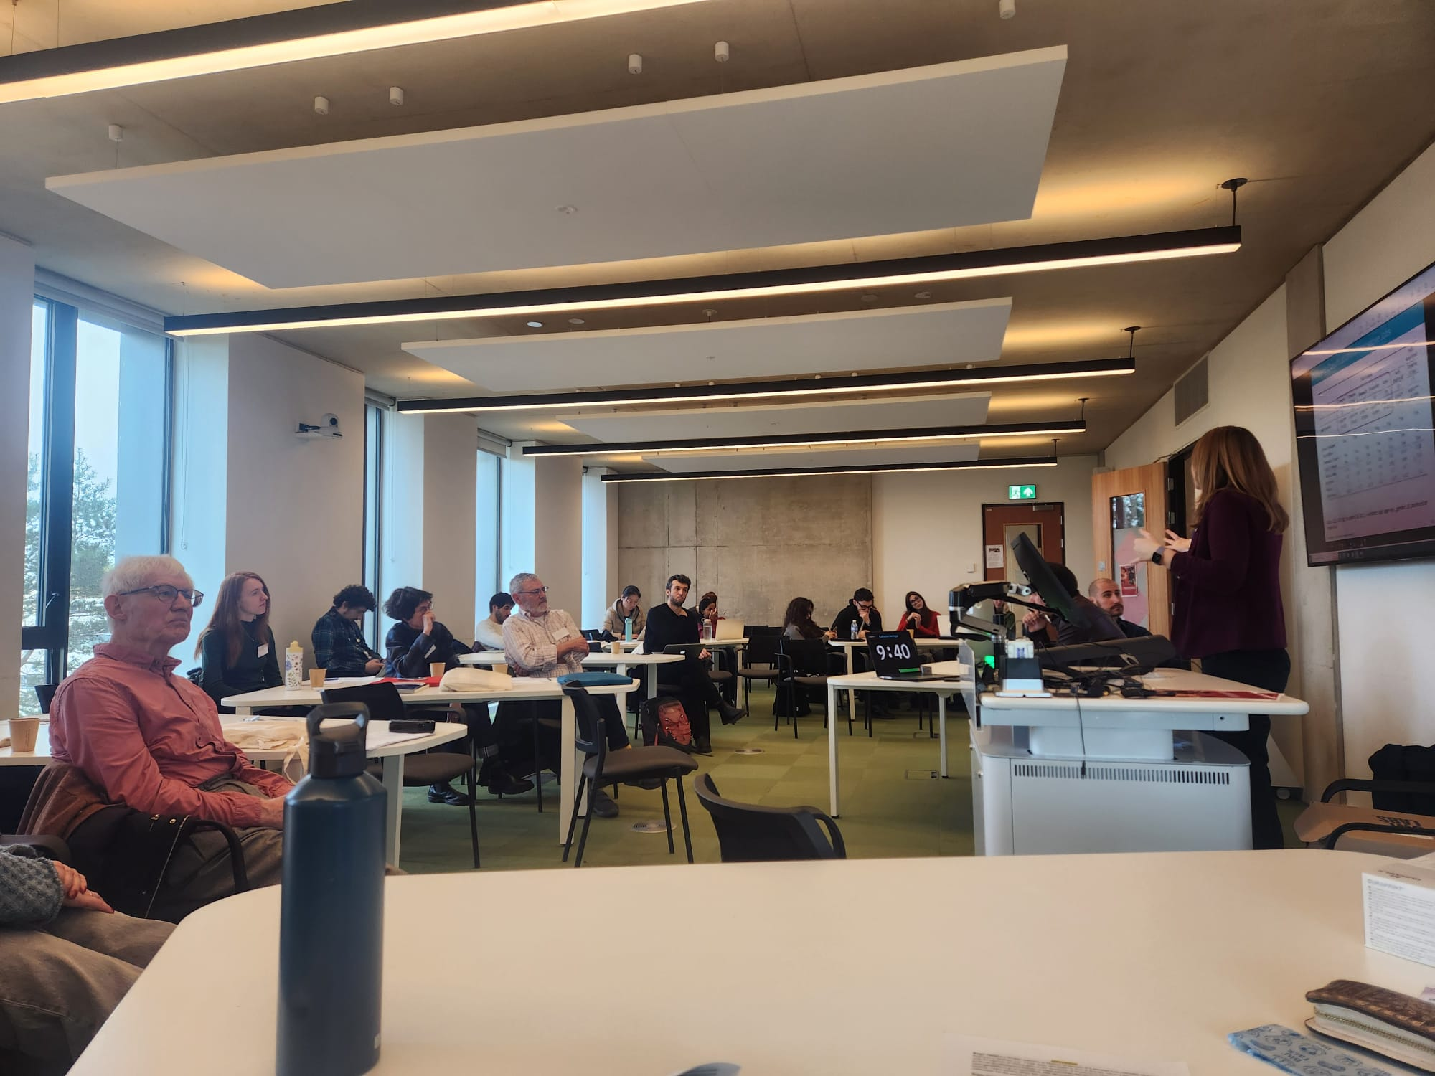
Figure 6. Katharina Hartinger presentation
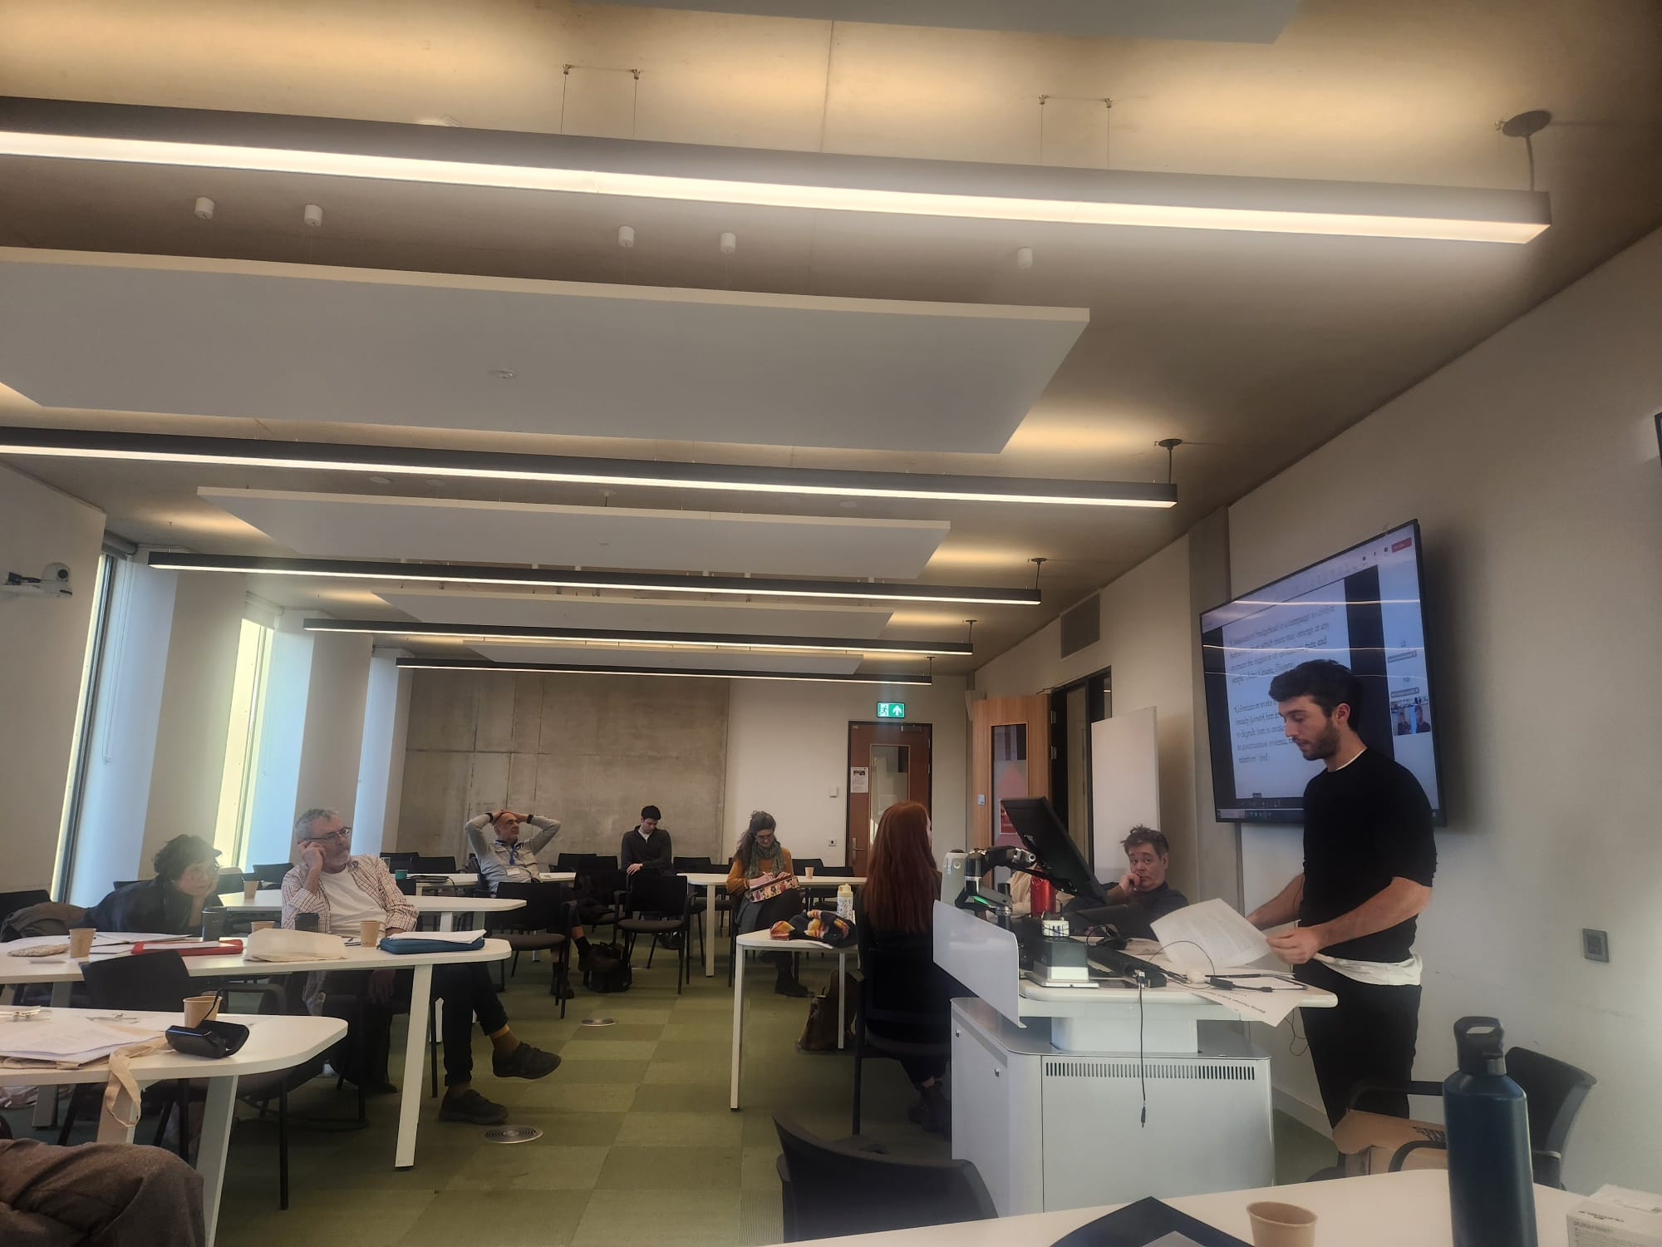
Figure 7. Philippe Le Goff presentation
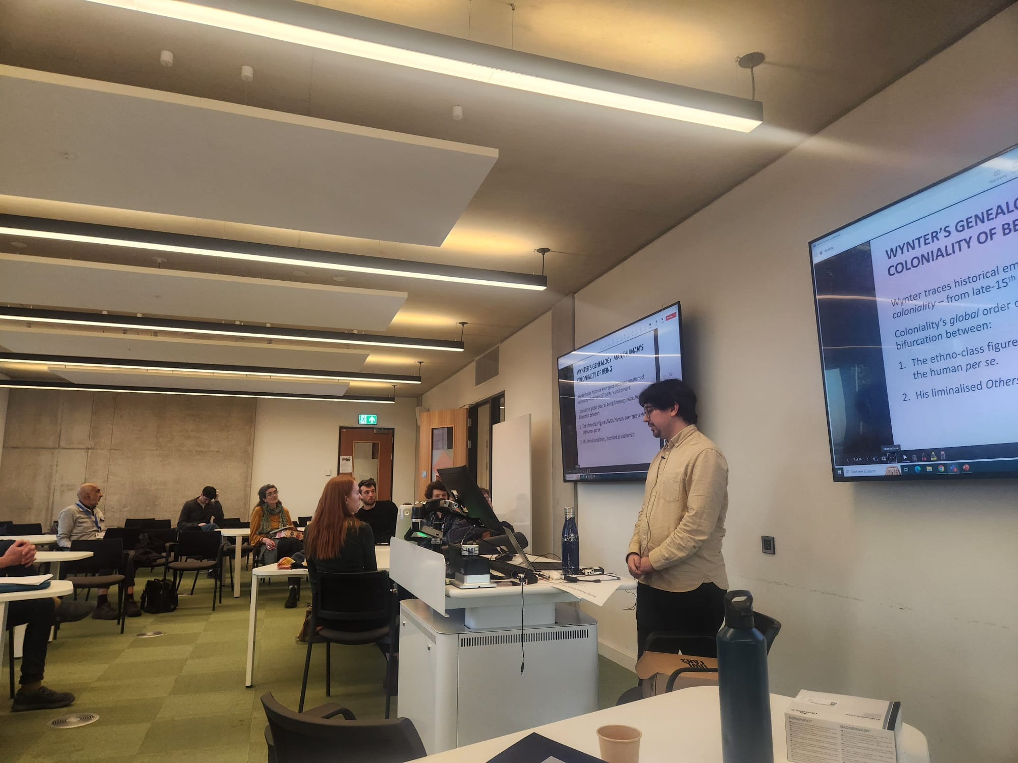
Figure 8. Sebastian Blanco Leyton presentation

