


Eleventh Warwick Symposium on Parish Research
Report on the Parish Studies Workshop ‘Berkswell and Beyond’
Saturday 25 May 2013, Berkswell, Warwickshire

For the first time since its inception in 2003, the Warwick Symposium on Parish Research went on the road. Acting on a suggestion made at the 2012 gathering, the organizers from the Parish Network based in the History Department teamed up with ‘The Spirit of Berkswell’ project to stage a public workshop in the Warwickshire parish of Berkswell. On Saturday 25 May 2013, nearly one hundred participants from a wide range of backgrounds gathered in the village’s Reading Room to discuss local history projects and new developments in parish research.

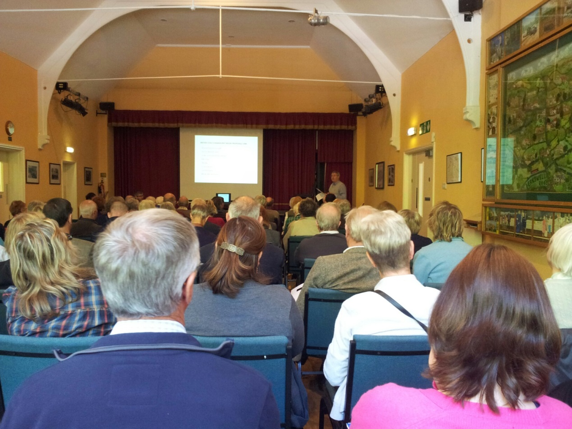

Parish projects presentations in the village’s Reading Room. Picture: Spirit of Berkswell Project.

Following welcoming remarks by the Revd Dr Mark Bratton (Berkswell) and Prof. Beat Kümin (Warwick History), the two morning session featured six presentations from Berkswell speakers and two from members of other Warwickshire history societies. The former offered fascinating insights into the school log book project (illustrated by the testimony of Innes Brett, who had started teaching there in 1949, as well as current pupils Grace and Robert), the Berkswell cannon (brought back from the Crimean war in 1859 by a local naval officer), the Millennium Oral History Project (recording the reminiscences/experiences of forty long-standing inhabitants), the resistance against a coal mining project in the 1980s (partly funded by a series of convivial events), the as yet uncertain outcome of the HS2 campaign (coinciding with reports of an apparent funding shortfall released the same day) and the Spirit of Berkswell project (aiming for an online demonstration on how the parish church has interacted with the local community over the centuries). Delegates also appreciated lively accounts of activities by the Avon Dassett Local History Group (including a weblog of what happened in the village over the course of a year in the early 20th century) and the Kineton and District Local History Group (reporting on the results of an in-depth graveyard survey). For Network members, these talks touched on many key themes of parish studies, e.g. centre-periphery relations, communal responses to sudden challenges, ways of commemorating the past and the value attached to specific material objects.

The lunch break offered delegates an opportunity to visit the Berkswell Museum, which the curators had specially opened for the occasion. Parish sources (such as service and prayer books) were among the many interesting items on display. The afternoon began with something of an experiment, labelled as an ‘ambulatory interpretation’ in the official programme. In glorious sunshine, a huge crowd of delegates and passers-by gathered at Bercul’s well, a focal point of the community since Anglo-Saxon times, to embark on a collective exploration of the exterior and interior of the stunning church of St John the Baptist. Led by the vicar, and benefitting from observations by Warwick/Birmingham early modernists and numerous other delegates, the workshop gained very tangible insights into the architecture, furnishings, rituals and transformation processes associated with an English parish church. The second afternoon session highlighted new instruments/media for local historians: innovative digital tools / apps developed by the Centre for the Study of Christianity and Culture (at the University of York) on the one hand, and the recently-launched online Warwick Network platform My-Parish.org on the other. In a concluding review of proceedings, delegates requested more time for the discussion of the presentations, the addition of short ‘academic’ papers and the planning of further exchanges of this kind. Informal discussions then continued at the Bear Inn, another key Berkswell landmark with pre-modern roots.

Looking back on the day from the perspective of the local organizers, Mark Bratton commented that most of the registered participants were from the locality of Berkswell and its environs. He observed that all the morning presentations were delivered by members of the local community (including Avon Dassett and Kineton). This made the day genuinely inclusive and non-intimidating, that is, not simply a ‘high-brow’ academic conference to which local inhabitants happened to be invited and might feel overwhelmed by. This is not to say that the material and discussion wasn’t high quality. It was – but the quality emerged from the genuinely democratic nature of the Symposium. There has since been much unsolicited anecdotal comment praising the programme and its high quality, and delight at Berkswell’s collaboration with a leading University History Department, as well as the hope that similar events will be held in Berkswell in the future. Berkswell Church is planning to hold a morning in the near future reprising one of the presentations on funerary monuments followed by an ambulatory interpretative tour of the Berkswell churchyard. Mark Bratton also believes that the Diocese of Coventry, and, indeed, the Church of England as a whole, can benefit from the research and initiatives of the Warwick Parish Network, particularly through collaborations like the Berkswell workshop.

The Warwick Network for Parish Research and Spirit of Berkswell project gratefully acknowledge the support of the Humanities Research Centre, research students John Morgan and Donald White, the Berkswell & District History Group, the WI and many individual helpers from the university and the local community. The success of this workshop has encouraged us to think about future collaborations.

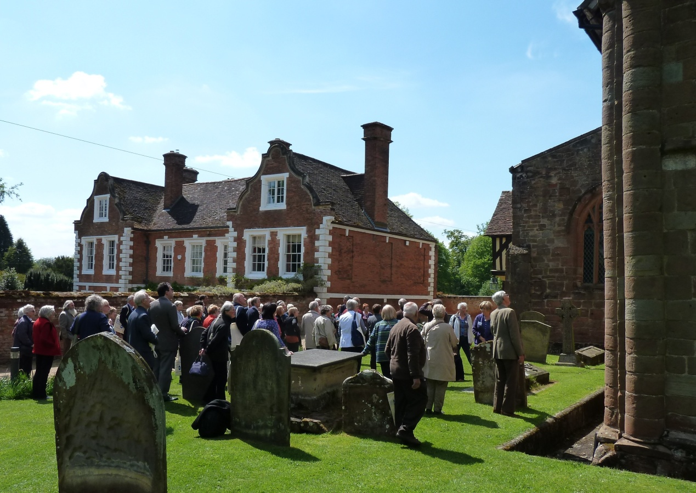

Participants attending the ambulatory interpretation of St John the Baptist, Berkswell.
Picture: Paula McBride.

For full programme details and visual impressions please visit the My-Parish platform: http://my-parish.org/events/parish-symposium-2013

Beat Kümin

Department of History
University of Warwick
Coventry CV4 7AL
b.kumin@warwick.ac.uk

