Bodies in Flux Conference Report
Bodies in Flux: Rewriting the Body in Medieval Art, Literature, and Culture, 1000-1450

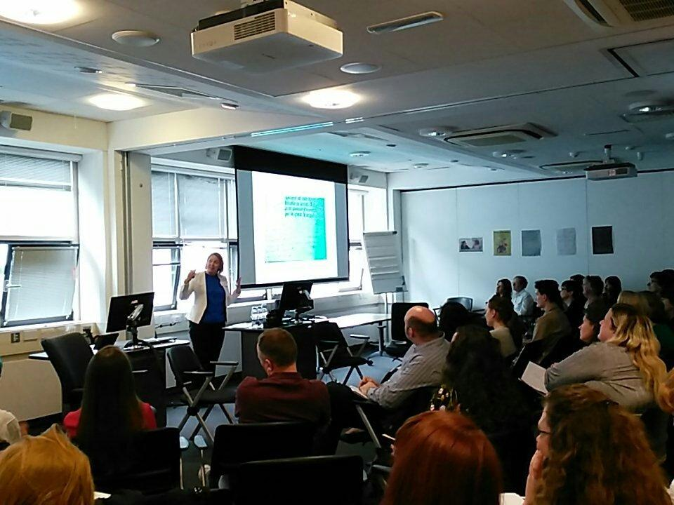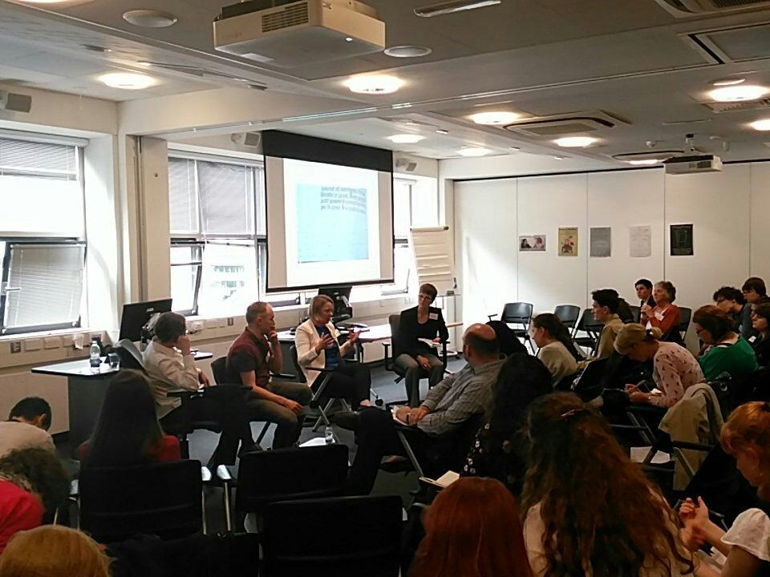

This one-day interdisciplinary conference, held at the University of Warwick on 20 May 2017, asked what bodily transformation means for the conception of bodies of different kinds in the Middle Ages, be they human, nonhuman, animal, material, or divine. The conference brought together a diverse group of international scholars from a variety of disciplines. Panels considered the portrayal of bodies in flux in different media and reflected on the boundaries conventionally associated with the body in art, literature, and culture from c.1000-1450. There were forty attendees in total, including sixteen speakers on paper panels. Topics for these panels included the following themes: animal and divine transformation; gender and abstract thought; monstrous and hybridised bodies; fragmentation and mutilation of the body. The interdisciplinary nature of the event gave rise to discussion of medieval reading practices across the literatures of Europe, archaeology, codicology, art history, and critical theory. The day culminated in a roundtable discussion with Dr Miranda Griffin (St Catharine’s College, Cambridge), Dr Robert Mills (University College London), and Dr Debra Strickland (University of Glasgow). This conversation covered topics as diverse as the challenges of transformation in the medieval tale of the snake-woman Mélusine, the relics of Saint Eugenia, and Hieronymus Bosch’s hybrid creatures. The roundtable format proved fruitful in synthesizing the themes of the day and in drawing the conference to a close. We would like to thank several funding bodies at the University of Warwick, including the Humanities Research Centre, the Department of French Studies, and the University Library. We are also grateful to the Society for French Studies for their conference grant for postgraduate travel, appreciatively received by a number of delegates.
Report by Liam Lewis and Jane Sinnett-Smith (University of Warwick)

