Breaking Containment Public Lab: Event Report
By Wes Lin
On 10th June 2025, Global Sustainable Development at the University of Warwick hosted a public lab of creative practice at the Faculty of Arts Building, funded by HRC, WIE and SCFS. Led by Dr Wes Lin, the initiative of Breaking Containment public lab brought together the general public to engage with global challenges and artistic practice, exploring how we might reimagine approaches to sustainability. The public lab aims to serve as a space for conversation, collaboration and creation with the public, artists and thinkers. We believe that artistic design and creativity can create new ways of approaching sustainability, opening up possibilities to engage with urgent global issues, not just through words, but through making, questioning and reimagining.
The event featured the Care-fully Plate-up exhibition, emerging from Dr Lin’s latest UKRI-funded research on the double burden of childhood malnutrition in China. By exploring the everyday practices of sourcing, cooking and serving food, Care-fully Plate-Up reveals how parents across different regions, socio-economic backgrounds and age groups negotiate their practices in response to the shifting landscapes of parenting and nutrition in contemporary China. Through these visual stories, Care-fully Plate-up invites us to reflect on the evolving meanings of care, health, and family food practices, while opening up conversations about different ontologies of ‘good food’ and the layers of meanings of food, as materiality of care, represented by the layers of photographs for each theme and individual group.
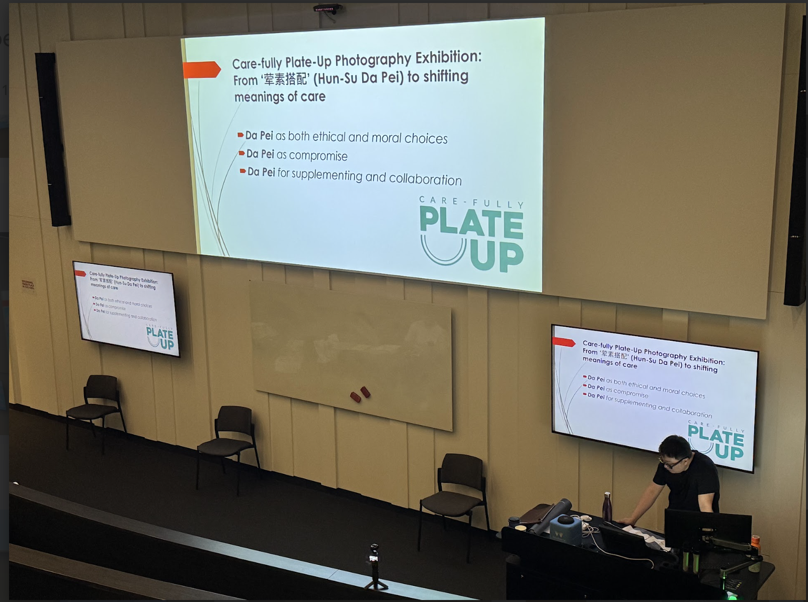

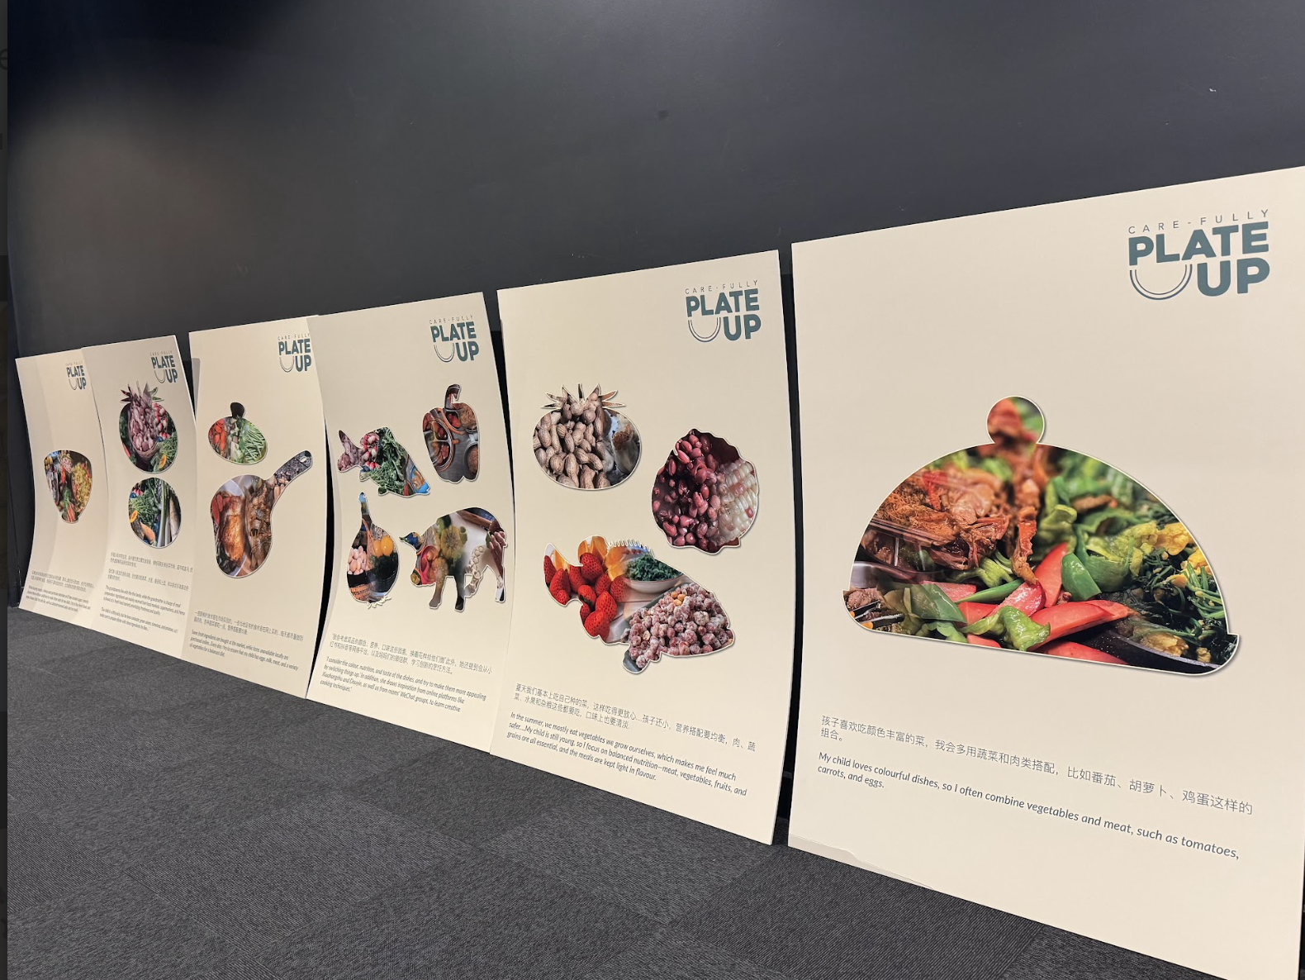
The event began with an introductory talk by Dr Lin about the public lab and the agenda of learning and experimenting with new skills and questioning what we know and how we know, unsettling the assumptions that shape our understanding of the world.
Dr Lin suggested that: ‘From the food we eat to how we engage with global challenges, such as childhood malnutrition or climate change, our thinking often operates within a containment. These frameworks and discourses help us make sense of the issues, but they can also limit us, restricting how we approach the problems, imagine solutions and engage with different ways of knowing. As we face urgent challenges and crises globally, the dominant discourse can feel distant, even alienating. Academic jargon and policy language can box us in rather than opening up new possibilities.’
In the context of research impact, public engagement with art is often treated as mere dissemination rather than a vital opportunity for creating knowledge. The event aimed to move beyond the market-driven economy of knowledge production, seeking new ways of telling stories, through skills we haven’t yet explored and through practice.
The introductory talk was followed by the Sustaining Stories paper-cutting workshop, facilitated by acclaimed Los Angeles-based multimedia artist Sijia Chen. Sijia’s work, spanning intricate paper-cut collages to large-scale installations, engages with themes of cultural identity, collective memory and human displacement, blending traditional craftsmanship with contemporary style. Her work has been curated by major international museums and galleries.
Ms Sijia Chen presented the inspiration behind her work. Trained in both contemporary art and traditional Chinese paper-cutting (a skill passed down through generations in her family), Sijia has developed a distinctive practice that transforms paper-based documents, such as visa application forms, government forms, and institutional paperwork, into intricate works of art. Her work has repurposed paper-based documents and everyday life materials into landscapes of symbols that contain personal narratives, which particularly captured the audience’s imagination. She explained that the materials she uses are documents containing people’s stories. She argued that, ‘Sustainability isn't just about preserving what we have, but asking what kind of future we want to build.’ Such an ethos resonated with the audience and aligned with the values of the University of Warwick.
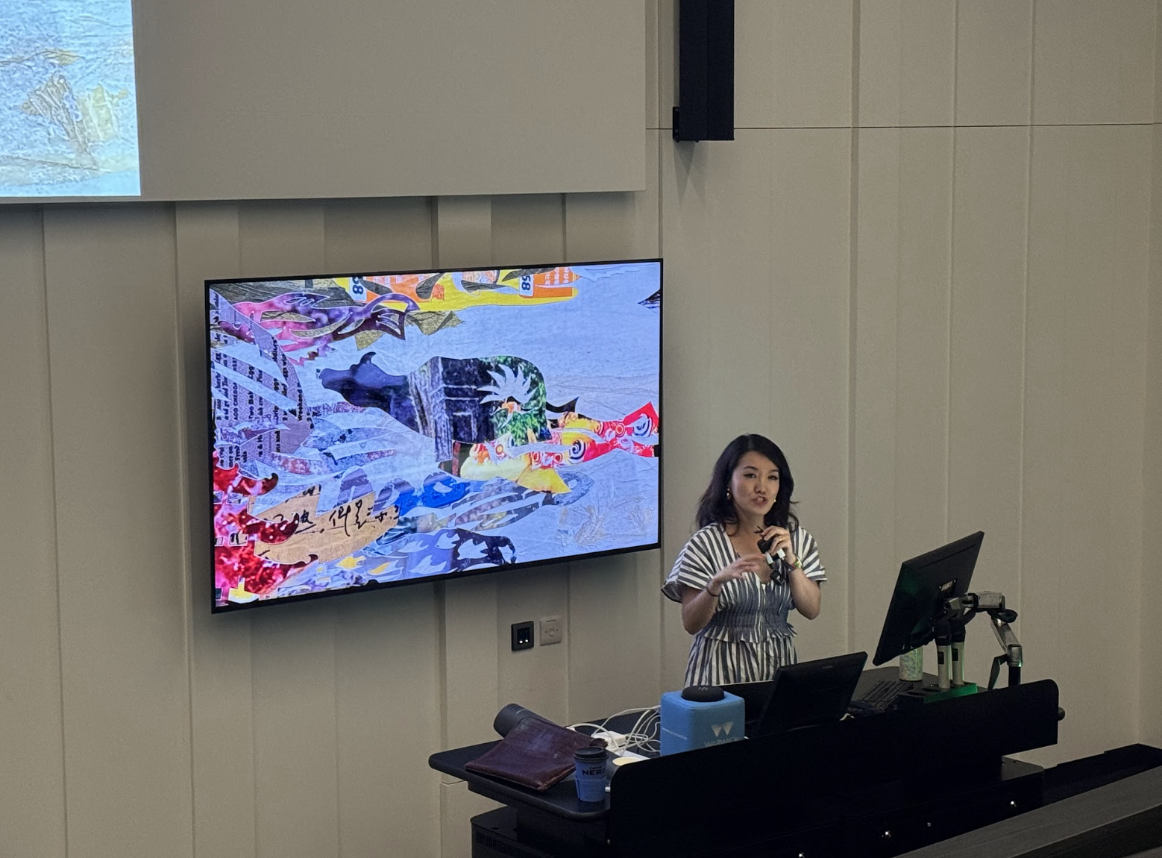
The event then moved into a practical workshop. Participants were joined by Sijia and her father, Mr Chuansheng Chen, a well-known master of Chinese paper-cutting. The intergenerational dynamic between the traditional and the contemporary created a dialogue on cultural preservation versus transformation. Participants, a diverse mix of university staff, students from within and outside the University of Warwick and local community members, engaged with this activity to learn directly from Sijia and her father, while being encouraged to reinterpret meanings of global concerns. Participants chose from four themes and explored new sensibilities in relation to them, using either materials they had brought or those provided at the event:
- Good Food
- Waste and Discard
- Climate and Environment
- International Education, Transnational Migration and Mobility
The public lab became a space that was filled with creativity. Participants worked with recycled documents, old magazines, leaflets and other paper materials. What emerged from this creative process was a different way of transforming something ‘wasteful/disposable’ into something with meanings for sustainability. The act of creative practice, cutting paper and creating images, became a form of knowledge production, with paper serving as both medium and metaphor for how our lives are simultaneously shaped by and resist structures of feelings.
Sijia, Mr Chen and Wes worked with participants in talking through their creative work on canvas boards, displaying personal expressions that spoke to shared experiences. The Breaking Containment lab succeeded in its ambitious aim to foster dialogue between academic research, artistic practice and community participation. Participants from diverse cultural backgrounds were not passive observers, but active co-creators who formed connections with both the artistic process and its underlying concepts. The paper-cutting workshop generated stories that will continue beyond the lab’s conclusion.
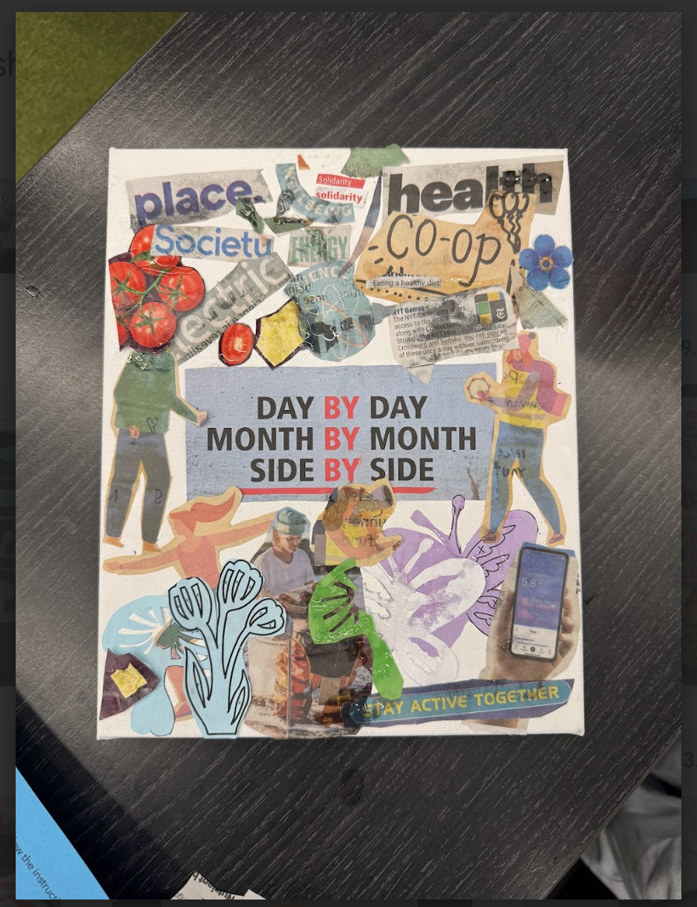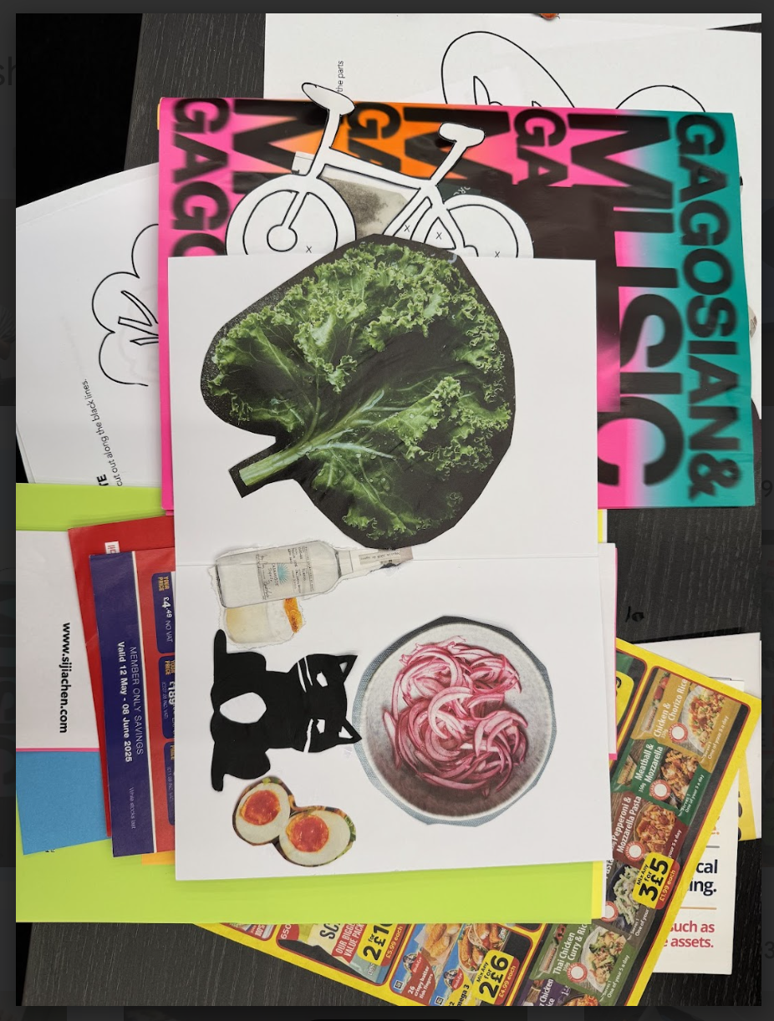
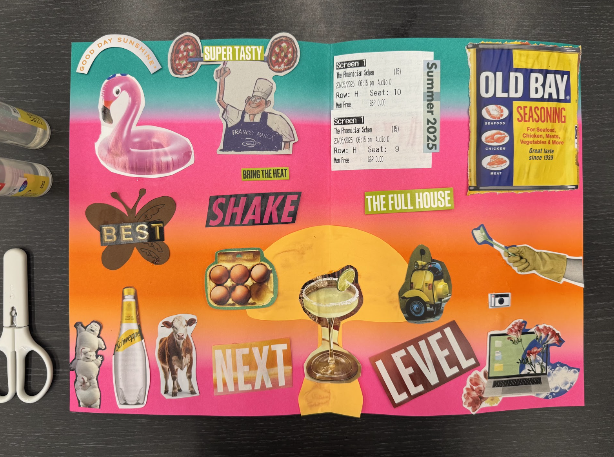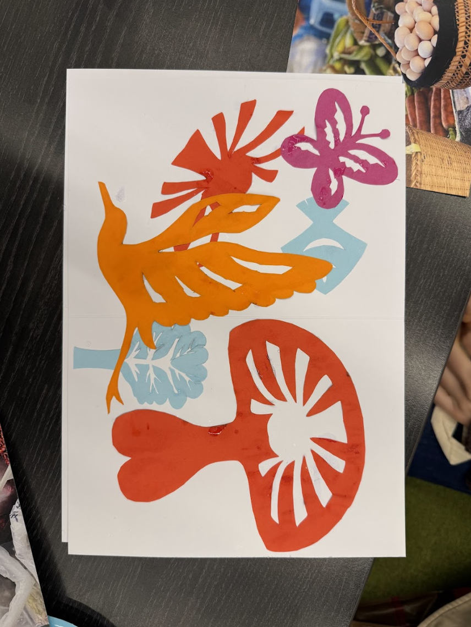

We have received great feedback from the participants, either verbally or through completed feedback forms. Here is a selection of feedback:
‘It made me realise that something we see as useless can actually become valuable—recyclable material that helps save our environment.’
‘It definitely inspired me to rethink the role of everyday items and how I can use them to communicate memories.’
We plan to build on this successful event that bridges academic disciplines and community engagement. As climate change, migration and sustainability continue to shape our collective future, initiatives such as Breaking Containment suggest one possible path forward, where research and creative practices join forces to cut through the constraints of conventional thinking and create space for more inclusive and sustainable narratives to grow.

(Photos credit: Dr Manli Zhu)

