Warwick Numismatic Day 2023 – Imitations of Ancient Coins and their Function
organised in conjunction with the
Money and Medals Network Training Day
15-16 June 2023

Ancient Numismatics, the study of ancient coinage, is one of Warwick’s Classics Department’s research strengths. The Department is an international hub in numismatics with three staff members, experts in the field, embedding their research in the wider context of Ancient History, Classical Archaeology and Ancient Economy.
The Warwick Numismatic Day has been an annual event since 2010, assembling specialists, including young researchers and students, as well as members of a wider audience, such as collectors, to share and discuss papers around topics on ancient Numismatics https://warwick.ac.uk/fac/arts/classics/research/interests/numismatics/numismaticday/. After a two-year break due to the pandemic, this year’s workshop saw the return of the 11th Numismatic Day, dedicated to imitations of ancient coins and their functions https://warwick.ac.uk/fac/arts/classics/research/money-and-medals/events/ This workshop was a milestone for two reasons.
First of all, this was the perfect opportunity to mark the move of the prestigious Money and Medals Network (MMN) from the British Museum to the Department in August 2022, an institution offering training and advice to c. 240 museums and other institutions in the UK holding coins in their collections. Therefore, organising the Numismatics Day together with the first MMN Training Day at the Department was straightforward. Campbell Orchard, a PhD student investigating the mint of Tarsus, and the new MMN officer will report on that event separately below. The other asset and hallmark was the presence of Clive Stannard as the Visiting speaker. Clive joined the Department as an Honorary Research Fellow in September 2022. He has written extensively on non-state coinage, including imitations and the value in minor coinage in ancient economies, as well as on minting and die technology https://warwick.ac.uk/fac/arts/classics/intranets/staff/stannard and hence delivered a keynote paper at both events.
The Numismatic Day (16 June)
The term ‘imitation’ of ancient coins refers to coins deliberately made to resemble genuine coins; however, as opposed to fake coins, they were not produced to deceive the user. Yet, similar to forgeries, they were not made by official minting authorities. Such coins can be a source of important historical and cultural information, shedding light on issues such as local economic conditions, political affiliations, and artistic styles. Imitation coinage can be found from various historical periods and in various parts of the world, making it a fascinating area of study for numismatists and historians alike. They were mainly produced when states were unable to provide coinage, yet needed to perform transactions, typically those at the lowest level of the economic scale for daily use, with small bronze coins. The production and circulation of such coins were therefore tolerated, if not encouraged, by the official authorities.
In the past, the phenomenon of imitative coinage was studied more widely, e.g. for the so-called barbarous radiates of the third quarter of the third century AD, produced by the usurpers of the Gallic Empire, Postumus (260-268), Victorinus (269-271) and the Tetrici (father and son, 271-274). Imitations of other periods and regions were less studied, if studied at all. Such coinages were discussed at the occasion of the Numismatic Day, in three parts, on imitations a) of the Western Mediterranean, in the Republican period, and in Italy in particular, b) of the Eastern Mediterranean in the Roman Empire, and c) of the late imperial period in the West. This included seven papers by scholars from the Universities of Liverpool, Nottingham and Warwick, including three female PhD students, a proportion which is rare in disciplines related to ancient economy. Kevin Butcher, Suzanne Frey-Kupper and Clare Rowan moderated the discussions after the three thematic blocks.
For a long time, the general view was that Republican Rome provided coinage on a regular basis to its colonies, and allies in Italy. Stannard who conducted groundbreaking research in this field was able to demonstrate that this was not the case, and that from the mid-second century to Augustus, a wide range of local (non-state) coinages were issued by various actors in Latium and Campania to bridge the gap of small change. His keynote paper gave an ample account of these coinages as well as of small silver obols circulating in Southern France imitating after prototypes of Carthaginian coins of the Second Punic War. Suzanne Frey-Kupper (Warwick) who has worked with Clive Stannard on imitations in the past, argued in her paper ‘Imitative coinages in Italy as a prelude to Augustan quadrantes?’ that the iconography of the quadrantes issued under Augustus may reflect the choice of iconographies on imitative coinage circulating Latium and Campania. In this workshop, these western imitations were for the first time, paralleled to small bronze coins from the Roman Near East. Just as the imitations from Italy they operate by the use of hybrid combinations of obverse and reverse dies for which Andreas Kropp coined the appropriate definition ‘mix and match coins’. The paper by Kevin Butcher (Warwick) ‘Small coin, big implications?’ discussed the wider implications of these coins, produced from the later second century AD, complemented by the contribution of Nathalia Kristensen (Warwick) on ‘Imitations of Caesarea Marittima’ and of Andreas Kropp (Nottingham) ‘Syrian imitation coins: types, die links and attributions’. In the final part, Susan Walker (Warwick) discussed ‘Usurpers and commemoratives – the importance of site finds: the Roman sanctuary of Uley and its imitations of Magnentius’ Chi-Rho SALVS issues’ and Naomi Rubinstein (Liverpool) presented a paper on ‘Identifying Constantinian base metal copies in Romano-British coin hoards (AD 330-341) through compositional analysis with XRF’, highlighting the importance of scientific analysis to understand the production and diffusion of imitations.
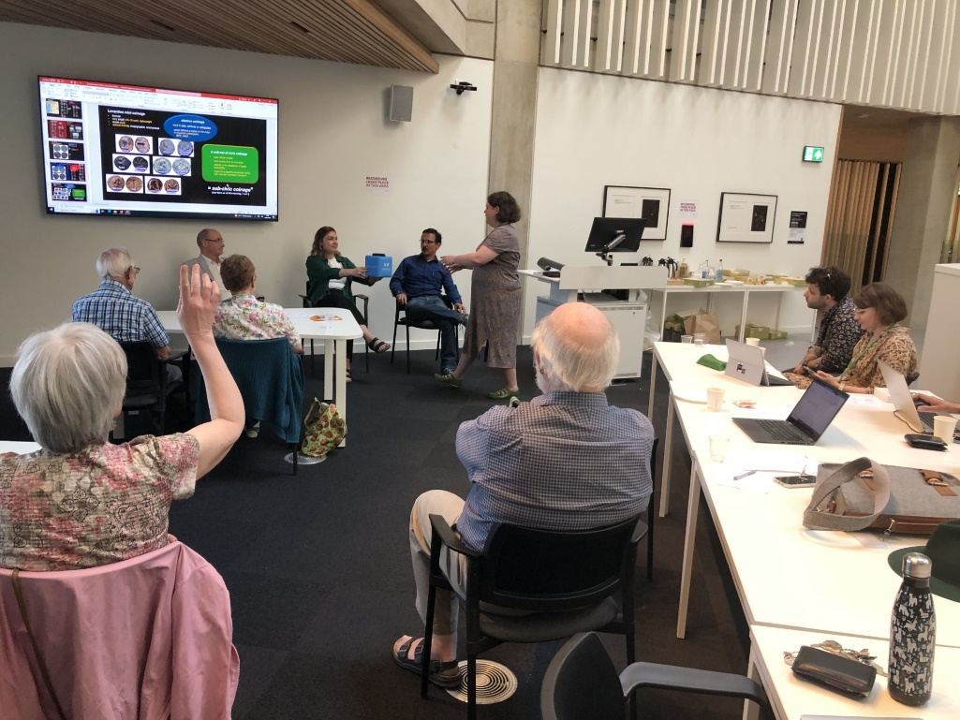
Warwick Numismatic Day 2023: the lively discussion following the sections on imitations of the Ancient Near East.
The pluridisciplinary approach of the workshop and the following discussion allowed to address a number of questions regarding the function of imitative small coins and to pinpoint directions for future research. It was agreed that more data from finds as well as rigorous die-analysis combined with metal analyses are promising tools for a better understanding of the phenomenon which helps to enlighten not only economic aspects but also question the choice of often obscure iconographic choices. Overall, the workshop was a welcome and helpful platform to advance in this direction with Warwick and its colleagues from elsewhere who are longstanding fellow researchers, at the forefront of this research.
The Money and Medals Training Day (15 June)
The Money and Medals Network (MMN) Training Day on June 15th marked a significant milestone for the network, as it was the first in-person training event since 2019. The event provided attendees with a unique opportunity to enhance their skills in coin identification, expertise currently underrepresented in the sector due to the move towards more general curation. With experienced professionals leading the training sessions, participants gained practical knowledge and engaged in discussions on current issues and challenges in the field.
The MMN Training Day attracted a diverse audience consisting of 14 individuals from the museum sector, metal detectorists, and students. The event commenced with an opening talk by Campbell Orchard, the MMN Project Officer, who discussed the future of the network, particularly its commitment to offering training opportunities throughout the UK once again.
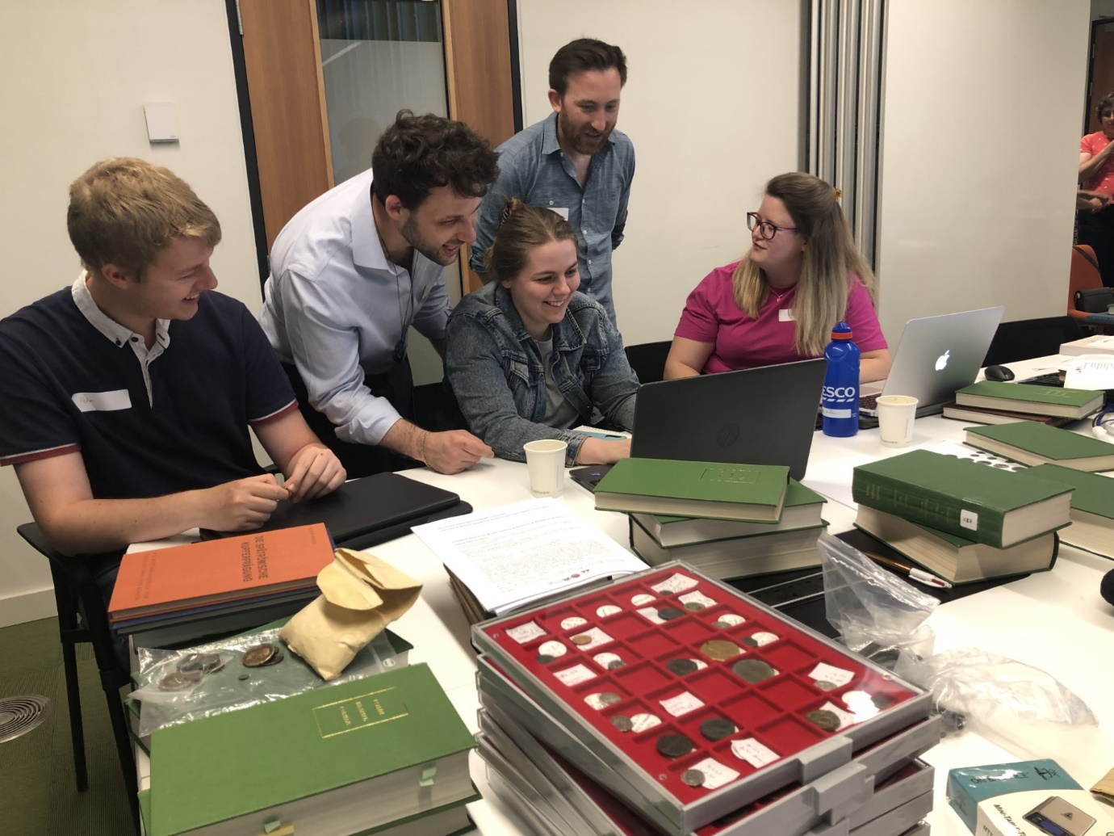
Money and Medals Network: Training Day with hands on activities on coins from the Classics Department’s coin collection.
The training sessions were facilitated by Suzanne Frey-Kupper and Kevin Butcher, supported by Clive Stannard and Andrew Brown (London) from the Portable Antiquities Scheme based at the British Museum. These knowledgeable professionals guided participants through hands-on activities, imparting practical skills in coin identification and cataloguing.
In the afternoon, Andrew Brown delivered a talk on the Portable Antiquities Scheme https://finds.org.uk/ , shedding light on its significance and impact within the field of numismatics. The talk emphasized the scheme's mission to promote the reporting and preservation of portable antiquities, highlighting the scheme's role in encouraging best practices among finders, landowners, archaeologists, and museums in the discovery, recording, and conservation of finds made by the public. This session provided attendees with a broader perspective on the cultural and historical significance of portable antiquities and their role in elevating museum collections.
A key highlight of the MMN Training Day was the roundtable discussion, which fostered an open exchange of ideas among all attendees. The discussion primarily revolved around how the network could best support museums in the UK with their numismatic collections in the future. This fruitful conversation allowed participants to voice their opinions and share insights, ultimately helping to shape the network's future offerings and initiatives.
The day concluded with a captivating talk by Clive Stannard titled 'Dies, transfer dies, punches, and hubs.' This presentation delved into the production process of coins, enlightening attendees about the intricate nuances involved in coin manufacturing. The talk seamlessly connected with the upcoming Warwick Numismatic Day, further enhancing the attendees' understanding of both official and unofficial currency.
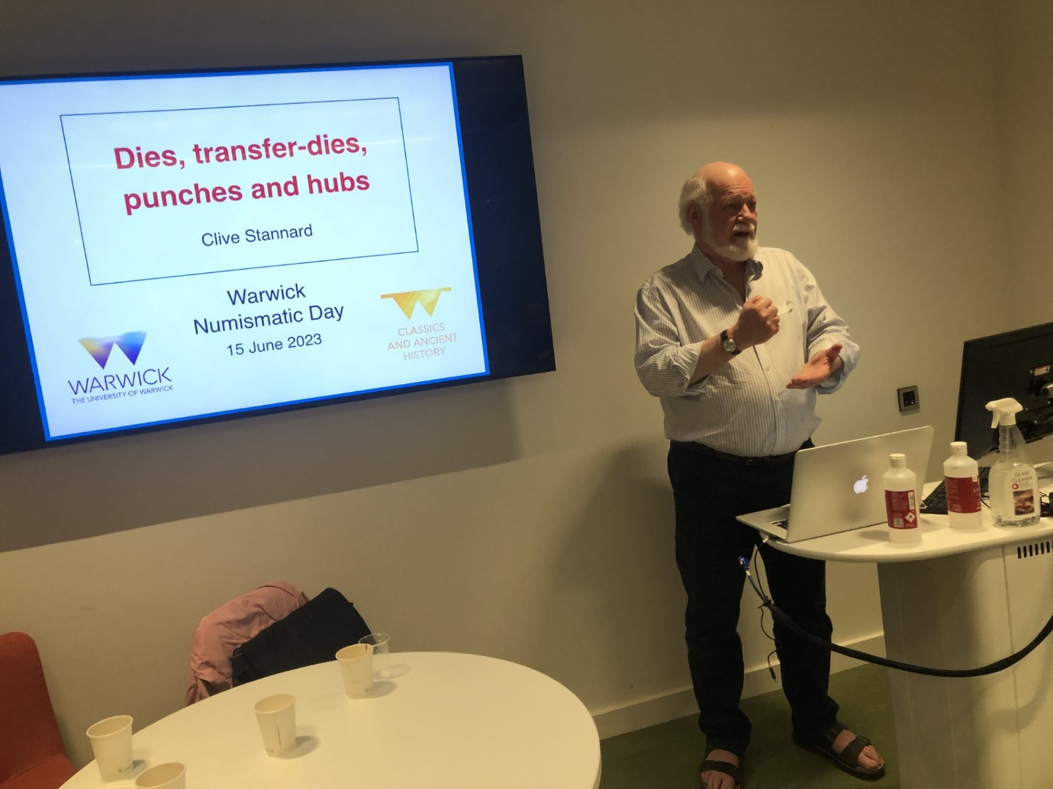
Clive Stannard, Honorary Research Fellow of the Classics Department, explaining coon technology to participants of the Money and Medals Network’s Training Day.
The Money and Medals Network Training Day held on the 15th of June marked a successful return to in-person learning for the network. With a diverse range of attendees, the event provided a valuable platform for individuals from the museum sector, metal detectorists, and students to enhance their numismatic knowledge and skills. Through engaging training sessions, informative talks, and a productive roundtable discussion, participants gained practical insights and contributed to shaping the future direction of the network. The event's conclusion with Clive Stannard's talk served as a fitting segue to the upcoming Warwick Numismatic Day. Overall, the MMN Training Day was an enriching experience for all involved.
We are grateful to HRC for its support, allowing the organisation of the Numismatic Day and enriching the MMN Training Day, funded by the Royal Numismatic Society and the British Numismatic Society, by Clive Stannard’s keynote paper.


Suzanne Frey-Kupper and Campbell Orchard, 30 June 2023

