PARISH AND PERFORMANCE
Twenty-First Warwick Symposium on Parish Research
Co-organized by Beat Kümin (Warwick History / My-Parish) & John Craig (Simon Fraser / Records of Early English Drama) with Daniel Gettings & Maria Tauber (Warwick History)

Report by Daria Akhapkina (Centre for the Study of the Renaissance, Warwick)

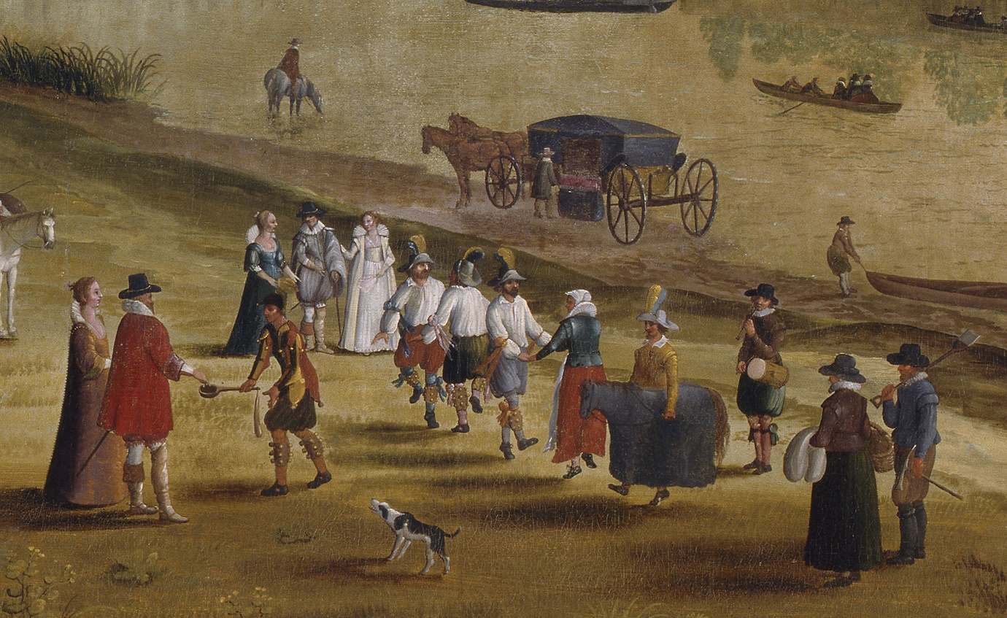
‘The Thames at Richmond, with the Old Royal Palace’
(unknown Flemish school, early 17thC). © The Fitzwilliam Museum, Cambridge.

This Symposium was held in a hybrid format and welcomed researchers from Belgium Canada, Hungary, the UK and the US to Warwick’s Institute of Advanced Study as well as online. In his opening remarks BEAT KÜMIN (Warwick) stated that – from the preaching of sermons via the staging of plays to the conduct of ceremonies – parish culture has always included elements of oral, musical, mimetic and other types of performance. The speakers explored a variety of sources from the Middle Ages to the present, addressing aspects of regulation, contexts as well as perception.
The keynote speaker PETER GREENFIELD (Puget Sound) introduced the audience to REED ONLINE, the digital version of Records of Early English Drama. He began his address by quoting a diocesan letter written in 1585 by Thomas Cooper, Bishop of Winchester. Cooper wrote of the ‘straunge perswasion among Christians’ in his diocese that ‘they can not by any other meanes of contribution repaire their Churches and set forth the service of God, but that they must first do sacrifice to the devill, with Dronkennes and dauncing, and other ungodly wontonnes’. Cooper’s fulminations were set against the very different language used two decades later by the inhabitants of Rangeworthy in Gloucestershire, where the Whitsuntide revel was called a ‘generall feast or meetinge of Freindes’ used for the ‘refreshinge of the mindes and spirittes of the Countrye people’ and for the ‘preservacion of mutuall amytie, acquaintance and love…’. These contrasting examples were used to illustrate REED’s main mission of locating, transcribing and publishing the comprehensive evidence of the development and existence of English drama from its documented beginnings to the closure of the London theatres in 1642. Greenfield demonstrated how the digital collections make individual records easily accessible to the researchers, facilitating the users’ experiences and encouraging a deeper understanding of the performances in early modern communities.
The first panel on music, dance and charivari included papers from SUSAN SKINNER (Plymouth), MICHAEL HEANEY (independent scholar), TAYLOR AUCOIN (Edinburgh) and EMILY WINEROCK (Point Park). Common themes included changing and vanishing traditions: all speakers presented evolving perspectives on specific parish activities. Skinner focused on the tradition of Cornish parish music, looking into the history of Polperro and Looe fishermen’s male voice choirs. She argued that the practice of choral singing, which practically died out in the aftermath of the WW2, was a way to unite the community and share their lived experiences. By committing to performances, the unprofessional singers strengthened their sense of comradery, raised funds for charitable causes and forged a local Cornish identity. Heaney discussed another once prolific tradition that moved in and out of parish life – that of morris dancing. His paper traced how the once widespread entertainment was viewed with increasing disapproval from the mid-sixteenth century, which eventually led to its total suppression and exclusion from the parish activity. Aucoin examined ‘nuptial’ charivaris – traditions of communal exactions of food, drink and entertainment from newlyweds – which have long remained understudied due to being less ‘sensational’ than their ‘marital’ counterparts aimed at transgressions of gender norms. Aucoin investigated a type of exaction known as ‘ball-money’, where local children or adults demanded a football, or money to purchase one, either on the respective wedding days, or during festive seasons like Shrovetide. He concluded that the underlying idea of such rituals was that all newlyweds owed something to the community. The final paper returned to the previously mentioned 1613 Rangeworthy case: Winerock argued that constable Parker arrived at the site being aware of the ‘unlawful activities’ taking place and therefore likely had an interpretation already in mind, while the parishioners defended their traditions. The lack of respect for such customary celebrations felt like an attack on the community, since local parish festivities were already under pressure from the religious authorities. This explains the harsh response from the parishioners who refused to follow the constable’s orders.
In the second panel, LYNNETH RENBERG (Anderson), LYDIA FISHER (Exeter), KRISTY FLAKE (Warwick) and CHRIS HIGHLEY (Ohio) all concentrated on the parish relationship with drama. Renberg discussed the role of the York Mystery Cycles in modeling emotive performance. She suggested that they had a didactic function, presenting the audience with a normative understanding of emotional expressions as well as a rhetorical framework for expressing their feelings. By using rhetoric in sermons and plays that framed joy as a future delight, parish performances steered lay audiences towards heavenly joy through performed earthly models. Fisher emphasized the dramatic qualities of stained glass images in the church of St Kew (Cornwall) that evoke the narrative and spectacle of religious plays. She argued that several scenes, such as Christ’s entry to Jerusalem, borrowed certain details from the miracles of the Cornish Ordinalia cycle, i.e. created an artistic dialogue between stained glass and religious drama which sought to move the audience to worship and actively experience these climactic events in present terms. Flake’s paper was dedicated to the performative practices of preaching the Book of Homilies, which became a foundational text for the development of English Protestantism and the Church of England. The Homilies’ performances fulfilled a range of functions such as social cohesion during the Rogation days, discipline in form of public penance and political control. Flake discussed examples which highlighted different appeals to – and experiences by – the congregations. At one point, she asked a Symposium participant to impersonate a sinner who had to go through a disciplinary reading of the homily against gluttony and drunkenness, which – quite contrary to the preacher’s original intent – made the modern audience sympathise with the poor penitent. Highley’s final paper concerned the representation of parish life in the drama The Spanish Curate. Although the title character Lopez and his sexton Diego fail to carry out their duties as the religious leaders of the community, they are still loved and respected by their parishioners for being undemanding and allowing the beloved communal activities. Highley discussed how the portrayal of corrupt clergymen from Cordova might have resonated with seventeenth-century English audienees.
As a part of the next session entitled ‘performance’, DAVID FLETCHER (Warwick) directed a dramatic reading of a pamphlet (‘Parochial Tyranny’) by Mark Roberts (from Leamington Spa’s Loft Theatre Company), who engagingly moved among and appealed to the Symposium participants. After that, THOMAS STRASZEWSKI (York) shared his experience of performing the York Mystery Plays, Heaven and Earth in Little Space, at the church of All Saints North Street in York. The limitations placed on the performers by the restoration works and lockdown regulations made them apply Levi-Strauss’s theory of bricolage through inventorying, sifting, assemblage and indirect approaches. In the end, the actors managed to improvise upon traditions and use the absence of certain images and audiences as a frame for their performance.
The final panel on processions widened the geographical framework to Italy, Hungary and the Low Countries. KLAAS VAN GELDER (Vrije Universiteit Brussels / State Archives in Brussels) presented on joyous entries – medieval and early modern investiture rituals held for feudal lords. Consisting of several components, they appeared very flexible and strived toward maintaining a balance between the lord’s authority and the respect for the community. Changes in their structure, Van Gelder argued, could be interpreted ambivalently and showcase the shifts in the power dynamic between the seigneurial authority and the people. EVA VAN KEMENADE (Warwick/ Royal Netherlands Institute in Rome) presented a paper on the Decennali Eucharistiche processions in 16th and 17th-century Bologna. She interpreted these celebrations as top-down tools of implementation of the Tridentine Reform on a communal level and discussed how the lavish and elaborate processions reinforced Catholic identities and at the same time encouraged competition between parishes, which later led to the authorities striving to suppress ‘blasphemous’ activities in favour of more pious ones. BELA MIHALIK (Budapest) addressed the processions held in Eger, an ancient episcopal seat in Hungary, which was liberated in 1687 after ninety-one years of Ottoman rule. In his paper, he demonstrated how the religious community, torn apart by contradictions in the absence of a single leader, instilled an image of unity through finding compromises and forcing non-Catholic residents to participate in the processions in order to continue living in the city.
The contributions raised several interesting questions, highlighted different views on the participants, occasions and evolution of parish performances, and elucidated the various meanings associated with such activities. The closing remarks addressed the nature of parishes as more than just an ecclesiastical units and the subsequent political and economic meanings that performances carried. Several interventions pointed to the importance of perspective and temporal context in researching the evidence discussed here. The participants also commented on the paradox of the material culture, which by itself may not be performative, but becomes so as an extension of the artists and viewers.

Full programme details:
KEYNOTE ADDRESS
Peter Greenfield (University of Puget Sound), ‘A strange perswasion’: English Parish Performances and the Records of Early English Drama
Session 1: MUSIC, DANCE & CHARIVARI – chair: Beat Kümin
Susan Skinner (University of Plymouth), ‘Music, Place and Culture: the Male Voice Choirs of two Cornish Fishing Communities’
Michael Heaney, ‘From Centre Stage to Outcasts: Morris Dancers in Parish Performance 1540-1660’
Taylor Aucoin (University of Edinburgh), ‘The “Parish Football Fund” and the Hunt for Britain’s Nuptial Charivari’
Emily Winerock (Point Park University, USA/Shakespeare and Dance Project), ‘Choreographing Community or Performing Profanation? Competing Conceptions of Dancing in English Parishes, c. 1550–c. 1640’ (delivered via video address)
Session 2: DRAMA – chair: Maria Tauber
Lynneth Miller Renberg (Anderson University), ‘Performing Joy: Plays and Emotion in Medieval York’ (delivered via video address)
Lydia Fisher (University of Exeter), ‘The Drama of Stained Glass: an Examination of the 15th century Passion Window at St Kew, Cornwall’
Chris Highley (Ohio State University), ‘The Drama of the Parish: Performing Local Life in Early Modern London’
Kristi Flake (University of Warwick), ‘The Performance of the Book of Homilies in the English Parish, 1547-1720’
Session 3: PERFORMANCES – chair: Andrew Foster
David Fletcher (University of Warwick) and the Loft Theatre Company: ‘Parochial Tyranny’ – a Dramatic Reading
Tom ‘Strasz’ Straszewski (University of York), ‘“Heaven and Earth in Little Space”: Performing the Parish through the York Mystery Plays’
Session 4: PROCESSIONS – chair: Daniel Gettings
Klaas Van Gelder (Vrije Universiteit Brussels/State Archives in Brussels), ‘The Parish as the Main Stage: Seigneurial Joyous Entries in the Burgundian and Habsburg Netherlands’
Eva Van Kemenade (University of Warwick/Royal Netherlands Institute in Rome), ‘Corpus Christi processions in the parishes of Post-Tridentine Bologna’
Bela Mihalik (Institute of History, Budapest), ‘The Performance of Unity: Processions in Eger in the first decade of the post-Ottoman Era, 1687-99’

