Conference Report
“Locations of (Dis)embodied Labour in Theatre and Performance” funded by the Humanities Research Centre and Theatre and Performance Studies organized by doctoral researchers Yangzi Zhou, Varvara Sklez and Prodosh Bhattacharya, on November 30, 2023.
Duration: 9.15 am to 5.30 pm
Venue: Seminar rooms, Wolfson Research Exchange
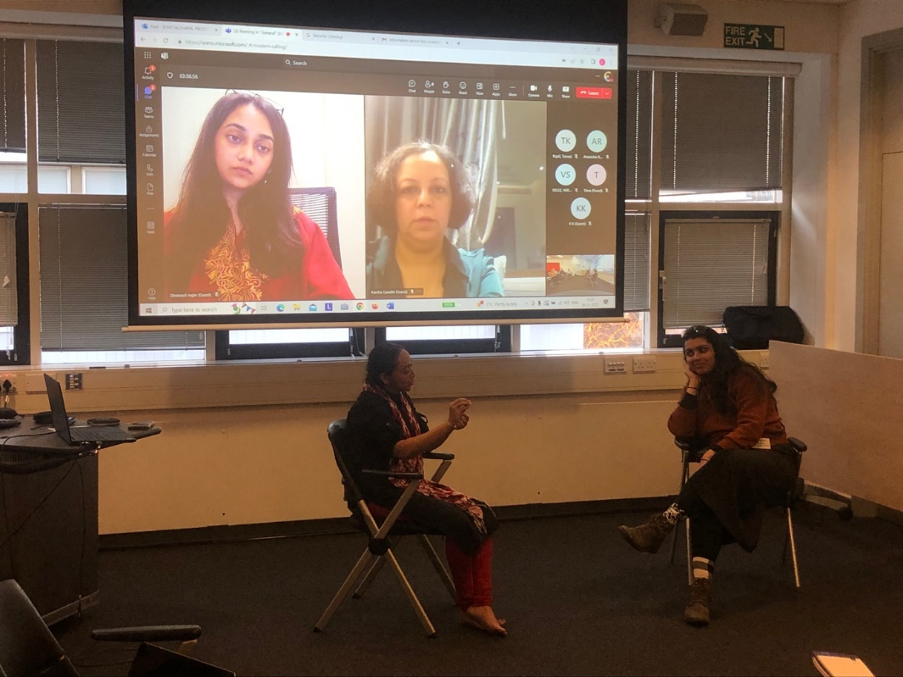
This one day conference brought together scholars and practitioners from across the globe to reflect as a community on how theatre and performance studies could offer novel ways to problematize an idea of the labouring body. There has been an increasingly vibrant trend to consider theatre and performance as a holistic event involving bodies that are not only seen as carriers of aesthetic techniques and dramatic actions to evoke emotions from audiences, but also as working entities embedded in the historical and contemporary web of labour and politics. The conference provided an apt occasion to unpack the veracity of such a theme and we had a good participation from academics, and creative practitioners with a rich and engaging repertoire of ideas to problematize the theme. We had a good mix of experienced professors and academics, creative practitioners, as well as early career scholars and researchers as part of this event that afforded the opportunity to build networks and opportunities of collaboration.

A hybrid format facilitated a wider participation from scholars and practitioners from UK, Europe and South Asia. The conference program was curated and designed to elaborate on relevant subthemes that formed a constellation on our conference theme. We had a total of seventeen presenters spread across six panels, selected from more than 40 responses to the conference call.
In the morning session, we had two panels that ran parallel to each other and had an even participation from those present. Panel IA had the overarching theme of ‘Beyond Embodied Labour’ and the presenters from a wide range of expertise came together to explore how modes of concrete and abstract forms of labour may be problematized in the dual nature of embodying and disembodying performance, and to what extent existing frameworks of understanding embodiment in performance explicate its relation to racial, communitarian and caste-laden subjectivities. In panel IB titled ‘Labouring through the Irreconcilable,’ scholars from theatre and performance studies explored how political events marked by strife and trauma are explored through performative re-enactments in the form of cultural tourism, dance and verbatim theatre, and what remains irreconcilable about labouring bodies in artistic practice.
There were four sessions post lunch, with the first two being held as parallel sessions for one and a half hours. Panel 2A was themed as ‘Global Perspectives on Gendered Labour’ and explored the intersections of gender and labour in ritualistic and theatrical performances. Panel 2B was titled ‘Agency of Labouring Bodies’ and scholars came together to think on the artistic agency of labouring bodies in circus, dance and creative practice. One of the significant highlights of this session also lay in a performance artist and dancer Shruti Ghosh presenting her creative work to explore the relationship of the artist’s body in dance with migrant workers she sought to represent. It received a good response and engagement from the audience both online and in person.
The final two parallel sessions focussed on problematising the concept of labour in theatre and dance work in the UK. Panel 3A titled ‘Theatre Works’ and Panel 3B - ‘Facets of Aesthetic Labour’ looked at the performance industry in UK, and the complex relation between aesthetic labour and professional work in freelance performance, ballet and community theatre as few examples of the various modes of performance.
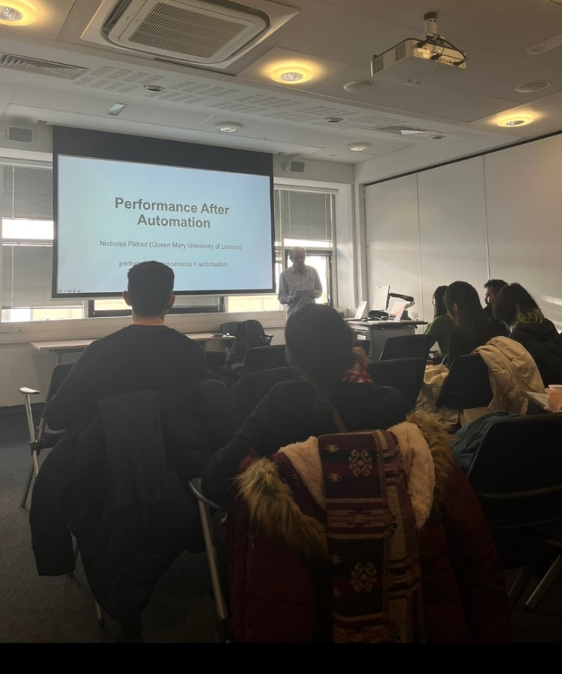

A significant part of the conference was the keynote delivered by Professor Nicholas Ridout from the Department of English and Drama at Queen Mary University of London. His talk was titled ‘Performance after Automation’ in which he deliberated critically on how theatre in the mid-twentieth century can now be examined fruitfully as a site, in which a new regime of labour management is made visible in the actions of performing bodies on stage. The discussion following his talk was quite engaging and spilled over into informal spaces during coffee and lunch breaks. His talk also forms part of his very recent research project funded by the AHRC, and therefore elicited the opportunity for young scholars in the field to engage with a new area within this wider theme of the conference.
Overall, the conference was a success, as testified by the long and engaging conversations between everyone present both within the scope of the panels as well as beyond it. We gathered for our last session for rounding up and deliberating on the day, with three of our participants leading a roundtable. We all collectively came to discuss and open paths of interrogation on the theme of our conference, and its afterlife within institutions of academia and beyond. Being in a global situation marked by ever shifting regimes of work and labour, the capacity of bodies (in a range of contexts) as both the site and currency of such protean entanglements was an emerging and crucial concept in thinking about the theme and became a focal point in our final conversations.
Drawing from such a trajectory we the organizers are now in the process of working towards a publication on this theme, and the possibilities it has thrown up. We have received a positive response from the participants, and abstracts that approach our theme from diverse contexts that may navigate the complex and poignant relationship on how forms of understanding labour and its’ (dis)embodiment in performance, may unpack new avenues of comprehending bodies, labour and work in their entanglements.
We are at a preliminary stage of dialogue with Brill, whose series “Themes in Theatre: New Directions in International Theatre and Performance” resonates with our theme, and we hope to make a significant publication in the process. We plan to work through this spring on the book proposal so that it suits the scope and objectives of an edited volume.

