Hardboiled History: A Noir Lens on America’s Past
May 19th 2017
Co-organised by Hannah Graves and Esther Wright (Warwick History)

Hardboiled History was conceived as an interdisciplinary conference to investigate the ways contemporary visual media and literature – in all its forms – continues to utilise, reshape or subvert preconceived notions of ‘noir’, often as framework for imagining and reinterpreting American history.

Despite a range of theoretical and historiographical engagements with the ‘classic’ film noirs produced in postwar America, noir remains an academically illusive term that avoids easy definition. Our aim was to create a space in which scholars approaching with the idea of noir from a number of disciplines and mediums could come together and consider where their research areas intersect.

In addition to opening remarks from Professor J.E. Smyth (University of Warwick), we were delighted to welcome two keynote speakers, Helen Hanson (University of Exeter) and Warren Pleece (an illustrator and graphic novelist), who provided us with insightful academic and practice-based perspectives on the noir phenomenon respectively. Generous support from the Humanities Research Centre, Warwick’s History Department, and the British Association for American Studies allowed us to ensure that postgraduate speakers and delegates were able to attend for free.

Panels were dedicated to interrogating popular culture’s attempts at (or resistance to) representing history, depictions of gender relations and ethnicity, and the way aesthetics and ideas of place play a part in cultural engagements with noir. The entire day generated lively discussion around the history of noir, what it means to us today, and how it might be approached and analysed in the future, as well as what might be at stake when we try and conceptualise pop-cultural representations of society and culture as part of a wider noir phenomenon. These discussions continued into the evening.

Tweets about the day by several participants can be found on the hashtag #HardboiledHistory, and full panel details and abstracts are available at www.hardboiledhistory.wordpress.com.

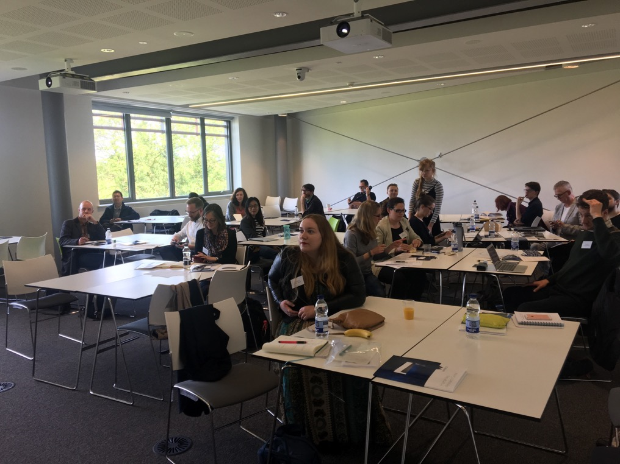

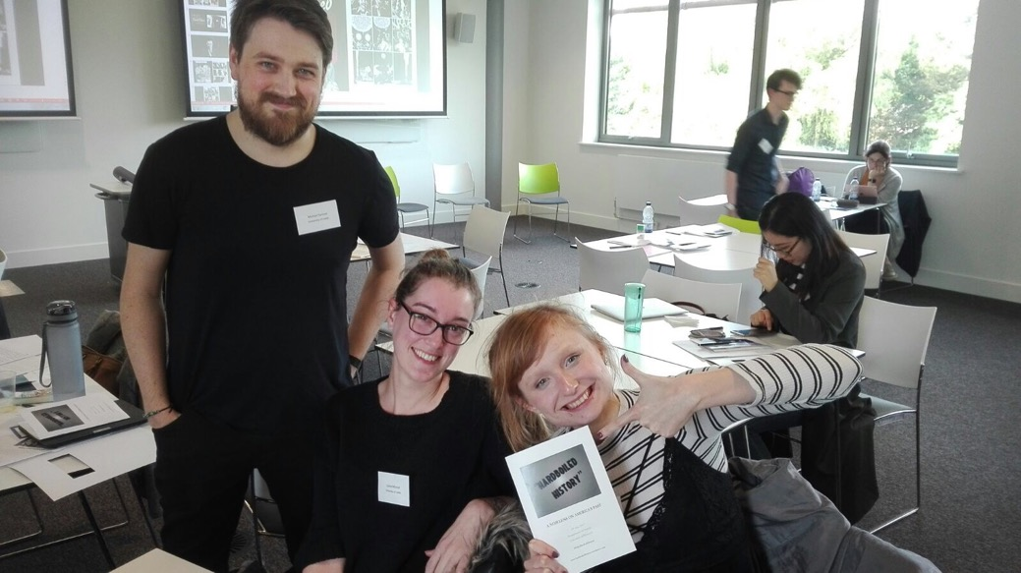
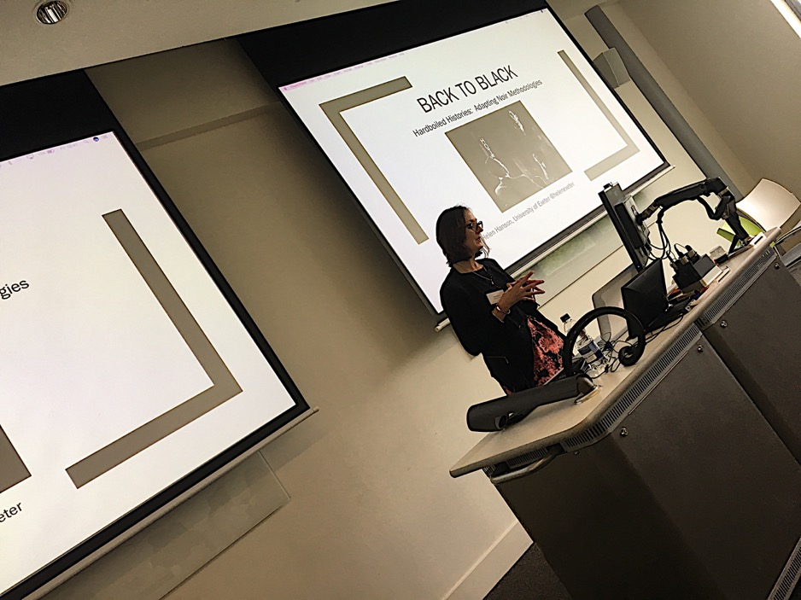
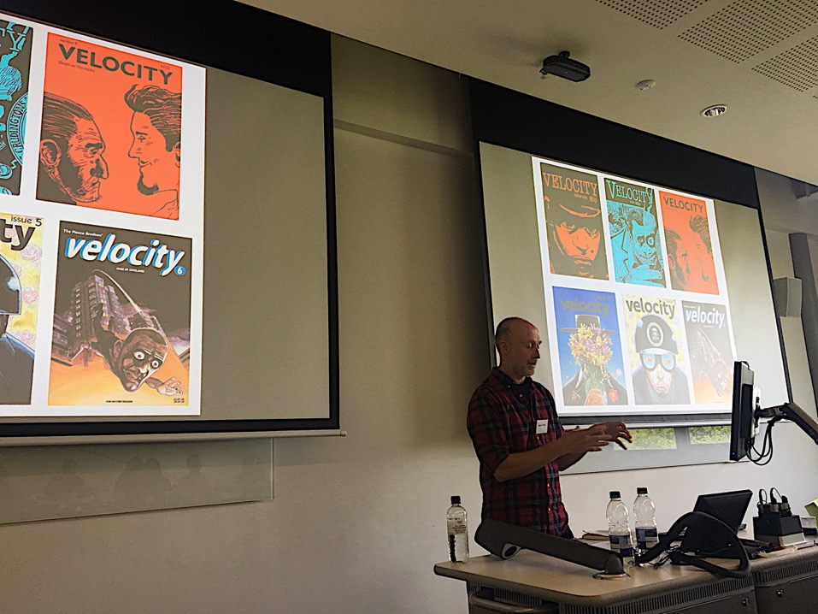
Dr. Helen Hanson (University of Exeter) gives her keynote lecture: “Back to Black: Adapting Noir Methodologies”
Warren Pleece discusses the noir inspirations on his work in illustrations and graphic novels.

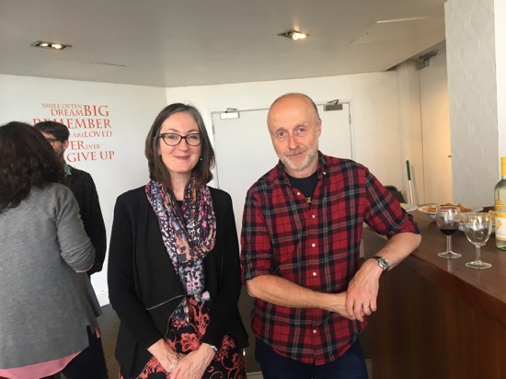
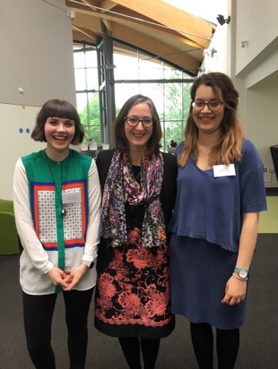
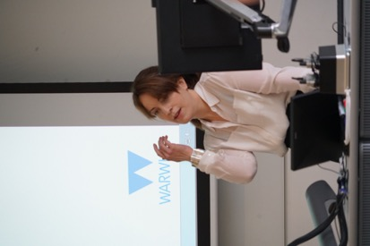
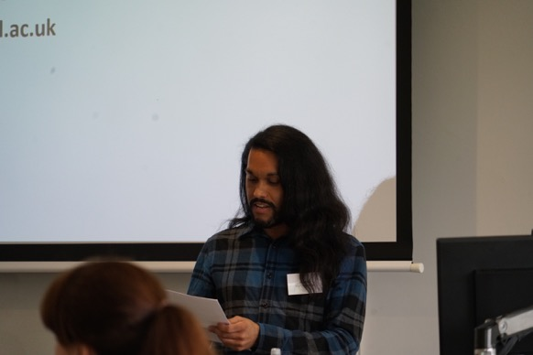
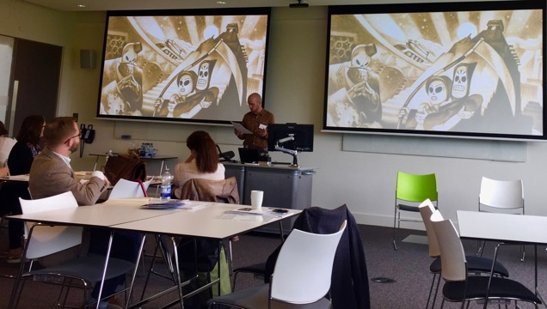
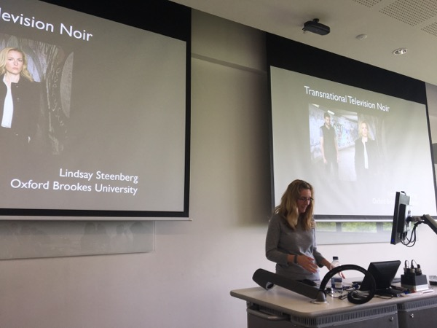
Left to right: Professor J.E. Smyth gives the conference’s opening remarks; Keynote speakers Helen Hanson and Warren Pleece; Co-organisers Esther Wright and Hannah Graves (History) with Helen Hanson.
Left: Michael Docherty (University of Kent) on video game Grim Fandango’s representation of Mexican American history and iconography
Right: Kulraj Phullar (King’s College London) on L.A. Confidential’s engagement with the star image of Veronica Lake
Left: Lindsay Steenberg (Oxford Brookes) on Transnational Television Noir and BBC’s The Fall

