IPCITI 2025 Conference Report for Warwick HRC
International Postgraduate Conference in Translation and Interpreting (IPCITI 2025)
Report prepared by the IPCITI 2025 Organising Committee and panel chairs:
Yaqi Xi, Laura Woolley-Núñez, Belén Rodríguez Salvatierra, Jenny He, Yanyu Liu, Shaoyu Yang, Xiaoyan Tan, Leilani Willis, Daniel Cabeza-Campillo, Zhang Xinyao and Minghao Ma.

1. Conference overview and participation
The 18th International Postgraduate Conference in Translation and Interpreting (IPCITI 2025), hosted at the University of Warwick, welcomed over 65 delegates from more than 12 countries. Thanks to generous support from the Humanities Research Centre (HRC) and the International Association for Translation and Intercultural Studies (IATIS), we were able to waive registration fees for seven international delegates from the Global South, advancing our objectives of affordability, inclusivity and international reach.
Across two days, the programme featured a keynote lecture, two workshops and nine themed panel sessions. In total, over 40 postgraduate and early-career speakers presented papers, joined by senior scholars as keynote speaker and workshop leaders. Participants from the UK, Europe, Asia and Latin America contributed to a lively international conversation about the future of translation and interpreting studies.
The conference opened with remarks from Professor Elisabeth Herrmann, Co-Head of the School of Modern Languages and Cultures (SMLC), and Dr Caroline Summers from Translation and Transcultural Studies at SMLC. They welcomed delegates, outlined the history and ethos of IPCITI and underscored Warwick’s commitment to nurturing postgraduate-led research events.

2. Keynote and major thematic strands
The conference was formally launched by the keynote lecture, ‘Translating Rape’, delivered by Dr Pauline Henry-Tierney (Newcastle University). Presented in a hybrid format to maximise accessibility, the keynote outlined a feminist translation methodology for engaging ethically and sensitively with traumatic texts. The discussion that followed foregrounded issues of voice, consent, the mediation of trauma and the responsibilities borne by translators working with such material.
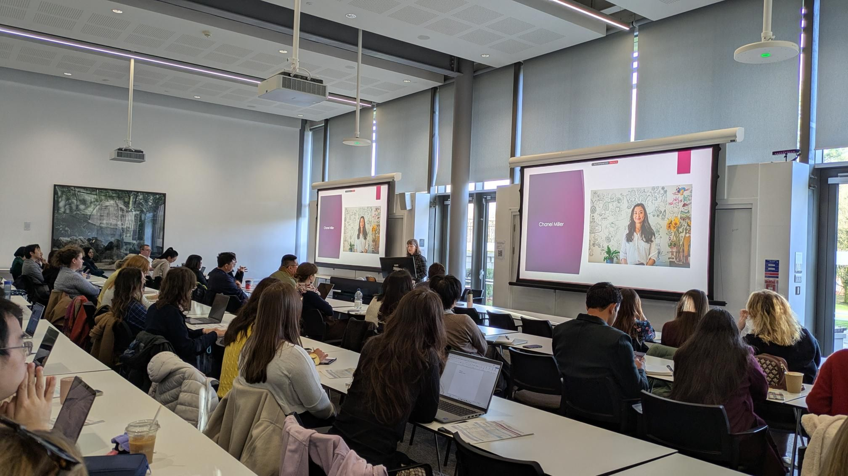(Live photo from IPCITI 2025 Keynote Speech: ‘Translating Rape’)

The panels that unfolded across the two days extended these concerns while also showcasing the breadth of current work in translation and interpreting studies. One major strand focused on feminist, queer and gender-informed approaches, highlighting translation as a site of resistance, agency and gendered meaning-making. Another strand centred on humanitarian and community interpreting, media accessibility and inclusive practices, engaging with ethics, professional standards and the role of translation technology and positionality in supporting vulnerable communities.
A third cluster of papers examined memory, ideology and (re)translation, emphasising translation’s role in shaping collective memory and political imaginaries. Panels on performance, theatre and intermediality approached translation as performative and collaborative, moving across media from poetry and theatre to site-specific performance art. Further contributions on society, media and cultural politics brought sociological, political and feminist concerns into dialogue with literary and media translation.
Audiovisual translation, digital platforms and AI formed another key area, with speakers addressing politically sensitive subtitling, film and game localisation and viewer reception. A dedicated panel on AI and human–machine collaboration considered neural machine translation, large language models and generative AI for subtitling. Work on intersemiotic and multimodal translation explored adaptation to film, textiles and craft practices, and picturebook translation. Across all panels, Q&A sessions were lively and constructive, often drawing connections between strands.

3. Workshops and professional development
Two workshops were designed to support our delegates’ professional trajectories and creative practice.
Workshop 1 – Publishing in Academia: Journal Articles and Monographs
Led by Dr David Orrego-Carmona (Warwick), this session demystified the publishing process. Participants used reflection sheets to locate themselves in the publication pipeline, before working through journal selection, peer review, responding to reviewers and longer-term planning. The workshop fostered peer-learning networks and concrete publication plans.
Workshop 2 – Poetry Translation: ‘Conscientious Objector’
Led by poet and translator Cristina Viti and supported by Modern Poetry in Translation, this workshop invited participants to translate Edna St Vincent Millay’s ‘Conscientious Objector’ into a range of languages, working collaboratively and individually. The session created a space to explore rhythm, resistance, voice and politics through creative practice, and selected translations will have the opportunity to appear on the MPT website.
Together, the workshops addressed one of IPCITI’s central aims: to combine scholarly exchange with practical skills development and creative experimentation for early-career researchers.

4. Objectives and outcomes
International reach and inclusivity
International reach and inclusivity were key objectives for IPCITI 2025. Delegates and speakers joined us from more than a dozen countries, and HRC funding enabled seven fully supported international delegates from the Global South to attend who might otherwise have been unable to do so. Panels reflected diverse linguistic, geographical and institutional backgrounds, and many discussions explicitly addressed inequality, marginalisation and access.
Platform for postgraduate and early-career researchers
A second objective was to provide a high-quality platform for postgraduate and early-career researchers. With over 40 papers, a keynote and two workshops, early-career voices were at the heart of the event. Chairs reported confident, original and methodologically innovative presentations, and discussions during panels and informal breaks were consistently engaged and collegial.
Thematic innovation, networks and future work
A further aim was to encourage thematic innovation and interdisciplinary dialogue. The breadth of panels – from feminist and queer approaches to AI and intersemiotic practice – prompted cross-references and new connections between participants. IPCITI 2025 also generated concrete outcomes that will continue to shape participants’ research trajectories:
- New international networks and informal working groups formed around shared interests, laying the groundwork for future collaborations, joint panels and co-authored projects.
- The academic publishing workshop prompted several participants to outline plans for journal submissions and monograph proposals, creating a pathway for future outputs linked to IPCITI 2025.
- The poetry translation workshop is expected to result in a curated selection of translations published on the Modern Poetry in Translation platform, increasing the visibility of delegates’ creative practice.
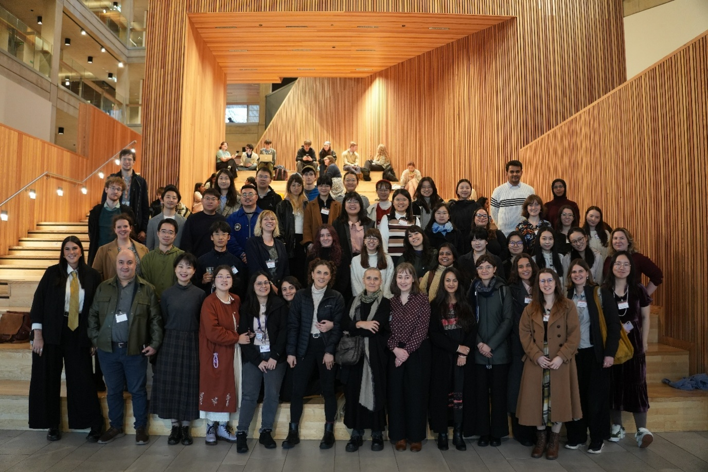
(Group photo of IPCITI 2025 attendees, keynote speaker, and workshop leaders)

5. Conclusion and post-conference feedback
With its strong international participation, diverse programme and practical support for emerging scholars, IPCITI 2025 met – and in many respects exceeded – its objectives. The support of Warwick HRC was instrumental in sustaining the conference’s ethos of accessibility and inclusivity, enabling fee waivers for delegates from the Global South and supporting the delivery of high-quality hybrid and in-person sessions.
The event offered a snapshot of postgraduate research in translation and interpreting studies, and an environment in which delegates could build networks, develop skills and initiate future research outputs. Selected feedback highlights:
- ‘The interdisciplinary and multicultural aspect of presentations.’
- ‘Vitality created by a bunch of enthusiastic young scholars.’
- ‘The two workshops; the networking.’
- ‘The insights gained, connections made, and confidence built through this experience will be instrumental as I continue to develop my research career.’
This feedback reflects a strong appreciation of IPCITI 2025 and reinforces the importance of postgraduate-led initiatives in the wider scholarly community.

6. HRC budget breakdown
Keynote | Dr Pauline Henry-Tierney from Newcastle University
PHT | Travel | Trains Newcastle >< Coventry | 151.6
 |  | Taxis Coventry >< campus | 21.94
 | Subsistence | Evening Meal (12 Nov 2025) | 17.99
 | Accommodation | Radcliffe £120 x 1, £100 x 1 | 220
Sub-total |  |  |  | 411.53
Conference waivers | Contribution towards conference registration fee waivers for 7 international delegates (7 x69pp) |  |  | 338.47
TOTAL |  |  |  | 750

