Kafka and the Human Animal
HRC/CRPLA Colloquium
21 October 2015
To mark the 100th anniversary of publication of Franz Kafka’s ‘The Metamorphosis’, we gathered for an afternoon of talks about the intriguing animals—non-human and human—that we meet in Kafka’s works. Four speakers, Elizabeth Boa (German Studies, Nottingham emerita), Carolin Duttlinger (German/Kafka Research Centre, Oxford), Anne Fuchs (German Studies, Warwick) and Nick Lawrence (English and Comparative Literary Studies, Warwick), gave tremendously engaging presentations on well- and little-known Kafka creations, including Josephine of the Mouse People, a kitten-lamb, the ape Red Peter, and a stork-like bird.
Each talk gave us different contexts and concerns to bring to our reading and appreciation of Kafka. Boa spent time with the hybrid kitten-lamb in ‘A Crossbreed’, with its tears and ‘look of human understanding’, and presented Kafka as querying humanness defined in opposition to animality. His animal stories, in keeping with Darwin, suggest human-animal continuity; the humanized animals and animalized humans point towards further hybrid identities, whether ethnic, linguistic, generational or zoological. Anne Fuchs let Kafka’s whistling mouse Josephine resonate, as a feminine voice triggering ambivalent attention and efforts at control, with both the ancient Sirens resisted by Odysseus and with modern loss of enthrallment and the alienation emerging from projects of domination and total knowledge. Carolin Duttlinger highlighted Kafka’s interest in the reality and the dream of flight, focusing on a strange and funny fragmentary story in which a man contracts himself to nurture a large bird—the man-bird collaboration conveys a spirit of experimentation and trust that is exhilarating. Nick Lawrence connected Kafka to a rich 19th century context—Poe, Frederick Douglass and slave narratives, and Marx on species-being—and made a compelling case for Kafka ’s attention to policing the human/animal divide as deeply engaged in a critique of racism in our accounts of human nature and ‘where we come from’.
We concluded the colloquium with roundtable discussion and comments from the audience, which included undergraduates, postgraduates and faculty from around and beyond the university. Based on the ideas and conversation we shared, we have a great deal to learn about ourselves from Kafka’s animals. We are very grateful to the HRC for sponsoring this event and to colleagues in German Studies for providing intellectual and practical support.
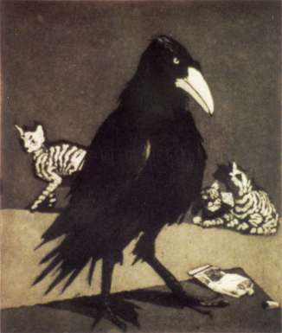

Paula Rego, Crow (1994),
University of Warwick Art Collection

