Literary Journalism in Times of Crisis and Transition (1870-1970)
26th November 2016 (University of Warwick)
A one-day interdisciplinary conference
organised by Sara Boezio and Giulia Brecciaroli (School of Modern Languages and Cultures)

The conference Literary Journalism in Times of Crisis and Transition (1870-1970) took place at the University of Warwick on Saturday 26th November 2016.
The aim of the event was to investigate the role played by literary journalism in capturing historical and social changes on a global scale over the time span of a century, from the 1870s to the 1970s. Considering the complexity of the issue, in our call for papers we called for an interdisciplinary perspective and encouraged papers involving history, media studies, cultural policy, and literature in a wide range of languages. This goal has been fully achieved, as testified by the enthusiastic response we had in terms of abstracts received and as reflected in the conference programme. We are also pleased with the transnational interest that our call for papers managed to raise and with the participation to the event of speakers coming from different nations and whose papers focused on case studies about different countries (Austria, France, Italy, Germany, Spain, the United Kingdom, and the U.S.A.).
After registration and welcome coffee, we gave a brief introduction, explaining the choice of the conference topic and timeframe, and guiding the delegates through the panel structure. The conference was organised into three sessions with three presenters each, framed by two keynote addresses. The first panel tackled the formal evolution of literary journalism; the second focused on the way literary journalism narrated wars, economic growth and post-modernity between 1920 and 1970; the third and last panel was devoted to the early stages of literary journalism, thus moving backwards in time until the end of the nineteenth century.
The conference day was opened by keynote speaker Dr Susan Greenberg from the University of Roehampton (London), former reporter and columnist for The Times and The Guardian, and founding member of the International Association of Literary Journalism Studies. Dr Greenberg’s speech focused on the tradition of Polish reportage as illustrative of the potential of literary journalism in connecting fact and feeling in times of crisis and social turmoil. Drawing upon her experience in the field of creative nonfiction and publishing, Dr Greenberg’s insights enabled the conference to transcend the limits of a purely academic viewpoint.
The first panel explored the formal evolution of international literary journalism in the course of its history and its peculiarity as a genre that has been shaped by transnational and cross-cultural influences. Dr Julie Weelwright’s (City University London) talk on Guy Talese’s best-seller Thy Neighbour’s Wife offered insight for the history of literary journalism in considering the rise of confessional modes of writing and how authors have striven to balance the narcissism of the author and the voyeurism of the reader with genuine public interest. Mara Logaldo (IULM) analysed the interconnectedness of captions and pictures, and their role in the evolution of photojournalism, especially in regard to criminal cases. Mila Milani (University of Warwick) concluded the panel with a paper exploring the role of ‘affiliated’ journals, containing forms of fiction and nonfiction writing, in relation to the cultural project of the PCI in Italy.
The second panel concentrated on the more recent history of international literary journalism (1970-1920) before going backwards in time and exploring the early stages of the genre (1920-1870) in the concluding panel. Dr Jim Clarke’s (University of Coventry) paper threw light on the parameters of literary war journalism, through an account of the relationship between Ernest Hemingway and his second wife, the war reporter Martha Gellhorn, which spawned some of the most influential war correspondence of the 20th century. Franco Baldasso (Bard College, New York) concentrated on Alberto Moravia’s political pieces, collected in Diario politico, as an insightful document of the political fluidity of a period of transition of Italy in the context of the hectic intellectual climate of post-war Rome. To conclude, Irene Piazzoni (University of Milan) analysed the interplay of literature and photography in the cultural magazine Omnibus, funded in Milan in 1937, and more broadly the role of the artistic and aesthetic elements in the journalistic products of the time.
The last panel opened with the paper of Albert Göschl (University of Graz) who, on the basis of a comparative perspective between German and Italian literary Journalism, evaluated how the concept of crisis itself has changed in literary journalism over the decades since the 19th century until WWII. Sara Prieto (University of Alicante) focused her talk on war correspondence and, more precisely, on the several pieces of literary journalism produced by British war correspondents, such as William Beach Thomas and Philip Gibbs, about the Battle of the Somme, one of the most significant events in the timeline of the First World War. Helena Goodwyn (Queen Mary, University of London) devoted her presentation to W. T. Stead, a crucial figure for journalism worldwide, who contributed to the development of literary journalism in his belief that fiction and journalism were simply related nodes on a spectrum of rapidly evolving communication technologies.
The day ended with the keynote speech of Prof. David Walker who delivered an engaging lecture investigating the tension that arose since the nineteenth century between journalistic practices and the aspirations of would-be literary writers who found themselves, willingly or reluctantly, seeking to make a living from newspaper jobs. Prof Walker explored how the urge to resist the sensationalist temptation that journalism can be prey to, and to enhance the credentials of journalistic writing, is exemplified in the work of some key modern writers in France, and provided examples of relevant works of such authors, including Zola, Gide, Perrault, Rouart and Camus.
The conference was very well attended (30 people): in the audience there were members of Staff, Postgraduates and students from the University of Warwick, alongside Post-docs and Postgraduates from other Universities, who heard about our event via the conference webpage (http://goo.gl/0RmV1v), the conference Twitter account (@LiteraryJourn16) we created, and the mailing lists to which we sent info about the programme (https://goo.gl/gN5x23). The event has been followed by a live institutional tweeting throughout the day, which allowed us to engage with a large number of people who, despite not being able to attend in person, showed their interest in our event by following us, by retweeting our posts, by taking up our hashtag #LiteraryJourn16 and by contacting us via our conference e-mail address literaryjournalismconf@gmail.com.
We are very pleased with the outcome of our conference: we have received positive feedback from the participants who congratulated us (both in person on the day of the conference an in follow-up emails) on the conference organisation and voiced a keen interest in expanding the research project lying at the heart of the event in order to foster future collaborations. We hope to publish a volume that will reflect the liveliness and richness of the discussions that have taken place throughout the day. In this respect, most of the speakers have already shown their interest in contributing to a collective volume.
The Literary Journalism conference has been possible thanks to the support of the Warwick’s Humanities Research Centre, the Research Student Skills Programme and the School of Modern Languages and Cultures, which we would like to thank for making possible such a great opportunity for development and professional exchange.
Sara Boezio (PhD student, School of Modern Languages and Cultures)
Giulia Brecciaroli (PhD student, School of Modern Languages and Cultures)

Please find below some photos of the conference and some screenshots of the Twitter page:
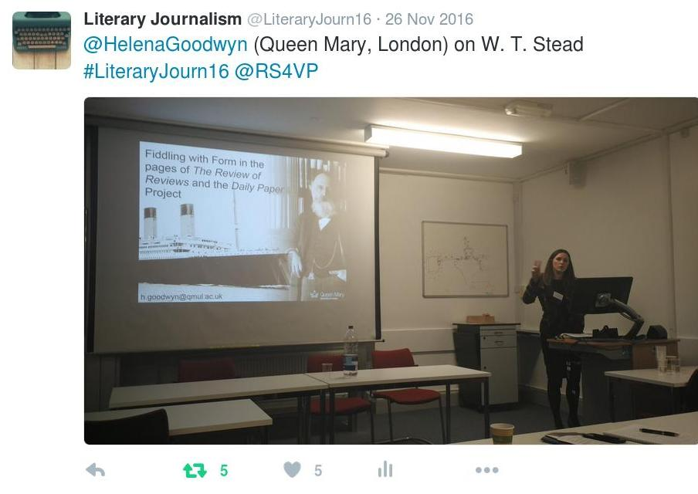
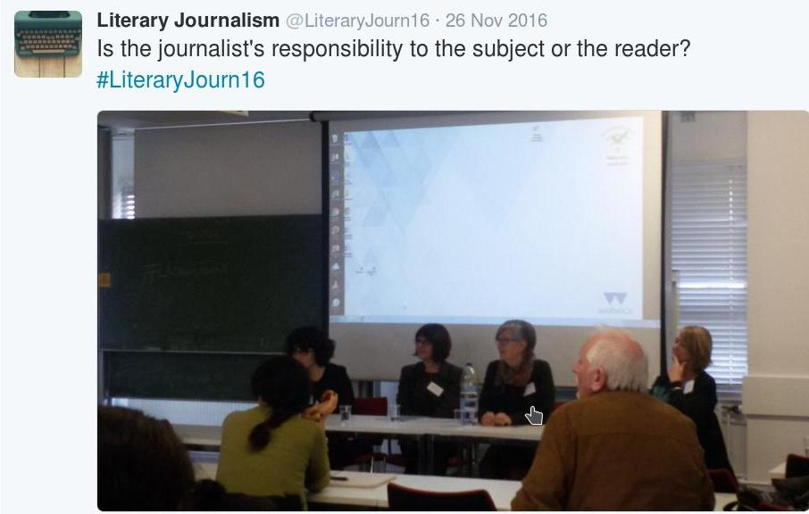
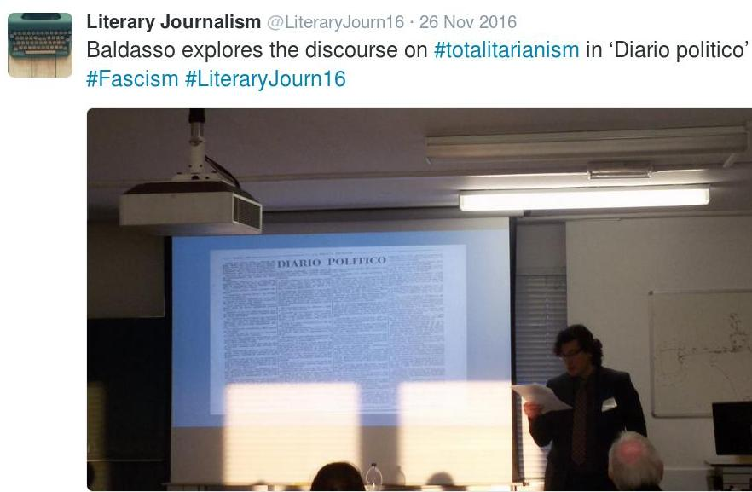
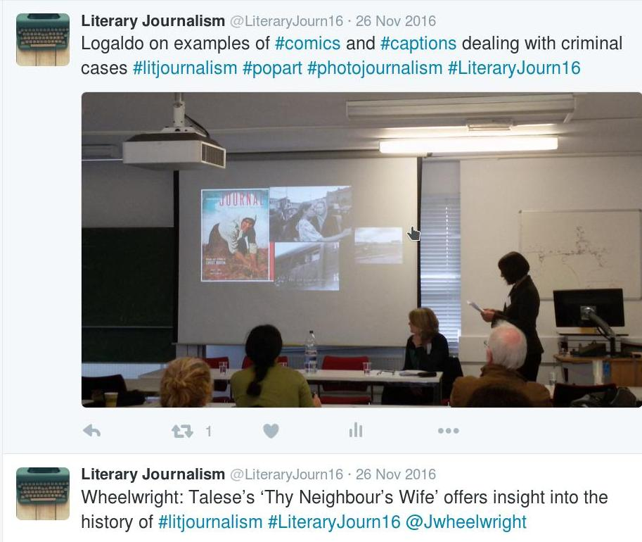

https://twitter.com/LiteraryJourn16?ref_src=twsrc%5Etfw

