Midlands Conference in Critical Thought 2026 Event Report
(prepared by Dr R. Chenet – includes some use of Copilot for event summarising purposes)
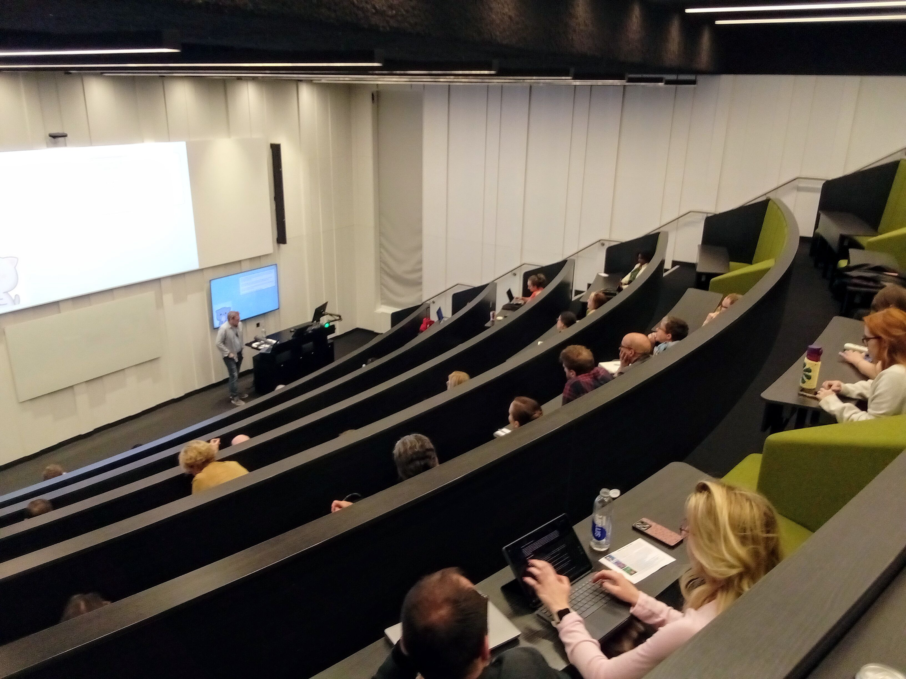
The Midlands Conference in Critical Thought (MCCT) 2026 took place over 21 and 22 May at the Faculty of Arts Building at the University of Warwick. Now in its third year, the conference continues to deliver on its core purpose: open and interdisciplinary space-making for critical engagement. As a perpetually free event, it united scholars, artists, practitioners and students from different disciplines and career stages. From the outset, the conference emphasised intellectual exchange without a focus on academic hierarchy or constraints of positivist rationalization. In not privileging keynotes or formal plenaries, our programme was also organised via participant-led thematic streams. This format encouraged collaborative dialogue and allowed emerging and established voices to share ideas on an equal footing. The overall atmosphere was one of curiosity, experimentation and collective critical inquiry across 137(!) paper presentations.
Across the two days, the conference hosted a wide range of parallel sessions covering themes such as creative health, Black feminist thought, posthumanism, artistic practice in technological contexts, crime and media, and pressures of contemporary academic life. Each stream developed its own intellectual focus, creating a diverse exploration of critical thought. Day one began strongly by screening Reclaimed Voices, a documentary that highlights how storytelling, research and community engagement can intersect to challenge dominant representations. Across our efforts on these topics, we also included a range of opportunities for radical thinking on unusual foci.
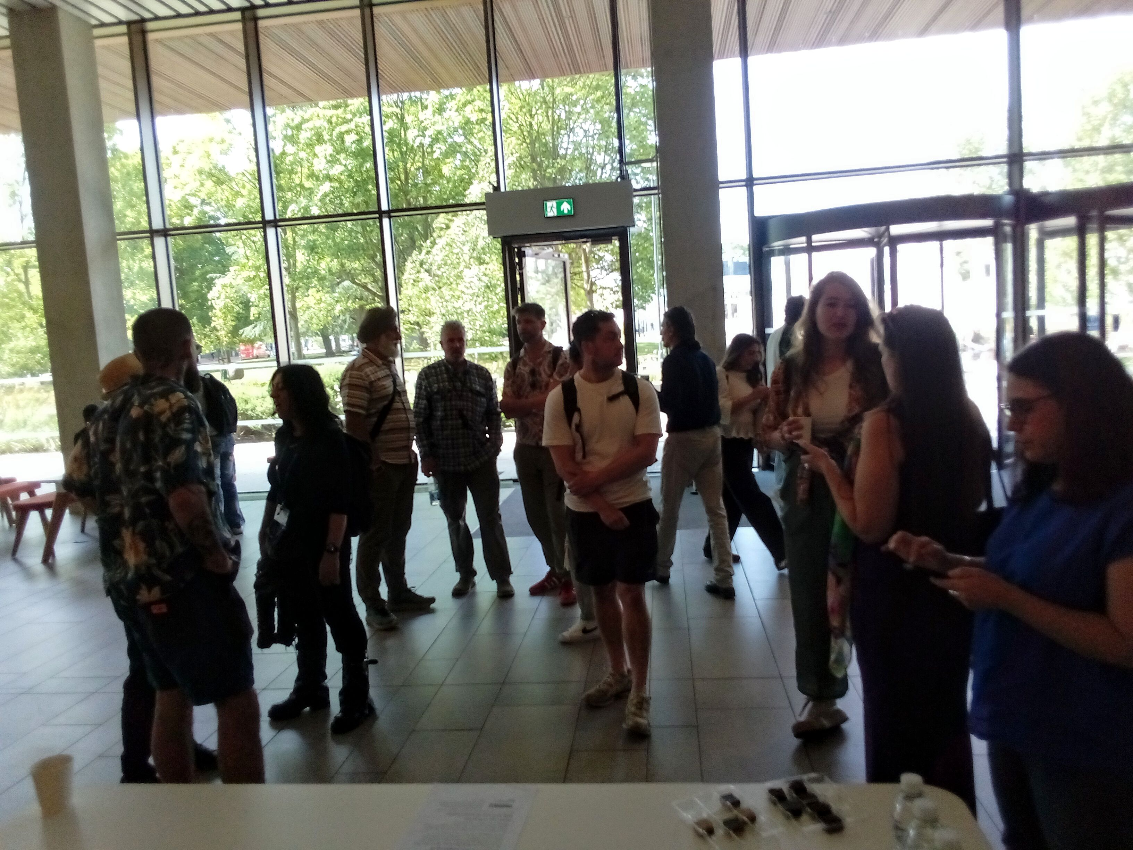
The conference also focused on exploring structures of power and resistance. Discussions on hegemony examined contemporary governance, inequality and the persistent violence of dominant systems. Presentations on welfare, resistance and social control brought attention to lived experiences within broader political and economic frameworks, fostering lively exchanges and often connecting theoretical perspectives with tangible social issues. Another key strand involved reflections on diversity, inclusion and the role of academia. Papers here addressed challenges facing critical scholarship, including the marginalisation of dissenting perspectives and barriers to interdisciplinary work even in organisations ostensibly set up to empower and champion them.
Contributions on science policy, gender equity and academic freedom highlighted the ongoing need to reimagine institutional practices and expand opportunities for inclusive knowledge production. This is as the core dominant logics of much academic enquiry are now instrumentalised into labour and economic value extraction from precarious, disempowered groups engaged in underpaid or unpaid ‘hope labour’ to the benefit of monopoly publishers, senior academics, and managerial cartels that dominate much of our ‘scholarly’ landscape. A range of new approaches and progressive opportunities also emerged in discussions, helping to showcase methods and styles of critical enquiry that can, subject to our own agency, bring scope for meaningful transformation in lives we occupy. Creative and practice-based work was another theme throughout the event. Sessions on artistic practice under the encroachment of technology explored themes of fatigue, failure and resistance, and participants engaged via installations, workshops and performances that examined how environments shape creativity. From discussions held, these were well-received and useful in encouraging attendees not only to reflect on their own practices, but to consider how artistic methods can function as forms of critique in and of themselves. The conference also pursued questions of embodiment and identity. Streams focusing on bodies in flux examined how human forms are represented and experienced across cultural, technological and social contexts. Presentations ranged from explorations of sensory experience and complex disabilities to discussions of gender, migration and belonging. The variety of approaches illustrated the richness of interdisciplinary work and the importance of embodied perspectives to critical thought.
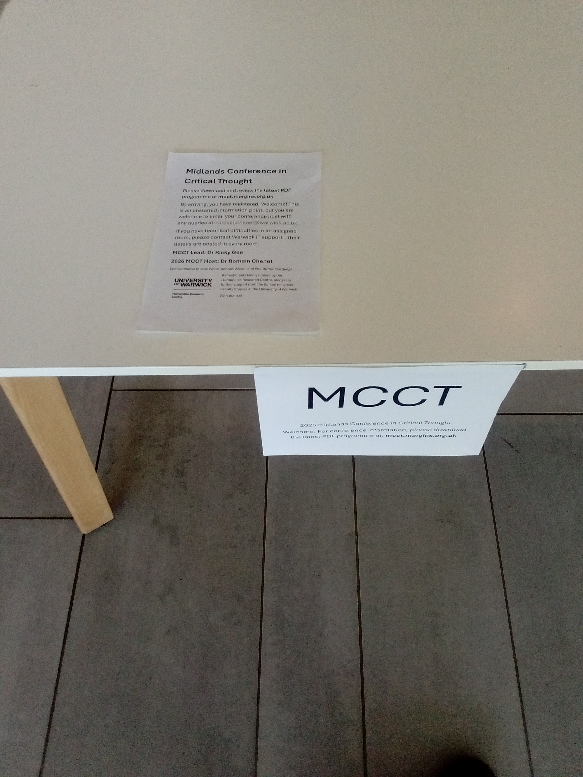

Throughout the first day, the structure of parallel sessions created opportunities for participants to move between themes and engage with different perspectives. Informal conversations during breaks and the evening reception extended these exchanges. The reception, held in the Faculty of Arts Building, provided a relaxed space for networking and included a film element, reinforcing the integration of creative and academic work. Day two continued the momentum with further sessions that expanded on the themes introduced earlier. Pedagogic panels explored innovative teaching approaches, including the concept of studio-based learning as a space for experimentation and dialogue. These discussions emphasised the importance of flexibility, collaboration and creativity in educational practice. Another significant focus was the neoliberal transformation of higher education. Sessions examined precarity, employability and the pressures placed on both students and staff. Contributors highlighted the impact of market-driven policies on academic work and student experience, while also proposing alternative models grounded in social justice and collective care.
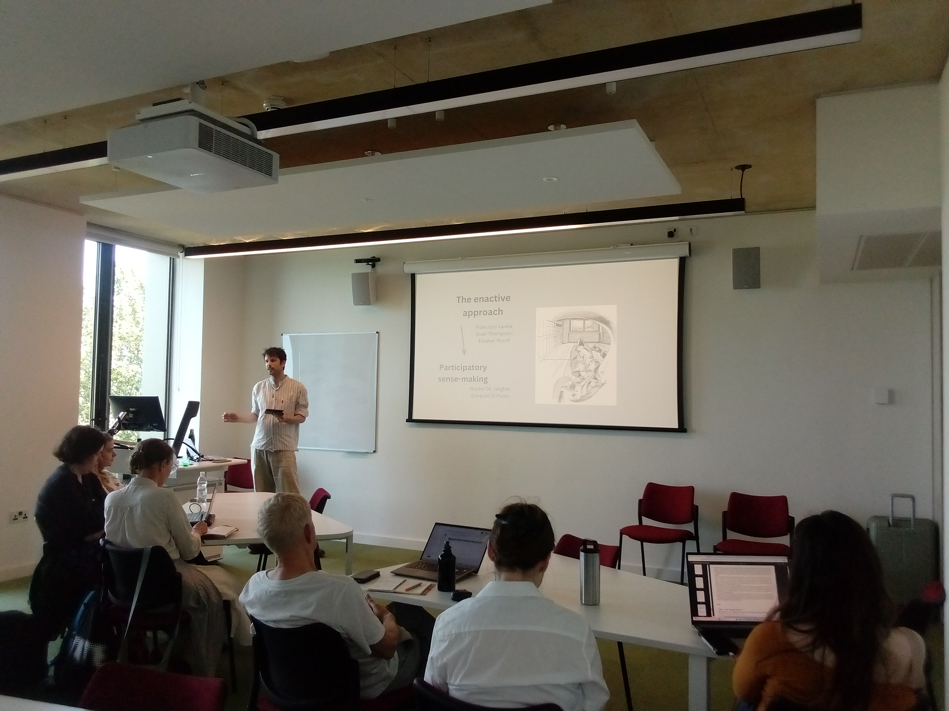
The intersection of technology and society remained a recurring theme. Presentations addressed topics such as artificial intelligence, algorithmic systems and digital media cultures. These discussions considered not only the opportunities offered by emerging technologies but also the ethical and political challenges they present. By bringing together theoretical and practical perspectives, the conference encouraged a nuanced understanding of technological change.
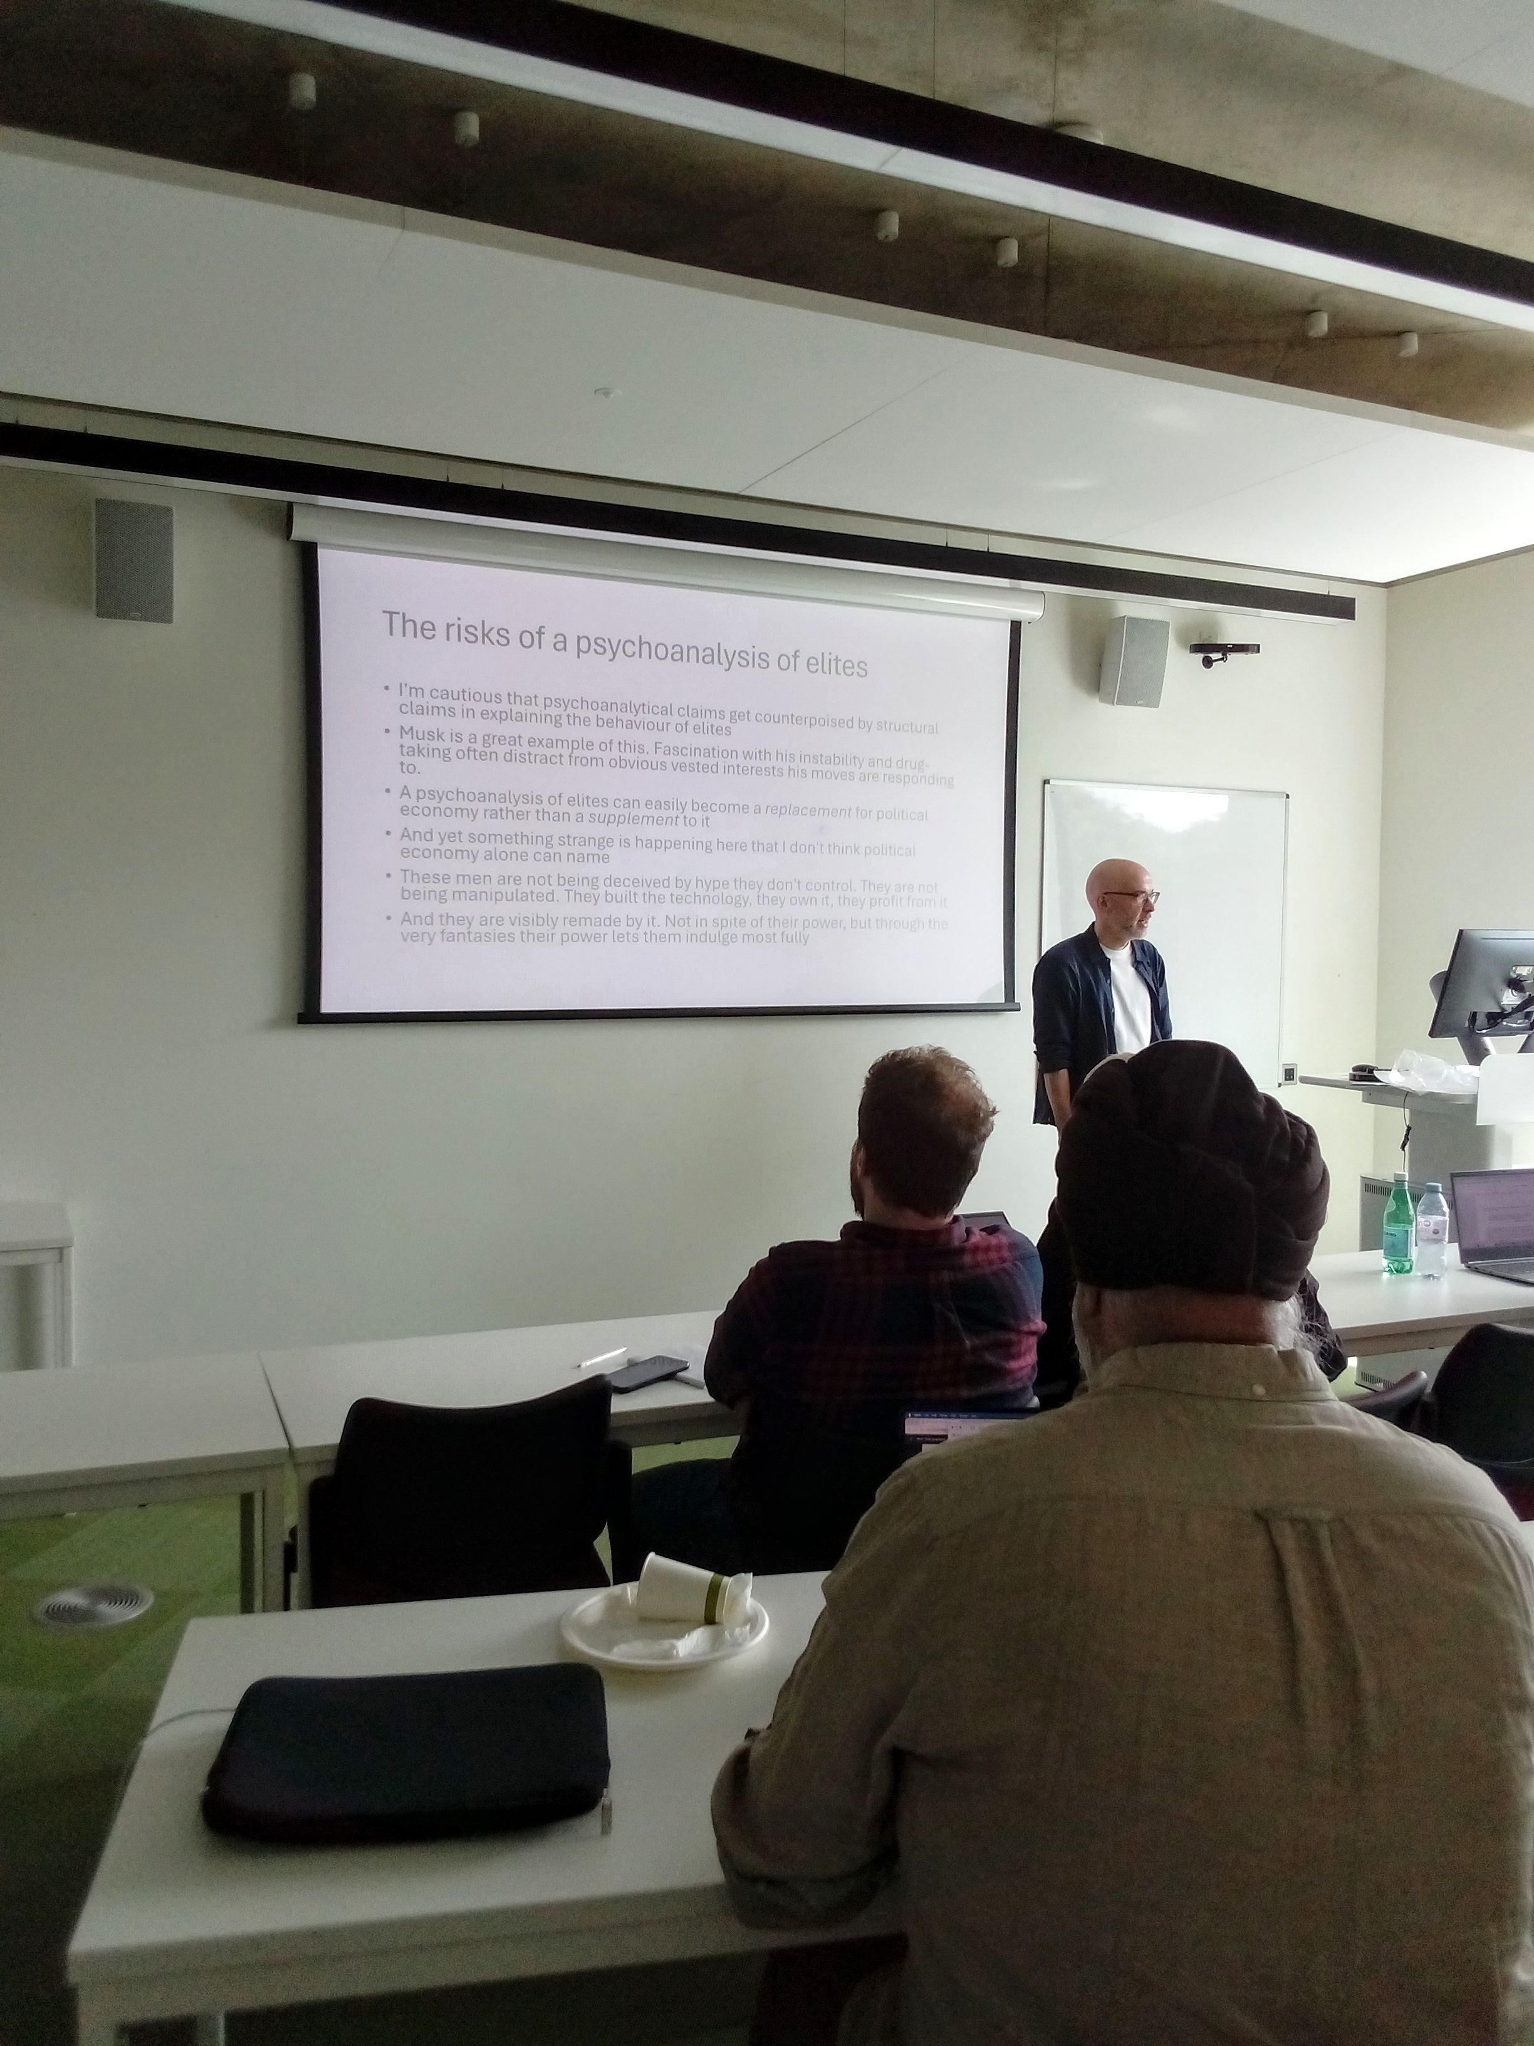

The final sessions of the conference revisited core questions of resistance, collaboration and transformation. From feminist and decolonial approaches to environmental and social justice, participants explored how critical thought can contribute to meaningful change. The diversity of contributions underscored the value of maintaining open and inclusive spaces for intellectual exchange. The conference concluded with a post-event social gathering, offering participants an opportunity to reflect on the experience and strengthen connections formed over the two days. These interactions were an important aspect of the event, reinforcing the sense of community that characterised our efforts. Overall, the Midlands Conference in Critical Thought 2026 successfully provided a platform for interdisciplinary engagement and critical dialogue. Its commitment to accessibility, inclusivity and non-hierarchical organisation created an environment in which diverse voices could be heard. The range of topics and approaches demonstrated the continuing relevance of critical thought in addressing contemporary challenges. As the conference continues to develop, it remains an important space for experimentation and collaboration. By bringing together different perspectives and encouraging open exchange, it contributes to the ongoing evolution of critical scholarship and practice.
On behalf of my co-organisers and co-founders of the Midlands Conference in Critical Thought, please accept my continued gratitude for the Humanities Research Centre’s kind support to our work.
Dr Romain Chenet, University of Warwick.

