Workshop Report

Mediterranean Migration in Interdisciplinary Perspective

University of Warwick, 3 March 2017

Migration is a central issue for disciplines as diverse as sociology, political science, anthropology, history, literary / religious studies and economics, with each of these adopting a wide set of methodologies and theories. On this background, the aim of the workshop was firstly to foster greater interaction between specialists in different fields of migration studies; secondly, to explore aspects of continuity and change across different periods in Mediterranean history. Finally, in a broader perspective the workshop also sought to foster a reflection on the contribution that early modern history can give to current political debate on what has been called “The Mediterranean migration crisis”.
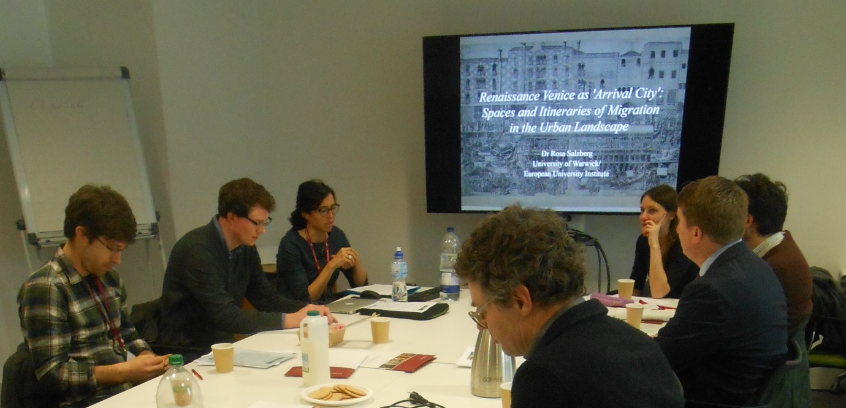
In order to realize these goals, the workshop – co-organized by Dr Felicita Tramontana (Centre for the Study of the Renaissance) and Prof. Beat Kümin (History) within the framework of the MIGMED project – gathered together migration specialists and research students from six European institutions. The event was generously supported by The European Commission through the Marie Skłodowska Curie Actions, the Humanities Research Centre and the CSR.
Following introductory remarks by Felicita Tramontana on the state of scholarship, the first session “Migration across the Mediterranean: Contemporary Challenges and Historical Perspectives” focused on diachronic approaches. Dr Jacob Norris (Essex) talked about movements of early modern Catholics between the Middle East and Europe, while Dr Nina Perkowsky (Warwick) explained the methodological framework of her work on the motives and experiences of present-day migrants.
The second session “Italian Migration: Literature and History”, chaired by Beat Kümin, featured a historian and a literary scholar from different Warwick departments: Dr Rosa Salzberg (currently at EUI Florence) discussed Venice as an arrival city in the Renaissance and Dr Jennifer Burns (School of Modern Languages) analysed migration narratives in recent Italian literature. The last session of the workshop, “Migration, History and Methodological Challenges”, was chaired by Prof. Leo Lucassen (Leiden/Amsterdam) who also provided the concluding comment. Dr William O’Relly (Cambridge) addressed information networks shaping transatlantic movements from the 17th century and Prof. Sascha O. Becker (Warwick) analysed the effects of Polish westward migration from an economic perspective.
The organizers’ expectations were fully realized. Participants exchanged views and identified stimulating areas for further research. Some of the issues addressed during the day were methodological in nature, such as how to relate quantitative and qualitative approaches. Part of the conversation also revolved around the use of categories elaborated by research on present-day migration to investigate mobility in the Mediterranean at other times. Leaving aside methodological questions, another point that was amply discussed is the existence of continuities between early modern, modern and contemporary migration across the Mediterranean.
The final discussion zoomed in on big data / GIS techniques, with particular emphasis on Dr Tramontana’s current project on early modern Palestine.

FT/BK
March 2017

