‘More than meets the Page: Printing Text and Images in Italy, 1570s – 1700s’
Rebecca Carnevali and Gloria Moorman
On 4th March 2017, ‘More than meets the Page’, a one-day HRC sponsored conference took place at Warwick. Organised by second year PhD candidates Rebecca Carnevali and Gloria Moorman (Centre for the Study of the Renaissance), who share a keen interest in print studies, the day was dedicated especially to Italian printing, approached from an interdisciplinary and European perspective. Point of departure for the conference was the, seemingly contradictory, notion that although for Italy the so-called ‘long seventeenth century’ was a period of considerable financial challenges, particularly evident on the book market, it nevertheless saw the birth of innovative book and print genres thanks to new techniques and formats which mutually related text and images within the same publication. The products that thus came into being were marketed towards both ends of the audience spectrum, from the learned to the illiterate, as an expanded and diversified landscape started to characterise the production and consumption of books and prints. The overall question addressed over the course of the day was to what extent the specialisation on the book and print market visible during the ‘long seventeenth century’ was influenced, or even shaped, by the economic difficulties that similarly characterised the period.

The day’s first session, Understanding Techniques and Genres, focussed on the practical aspects of print- and book production and their impact on contemporary projects and methodologies. How this relates to issues very much alive today, was brilliantly shown by Angela Mc Shane (University of Sheffield / V&A, London) in her key-note speech on digital cataloguing projects, their value, and potential risks, in terms of today’ s access and consumption practices of early modern printed items. McShane’s thought-provoking paper argued the case for an ever vigilant eye on the close interrelation between objects and their materiality. In this way, it perfectly opened the floor to contributions such as that of Liz Miller (V&A), who, too, speaking about a bound collection of prints produced by Antonio Lafreri in Rome, questioned the often overly strict considerations of early modern genres and types within the wide realm of printed items. Interesting observations on genres and types of print production also came from Loretta Vandi (Scuola del libro, Urbino), who in her paper examined the chap-books printed and sold by the Florentine tipografo Giovanni Baleni, contributing to research on the most accessible and ephemeral printed products. Material features were likewise explored by Floriana Giallombardo (University of Palermo) in her paper on the Venetian Musei of Paolo Boccone. Giallombardo argued how competition among professionals could lead to innovative outcomes for specific fields of intellectual and scientific enquiry, much rooted in the technology employed for their dissemination on paper.

After lunch, session two, Tracing Networks, was opened by Ian MacIean (University of Oxford), who superbly illustrated the great significance of networks in the printing world in his keynote lecture on Italy and the Frankfurt Book Fair. Revealing the ongoing relevance of relations and routes that often stemmed from the middle ages, MacIean compellingly made clear how these geographical and social connections formed the mould, or basis, from which later dynamics at Frankfurt took shape, thus highlighting the opportunistic, mercantile heritage essential for the fair as a hub for books, individuals, and the ideas that came with them. Ingeborg van Vugt (Scuola normale superiore, Pisa / Amsterdam University) followed up on this in her paper, that was similarly centred on the impact and meaning of European intellectual networks. Ingeborg’ s illustration of the conflict between near and far centres, openness and closeness, liberty and control as well as the need to avoid objections in the early modern book trade, was presented visually on a digitally-generated map highlighting the multi-layered nature of Antonio Magliabechi’s correspondence. The movement of people as well as information, communication, and printed items was also investigated by Huub van der Linden (École Française de Rome / University College Roosevelt), who showed us yet another type of circulation, namely that of printed ephemera through family members, private amateurs of noble descent, as well as women. Finally, the paper presented by Nina Lamal (University of St Andrews) investigated the earliest Italian printers of news reports and gazettes. Focussing on market strategies, Nina discussed printers that had to face particular challenges, originating both from contemporary financial difficulties in general and from more specific factors related to the introduction of a new genre throughout Italy.
During the third and final session, Evolving Markets and Audiences, Julia Martins (Warburg Institute, London) presented a case study on the use of images in Isabella Corteses book of secrets, through which she confirmed the existence of strategies aimed at facilitating readers in their understanding of procedures from the literature of secrets, thus enhancing its accessibility to a general public. Domenico Ciccarello (University of Palermo) splendidly closed the session by providing us with an overview of the wide range of printed products from early-modern Sicily that employed different combinations of texts and images. Ciccarello repeatedly pointed to the publications’ manifold purposes, varying from religious devotion, to commissions of public bodies, or the satisfaction of the general curious reader. Throughout his paper he too dealt with the question of specialisation by printers and booksellers within the market place, while simultaneously showing the extremely wide range of printed products they could venture into. Considerations on abundance and specificity clearly inspired the closing remarks and subsequent discussion at the end of the day in which speakers and attendants took an active part, helping us think through the implications and challenges that come with the preservation and consultation, but also the sometimes inevitable loss, of printed products.
‘More than meets the Page’ was meant specifically to provide a platform for both established and young scholars, researchers as well as librarians and museum conservators. As an extension of this aim, the organisers were particularly happy to note that a common thread running through all papers presented during the day was the power of the printing press to unite individuals, be they professionals or mere readers, as well as materials and techniques within a single product, functioning as the connective tissue through which ideas and identities circulate. Like the professionals, products, and audiences encountered over the course of the day, its organisers firmly believe that a shared history of print products requires collaboration in new and intelligent ways, from a solid interdisciplinary foundation. Continuing the ambitious aims set out at last year’s HRC sponsored postgraduate conference dedicated to print, ‘Shaping the Self’, the organisers of ‘More than meets the Page’ hope to have contributed, however modestly, to this shared history, and to have fostered further conversation and collaboration. The papers presented during ‘More than meets the Page’ uncovered the world of people and ideas beyond books and prints. Just like the printing process in the past would have made one aware that ‘just’ using good, or reasonable, matrices, ink, and paper was not enough, it has shown that there was, and is, much more than meets the page.
The organisers would like to express their gratitude for additional conference sponsorship to the Society for Renaissance Studies, and thank Mrs Sue Rae (HRC Administrator, Warwick), Alex Green, and Paloma Perez Galdovan for their indispensable support in making this day possible.
For social media coverage on ‘More than meets the Page’, see Storify: ow.ly/kkGX30afvuF


Session 2 opened by Ian MacIean's keynote lecture on 'Italy & the Frankfurt Book Fair 1559-1629'
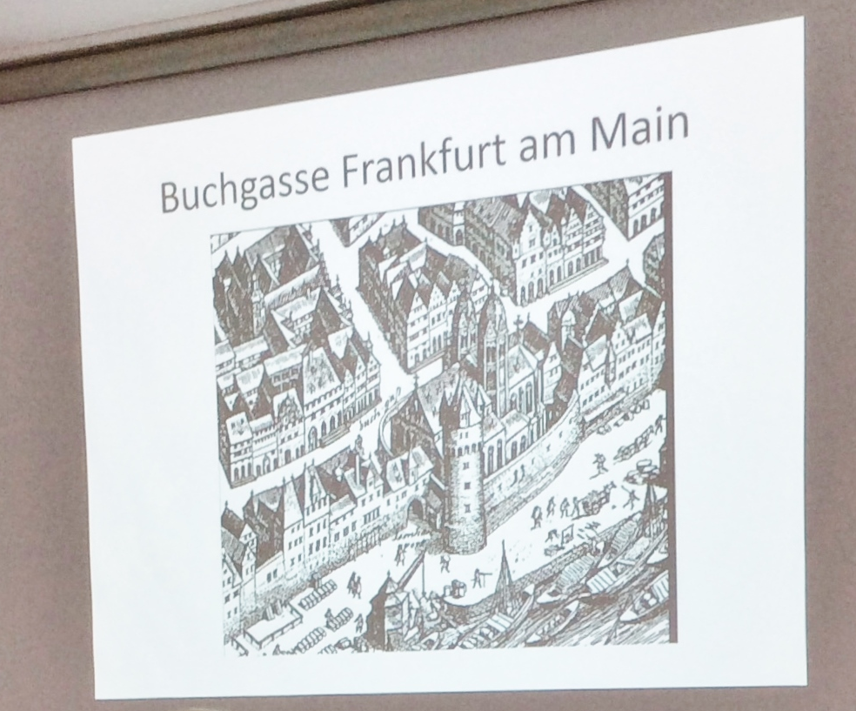

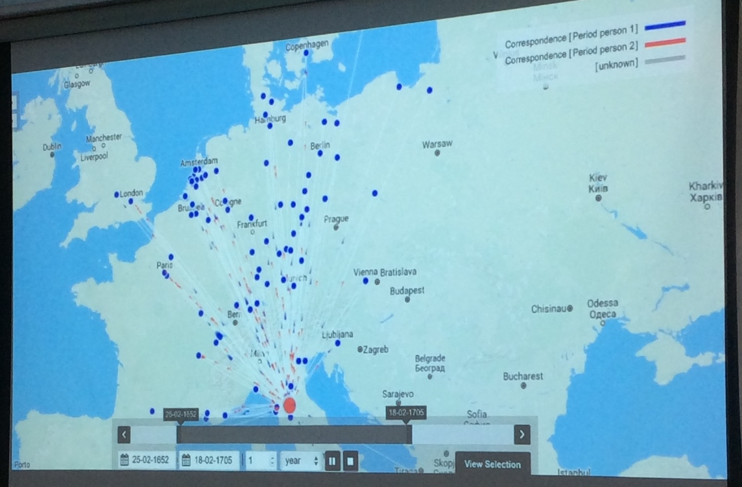
The vivid epistolary network of Magliabechi as shown by Ingeborg van Vugt

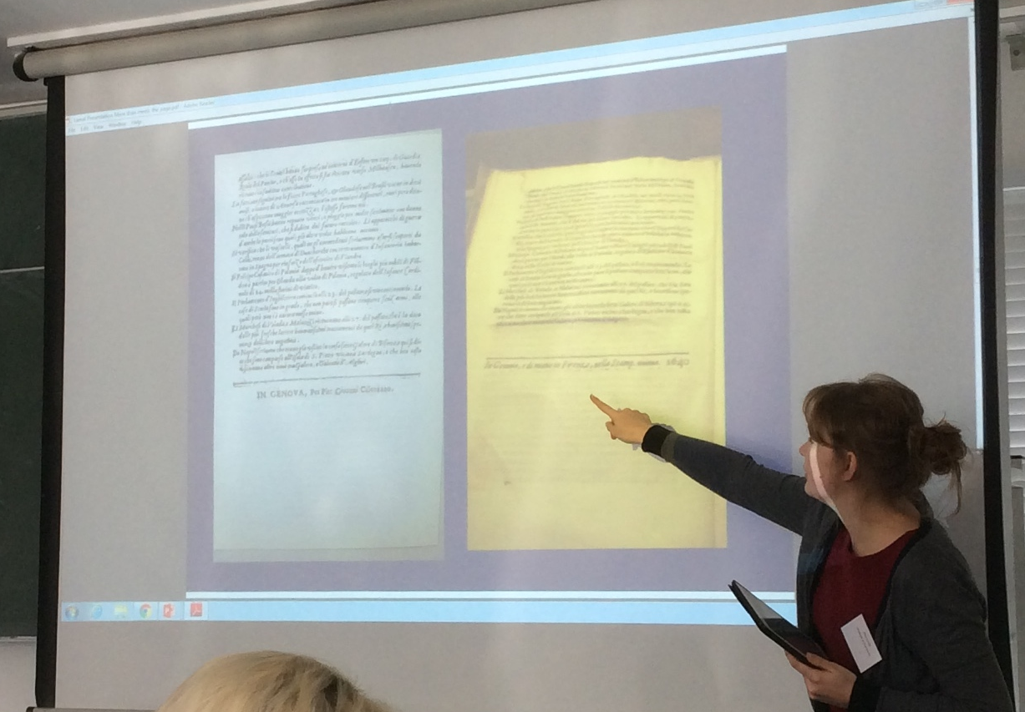
Nina Lamal discussing the practices involved in marketing the first Italian newspapers.

[left to right] Giacomo Comiati (CSR), Liz Miller (V&A), Gloria Moorman (CSR), Rebecca Carnevali (CSR)
