Parish Memory

The Twenty-Second Warwick Symposium on Parish Research took place in hybrid format at our Institute of Advanced Study on Saturday 11 May 2024. It featured a keynote address by Katalin Szende (Central European University) plus 15 shorter papers and attracted around 40 participants from eight countries.

Report by Beat Kümin (Warwick History)

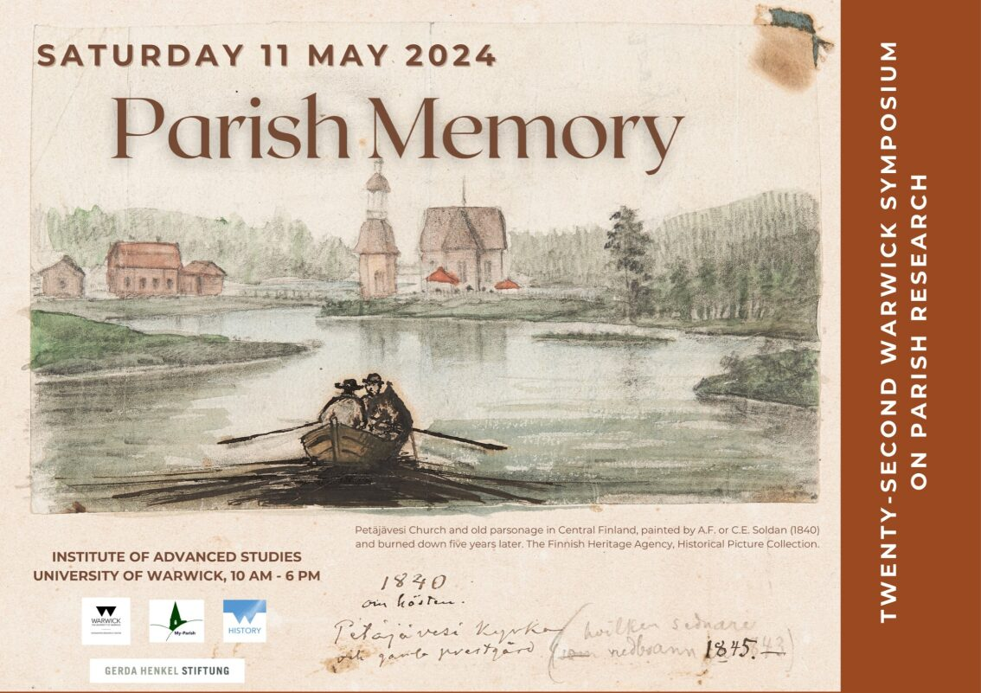
Fig. 1: Symposium Poster designed by Kristi Flake.

Our 2024 theme intersected with the lively interdisciplinary field of memory studies, focusing particularly on when / how / why parishioners remember(ed) events, customs, people and other aspects of their locality & culture. The Symposium coincided with Miia Kuha’s (Jyväskylä University, Finland) tenure as a My-Parish Fellow (to study Anglophone literature clergy widows) and Beat Kümin’s project on tower capsule deposits (funded by the Gerda Henkel Stiftung).

The opening keynote address took us to Central Europe. Prof. Szende offered a splendid panorama of ways in which parishes fostered individual and community memory in the Middle Ages and early Reformation period. Clergy and laity utilized a wide range of oral, written, visual and material media alongside processions, performances and numerous forms of symbolic communication. A distinctive element from a comparative European perspective are the wall chronicles, i.e. records of reigning monarchs as well as prominent events from the fifteenth century which have survived in several churches of the region.

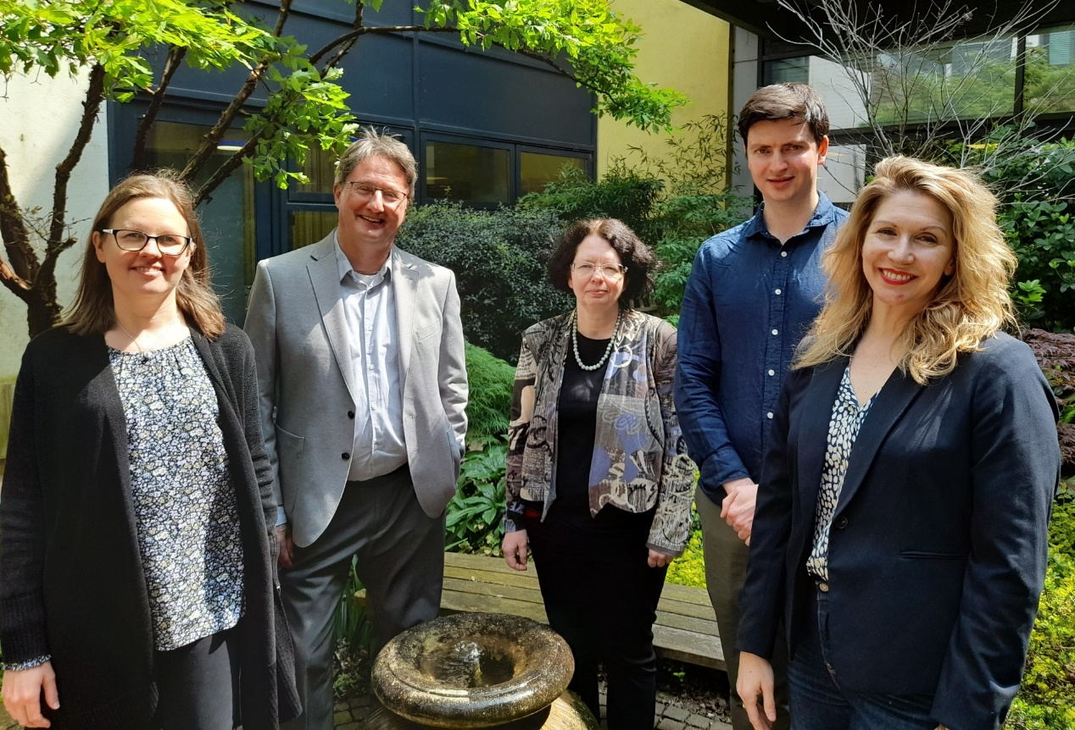

Fig. 2: Miia Kuha (Jyväskylä / My-Parish Fellow), Beat Kümin (Warwick History / Parish Network), Katalin Szende (Central European University) and Angus Crawford
/ Kristi Flake (Warwick History PGR) at the IAS on 11 May 2024. Pic: Andrew Foster.

The Symposium, inaugurated in 2003 and run by the Warwick Network for Parish Research (with its My-Parish research platform), has always been an inclusive forum of exchange between anyone with active research interests in parish culture from whatever background or career stage. Following a call for papers earlier in the year, we featured 15-minute contributions from doctoral students, independent scholars, early career researchers as well as senior academics. Proceedings were arranged in five sections, dedicated to the themes of ‘medieval culture’ (featuring talks on mortuary bequests, stained glass windows and chantry foundations), ‘memory sources’ (highlighting parish registers, local histories, funeral biographies and tower capsule deposits), ‘memory divisions’ (specifically in early modern Scotland and modern Ireland), ‘parishes remembered’ (dealing with case studies in Southampton, the Isle of Wight, Hungary and present-day Romania) and ‘parish spaces’ (focusing in particular on churchyards and territorial disputes; see full programme at the end of this report).

The intense but refreshingly informal event concluded with an extensive plenary session on the sources, methods, concepts, regional peculiarities and chronological evolutions emerging from the day’s presentations. Among the principal ‘take aways’ were differences of scale (from the personal / microhistorical via the regional and national to global levels) and the inherently unstable or fraught nature of memory (which could be lost, suppressed, manipulated and fluctuating as well as continuous and uncontested). Thanks to the cosmopolitan makeup of the gathering, there was also fruitful exchange on recent theoretical work beyond the ‘classics’ associated with scholars like Pierre Nora, Maurice Halbwachs or Aleida & Jan Assmann. In line with tradition, further space for informal discussion was afforded by a cheap and cheerful pub dinner on campus, accompanied by the more or less engaging Eurovision tunes blasting out from a nearby television screen (with Symposium participants rooting for many different entries).

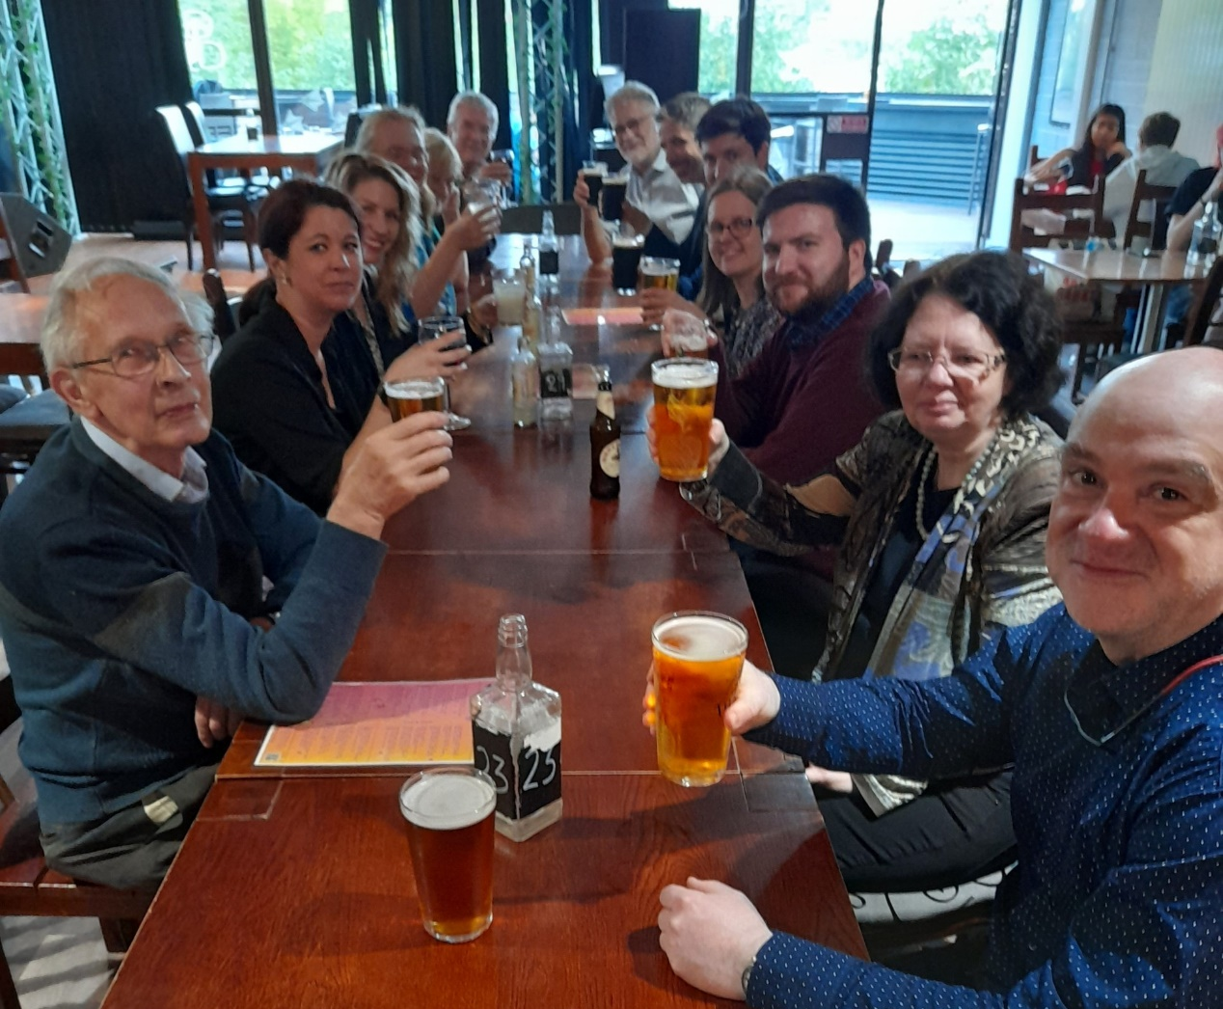

Fig. 3: ‘Parish Memory’ speakers and chairs, including Warwick Em. Prof. Bernard Capp (first left) and Cluj-Napoca Prof. Adinel Dinca (first right), raising their glasses
to a successful 2024 Symposium. Pic: Andrew Foster.

Further details, including paper abstracts, speaker biographies and visual impressions from the day, can be accessed on the Symposium homepage at: http://warwick.ac.uk/my-parish/parishsymposia/memory/. The Parish Network hopes to stage the next Symposium in May 2025 and is always open for thematic suggestions and/or ideas for related research projects.

The co-hosts gratefully acknowledge the generous support from the Humanities Research Centre (as always seamlessly mediated by Sue Rae), Warwick’s History Department and the Gerda Henkel Stiftung (based in Düsseldorf, Germany) as well as the organizational help from Angus Crawford and Kristi Flake (both Warwick History PGR).

Keynote Address – Chair: Beat Kümin (Warwick)

Katalin Szende (Central European University): ‘The parish as a place of memory in medieval Central Europe’

Session 1: Medieval Culture – Chair: Angus Crawford (Warwick)

Heather Falvey (Cambridge / Oxford): ‘Remembering the parish (priest): Mortuary bequests in medieval England’
Jessica Knowles (Vienna): ‘Commemorating Apocalypse: The Fifteen Last Days in All Saints, North Street’
Cindy Wood (Winchester): ‘The Parish Church of Ludlow, the 1547 Chantry Act and Commemoration of the Dead’

Session 2: Memory Sources – Chair: John Craig (Simon Fraser)

Ian Atherton (Keele): ‘Early Modern English Parish Registers as Forms of Memory’
Bernard Capp (Warwick): ‘Richard Gough and his Memories of Myddle’
Miia Kuha (Jyväskylä / My-Parish Visiting Researcher): ‘Remembering the pastor’s wife: Roles and responsibilities of 17th -century Finnish clergymen’s wives in funeral biographies’
Beat Kümin (Warwick): ‘Conceal to Connect: Tower Capsules in the Deposit Culture of the German Lands’

Session 3: Memory Divisions – Chair: Kristi Flake (Warwick)

Martin Duffy (Cambridge): ‘Parish Memory during the Irish Decade of Centenaries 2012-2022’
Jim Reilly (Edinburgh): ‘The contested memory of religious persecution in the early modern Scottish parish’

Session 4: Parishes Remembered – Chair: Miia Kuha (Jyväskylä)

Cheryl Butler (Winchester): ‘Why remember Peartree?’
Adinel Dinca (Cluj-Napoca): ‘Accessing the Memory in the Pre-Modern Parish of the Transylvanian Saxons’
Aidan Jones (King’s London): ‘’The simple, pretty little village church’: Queen Victoria’s Isle of Wight Parish Church’
Béla Vilmos Mihalik (Budapest): ‘Memory of the Old Parish: The Case of Hungary’

Session 5: Parish Spaces – Chair: Andrew Foster (Kent)

Jason Frost (Independent Scholar): ‘From Parochial Memory to Physical Memorialisation; How God’s Acre became Contested Space’
Kaye Sowden (Canterbury Christ Church): ‘An Ancient man of four score and ten: Bearing witness in parish disputes and the recording of happenings’

