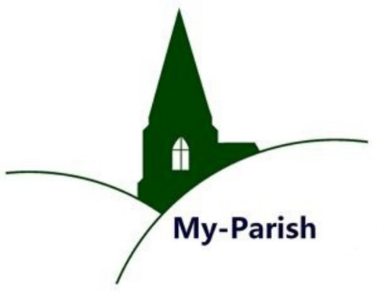
Parish Participation
Seventeenth Warwick Symposium
on Parish Research
University of Warwick, 18 May 2019
Report by Bethany Marsh (Nottingham)
This year’s symposium was co-organised by Beat Kümin (History/Warwick) and Malin Lennartsson (Linnaeus University/Växjö) with the support of the Humanities Research Centre. Participants explored various types of participation by locals and non-residents across England, Scotland and Scandinavia. These included parish office-holding, parish politics, court procedures and poor relief. Several themes emerged across the four panels, culminating in an interesting general discussion at the end of the day’s proceedings.

Speakers highlighted formal as well as informal ways of involvement. The latter was considered by Helen Gair (Nottingham Trent), Joe Chick (Warwick) and Marion Hardy. Gair’s contribution on Kirk sessions showed how parishioners were active participants in court sessions and played a key part in maintaining religious and social conformity. They may have had an unofficial role in the disciplinary process, but their participation was central to the functioning of court sessions. Chick and Hardy demonstrated that the boundary between informal and formal participation was not always clearly defined. In the case of parish welfare, the poor rate became more formalised over the course of the sixteenth and seventeenth centuries but other informal measures – such as donations to poor boxes, hospitality to neighbours and testamentary bequests to the poor in wills – persisted.

Several papers focused on parish office-holding, which over the course of the early modern period became increasingly specialised. Using literary evidence, Dave Postles (Hertfordshire) offered sceptical reflections on constables, while Donald Spaeth (Glasgow) showed how courts were used in parish politics and often used as a means of exacting personal gains. John Morgan (Manchester) highlighted how the role of parish dikereeves, responsible for water management, emerged in the sixteenth and seventeenth centuries in response to the expanding functions of local government in political, social, religious as well as environmental matters. At the same time the specific portfolios of officers contracted in order to increase efficiency.

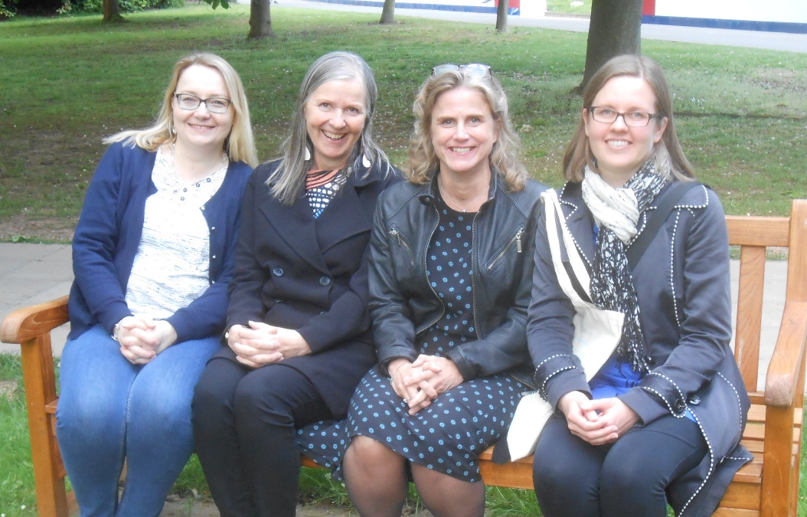
Ella Viitaniemi, Arja Rantanen, Malin Lennartsson and Miia Kuha
presented research on Scandinavian parishes. Picture: Beat Kümin.
Particular emphasis was also placed on the Scandinavian experience, with four papers dedicated to Sweden and Finland. Presented by Malin Lennartsson, Miia Kuha (Jyväskylä), Arja Rantanen (Jyväskylä) and Ella Viitaniemi (Tampere), they provided a helpful comparative element. During the general discussion, the similarities and differences between England, Scotland, Sweden and Finland moved to the centre of attention. The question of how and why certain languages were used for particular documents, for example, was raised. Multiple languages were used in documents both in the British Isles and Scandinavia. In Finland documents used both Finnish and Swedish, whilst in England and Scotland documents used Latin, English and Gaelic.
For full Symposium materials and information on other Parish Network activities please visit the Parish Network homepage at http://warwick.ac.uk/my-parish.

