‘PARISH COMMUNICATION’
Twenty-Third Warwick Symposium on Parish Research
Co-organized by Beat Kümin with Angus Crawford and Kristi Flake (Warwick History / My-Parish)
Report by Lynn Marriott (Warwick History PGR Student)

This annual day conference, first held in 2003, took place in hybrid format at the Institute of Advanced Studies on Saturday 17 May 2025 with delegates attending from New Zealand, Poland, Hungary and Italy as well as from all over the UK. Proceedings were divided into three parts with eleven speakers, all addressing different forms and media of the umbrella theme of ‘Parish Communication’ with 15 minute contributions.
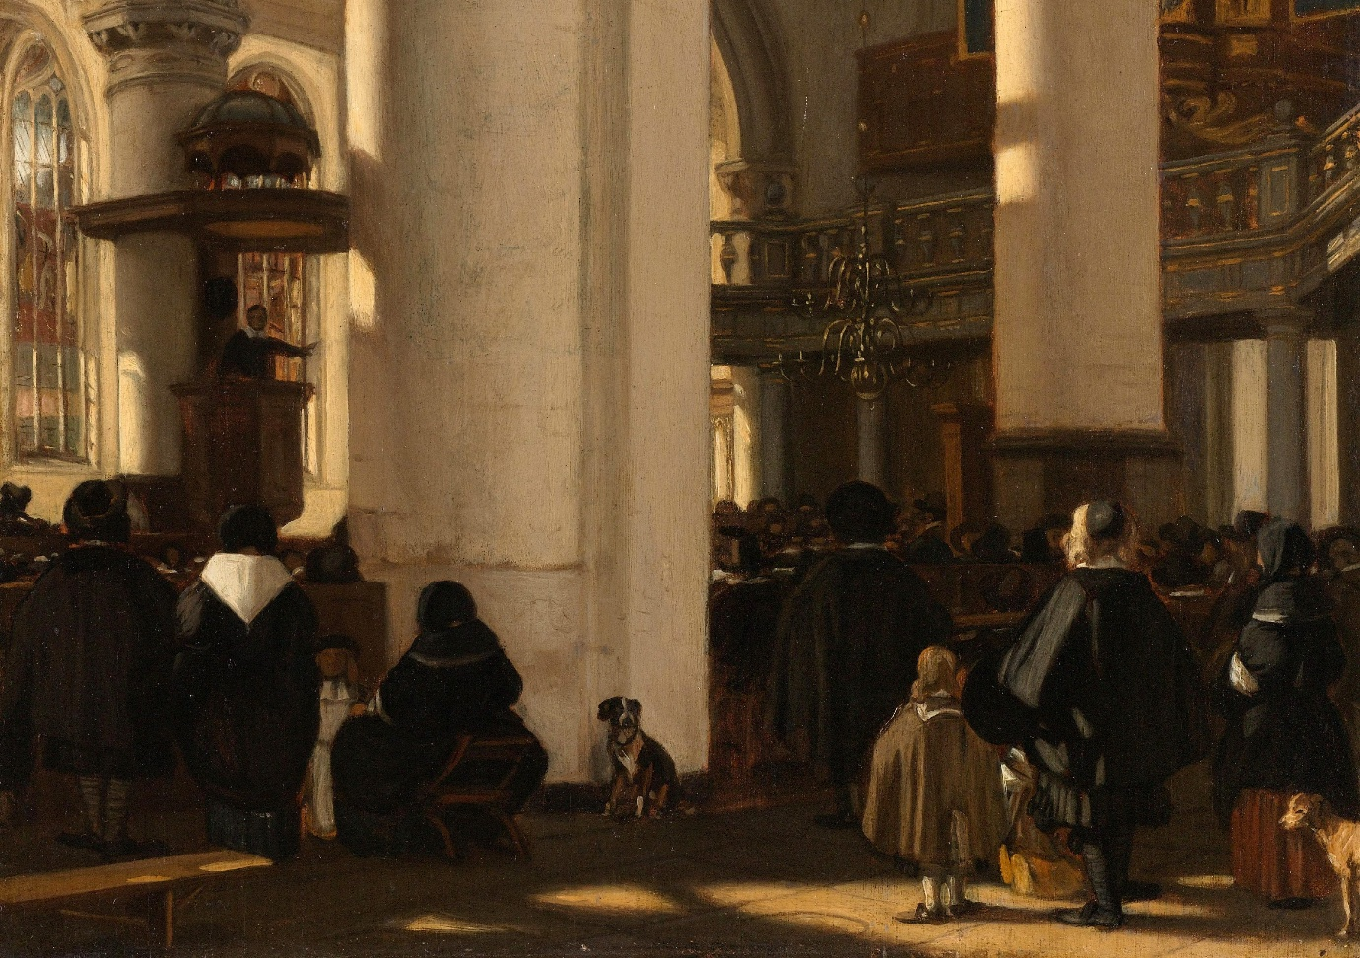
Emanuel de Witte, ’Interior of a Protestant, Gothic Church during a Service’ (oil on panel, 1669). Extract from the painting in the Online Collection of the Rijksmuseum, Amsterdam.
The first session of four papers used as its rubric the title ‘Directing’ (for speakers and titles, please see ‘programme details’ below). We were taken on a tour from the medieval period to almost the present day focussing on how the church authorities used different forms of communication in order to ensure compliance and obedience. Research encompassed the use of fourteenth-century church court cases, the effects of the 1604 Canons Ecclesiastical, the use of the Book of Homilies in the early modern period and the rise and contribution to political culture of parish magazines printed by the Church of England around 1900.
The second panel consisted of four papers under the title ‘Liaising’. These presentations demonstrated the effective communication channels that existed between Papacy, monarchy, clergy, churchwardens and laity not just in England but also in Poland and Syno-Palestine. Each presenter emphasized and demonstrated how intrinsic this two-way communication network was for the authority and the credibility of the Church in both urban and rural settings, as well as how the laity also used the same channels with which to bring their own petitions and requests with the expectation that they would be heard.
Discussion under the title of ‘Signalling’ constituted the final session of the day, with three papers on different regional contexts. In-depth analysis of churchwardens’ records emerged as a way to understand the confessional leanings in seventeenth-century East Anglia. In Latvia, by contrast, in spite of homogenizing pressures, communities were able to keep alive their own multilingual and multicultural identity to the present day. To complete the day’s proceedings, inter-faith communication in Hungary underlined once more how important communication was to all members of society, whatever their religious identities.
The day ended with a lively general discussion on the overarching themes that had emerged from the day. It was agreed that the process of communication within parishes had evolved over time, from relying primarily on oral and performative media to written and then printed documentation, but always in coexistence with other forms. Papers had highlighted a myriad of aspects and topics, including the ringing of church bells, rituals of punishment, the drawing up of petitions / questionnaires, direct action such as iconoclasm and the migration/exchange of ideas between centres and localities. By using qualitative case studies, quantitative approaches, geographical information systems, visual analysis as well as close reading of texts, the papers provided participants with an impression of available methodological instruments and ultimately conveyed a picture of parishes being hubs of interaction between local communities and church authorities. Whilst that communication did not need to be classed as successful in order for it to appear worthy of investigation, it became clear that all parties were aware of a wide range of options. Speakers often highlighted clergymen and churchwardens as lynchpins within their parishes, ensuring the communication from the church hierarchy was translated to the parishioners in a language that could be understood and acted upon. Ultimately, the day highlighted the interplay of deliberate and incidental communication and how both hidden and open agendas could be disseminated widely.
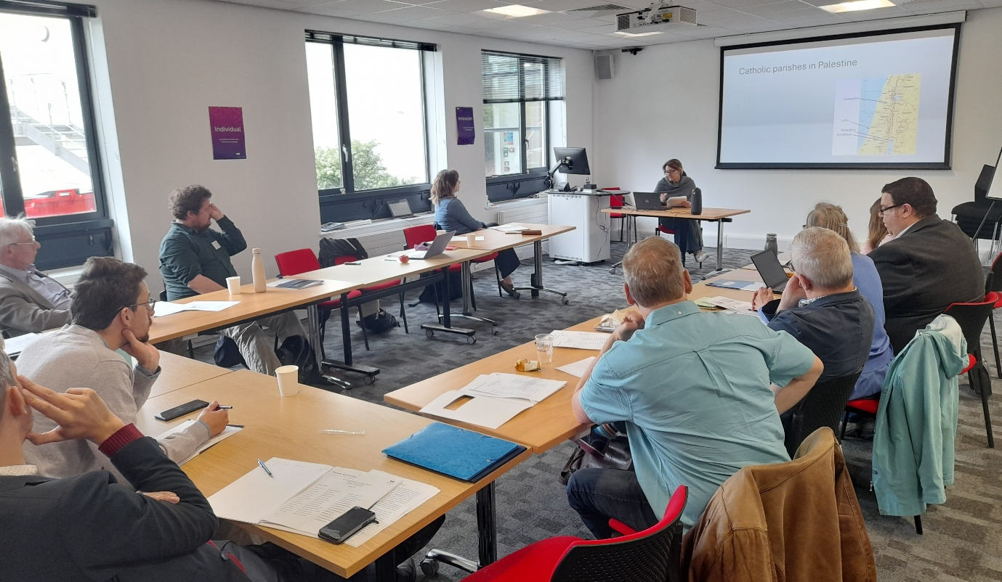
Delegates engaging with Felicita Tramontana’s presentation. Photo: Beat Kümin
The organisers gratefully acknowledge the generous support of the Humanities Research Centre, My-Parish Network and Warwick’s History Department; the help from Sue Rae; as well as the contributions of all session chairs and online/in-person delegates.
Symposium homepage:
http://go.warwick.ac.uk/my-parish/parishsymposia/communication/
Programme details:
Welcome and Session 1 – Directing Chair: Beat Kümin (Warwick)
Nicholas Ringwood (Auckland), ‘Incorrigibly Scandalous: Combatting Recidivist Sexual Misbehaviour in Late Medieval English Parishes’
Ashley Armstrong (University of East Anglia), 'England’s Canons and their Place in the Church: A Typographical Study of the Seventeenth Century’
Kristi Flake (Warwick), ‘Preaching the Homilies ... or not? Evaluating the Reception of the Homilies, 1547-c1860’
George Palmer (Cambridge), ‘Parish Magazines and Political Communication in England, 1885-1914’

Session 2 – Liaising Chair: Kristi Flake (Warwick)
Robert Swanson (Shaanxi), ‘Parishes and Communication in the Bureaucratic and Disciplinary Structures of the Pre-Reformation English Church’
Marion Hardy (Independent), ‘Demands, Duties, Rates, Taxes, Tithings … Who Would be an Unpaid Parish Official in Early Modern England?’
Marek Słoń (John Paul II Catholic University of Lublin), ‘The Role of the Parish in Urban-Rural Communication’
Felicita Tramontana (Roma Tre), ‘Communicating the Parish: Information Flows between Syno-Palestinian Parishes and Rome in the 17th Century’

Session 3 – Signalling Chair: Andrew Foster (Independent)
Christian Owen (Cambridge), ‘The Parish as a Battleground: Contested Visions of the English Reformation in East Anglia’
Melchior Jakubowski (Warsaw), ‘Multilingualism of Parishes in Latgale (Eastern Latvia) from the 1670s to the 1930s’
Béla Mihalik (Budapest), ‘The Jews of the Parish: Communicating the Otherness’

