Fifteenth Warwick Symposium on Parish Research

‘The Digital Parish’, 20 May 2017

This year’s symposium focused on new methodologies made available by digital technology. Beat Kümin (Warwick) opened the day by introducing the topic and drawing attention to the new web address of the recently relaunched My Parish website.

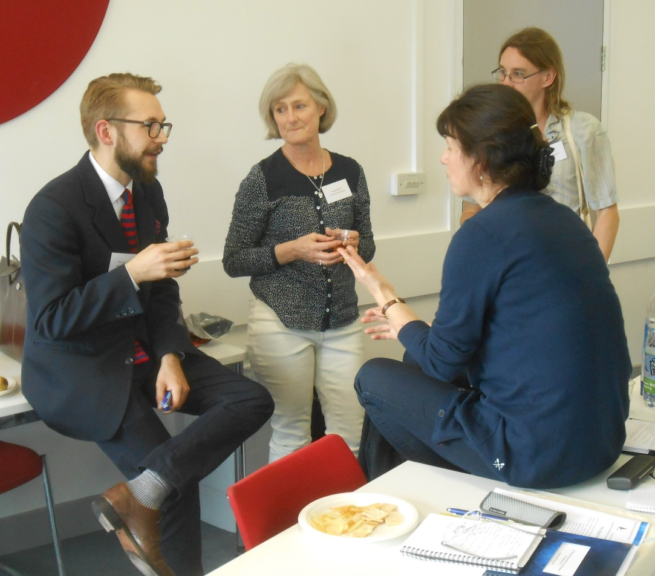

Eight speakers from the UK, US and Poland informed attendees of the ways in which digital resources had supported their research. Many focused on their use of Access, while others introduced specialist analytical packages such as NVivo and GIS or online sources for accessing historic maps. A list of these, along with useful forums, data storage sites, and training opportunities, has since been uploaded to the My Parish website.

A number of recurring themes emerged during the day. Alongside the practicalities of beginning an IT-based project, delegates emphasised careful considerations of source materials and research questions, the extent to which options are limited by the software to which an institution subscribes, and the difficulty of ensuring a project has long-term sustainability in a world where technology is constantly changing.

Other focal points of discussion were the need for collaboration and inner-/interdisciplinary exchange, the question of whether researchers receive credit for database design or just for the analytical results they produce, and the feasibility of a wider pooling of resources as well as the creation of one-stop access points for the sharing of digital information. There was universal agreement on the utility of such methodological and practical exchange, with the suggestion to hold a similar, hands-on workshop in the future. For full details on proceedings please visit: http://warwick.ac.uk/my-parish/parishsymposia/2017digitalparish/.

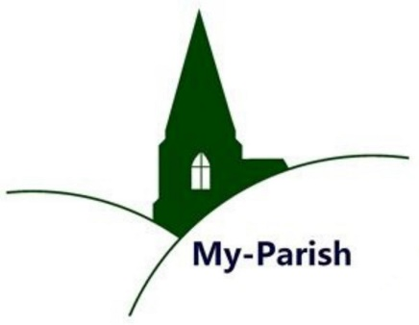

The next annual symposium of the Parish Network will be held in May 2018 on the topic of ‘Parishes and Migration’.

Joe Chick
(History)

