Self-Awareness and Intersubjectivity
Conference organised by the Warwick Mind and Action Research Centre (WMA)
Thursday 12th - Friday 13th March 2026
Webpage:
https://warwick.ac.uk/fac/soc/philosophy/people/nie/incrediblebeliefs/self-awarenessandintersubjectivityconference/

Programme
Thursday 12 March 2026 (Scarman House, Space 11)

13.30 - 14.50 Lucy O’Brien (UCL): "Reflection on One’s Interpersonal Self-Consciousness"

15.00 - 16.20 Matthew Boyle (University of Chicago): "From Other Selves to Intersubjectivity"

16.20- 16.50 Tea & Coffee

16.50 - 18.10 Naomi Eilan (University of Warwick): “Subjective, intersubjective, objective: On the role of joint attention”

19.30 Dinner (Dining room, Radcliffe House)

Friday 13 March 2026 (Wolfson Research Exchange, Main Library)

9.30 - 10.50 Henrike Moll (University of Southern California): “The intersubjective basis of identity: The case of dissociation”

10.50- 11.10 Tea & Coffee

11.10 -12.30 Richard Gipps (Oxford University): “What is superstition? Confusions of self-self, self-world, and self-other relating”

12.30 - 13.30 Lunch

13.30 - 14.50 Eliza Little (University of Warwick): "Literary knowledge and intersubjectivity"

15.00 - 16.20 Johannes Roessler (University of Warwick): “Joint attention and perceptual knowledge”

16.20 Tea & Coffee

We gratefully acknowledge financial support from the Behaviour Spotlight Programme; the Humanities Research Centre; the Warwick Mind and Action Research Centre; and the Leverhulme Trust.

Report

The Self-Awareness and Intersubjectivity conference took place between 12-13 March 2026. It featured seven interdisciplinary talks and attracted 47 participants from Warwick as well as from a range of other British and European universities, including Oxford, Cardiff, Exeter, Liverpool John Moores, Southampton, Birmingham, King’s College London, Roma Tre University in Italy, and Halle University in Germany. The conference successfully fulfilled its main objectives. It promoted interdisciplinary exchange between philosophical and empirical work on self-awareness and intersubjectivity, reinforced the University of Warwick’s, especially the Warwick Mind and Action Research Centre’s, research strengths in these fields, and established a foundation and network for future collaborative projects and joint funding applications.

The first day of the conference kicked off with a talk by Lucy O’Brien (UCL), and it was titled “Reflection on One’s Interpersonal Self-Consciousness”. In interpersonal self-consciousness, the subject is conscious of herself through the perspective of the other. Lucy argued that our capacity for interpersonal self-consciousness is both valuable and rational, and it depends on our ability to take in another person’s evaluative perspective without simply reducing our own to theirs. An important implication of this, she suggested, is that “we can stand in an uncomprehending, or ambivalent, but not thereby irrational, sense of ourselves and our value”.

The second talk was by Matthew Boyle (University of Chicago), and it was titled “From Other Selves to Intersubjectivity”. The talk first clarified that intersubjective consciousness includes two kinds of one-way cases (objectifying consciousness and interpersonal self-consciousness) and two kinds of two-way cases (mutual awareness and joint attention), and then distinguished intersubjective consciousness from mere object consciousness and collective consciousness. Based on this groundwork, Matthew proposed what he called the Intersubjectivity Thesis about personal understanding, according to which “our basic understanding of persons is the one we exercise in intersubjective consciousness.”

The third talk was by Naomi Eilan (University of Warwick). The title was “Subjective, intersubjective, objective: On the role of joint attention”. Naomi proposed a new account of joint attention that illuminates how “the subjective, intersubjective, and objective aspects of our engagement with the physical world are interdependent.” According to her account, joint attention has a triadic structure: the two sides of the triangle consist in the two subjects attending to the same object, while the base consists in a distinctive kind of communicative relation between the two subjects. This communicative relation entails a mutual awareness of each other as “you” and enables the subjects to refer demonstratively to the attended object.

The second day of the conference opened with a talk by Henrike Moll (Psychology, University of Southern California). The title was “The intersubjective basis of identity: The case of dissociation”. Drawing from developmental psychology (disorganized attachment and dissociation), social philosophy (Honneth and others), and psychoanalysis (Winnicott and Erikson), Henrike argued that underlying human self-relation is an intersubjective relation in which the child’s claims to (Winnicottian) holding are recognised, and dissociation is, at its core, a disorder of misrecognition: that is, a chronic defensive response to the denial of one’s claims to attachment and holding.

The next talk was by Richard Gipps (Psychiatry, Oxford University), and it was titled “What is superstition? Confusions of self-self, self-world, and self-other relating”. In contrast to intellectualist theories of superstition that reduce it to error, Richard argued that superstition arises when the boundaries between self and world, imagination and reality, and symbol and cause become blurred. In such a situation, superstition is appealing because it offers a feeling of control in the face of fear and uncertainty, but it is ultimately harmful because it distorts clear thought, weakens our grasp of reality, and damages the soul.

The afternoon started with a talk by Eliza Little (University of Warwick). The title was "Literary knowledge and intersubjectivity". Drawing on Simone de Beauvoir, Eliza argued that literature provides us with knowledge of other minds in virtue of granting us access to first-person thinking other than our own. What is at issue is not simply another first-person perspective, but a formal feature of thought unique to us as individuals, which, in Beauvoir’s terms, is the “flavour” of an individual’s experience.

The last talk was by Johannes Roessler (University of Warwick). The title was “Joint attention and perceptual knowledge”. The talk discussed two disagreements between McDowell and Stroud: (1) McDowell argues, while Stroud denies, that “perceptual knowledge is to be explained by reference to grounds for perceptual belief”; (2) McDowell argues, while Stroud denies, that “conscious perceptual experience plays an explanatory role in the acquisition of perceptual knowledge”. According to Johannes’s analysis, McDowell is right that “[i]t's because of our perceptual experience of objects and features that we are able to perceive and know what objects are like”, and Stroud is right that the explanation does not refer to one’s belief.

Attendee List
 |  | Name | University | No.
External | Staff | Anita Avramides | Oxford University | 1
External | Staff | Jonathan Mitchell | Cardiff University | 2
External | Staff | Chiara Brozzo | Birmingham University | 3
External | Staff | Kathleen Murphy-Hollies | Birmingham University | 4
External |  | Oli Needham |  | 5
External | PG | Wanda von Knobelsdorff | Oxford University | 6
External | PG | Pagliarone, Beatrice | Exeter University | 7
External | PG | Jen Benson | Liverpool John Moores University | 8
External | PG | Amin Mostajir | Southampton U | 9
External | PG | Eve Poirier | Oxford University | 10
External | UG | Lavinia Grimaldi | Roma Tre University | 11
External | PG | Anita Watzel | Halle University, Germany | 12
External | PG | Sean Maroney | KCL | 13
Warwick | Staff | Christoph Hoerl | Philosophy | 14
Warwick | Staff | Richard More | Philosophy | 15
Warwick | Staff | Matt Nudds | Philosophy | 16
Warwick | Staff | Heather Widdows | Philosophy | 17
Warwick | Staff | Guy Longworth | Philosophy | 18
Warwick | staff | Kirk Surgener | Philosophy | 19
Warwick | Staff | Magnani, Noemi | Philosophy | 20
Warwick | Staff | Quassim Cassam | Philosophy | 21
Warwick | Staff | Oscar North-Concar | Philosophy | 22
Warwick | Staff | Costello, Diarmuid | Philosophy | 23
Warwick | Staff | Chenwei Nie | Philosophy | 24
Warwick | Staff | Davide Nicolini | WBS | 25
Warwick | Staff | Matthew Hurst | WBS | 26
Warwick | PG | Keyu Qiu |  | 27
Warwick | PG | Wenxuan Shi |  | 28
Warwick | PG | Mirko Prokop |  | 29
Warwick | PG | Yixuan Li |  | 30
Warwick | UG | Ana Canas Molteni |  | 31
Warwick | PG | Ateş Metin |  | 32
Warwick | PG | Anpeng Liu |  | 33
Warwick | UG | Melina Macfadyen |  | 34
Warwick | UG | Ruby Zhang |  | 35
Warwick | UG | KHANH Vu |  | 36
Warwick | PG | Juyong Kim |  | 37
Warwick | UG | COURTNEY, ELLIE |  | 38
Warwick | UG | Sam Brass |  | 39
Warwick | PG | DINGLE, NANSI |  | 40
Warwick | PG | RADKOVSKII, SASHA |  | 41
Warwick | PG | Emily Boocock |  | 42
Warwick | PG | Leo Deng |  | 43
Warwick | PG | Iulia Mitu |  | 44
Warwick | PG | Liza Yousf |  | 45
Warwick | PG | Alicia Klemm-Silva |  | 46
Warwick | PG | Rozemin Keshvani |  | 47

Photos

Naomi Eilan’s talk on Day 1, Scarman
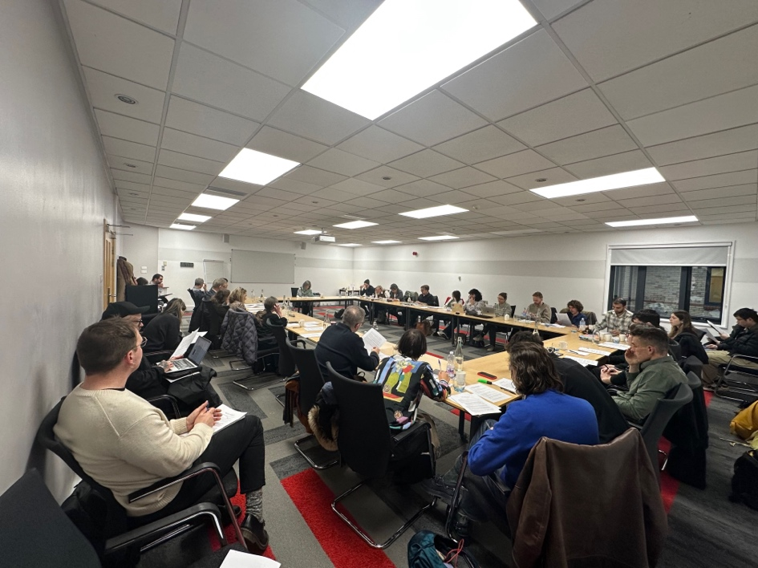

Henrike Moll's Q&A session on Day 2, Wolfson Exchange
