Report for HRC on Spying on Spies: Popular Representations of Spies and Espionage
(3-5 September 2015)
Joseph Oldham, Department of Film & Television Studies, University of Warwick

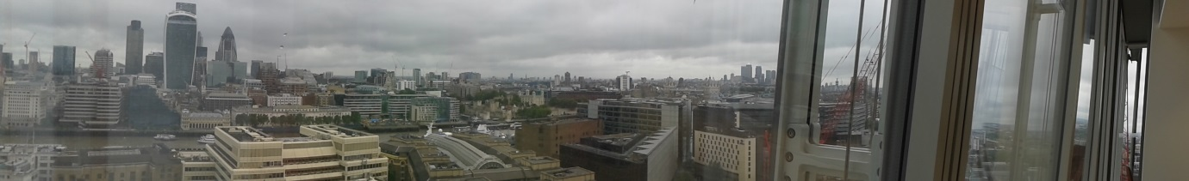
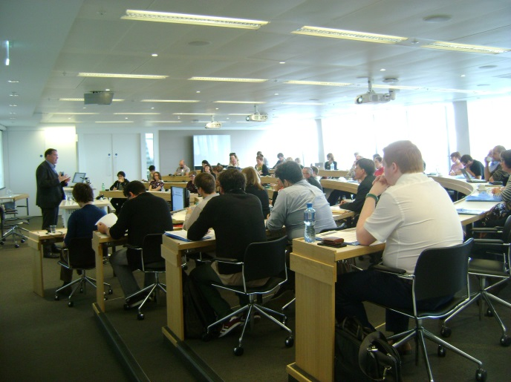
Spying on Spies was an international conference held at the Warwick Business School space in The Shard, London, organised collaboratively by Joseph Oldham (University of Warwick) and Toby Manning (Open University). The aim was to bring together a diverse array of international research on the spy thriller, one of the defining popular genres of the 20th and early 21st centuries, which has provided an alternative lens onto broader cultural and geopolitical shifts over the this time.

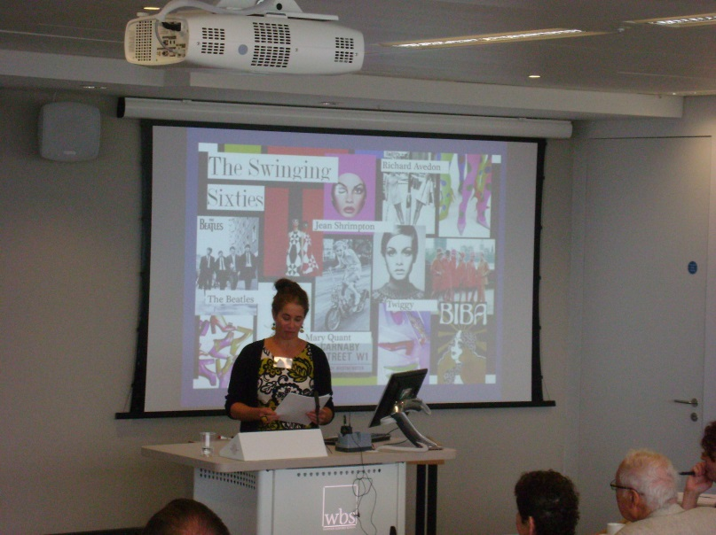
Across 15 parallel panel sessions scholars examined representations of espionage from around the world (including from both sides of the Cold War divide), and across diverse media including literature, film, television, theatre, comics, poetry and computer games. Our three keynote speakers were Professor Phyllis Lassner (Northwestern University), who looked at women writers of spy fiction, Professor James Chapman (University of Leicester) who discussed the spy films of Alfred Hitchcock, and finally Dr Rosie White (Northumbria University) who presented on the topic of women, aging and espionage.

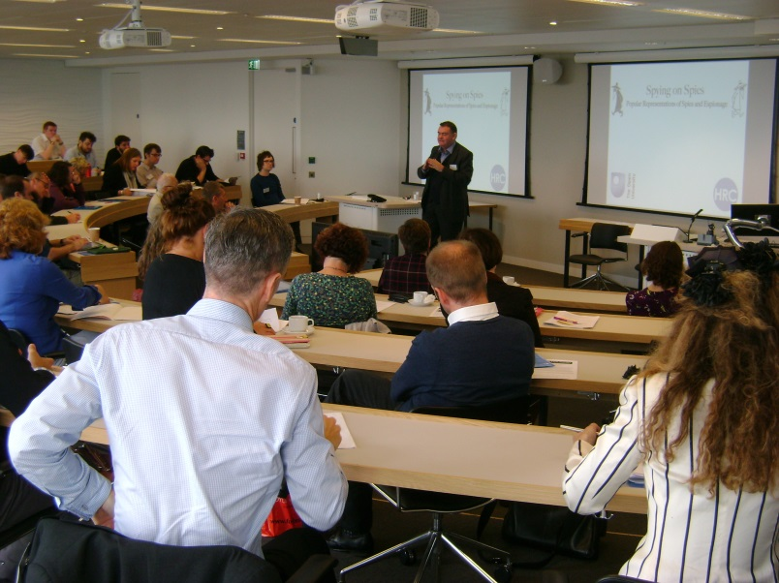
The conference was a huge success, attracting delegates from countries as diverse as the USA, Russia, India, Germany, Spain and Italy. We were particularly delighted by the huge international scope and cultural diversity of the research our delegates presented, enabling the establishment of more global and cross-cultural perspective than the genre has typically previously received. In addition, the unusually spectacular and state-of-the-art venue was very popular with delegates, and we are very grateful to WBS for allowing us to use it. There is now a move to create an ongoing research community around this topic as a direct outcome of the conference’s success, with similar events likely to be organised in the future to continue this valuable exchange of ideas.

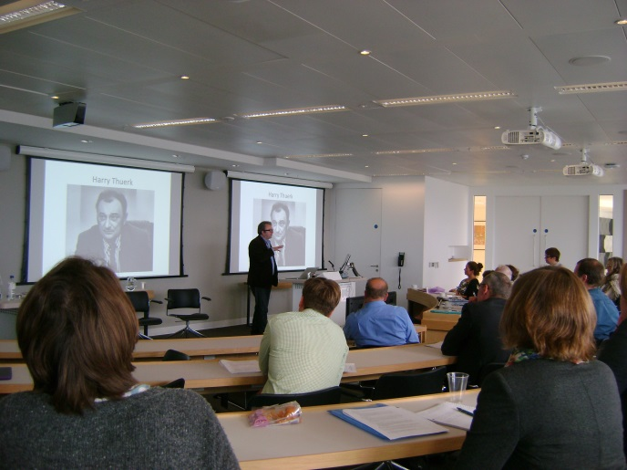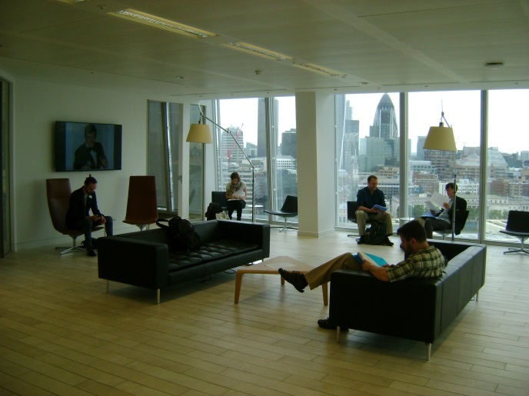
Photographs taken by Eli Gumble, Joseph Oldham and Rosie White.

