Workshop Report: ‘Approaches to Teaching the #EarlyModernHispanicWorld to 21st-Century Students’
How do we continue to engage students with the early modern and pre-modern Hispanic world in innovative ways? How can we make these texts more accessible to today’s learners whilst also retaining the essential differences of another culture and another era? These are some of the questions that scholars, in collaboration with students, explored during the interdisciplinary workshop ‘Approaches to Teaching the #EarlyModernHispanicWorld to 21st-Century Students’, which took place at Warwick on Friday, 13th October 2023. The aim of the event was to rethink approaches and pedagogical methods to open up these texts and topics to higher education students and it included short presentations on all aspects of pedagogy and strategies for teaching, learning, and assessment that encourage learners to engage with key works using a variety of means, including visual and digital media. The hybrid format facilitated the attendance of scholars and PG students; overall, we had colleagues joining us in person and online from British, Irish and US institutions.
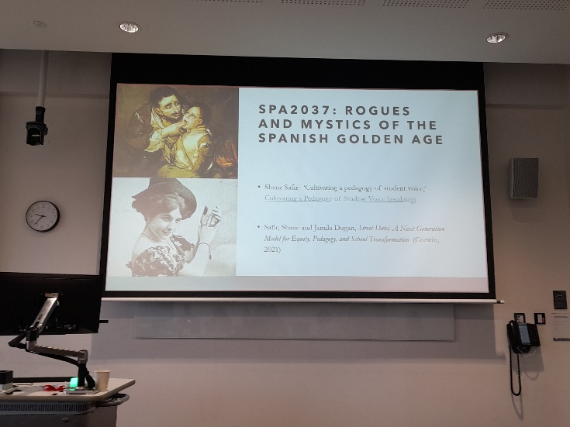
The first panel, entitled ‘Teaching Early Modern Literature’, included very engaging presentations by Prof. Isabel Torres (Queen’s University Belfast), Dr Anne Holloway (Queen’s University Belfast), and Dr Idoya Puig (Manchester Metropolitan University). They all offered some reflections on their experience facilitating effective engagement with literature from an era which is at a double remove from the twenty-first century student. Professor Torres focused on the rationale for learning and evaluation strategies which followed Egan’s ‘Imaginative Approach to Teaching’ (2005) and recent work on the concept of ‘Salience’ in Shakespearean Studies (Dadabhoy and Mehdizadeh, 2023). She concluded by showing her students’ ‘creative response’ project work for the poetry module and reflections on ‘embodiment activities’ that will be further developed on the theatre course. Similarly, Dr Holloway showed the audience the potential in foregrounding the continuing resonances of the Early Modern within the modern, and in anchoring literature within more familiar or immediate contexts for students. This was then clearly illustrated in the innovative assessment options that allow students to become editors, curators, or producers of podcasts or documentaries. In the last presentation of this panel, Dr Puig showed how we can make use of new media literacies in the university context to rediscover and renew Spanish Golden Age literary texts. By focusing on Cervantes’s La española inglesa, Puig demonstrated how literature, particularly classic texts, can be embedded in the language classroom in innovative ways.
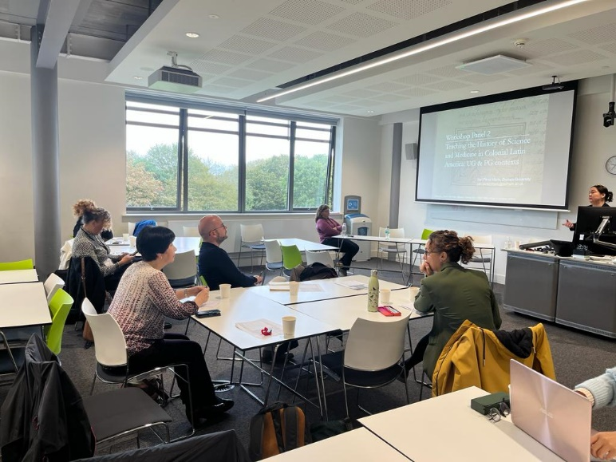
During our second panel, we learned about the teaching of history of science and medicine in colonial Latin America thanks to Dr Yarí Pérez Marín (Durham University) and Dr Fiona Clark (Queen’s University Belfast). Dr Pérez Marín shared some examples from her teaching practice on how to facilitate student engagement with early modern sources on natural history and medicine at different levels, from ideas best suited for introductory undergraduate modules to more specialised postgraduate contexts. For instance, the opportunities her students have to collaborate and put into practice their knowledge at the Spanish Gallery at Bishop Auckland. Similarly, Dr Clark discussed some approaches to engage students with 18th-century topics by centring assessment in real world contexts (taking examples from the Gazeta de Literatura de México, treatments for syphilis, art and health, and polemics around uses of chocolate). In addition to developing an understanding of primary sources, the underpinning aim of these modules is to help students develop more advanced writing and communication skills with an awareness of a specific audience and using digital technologies e.g., podcasting, digital editing, and working with interactive images.

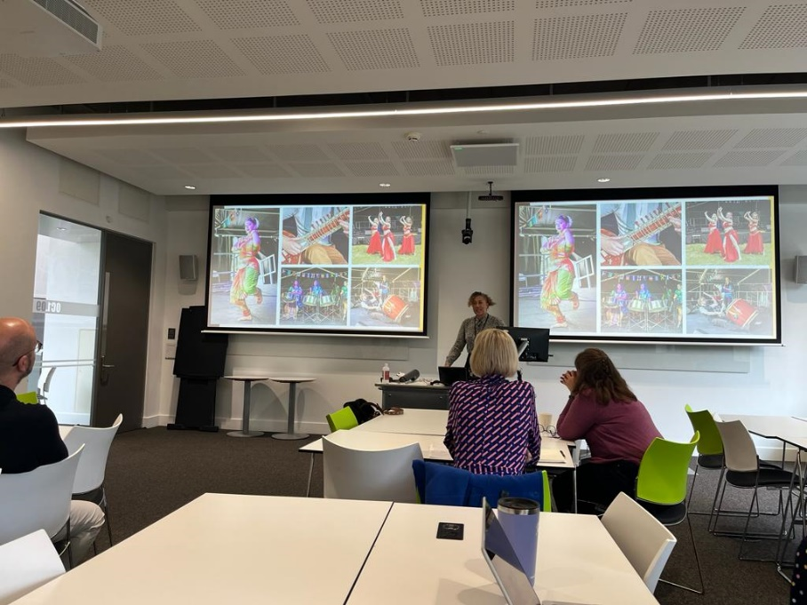
The keynote presentation was delivered by Tara Munroe, Creative Director of Opal22 Arts and Edutainment, a historical researcher and museum curator who has been working within a number of museums and community organisations across the Midlands area in England over a number of years. Her work with Arts, Heritage and Cultural projects for the local communities has been nationally acclaimed and is being used as templates across the country. She brings a modern innovative twist to the heritage area and makes it fun for those she targets. Her presentation ‘Casta Paintings through 21st-Century Eyes’ was highly engaging and refreshing, particularly her work with local communities through workshops and events. Tara Munroe talked about her new exhibition, Casta: The Origin of Caste - which we totally recommend!-, which showcases a series of rare, historically important 18th-century Mexican paintings which she discovered in the basement of the Leicester Museum and Art Gallery. The paintings are explored by different experts that bring different approaches and readings, but her talk made us think beyond all this, looking at their legacy, their role, and how to decode and decolonise the modern world.
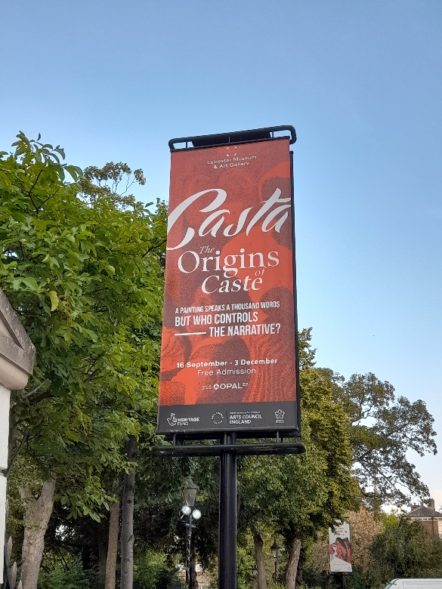
The last panel brought together different colleagues from Warwick that teach the early modern Hispanic world in three different departments: School of Modern Languages and Cultures, History and Liberal Arts. Prof. Rebecca Earle, based in the department of History and also an expert on Casta painting, explained how the history of food is an effective vehicle for exploring the past, particularly in her own experience of teaching Latin American history through food, and how this experience has in turn shaped her own research trajectory. Dr Liz Chant, based in Liberal Arts, explored how historical maps offer unique insights into the early modern Hispanic world, particularly to engage with issues of environmental history, historical geography and the history of science in the Spanish Empire. And finally, Dr Rich Rabone and Dr Leticia Villamediana González (SMLC) shared some pedagogical reflections on their collaborative teaching of ‘Knowing Women: Gender, Education, and Power’, in which students analyse strategies for engagement with or subversion of prevailing gender norms in the cultural production of two different periods: the Baroque, and the Enlightenment.
The workshop concluded with a roundtable that brought together in conversation scholars from different disciplines as well as some UG and PGR students. Some of the questions discussed were: What first attracted you to the study of early modern culture and literature? Out of the workshop sessions, have you found any new approaches to texts that you can see fitting well with their own work? For those ECRs / PGRs whose work sits between subjects like History and Languages, do they see any particular challenges? What do you see as being the greatest barriers to drawing new students into these subject areas? How important the canon should be when you design a curriculum?
Our main purpose when we first started thinking about this workshop was to initiate interdisciplinary conversations that might help participants to develop their own teaching practice. We think we achieved our goal; we were extremely pleased and impressed by the quality of the presentations, as well as the lively conversations and networking that took place during the coffee and lunch breaks. But just in case we are a bit biased, these are some of the comments of those who attended the event:
‘I was really interested to hear about the use of creative writing in assessment, especially approaches to assessing commentary on the creative piece rather than the piece itself. it was a really useful and fruitful exchange that has given me lots of new ideas for my teaching.’
‘It was wonderful to have an opportunity to be among like-minded colleagues reflecting on teaching. We need to acknowledge that the context in which these texts are received is always shifting and our approaches need to shift accordingly.’
‘Opportunity to share practice underlines the importance of creating a space for reflection on why we do what we do, and how, in our teaching and how we might develop our own practices; very positive and uplifting!’
‘After the presentations I thought on how to guide mi classes towards a more democratised learning, and importantly by establishing an affective connection that would help the co-creation of the curriculum and the educational materials.’
‘I was very interested in the transdisciplinary approach, and the experiences shared certainly gave me clear ideas on how to plan creative assessments in my art historical teaching. I am really happy for having attended to the workshop which generated such rich discussions and collegiality.’
‘It was very helpful to see specific examples of how to engage students with different media to read some texts and produce videos, commentaries, artefacts, etc. with their own interpretations. The concept of salience was very helpful to approach works from early periods of history.’
Finally, we are extremely thankful to those who generously funded the event and made it possible: the Humanities Research Centre at Warwick, School of Modern Languages and Cultures, Connecting Cultures Group at Warwick and the University Council for Languages.

Dr Leticia Villamediana González
Associate Professor in Hispanic Studies
School of Modern Languages and Cultures

