THIRTEENTH WARWICK SYMPOSIUM ON PARISH RESEARCH:
‘WARWICKSHIRE PARISHES: HISTORY AND LEGACIES’
Report by Paula McBride, MA (History/Warwick)
Celebrating the fiftieth anniversaries of both the University of Warwick and the Warwickshire Local History Society (WLHS), over 35 delegates came together on Saturday 16 May 2015 to build on long-standing – personal, academic and institutional – links between the co-organizers. The Symposium aimed to showcase the parishes’ key cultural roles across all ages. Alongside, two stalls by the Kineton & District Local History Group and WLHS featured examples of their respective activities.
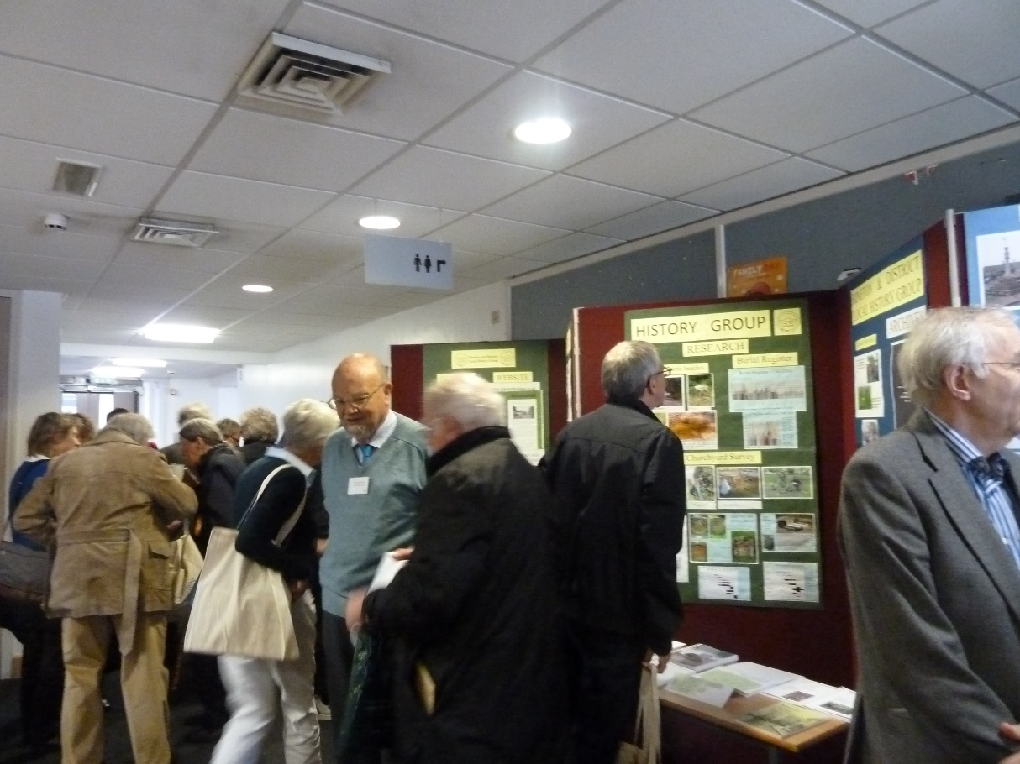
History society stalls at the Symposium. Picture by Paula McBride.
The keynote address by Robert Swanson (Birmingham) investigated ‘little local difficulties: parochial problems in pre-Reformation Warwickshire’. He presented a selection of legal and cultural conflicts shedding light on a late medieval county/diocesan community and ultimately England as a whole. Looked at in hindsight, the case studies may appear ‘petty’ – their impact was precisely local, yet played out at many levels, even internationally, and so they deserve more extensive historical scrutiny.
The first afternoon session featured eight short presentations offering interesting insights into current parish-related projects, and the final panel included three research papers on early modern Warwickshire, specifically church memorials, conflicting religious cultures and parish charities.
In his closing comment and outlook, Beat Kümin (History/Warwick) invited further reflection on origins and transition points: When did the idea of the parish emerge? How much ‘competition’ could it accommodate? What is its significance today?

The Warwick Network for Parish Research gratefully acknowledges the support of the HRC and WLHS. Looking ahead, the 2016 Symposium is likely to celebrate the launch of the churchwardens’ accounts database on the My-Parish platform.

For programme, abstracts and impressions see
http://my-parish.org/events/parish-symposium-2015.

