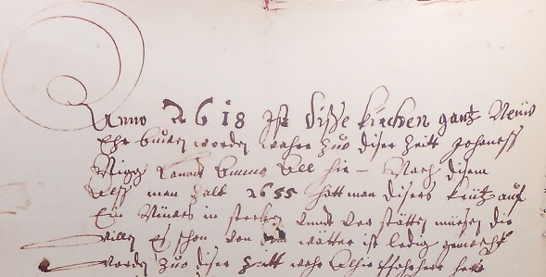 Fourteenth Warwick Symposium on Parish Research

University of Warwick, Humanities Building, Saturday 7 May 2016

‘Reflecting the Parish’

10.30–11.00 Registration & coffee (Humanities, Graduate Space, Fourth Floor Annexe)
11.00–11.15 Introduction – Beat Kümin, University of Warwick (all sessions in H5.45, Floor 5)
11.15–12.15 Keynote: ‘In the Nave with Chaucer’ – Ellen K. Rentz, Claremont McKenna College
12.15–13.15 Lunch (Graduate Space)
13.15–14.45 Session 1: ‘Parish and Family’
- ‘Out of a Christian dewtie’: Child care and parish networks in seventeenth-century Scotland – Chris Langley, Newman University, Birmingham
- ‘The Manor and the Parish: Local Organisation in the Sixteenth Century Through the Example of the Blount Family – Elizabeth Norton, King’s College, London
- ‘Perceptions and Expectations of the Elizabethan Clergy Wife: Evidence from within the Parish’ – Anne Thompson, University of Warwick
14.45–15.15 Tea (Graduate Space)
15.30–17.00 Session 2: ‘Parish, Place and Identity’
- “noþing ells but kepe riȝt mesure”: Cultivating Moderation in Eating and Drinking for the Community in the Book of Vices and Virtues – Sunyoung Lee, Arizona State University
- ‘Parish registers and religious communities in south Germany’ - Eva Marie Lehner, Universität Duisburg-Essen
- ‘The Gotlandic Parish. Concepts of identity and social differentiation’ – Jörg Widmaier, Eberhard-Karls-Universität Tübingen
17.00–18.00 ‘Context, comment and outlook’, with wine reception and general discussion

For updates see http://my-parish.org/events/parish-symposium-2016-reflecting-the-parish; Contact:
Beat Kümin: b.kumin@warwick.ac.uk; Figure: Tower Capsule Chronicle of 1655; District Archive of Gersau.

