
Humanities Research Centre
The Supernatural: Sites of Suffering in the Pre-Modern World
14th May 2022 – University of Warwick
Keynote speaker: Professor Diane Purkiss (Keble College, Oxford)
Call for papers
Across the globe, countless societies and cultures, both past and present, have produced their own interpretation of ‘the supernatural’ to which unusual or seemingly inexplicable phenomena can be attributed. The concept of the supernatural has thus proven itself to be a lively and fertile ground for academic debate and exchange. An ever-present theme in such supernatural narratives, irrespective of their contextual setting, is that of suffering. For often when faced with hardship, it is to the supernatural that many turn in seeking to explain, exemplify, or resolve the anguish they find themselves experiencing. Whether this suffering is personal or collective, physical or mental, ‘real’ or ‘imagined’, other-worldly narratives offer a unique window into understanding humanity’s complex relationship to suffering when worldly explanations or expressions of it fall short.
The Supernatural: Sites of Suffering in the Pre-Modern World will be a one-day interdisciplinary conference that brings together scholars in an effort to disentangle this symbiosis of suffering and the mystical, magical and metaphysical. In aid of this, the collaborative study of several ‘sites’ of suffering which, though broadly conceived, will allow for a focused and comparative analysis of the pan-historical and multi-cultural facets of the supernatural. A brief explanation of these sites are as follows:
  - The embodied site – addressing the physical, bodily manifestation of supernaturally-induced suffering.
  - The emotional site – recognising the importance of locating suffering beyond a corporeal register, including mental and psychological torment.
  - The material site – illuminating the relationship between the transcendental and human suffering as relating to specific spaces, places or objects.
These sites of suffering are intended as an analytical framework to place papers within a wider academic discourse but the boundaries between them may be blurred. Applicants are therefore encouraged to view these sites as interpretive tools rather than constraints, adapting them as best fits their work. Our mission to promote wider interdisciplinary exchange is happily facilitated by the broad epistemological fluidity of the supernatural and thus we wholeheartedly welcome submissions from a broad temporal and geographic scope. Equally, all academic disciplines are valued, and no topic is off-limits.
Some suggestions for topics that may be of interest, but are by no means exhaustive, include: demonic possession, human sacrifice, haunted buildings, holy relics and amulets, monsters, pilgrimage sites, mysticism, spirituality, karma, witchcraft, folklore, death, angels, mythology and religious rituals.
Lastly, successful applicants may also have the opportunity to submit their final papers for publication as part of an edited collection from the conference.
Abstracts of 300 words (max) for approximately twenty-minute papers along with a short bio (150 words max) should be submitted by 31st December 2021 to the following email address: sitesofsuffering@gmail.com specifying: presenter’s name, title, institutional affiliation and email.
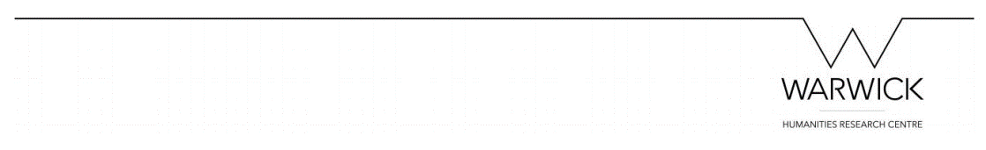
Follow the conference on Twitter @SufferingSites

