
Humanities Research Centre
The Supernatural: Sites of Suffering in the Pre-Modern World
14th May 2022, ONLINE
10:00-10:15 Arrival/virtual coffee
10:15-10:30 Introduction: Francesca Farnell and Imogen Knox
Session 1: 10:30-12:25 (Dis)embodied suffering
Dr Kristof Smeyers Time heals no wounds: historicism and the retroactive diagnosis of stigmata
Ryan Denson A Disembodied Sea Monster: Ontological Uncertainties of Charybdis
Sara Mah Interpreting Accidents in Early Modern Scotland
Cameron Cross Leprosy, Sin & Stigma in Hartmann von Aue’s Der arme Heinrich: A Disability Studies Reading
12:25-13:30 Lunch
Session 2: 13:30-15:25 Suffering souls
Meaghan Allen The Back Hand of God: Suffering and the Supernatural in (Modern) Medieval Texts
James Galvin The Ghost’s Wife: Widowhood and Purgatory in the Middle English Gast of Gy Tradition
Cat Stiles Infernal Seductresses: Seducing Witch Figures and the Female Embodiment of Sexual Sin in Early Modern Literature
Dr Hailey Bachrach Supernaturally Induced Love in Early Modern Drama
15:25-15:45 Break
Session 3: 15:45-17:15 Suffering spaces
Dr Roxanne Douglas Buried in the Desert and Lost in the City: How Wa’d Al Banat Haunts Modern Spaces in Egyptian Feminist Writing
Laura Glover The Cemetery and Malicious Witchcraft in Roman Literature
Crystal Hollis Fear and Sorrow: Using Graffiti to Commemorate and Prevent Tragedy
17:15-17:30 Break
17:30-18:30 KEYNOTE ADDRESS
Prof. Diane Purkiss

18:30-18:45 Closing remarks: Imogen Knox and Francesca Farnell

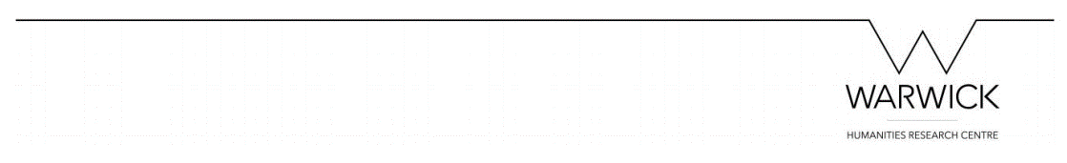
Follow the conference on Twitter @SufferingSites

