
Humanities Research Centre
Workshop Series on ‘Passion’ 2018-19
Co-directed by Prof. Beat Kümin (History) and Prof. Christina Lupton (English)

‘PASSIONS IN PRACTICE’
Public Keynote Event
Friday 17 May 2019, Oculus Building OC0.04, 1.30-6 pm
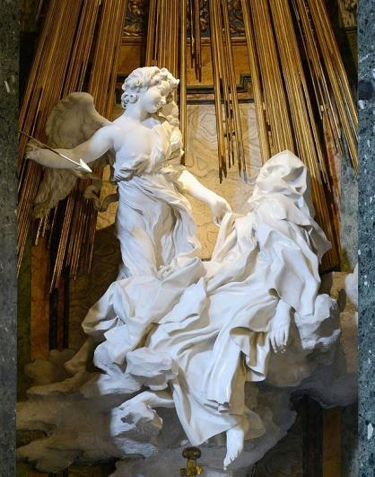
How has 'passion' been defined, represented and analyzed to date? What can be gained from studies of obsessive quests or irresistible urges? Which authors, actors, directors or artists offer privileged insights? Is there more to say on the Passion of Christ or Les liaisons dangereuses? Should we take stronger stands for / against specific developments in the Arts and Humanities or put more effort into public engagement? These are just some of the questions this group - composed of Arts Faculty members selected in a competitive process last summer – has been discussing. Now we are concluding the series with a public keynote event intended as a space to hear from experts in the field, share our findings, build conversations, leave comfort zones, explore follow-on projects and to give researchers a chance to interact within and beyond the Faculty of Arts.
Everyone welcome – please book a place by mailing Sue Rae in the HRC by 30 April 2019: HRC@warwick.ac.uk

Bernini, ‘The Ecstasy of St Teresa’ (c. 1650). Santa Maria della Vittoria, Rome.

PROGRAMME
1.30 - 2.30 Dr Michael Meeuwis (English / Warwick)
‘Passions in Practice’ Workshop
2.30 - 3.30 Dr Naomi Pullin (History / Warwick)
‘Best Friends and Worst Enemies: Contrasting Passions in Early Modern Britain,
c. 1660-1775’
4.00 - 5.30 Keynote by Professor Margrit Pernau (Max Planck Institute for Human
Development / Center for the History of Emotions, Berlin)
‘Riots and the desire for passions. Violence, emotions and temporality,
North India 1880-1947’
5.30 - 6.30 Wine reception and seminar series roundtable / conclusions
FOR FURTHER INFORMATION & UPDATES PLEASE CHECK THE SERIES WEBSITE AT
https://warwick.ac.uk/fac/arts/hrc/irf/workshop

