‘The European Renaissance’ 24 January 2014

The free people of Gersau:
Politics and Religion in a Swiss Village Republic –
Examples of Primary Sources

Prof. Beat Kümin, Department of History, University of Warwick

Medieval Charters

‘To all seeing or hearing this charter, we [several members of the von Moos family], Burghers of Lucerne, having received the jurisdiction and dues of Gersau from the Lords of Habsburg, proclaim that we have sold [the said rights], for us and our heirs, ... to the honourable people Ruedin Truochfelder, currently mayor of Gersau, Jenni Heintzen, Heini Kamenzint, und Jenni Megger of Gersau, on behalf of themselves and the commonality of others of Gersau, ... for the sum of £690. Thus we have acquitted ourselves .... of the same jurisdiction and dues and reserve nothing for ourselves or our heirs, pronouncing the above said of Gersau commonly and individually and all their heirs free, quit and released with this charter ... . We also profess in good faith to observe this sale and the contents of this letter in perpetuity, never to do anything against it.’
Charter No. 6 (3 June 1390): District Archive, Gersau (DAG).

‘I, Johann of Büttikon, Burgher of Lucerne, declare publicly with this charter that, ... having received the right of advowson of the church of Gersau ... and having been compensated for this by the mayor and parishioners of Gersau, I have passed it on, for me and my heirs, ... to the honourable and wise Ulrich Kamenzind of Gersau on behalf of the mayor and common parishioners of Gersau, ... with the specification, that the said mayor and common parishioners of Gersau and all their successors in perpetuity may have the said advowson ... and dispose of it as with their own property ... . In confirmation, I have attached my seal.’
Charter No. 12 (4 October 1483): District Archive, Gersau.

Early Modern ‘Tower Capsule Chronicles’

‘Should this letter be opened by our successors, may the residents of our land at that time pray for us current inhabitants as well as for all founders and benefactors of this church, with a general Christian prayer, that He will graciously forgive us all our sins and misdeeds. May this land also be graciously preserved in the true Catholic faith and in its ancient God-given liberties, acquired by our ancestors from the old emperors ... and honestly preserved since, and may it always be governed in good peace and prosperity, for what discord can do to our land, we have painfully experienced with the highest damage and loss of a precious good.’
No. 1, written by Anton Nigg on 24 September 1655: Parish Archive, Gersau.
‘In 1733, on the first of May, when I was 35 years old, [I was] elected as parson to administer the cure of souls by the whole parish here. … .[Over my 20 years of service,] I have prompted the extension of the church, the repair of flood defences and many other things for the benefit of my dear homeland.
[The new village hall was built in 1745] ‘at relatively modest expense…, drawing on interest from our capital, a few 100 f. set aside for emergencies in our church funds. As in the case of the church, the common people, working in shifts, offered their free labour, so that the hall ... could be built for 2000 f.
[On 25 May 1752, Gersau’s high/blood court, chaired by headman Joseph Franz Schöchli, sentenced common thief Johann Christian Rigert] ‘particularly for break-ins into the charnel house and St Mary’s chapel … to public decapitation by the executioner of Schwyz, with the parson and chaplain in attendance to the end.
[On 24 June, at 6 pm, there was] ‘a terrible thunderstorm …, so that it appeared as if everything would be destroyed, when the two brooks from the mountains swelled to such high levels that everything got flooded and no man could leave the house without fearing for his life.’
No. 4, written by parson Jost Rudolf Tanner on 15 June 1752: Parish Archive, Gersau.
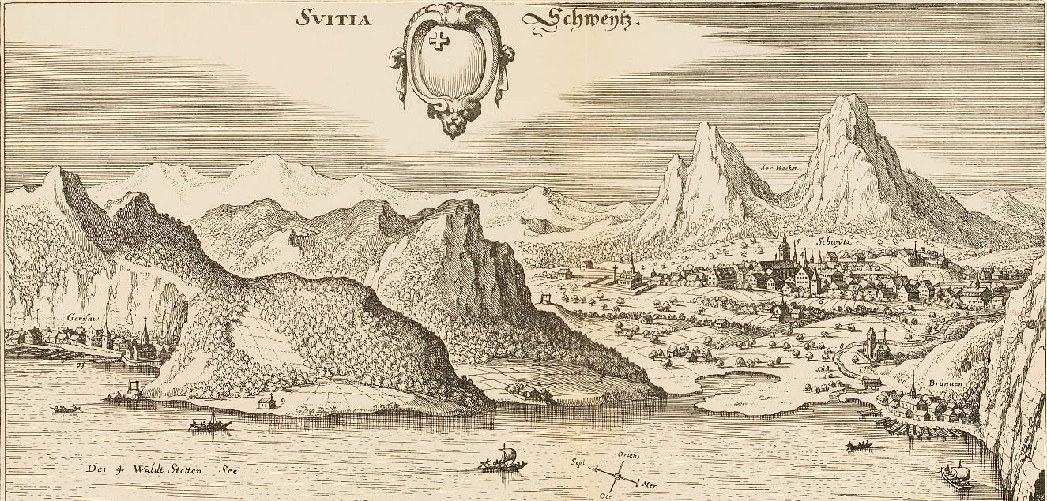
Prospect of the Canton of Schwyz in 1654 from Matthäus Merian (ed.), Topographia Helvetiae, Rhaetiae et Valesiae [1654] (Reprint, Basel: R. Geering, 1926), between pp. 38-9.

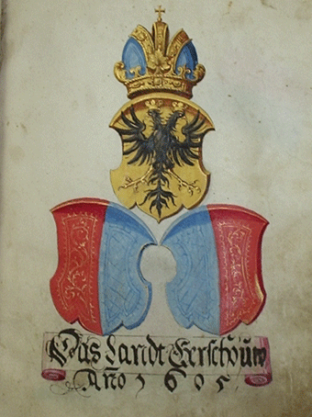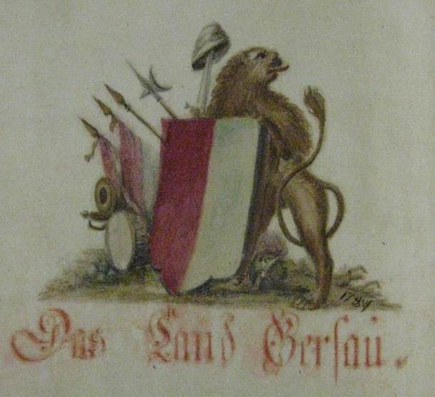
Gersau’s changing crest in the ‘land book’ of 1605 (left) & the assembly minutes of 1784 . DAG, LB4/LG 1.

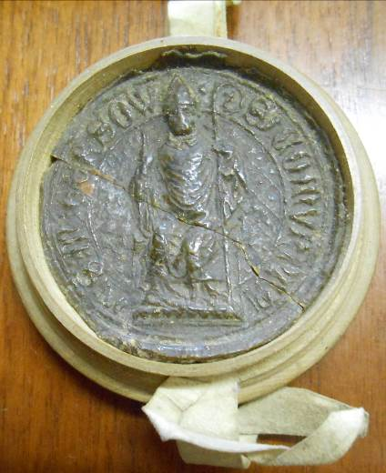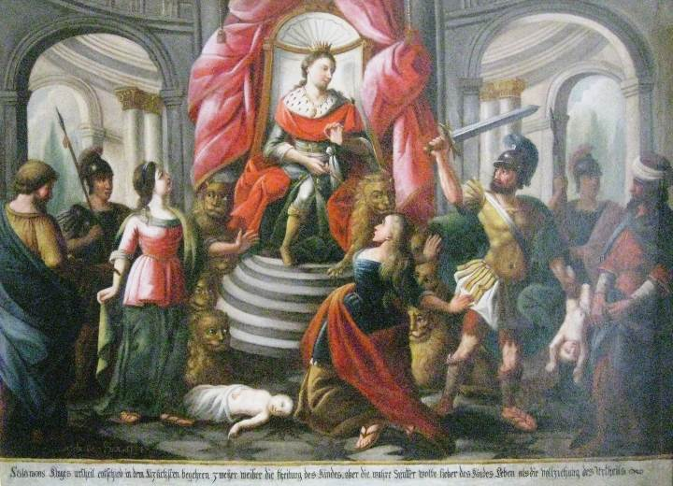
The communal seal of 1436 (left; DAG, charter no. 9) & a painting with the caption ‘Wise Salomon ordered to cut the baby in half, but the true mother preferred to save his life rather than to adhere to the verdict.’ (painted by Josef Martin Obersteg in 1794 and displayed in the council chamber of the village hall).

