Sample successful student dossier pages using Mahara platform
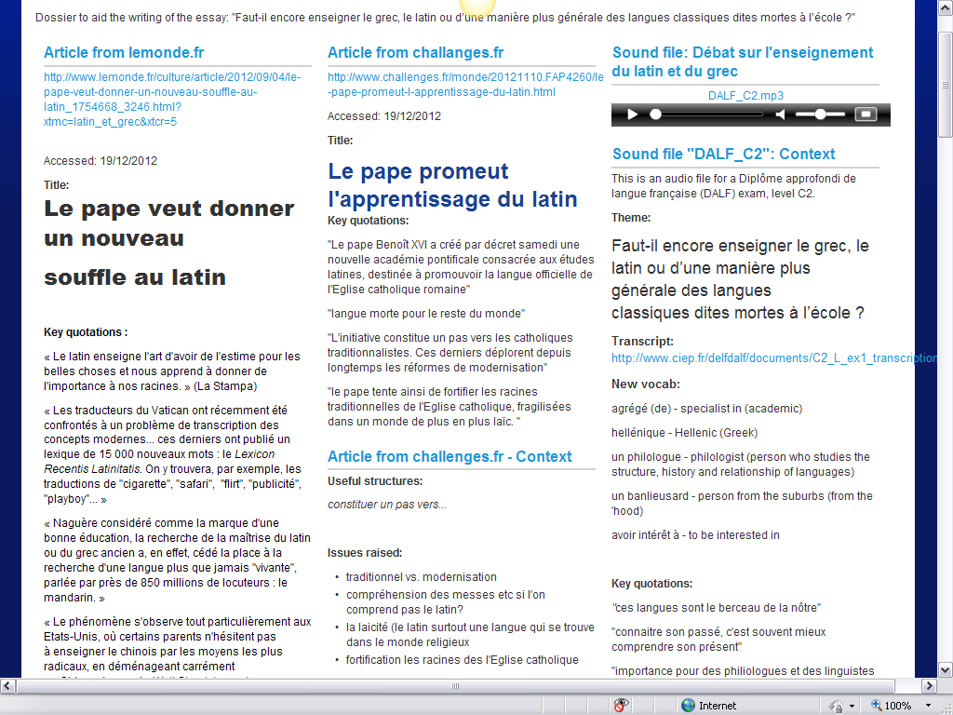

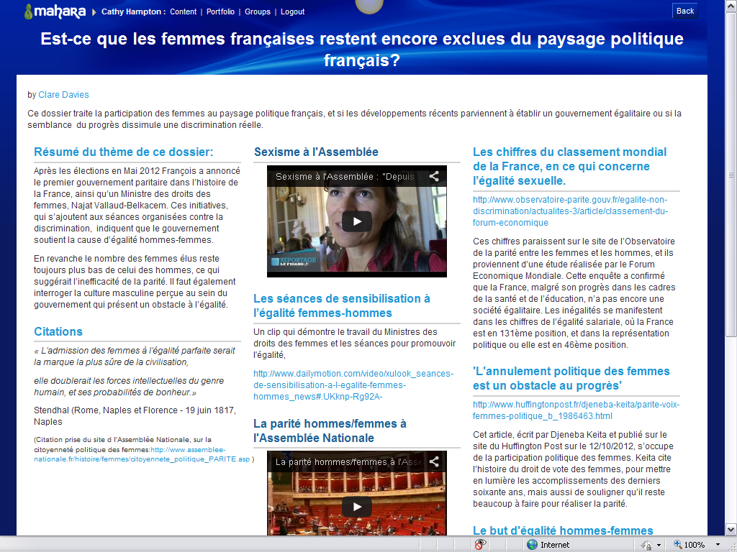
Free reflective writing in French assessing content

