WATE finalist support statement: Cathy Hampton, Department of French.

I am a part-time teaching fellow in the French Department with responsibility for teaching first- and second-year students in a range of language and content modules. I have a particular interest in the pedagogical needs of first-year students as they make the transition from school to university (I convene the department’s major core first-year content and language modules). Over a number of years I have sought to enhance the acquisition of independent learning skills by first- and second-year students through the use of e-learning. I have collaborated with E-Lab to produce extensive online grammar resources using Perception, with Rob O’Toole to re-design the department’s first-year web gateway, and with IT services more widely to promote the use of collaborative media such as forums. I have tested and shared my practice with colleagues through my participation in the EAPP programme (2010) and recently with Emma King in her Perspectives on E-learning focus group. That said, years of work with new students striving to succeed socially and academically in a university environment has taught me that inculcating good face-to-face interaction is of paramount importance, and I have found these virtual tools to be at their most productive once students have gained a strong sense of community at departmental level. In my experience, our students are keenly receptive when asked to act as building blocks for the educational experience they are engaging with (their enthusiasm to act as tour guides, mentors, and reviewers of Year Abroad activities is testimony to this). I have sought this year to capture their readiness to share knowledge and assume the role of expert in other learning contexts, both informal and academic. The three new initiatives I have undertaken in the current academic year have been inspired by practical conversations about planning and organisation with students abroad, the French Society and the SSLC as well as by conversations about academic content and pedagogy with fellow teachers, support staff and students. What follows is an outline of the steps I have taken to establish collaboration and interdependence as fundamental foundations for good learning, drawing on the excellent range of technological and human resources available at Warwick

Promoting and enhancing the student learning experience

A. The Family Way Module / Student as Researcher project

The thrill of research-led teaching for me comes not so much from communicating my subject to others as from exploring with them the endless variety of ways in which a topic might be interrogated (a process enriched by new technologies and by innovations in the assimilation, organisation and presentation of information). My collaboration with Peter Larkin and Cate MacKay on the Student as Researcher IATL project has allowed me to embrace new ideas in this area. Participation in the project grew organically from work with Peter to develop bespoke training in research skills for second-year students of seventeenth-century French literature in my Family Way module over several years. One outcome of the module, a student-led symposium, had proved a good way for students to take ownership of the subject area and demonstrate advanced-level research. However, its success had been limited by presentational and organisational weaknesses (poor use of powerpoint slides; lack of time management during Symposium presentations). Questionnaires suggested that students liked the collaborative and imaginative aspects of the exercise, but relied too heavily on being teacher led. The framework of the Student as Researcher project, with its emphasis on developing pathways to information fluency and the creation of research-based products, suggested the means to equip students with the professional skills to bring the symposium off better.

The module was reconstructed to give students immediate ownership of its learning spaces, namely a face-to-face workshop space, a collaborative wiki / web space, and a conceptual Symposium space, all of which were showcased in an introductory Teaching Grid session. Here students agreed to attending weekly workshops as informed learners having digested pod- and screencasted lectures online, to build from scratch a topic-based database of secondary resources (bibliographies and glossaries), and to imagine themselves as future communicators of their academic findings in an academic conference setting.

‘Workshopping’ and mapping

Having received scaffolded tasks that guided their response to the primary material under discussion, each student group was issued with an i-pad and asked to map responses to questions using mind manager software.The maps were dataprojected, discussed and expanded in plenaries, and proved extraordinarily fertile in prompting focussed, evidence-based discussion (since they could incorporate precise textual references to primary and secondary sources, web sites and so forth).

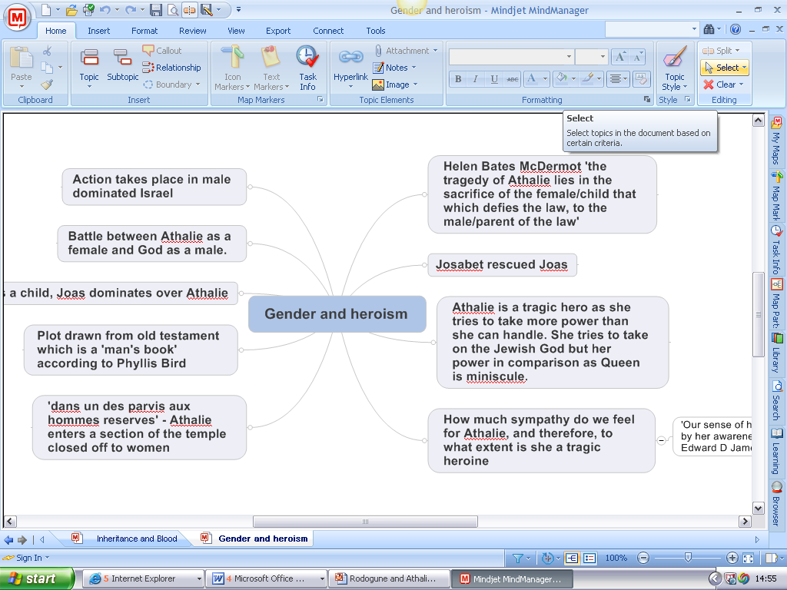
Mind map produced in seminar

The visual component of the maps was attractive to many and drew on what seemed to be innate ‘spacial’ learning inclinations. Interaction with the maps continues online as a vital learning resource for clarification and inspiration (‘I really like and find useful this method of study with mind maps.They help me to understand better what we study and to memorize the main points of each subject [sic]. […]I succeed in studying french literature better than the other subjects thanks to this method we use in class. When I come back home, i read the maps and i can easily remember everything.’(Family Way questionnaire respondent: Erasmus student)).

Building a virtual research environment

The wiki environment built with Cate MacKay asked students to contribute individual and group-sourced research data for peer edification and review. Peter Larkin’s training on the use of relevant databases developed students’ confidence in searching online resources more widely and in talking about them from the position of expert as they constructed bibliographies:

The second article (again I've linked this to the site though you may need to log on to project muse first) is a good general history of politicial structures and tensions, especially concerning women, in the 17th century. There is direct analysis of Rodogune on page 83 though the whole article is nicely relevant, even with discussion on the Salon culture influence. (Stephanie Willams)
Glossary building led to focussed, contextualised reading, and to the sharing of reviews in similar fashion:
A note on the Thelander article: I found it useful to relate the contes to their wider historical context (salon culture, absolutism...) rather than an analysis of the contes themselves. pp.477-9 in particular focus on notions of family and marriage in fairy tales in general, with regular reference to Perrault as she draws upon a wide range of his fairy tales to support her argument. (Nathalie Greenfield)
This half-weight module runs in terms 1 and 3: as it updates, the wiki allows students to be long-term project managers. Such management is a task shared between staff and students: Peter Larkin’s reference to new resources in January 2012 invites students to time manage: ‘I have found a second-hand copy of Jeanne Morgan's Perrault's Morals for Moderns. It will need to come from the US but with luck will be here in a couple of weeks.’ Group pages allow students to brainstorm and plan in an open way:
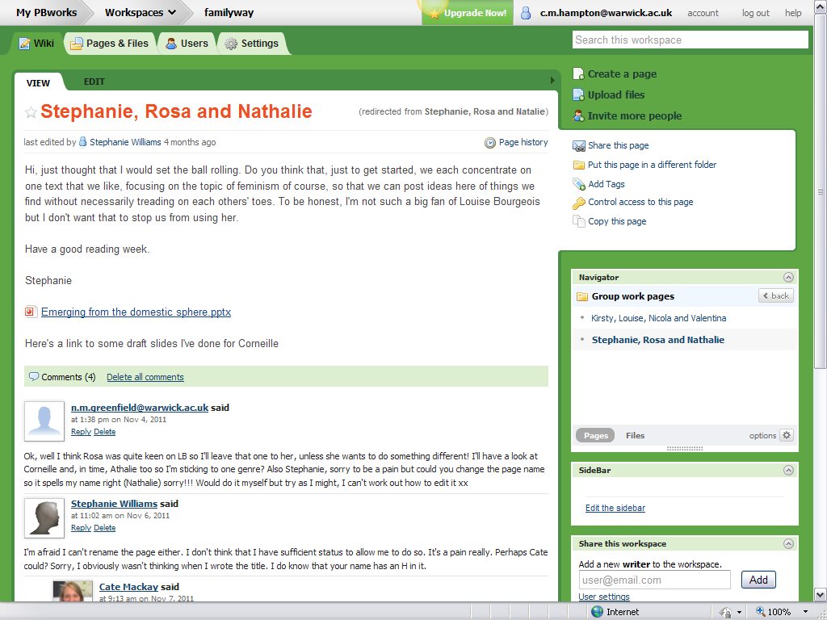
Wiki discussion
Envisaging a Symposium
As an addition to their usual summative assessment load rather than an assessment in itself, students were invited to see the Symposium as an opportunity to create a ‘free’ ending to the module that they controlled and managed. They elected a date to suit their needs as learners (term 3, as a ‘way in’ to revision), selected an appropriate technology for delivery of their paper (powerpoint presentation, poster, live delivery), and experimented with these media in a scaffolded way in class:

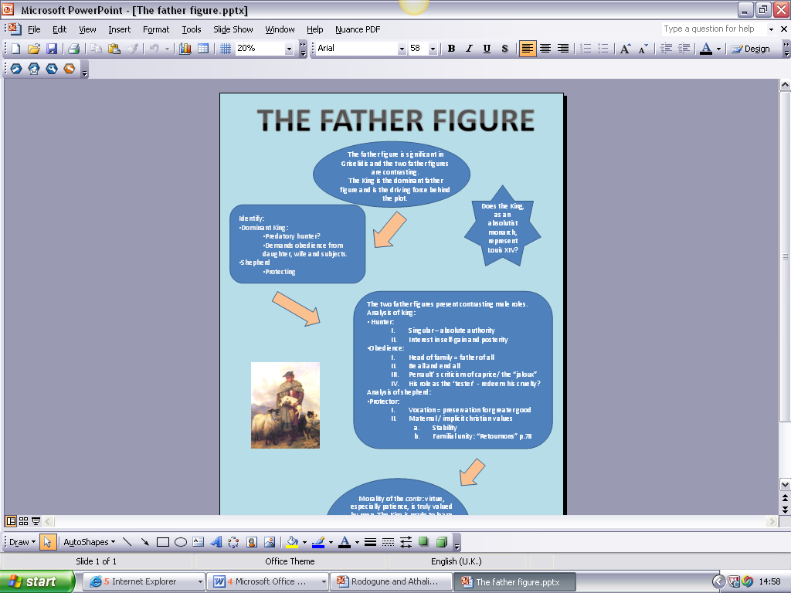
Trial poster production in seminar workshop
Mirroring academic conference procedure, students will submit titles for their presentations at the beginning of term 3 and must time manage the acquisition of relevant skills using the learning grid before showcasing their work in week 4. The enthusiasm for participation in the Symposium has been very strong within individual teams, to the extent that the Erasmus students involved are keen to participate virtually although they have returned to Italy. The employability and cross-curricular skills building has been appreciated: ‘‘before doing this module, I had no idea how to use any of the software that was presented to us so it was useful not just for this module but for applying to all areas of my course.’ (Family Way questionnaire respondent)
B. The Year Abroad Learning Environment: Using the Moodle VLE
Learner collaboration of a more pragmatic sort was at the root of the VLE created for Year Abroad students. Again this space emerged from a combination of top-down and bottom-up learning encounters. As co-ordinator of short, compulsory placements in France and the Francophone world, I had over 5 years required students to provide evidence of their stay by writing a review guide for the attention of future students. These reviews, available on the web, surprised in their reflective and often critical attention to detail and in their desire to inform (with email links, web addresses and personal advice to future travellers that have been much used). It was clear that with a little facilitation students were learning more from each other than from me! Meanwhile, the French Department Year Abroad programme had begun to seek ways to make students abroad feel connected to the Department as a whole both pastorally and as learners. Administrative difficulties encumbered this relationship: students submitted written work in hard copy to the department that had to be returned by post after marking (a time-consuming and labour intensive activity for secretaries); students compiled dossiers of resources in hard copy for use in final-year classes that relied on silent materials that were sometimes difficult to share. Conversations with Teresa MacKinnon about Language Centre learning spaces that combined clear submission and feedback resources with sound led to collaboration in the IATL voice project. The Moodle 2 VLE was used to create a distinctive environment that invited Year Abroad students to look inwards (inviting critical reflection on intercultural and personal experiences), to look ‘peer-wards’ (by sharing experiences and resources with fellow students), and to look outwards (by reflecting on skills development and encounters of interest to a would-be employer). The Mahara facility within Moodle 2 (a blog-like personal reflection space incorporating multi-media) allows for the completion of formative tasks (the production of virtual multi-media dossiers) and reflective e-journals. In addition, the site offers forums and voice email. A pilot group of students working as language assistants across France and Germany has used all of these facilities, collaborating on lesson plans, providing snapshots of life in France and populating dossiers with contemporary events:

Hey Team!
I’m working in France and teaching in two collèges – I have mainly used these lessons and activities with 4ème and 3ème – so thats 13 – 15 years old ish! Just added a couple of my favourite and most successful starter activities and lesson plans.
P.s. Joe used your creative 10 word game – worked well sir!
Forum discussion
Starter Activities:
“The instruction game” (apologies for the lack of imagination in the title)
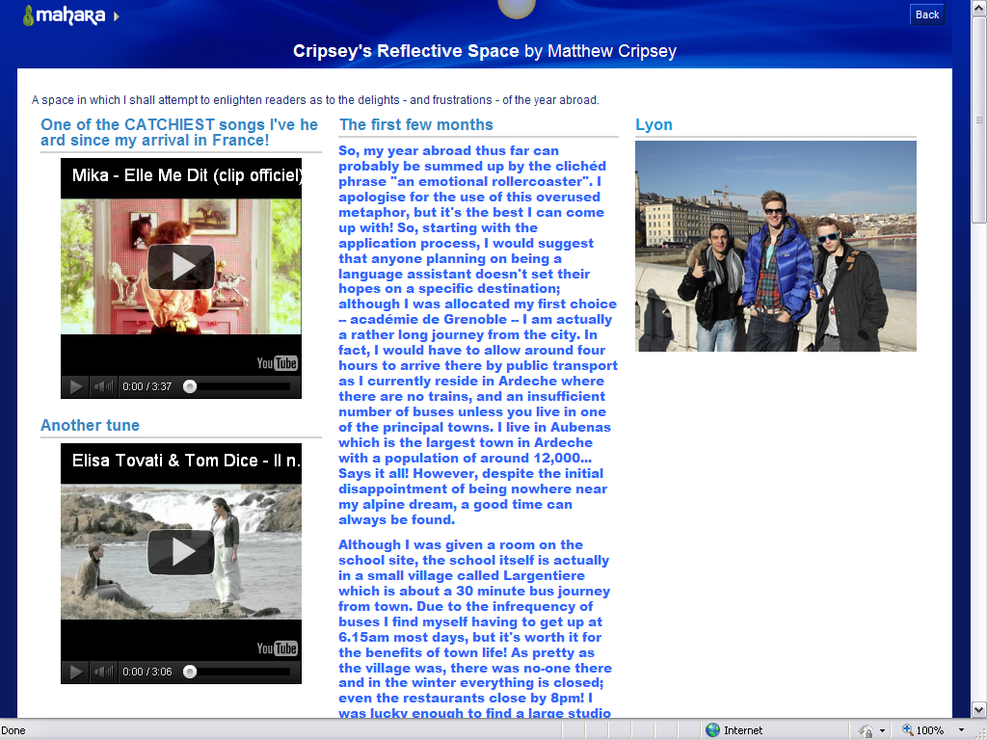
Personal reflection area

The site includes a careers space featuring advice from Fiona Kent on identifying and showcasing skills needed for internships abroad and CV building. It will also include a French voice discussion area between Year Abroad site users and a pilot second-year oral class focussed on the formulation of questions relating to planning for their Year Abroad. The community of users will thus stretch productively across years promoting diverse and learner-driven knowledge sharing.

Supporting colleagues and influencing support for student learning.
- Getting the most from the Moodle VLE: staff
Providing appropriate feedback for the formative tasks set for the Year Abroad has involved training the team of lecteurs who mark this work. Live training sessions on the use of the voice email system, on annotating work electronically and on the process of down- and uploading to the site have been given, supported by written documentation that can be used year on year (since our team of lecteurs changes yearly). Further training for support and academic staff, and the delivery of workshops to second-year students, will be provided in readiness for full use of the site by all Year Abroad students anticipated for next year.
The data received from student questionnaires at the end of the Year Abroad will feed into an ongoing dialogue with Teresa Mackinnon about maximising the potential of Moodle. In addition, David Lees and I will present the project at the LLAS subject-centre national conference in July, where it will feed into current national discussions about the place of the Year Abroad.
- Disseminating Good Use of Learning Spaces: from ‘Student as Researcher’ and ‘Moodle VLE’ to the Student Mentor Scheme
‘The culmination of the Student as Researcher project with ‘In the Family Way’ will be a student symposium held in the Teaching Grid. Students have been encouraged to access training on how to plan their output, equipment and practice space available in the Learning Grid, and also have the opportunity to obtain feedback on presentations from a student adviser in the Learning Grid’
‘[I]really enjoyed this module and believe I have learnt a lot about the topic in hand. Feel that I have learnt a lot in terms of research techniques, and would like to continue this further.’ (Family Way questionnaire respondent)
Promoting use of some of the services and learning spaces that Warwick offers (Learning and Teaching grids, library, Moodle VLE) amongst French Department staff and students has been a key aim of the aforementioned projects. I have also endeavoured to show how the dialogues that I have had with students and staff about how they like to acquire and share knowledge has helped me foster a more productive use of these spaces. One further example of this in the current academic year was born of my initiative to bring together first-year students and secretaries in a face-to-face focus group to discuss student induction. This meeting fundamentally altered our understanding of how these students processed resources on our web pages. It transpired that they did not access dedicated pages for incoming students effectively (to the point of ignoring key information), since they were looking instead for a more personalised initial interaction with the department. A new letter and FAQ pack will be formulated for the 2012-13 incomers as a result. Some of these students had appreciated receiving communications with the French Society before arrival, and I acted on this and other student-led desires to inaugurate a departmental mentor scheme that will use virtual and real spaces to ensure the largest possible community of users.
The values that are informing the scheme’s creation emerged naturally from what I have learned from the projects mentioned so far: it is predicated upon a belief in the productive potential of a community of knowledge providers and users stretching from the institutional to the individual. To gain a sense of Warwick mentoring values, I consulted with the careers department) and the LDC and found that we had much to learn from the Warwick staff coaching scheme. To gain a sense of the mentoring space desired by students, I consulted the French Society (who wanted to build an online community of peer mentors). To determine whether interest in the scheme stretched more widely than this core group, I consulted the entire French Department student community. The response suggested the desire to act as pastoral and academic building blocks was strong:
‘Thanks for the opportunity’
All the ideas about the training scheme sound great, I'm looking forward to it!

I am a French Studies student based in Leamington Spa and I am very excited about taking part in the department's new mentor scheme. Pursuing the Single Honours course allows me to experience the full breadth of the department's academic module diversity, and I would be happy to answer any queries relating to this.
Particularly surprising was the enthusiasm shown by students currently abroad, suggesting their real investment in the French department community despite their geographical distance from it.
The training materials I devised were formulated around LDC staff coaching materials and questions submitted by student volunteers that they felt the mentor scheme could address. Discussions were filmed so that Year Abroad students can access training online, and all volunteers have provided web profiles so that mentees can match their queries most effectively to a mentor. The scheme is due to go live in the next few weeks:
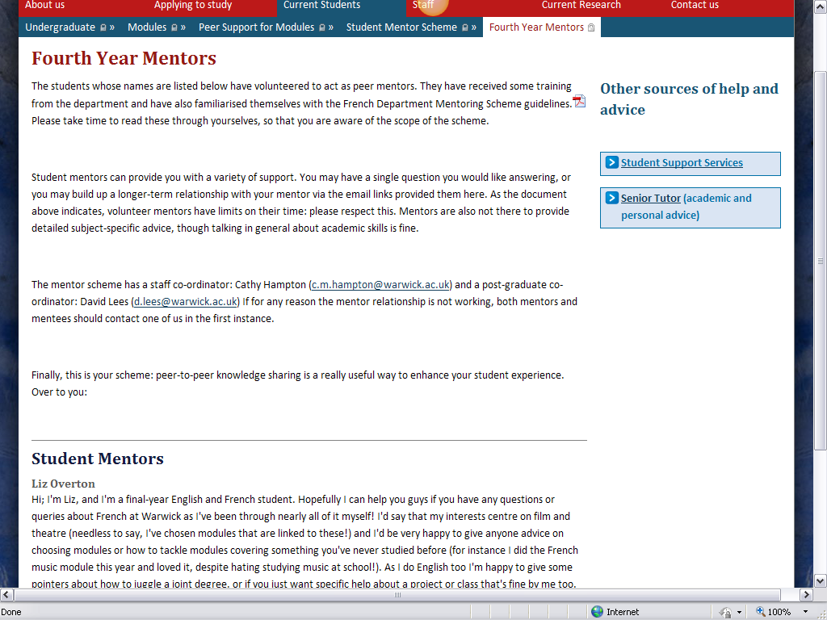
Conclusions
One of the WATE criteria asks finalists to comment on ‘imaginative use of resources’. I hope that this statement has shown that I and the staff I have worked with have tried to make ‘imaginative use’ of the imaginative resources that are the students themselves. In Integr@ting Technology in Learning and Teaching, Maier and Warren express the conviction that ‘independent learning only succeeds when it is truly interdependent’. Students readily subscribe to this view, in my experience, and when an institution such as Warwick provides students with the means – technological and human – to develop higher level transferrable and academic skills by collaborating with them, the results are rich.

‘Such engaged and active seminars; students so engaged in the texts […]’. Rob O’Toole, whose technical assistance in using the i-pads was imperative and whose exploration of their potential with my students was inspiring.
I enlisted the help of French Department postgraduate David Lees to help build the site. With recent experience of the Warwick Year Abroad, he has designed a page commended by other Moodle users. The site will respond to the French Department’s Institutional Review Report, which asks us to ‘consider the type of support, encouragement or structure it can offer the student population in their aim of establishing more peer-to-peer support for the Year Abroad experience.’
Training materials written variously by me and by David Lees.
‘Cathy also has clear ideas of how the platform can be used further to enhance existing teaching, particularly areas such as student autonomy and creativity, peer evaluation and collaborative working. I consider myself fortunate to be able to work with Cathy and highly value her input to the project.’ (Teresa Mackinnon)
Anxieties about maintaining the Year Abroad in the era of fees have led to widespread debate in HE language departments.
Cate Mackay, Student as Researcher Project manager, library. I will disseminate my findings in relation to this project at the LLAS subject centre conference this summer, and will continue to work with Cate to assess its outcomes on completion.
Maier, Pat and Adam Warren, Integr@ting Technology in Learning and Teaching. (London: Kogan Page, 2000), p. 14.

