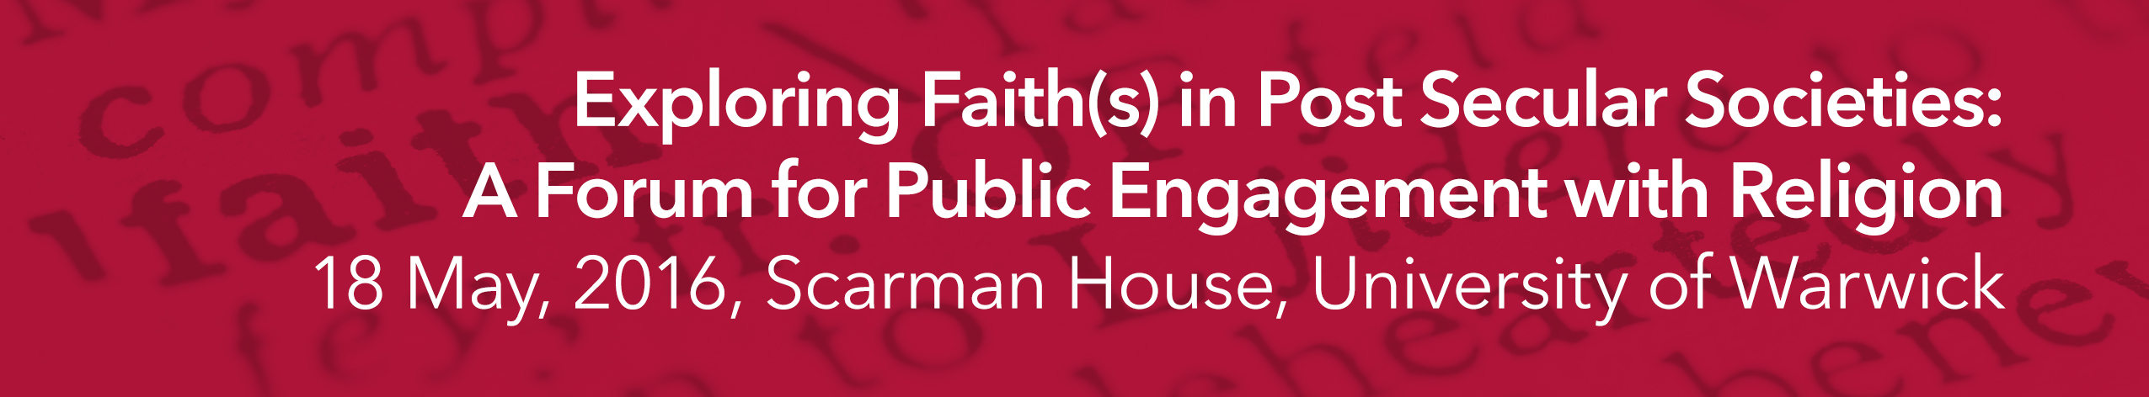

Wed 18 May, 10:30 am – 3:00 pm
Scarman Conference Centre, University of Warwick

Organised by James Hodkinson (SMLC, Warwick)
and Elisabeth Arweck (WRERU/CES, Warwick).

Registration Form

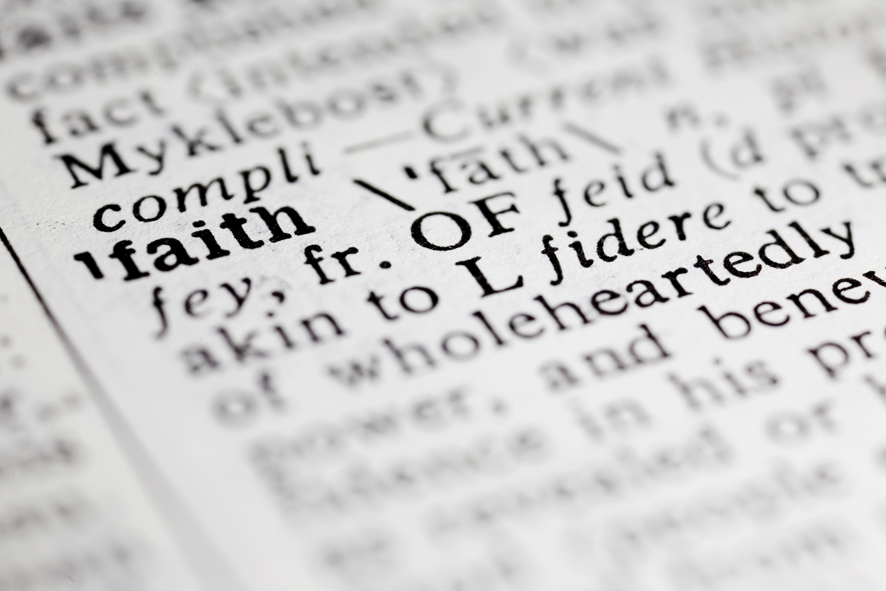

Venue and Timings
The conference will be held at the Scarman Conference Centre on the Warwick University campus. It will begin at 10:00 am and finish at 3:00 pm.

Cost
Refreshments, lunch and parking during the conference will be provided free of charge. However, travel expenses will have to be met by delegates or their institutions.

Note
To help with the conference organisation, please complete this form and send it to the James Hodkinson (see also below). It would be especially helpful, if you could indicate any areas of special interest, specialisation that you might bring to our discussions on the day.

Contd.
To complete:

First Name
Surname
Institution/Organisation
Areas of interest and/ or specialization

E-mail address

Contact Address
Telephone Contact No.
Dietary requirements (if vegetarian please state what foods this excludes)
Any other special requirements (e.g. wheelchair access)

What to do next

Send the completed form electronically (preferred) or by post to Dr James Hodkinson a.s.a.p, and by Monday 2 May 2016 at the very latest.

email: j.r.hodkinson@warwick.ac.uk

Post:
Dr James Hodkinson
School of Modern Languages and Cultures,
Warwick University
Coventry, CV4 7AL.

Contact telephone: 07779 255167

Please note that the form is needed to secure your place at the conference.

