After Nazi Germany’s devastating six-week invasion of France in 1940, Maréchal Pétain, as leader of the Vichy regime, accepted the new German domination of Europe and endeavoured to introduce a ‘National Revolution.’ Although Pétain preferred to use the term ‘National Renovation,’ thereby avoiding republican connotations, the ‘National Revolution’ is insightful for it goes beyond the one-dimensional model associated with Vichy, instead viewing the regime as a diverse amalgamation of conservative traditions, rather than a mere ‘bloc.’ Paxton rightly argues that ‘the National Revolution tells us about France,’ with Vichy symbolising longer-term discontents with the political, economic, and moral situation since the inception of the Third Republic. Replacing the republican motto of Liberté, Egalité, Fraternité, Vichy’s new trilogy of Travail, Famille, Patrie signifies the regime’s rejection of liberal individualism, instead focusing upon a renewed economic agenda, traditionalist family policies, and a nationalistic view of French identity. In exploring these three facets of the Vichy regime, this essay will argue that while an illusion of Travail, Famille, Patrie existed within the policies of 1940-42, Vichy France was subservient to the economic and political demands of Nazi Germany, and the wartime context represented an unconducive epoch for national renewal. Thus, in de facto terms, Vichy policies failed to match the early rhetoric of Pétain, meaning a ‘National Revolution’ never developed, leaving a regime overly reliant on its leader cult, as well as becoming complicit in the worst crimes of Nazi Germany.
To Pétain, travail, or work, represented ‘the crux of man’s identity.’ The ‘National Revolution’ possessed a two-fold economic agenda: first, a regeneration of the agricultural sector, focusing on la France paysanne. Second, the introduction of corporatism, an economic structure designed to surpass artificial class conflicts, benefitting ordinary workers through employer-employee dialogue. In the 1942 Vichy propaganda poster from Epinal, Pétain and the Vichy trilogy tower over an image of agricultural France. This indicates the new regime’s promise of social cohesion and a retour à la terre. Epitomising the argument made by Rod Kedward, that the government ‘extolled the particularities of the old provinces,’ this initial optimism for French farmers was accentuated through official state propaganda. However, while travail lay at the heart of Pétain’s discourse, by the end of the occupation Vichy rural policy ‘was in tatters.’ In fact, agricultural workers faced the greatest economic difficulties during the war, with 36 percent of prisoners of war coming from farms, the price of fertiliser increasing drastically, as well as a fuel shortage meaning machinery became useless. While the ‘National Revolution’ promised rural workers a better future, the economic realities of wartime, primarily due to Nazi control of the exchange rate, meant this was not achieved. Concerning corporatism, as emphasised in the Charte du travail, Vichy aspired to ‘rompre définitivement avec le vieux système de la lutte des classes.’ To surpass class struggles, Pétain advocated a new consensus between workers and bosses through the corporatist structure. However, as Amdur articulates, ‘despite the language of collaboration and community, Vichy’s National Revolution remained a vision of authority and hierarchy.’ For instance, in August 1940 all trade unions were dissolved and the right to strike abolished. This redressed the balance of worker-employer relations firmly in favour of management, and critically, the state. With the economy compliant with Nazi Germany, illustrated in that one-third of French production during the occupation went to the Germans, corporatism failed in its promise of economic gain for ordinary French people. Paxton’s assessment, that by the period 1943-44 ‘corporatism had become central planning and dirigisme,’ highlights the shortfall of ‘Vichyite’ economics. Travail may have been a founding principle of Pétain’s Vichy regime, yet neither an agricultural revival nor a corporatist revolution delivered, primarily due to German occupation and wartime economic actuality.
Where, according to Pétain, ‘man lives by his work,’ la famille was idealised as ‘the very foundation of the social edifice.’ Paxton emphasises the profound fear in France regarding the declining birth-rate, supposedly exemplifying the ‘decadence’ of the Third Republic. This belief, not exclusively held by Vichy supporters, informed the regime’s family policy, relations with the Catholic Church and education reforms. In a propaganda document from the Savoie department entitled: ‘La Mère de famille y a son rôle,’ the government exerts its expectations of women, summarised fittingly in the phrase ‘la place de la mère de famille est toute designée.’ This propaganda was compounded by legal pressure to conform to this traditional role, for instance in the autumn of 1940 measures were passed stopping married women from working.’ The rhetoric of Pétain idealised the agricultural nuclear family unit, in a rejection of Third Republic industrial individualism. Moreover, children occupied an equally pivotal position within the ‘National Revolution,’ under the banner of family policy. Lyndsey Dodd argues that ‘children were used to push the values of the National Revolution deeper into French society.’ In educating juveniles in state projects, the government sought to disseminate crucial messages, through a trojan horse tactic, into the wider population. Les Chantiers de la jeunesse, a youth organisation designed to instil the youth with Vichy values, provided an educative and work programme rooted in Vichy doctrine. The Vichy government, encompassing a broad spectrum on the right, acted on a widely held belief that France required population renewal. The other aspect of this traditionalism is the relationship between church and state, with Vichy associating itself with Catholicism and supporting a ‘moral crusade.’ Nicholas Atkin, in his article on church-state relations under Vichy, highlights the extraordinary Church involvement in Vichy government policy, with Cardinal Gerlier in the July 1940 edition of La Croix demanding the termination of secular schooling and fairer distribution of education subsidies. Nevertheless, in each area of family policy a schism exists between early Vichy promise and the realities of the occupation period. With wartime providing an unfavourable environment for a radical renovation of France’s schooling, church-state relations and population growth, the regime’s policies were wholly reversed after the Liberation. Traditionalism certainly was a cornerstone of Vichy policy, yet Pétain failed to institutionalise his agenda.
The patrie represents the National Revolution’s final pillar, with Vichy aiming to restore national pride despite the humiliating German occupation. In fighting against the decadence and national decline which the Third Republic had presided over, the government sought to reassert ‘Frenchness.’ Propaganda was once again the state’s prime weapon in promoting this view, with the Révolution nationale poster emphasising the duties of French people, rather than the rights instilled in the Declaration of the Rights of Man and the Citizen of 1789. Focusing on the notion of ‘légion,’ the poster invoked a proud sense of militarism associated with the heroic actions of Pétain at the Battle of Verdun, a popular image used incessantly during the Vichy years. Although most crucially, on the opposing image of the unstable Third Republic, the Star of David is utilised and associated with this governmental system. This anti-Semitism held deep roots on the French extreme-right, and informed Vichy identity politics. Sowerwine provides direct criticism of Vichy’s Jewish policy, arguing it was implemented, not simply for pragmatic reasons, but with conviction and a determination to be accepted into the German ‘New European Order.’ Anti-Semitic policies introduced by Pétain’s government were multitudinous, for example the laws of 1940 banning Jews from occupying public sector jobs, yet what interests this essay is whether this approach reaffirmed ‘Frenchness’ or la patrie. Rather than augmenting the Vichy regime in this supposed ‘New Order,’ (in fact the Nazis never entertained such a possibility), the discriminatory policies ‘became a major avenue for German influence.’ Paxton rightly declares that Vichy did not want discrimination to accelerate into mass genocide however, these laws legitimised Nazi Germany’s aims, culminating in Nazi-Vichy collusion in the Vel’ d’Hiv affair. Indeed, French identity politics under Vichy, endeavouring to reinforce la patrie, permitted the regime to become complicit in the horrors of Nazi genocide.
Pétain’s ‘National Revolution’ sought to implement a new economic model in France, revert to traditional family values, and renew French honour- encapsulated within the trilogy Travail, Famille, Patrie. In each facet of the Vichy motto, policies faced wartime instability and unfavourable economic conditions, with France effectively subservient to Nazi Germany. Although, more profoundly, where Vichy failed unequivocally was to produce ‘lifetime believers’ in the regime, meaning changes to the Third Republic were never institutionalised. Instead, the promise of the years 1940-42 was replaced with an overt focus upon Pétain as leader, with the abject failures of government policy visible to the French people. While this essay agrees with the analysis of Atkin, in that ‘the idealism of 1940 had been swept away by the harsh realities of the occupation,’ to my mind the Vichy regime’s shortfall went beyond a failure to implement its promises. Indeed, attempting to rejuvenate an image of France from a bygone era, the government became complicit in Nazi Germany’s most evil acts. Instead of placing the nation first, Vichy reduced France to a compliant state, unable to exercise any influence beyond that permitted by the Nazi occupiers.
Bibliography
Primary Sources
Affiche de propagande Vichy (No specific title), 1942, <http://propagande-2eme-guerremondiale.e-monsite.com/pages/la-propagande-dans-le-camps-de-l-axe/la-propagande-de-vichy.html>, Accessed: 17/02/18. (See Appendix).
‘La Mère de famille y a son rôle,’ 1940-44 (No specific date), <http://www.savoie-archives.fr/archives73/expo_savoie_des_ombres/pano08/pages/04-04-PN_50-1.html>, Accessed: 18/02/18. (See Appendix).
‘Loi de 4 octobre 1941 relative à l’organisation sociale des professions dite Charte du Travail’, 4 octobre 1941, <http://travail-emploi.gouv.fr/IMG/pdf/Loi_du_4_octobre_1941.pdf>, Accessed: 19/02/18.
Secondary Sources
Amdur, Kathryn, ‘Paternalism, Productivism, Collaborationism: Employers and Society in Interwar and Vichy France’, International Labor and Working-Class History, Vol. 53, pp. 137-163.
Atkin, Nicholas, ‘The Challenge to Laïcité: Church, State and Schools in Vichy France 1940-44’, The Historical Journal, Vol. 35 No. 1, pp. 151-169.
Dodd, Lyndsey, ‘Children’s citizenly participation in the National Revolution: the instrumentalization of children in Vichy France’, European Review of History, Vol. 24 No. 5, pp. 759-780, p. 765.
Jackson, Julian, France: The Dark Years 1940-44, (Oxford, Oxford University Press, 2003).
Kedward, Rod, La Vie en bleu: France and the French since 1900, (London, Penguin, 2006).
Kedward, Rod, Occupied France: Collaboration and Resistance 1940-44, (Oxford, Blackwell, 1985)

Le Crom, Jean-Pierre, Syndicats, Nous Voilà ! : Vichy et le Corporatisme, (Paris, Editions de l’Atelier, 1995).
McMillan, James, Twentieth-Century France: Politics and Society 1898-1991, (London, Bloomsbury Academic, 2010).
Paxton, Robert, Vichy France: Old Guard and New Order, 1940-44, (New York, Columbia University Press, 2001).
Sowerwine, Charles, France Since 1870: Culture, Society and the Making of the Republic, (New York, Palgrave Macmillan, 2009).

Appendix
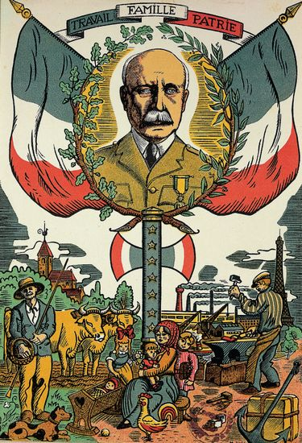
Affiche de propagande Vichy (No specific title), 1942, <http://propagande-2eme-guerremondiale.e-monsite.com/pages/la-propagande-dans-le-camps-de-l-axe/la-propagande-de-vichy.html>, Accessed: 17/02/18.
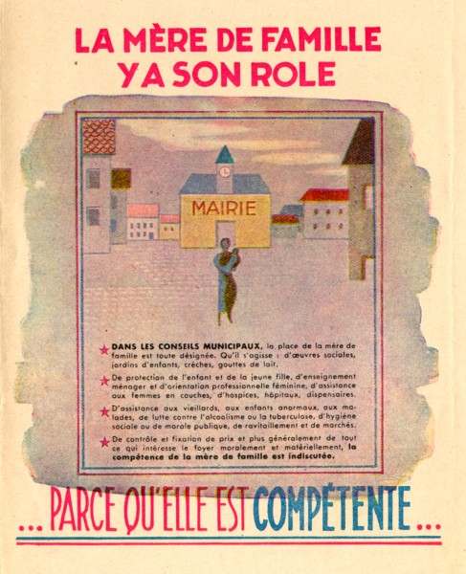
‘La Mère de famille y a son rôle,’ 1940-44 (No specific date), <http://www.savoie-archives.fr/archives73/expo_savoie_des_ombres/pano08/pages/04-04-PN_50-1.html>, Accessed: 18/02/18.

Charles Sowerwine, France Since 1870: Culture, Society and the Making of the Republic, (New York, Palgrave Macmillan, 2009), p. 185.
Jean-Pierre Le Crom, Syndicats, Nous Voilà ! : Vichy et le Corporatisme, (Paris, Editions de l’Atelier, 1995), p, 18.
Robert Paxton, Vichy France: Old Guard and New Order, 1940-44, (New York, Columbia University Press, 2001), p. 143.
Julian Jackson, France: The Dark Years 1940-44, (Oxford, Oxford University Press, 2003), p. 149.
Kathryn Amdur, ‘Paternalism, Productivism, Collaborationism: Employers and Society in Interwar and Vichy France’, International Labor and Working-Class History, Vol. 53, pp. 137-163, p, 146.
Le Crom, Syndicats, Nous Voilà !, p, 15.
Rod Kedward, La Vie en bleu: France and the French since 1900, (London, Penguin, 2006), p. 256.
Rod Kedward, Occupied France: Collaboration and Resistance 1940-44, (Oxford, Blackwell, 1985), p. 25.
Paxton, Vichy France, p. 209.
‘Loi de 4 octobre 1941 relative à l’organisation sociale des professions dite Charte du Travail’, 4 octobre 1941, <http://travail-emploi.gouv.fr/IMG/pdf/Loi_du_4_octobre_1941.pdf>, Accessed: 19/02/18.
Amdur, ‘Paternalism, Productivism, Collaborationism’, p. 145.
Kedward, Occupied France, p, 30.
Sowerwine, France Since 1870, p. 194.
Paxton, Vichy France, p. 220
Amdur, ‘Paternalism, Productivism, Collaborationism’, p. 146.
Kedward, La Vie en bleu, p. 256.
‘La Mère de famille y a son rôle,’ 1940-44 (No specific date), <http://www.savoie-archives.fr/archives73/expo_savoie_des_ombres/pano08/pages/04-04-PN_50-1.html>, Accessed: 18/02/18.
Kedward, Occupied France, p. 26.
Lyndsey Dodd, ‘Children’s citizenly participation in the National Revolution: the instrumentalization of children in Vichy France’, European Review of History, Vol. 24 No. 5, pp. 759-780, p. 765.
Ibid.
Kedward, La Vie en bleu, p. 252.
Nicholas Atkin, ‘The Challenge to Laïcité: Church, State and Schools in Vichy France 1940-44’, The Historical Journal, Vol. 35 No. 1, pp. 151-169, p. 155.
Kedward, La Vie en bleu, p, 253.
Affiche de propagande Vichy (No specific title), 1942, <http://propagande-2eme-guerremondiale.e-monsite.com/pages/la-propagande-dans-le-camps-de-l-axe/la-propagande-de-vichy.html>, Accessed: 17/02/18.
James McMillan, Twentieth-Century France: Politics and Society 1898-1991, (London, Bloomsbury Academic, 2010), p. 138.
Sowerwine, France since 1870, p. 185.
Paxton, Vichy France, p. 180.
Ibid, p. 184.
Kedward, Occupied France, p. 31.
Kedward, La Vie en bleu, p.270.
Atkin, ‘The Challenge to Laïcité’, p. 151.

