FR268 – French Cinema and Society from the First to the Second World War
Module Outline
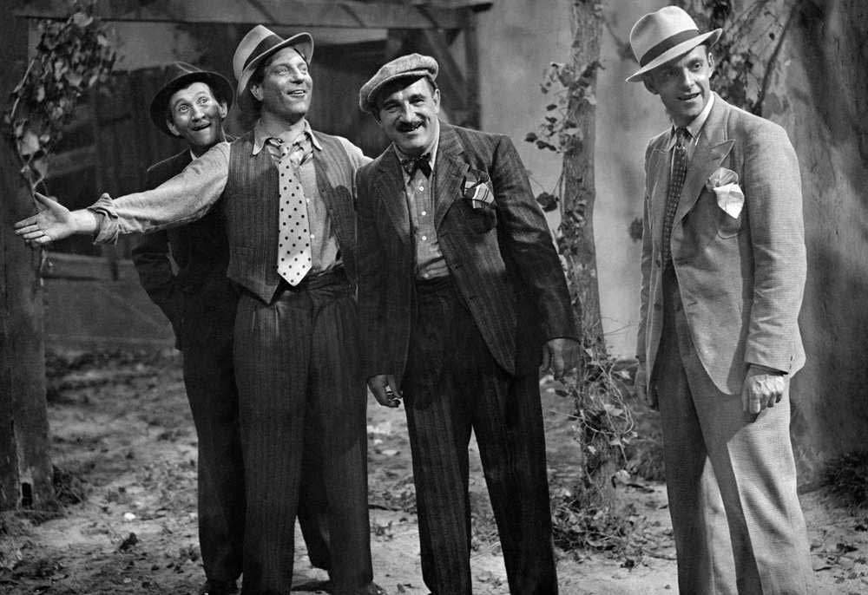
Convenor and tutor: Reece Goodall (r.a.goodall@warwick.ac.uk)

Overview
This module aims to explore France and its cinema from the period between the two World Wars, and examines the interplay between film, politics and history. The key aims of the module are these:
- To introduce key works, artists, techniques and debates in the so-called ‘classical’ period of French cinema from the late 1910s until the mid-1940s.
- To survey key events, actors, debates and problems in French social and political history of the period from the First World War to the Liberation.
- To explore and critically debate the relationship of mutual influence and interpenetration between the social and political history of France and its cinematic representations during the same period.
- To show how specific audiovisual techniques are used in filmmaking to convey ideas and emotions.

Preparation
For each seminar, the only requirement is to have watched that week’s film, which will be available on the module Moodle page (and, if you are presenting that week, to have prepared a short presentation about the film). It would be good if you were able to do some reading about the film, the director and/or the period, and I’ve included some hints as to where you may start in the outline below (though these are far from the only useful texts).
The sessions will take the form of a lecture delivered by me, which I’ll aim to keep at around 45 minutes, because I want to use the time more to discuss the texts with you. Each week, in advance of the sessions, I’ll circulate some questions to think about – you don’t have to come with pre-prepared answers, but it would be useful to watch the films and do the readings with those ideas in mind, and perhaps make some notes, in order to fuel discussion. See seminars as a space to test your ideas and to practice your film-reading skills, and I’ll do my best to support you!
If you’re a Letterboxd person, a list of all the required and bonus films is available here: https://letterboxd.com/reecegoodall6/list/fr268-french-cinema-and-society-from-the/
I am conscious that many of you may not have studied film before other than me blitzing it a bit on ‘The Story of Modern France’, but I’d urge you not to be too worried here. There is a video available on the module Moodle page called ‘Reece’s Intro to Film Terms’, in which I run through most of the language and terms you’ll need with examples, and I’d highly recommend that you watch it as early as possible if you’re unfamiliar with film analysis. If you would like to read something on filmic and audiovisual techniques, these books are worth finding at the library:
- David Bordwell and Kristin Thompson, Film Art: An Introduction (6th edn., New York: Knopf, 1998)
- Timothy Corrigan and Patricia White, The Film Experience (Boston: Bedford, 2004)
You will have many chances to practice unpicking film in the seminars (in general) and in your presentations, so you will be well equipped to respond to questions by the end of the module – however, if there are any worries, please do let me know and I’ll lend you a hand.

Assessment
There are two forms of assessment on the module:
- An essay of 3,500 words (80%)
- A 10-minute presentation (20%)
The essays will require you to situate a film in context, using evidence from the films themselves and the readings to explore how these films reflect the concerns and ideologies of their times. In short, it’s a chance for you to dig into the film on a thematic and formal level, and use both the evidence of the film and the context provided by the readings to describe exactly what these films indicate about interwar France and how.
The presentation will test your ability to unpick the formal aspects of a film, conducting a close reading into a particular technique or theme with the use of images/videos. You’ll make a 10-minute video with your presentation, and then submit the video to Tabula. I’ll give an example of the sort of thing we’re after in week 1, and then there will be opportunities for everyone to do a practice presentation in the seminars.
The questions/topics for both the essays and the presentations will be available on Moodle, and we’ll discuss assessment in the seminars too!
Week 1 – Studying history through film; looking at film historically; France between the wars
Film: La Grande Illusion (Jean Renoir, 1937)

Recommended readings:
The film/director
Martin O’Shaughnessy, Jean Renoir (Manchester: Manchester University Press, 2000)
Martin O’Shaughnessy, La Grande Illusion (London: I.B. Tauris, 2009)
Julian Jackson, La Grande Illusion (Basingstoke; New York: BFI/Palgrave Macmillan, 2009)

Cinema and cultural context
Robert A. Rosenstone, History on film, film on history (New York; Abingdon, Oxon: Routledge, 2017)
James Chapman, Film and history (Basingstoke; New York: Palgrave Macmillan, 2013)

Extra films:
Napoléon (Abel Gance, 1927; available in the Library)
La Marseillaise (Jean Renoir, 1938; available in the TRC)

Questions
Essay-type questions | - La Grande Illusion as an anti-war film  - National identity and nationalism in La Grande Illusion  - The role of social class in La Grande Illusion
Presentation-type questions | - Use of language in La Grande Illusion  - Construction of space in La Grande Illusion  - Types of performance in La Grande Illusion  - Role and uses of music in La Grande Illusion

Week 2 – French cinema and the First World War
Film: J’accuse (Abel Gance, 1919)

Recommended readings:
The film/director
Norman King, Abel Gance: a politics of spectacle (London: BFI Publishing, 1984)
James M. Welsh and Steven Philip Kramer, ‘Abel Gance’s Accusation against War’, Cinema Journal 14:3 (1975): 55-67

Cinema and cultural context
Richard Abel, French cinema: the first wave, 1915-1929 (Princeton, N.J.: Princeton University Press, 1984)
David Stevenson, 1914-1918: the history of the First World War (London: Penguin, 2012)

Extra films:
Tih Minh (Louis Feuillade, 1918; available here: https://www.youtube.com/playlist?list=PLdEvwfh8Nyj6tZrLL13A_byO7cVUe2dXT)
J’accuse (Abel Gance, 1938)

Questions
Essay-type questions | - The depiction of violence in J’accuse  - An analysis of gender in J’accuse  - Melodrama and narrative structure in J’accuse
Presentation-type questions | - Symbolism in J’accuse  - Editing in J’accuse

Week 3 – Les années folles and French Impressionism
Film: Cœur fidèle (Jean Epstein, 1923)

Recommended readings:
The film/director
Christophe Wall-Romana, Jean Epstein (Manchester: Manchester University Press, 2013)
Prosper Hillairet, Cœur fidèle de Jean Epstein : le ciel et l’eau brûlent (Crisnée: Yellow now, 2008)
Jason N. Paul and Sarah Keller, Jean Epstein: Critical Essays and New Translations (Amsterdam: Amsterdam University Press, 2012)

Cinema and cultural context
Richard Abel, French cinema: the first wave, 1915-1929 (Princeton, N.J.: Princeton University Press, 1984)
Jackie Clarke, France in the Age of Organization: Factory, Home and Nation from the 1920s to Vichy (New York: Berghahn Books, 2011)

Extra films:
La Glace á trois faces (Jean Epstein, 1927)
La Proie du vent (René Clair, 1927, available here: https://www.cinematheque.fr/henri/film/47593-la-proie-du-vent-rene-clair-1926/)
La Chute de la maison Usher (Jean Epstein, 1928)

Questions
Essay-type questions | - An analysis of gender in Cœur fidèle  - Genre and melodrama in Cœur fidèle  - Cœur fidèle and photogénie
Presentation-type questions | - The construction of space in Cœur fidèle  - Editing in Cœur fidèle  - Mise-en-scène and atmosphere

Week 4 – The Popular Front
Film: La Belle Équipe (Julien Duvivier, 1936)

Recommended readings:
The film/director
Ben McCann, Julien Duvivier (Manchester: Manchester University Press, 2017)
Edward Ousselin, ‘Film and the Popular Front; “La Belle Equipe” and “Le Crime de M. Lange”’, The French Review 79:5 (2006): 952-962

Cinema and cultural context
Claude Gauteur and Ginette Vincendeau, Jean Gabin : anatomie d’un mythe (Paris: Nathan, 1993)
Julian Jackson, The Popular Front in France: defending democracy, 1934-38 (Cambridge: Cambridge University Press, 1990)
Ginette Vincendeau and Keith Reader, La Vie est à nous !: French cinema of the Popular Front 1935-1938 (London: BFI, 1986)

Extra films:
L’Argent (Marcel L’Herbier, 1928)
A nous la liberté (René Clair, 1931; available in the TRC)
Le Crime de Monsieur Lange (Jean Renoir, 1936; available in the TRC)

Questions
Essay-type questions | - Gender, money and class in La Belle Équipe  - Precarity and solidarity in La Belle Équipe  - Gabin and the group in La Belle Équipe
Presentation-type questions | - Lighting in La Belle Équipe  - The sets of La Belle Équipe  - Sound and music in La Belle Équipe

Week 5 – Poetic realism
Film: Le Jour se lève (Marcel Carné, 1939)

Recommended readings:
The film/director
Jonathan Driskell, Marcel Carné (Manchester: Manchester University Press, 2012)
Ben McCann, Le Jour se lève (London: I. B. Tauris & Co. Ltd, 2013)

Cinema and cultural context
Dudley Andrew, Mists of regret: culture and sensibility in classic French film (Princeton, N.J.: Princeton University Press, 1995)
Noël Burch, Geneviève Sellier and Michelle Perrot, La drôle de guerre des sexes du cinéma français, 1930-1956 (Paris: A. Colin, c2005)
Deborah Walker-Morrison, Classic French noir: gender and the cinema of fatal desire (London: I.B. Tauris, 2017)

Extra films:
L’Atalante (Jean Vigo, 1934; available in the TRC)
Pépé le Moko (Julien Duvivier, 1937; available in the TRC)
Le Quai des brumes (Marcel Carné, 1938; available in the TRC)

Questions
Essay-type questions | - Gender identities and gender relations in Le Jour se lève  - A film of four characters: the characterization and narrative interaction of the four protagonists in Le Jour se lève  - Individual and crowd in Le Jour se lève  - Work and leisure in Le Jour se lève
Presentation-type questions | - Mise-en-scène and the creation of atmosphere  - Lighting and sets  - Use of props

Week 6 – Reading week

Week 7 – Renoir the Master
Film: La Règle du jeu (Jean Renoir, 1939)

Recommend readings:
The film/director
Martin O’Shaughnessy, Jean Renoir (Manchester: Manchester University Press, 2000)
Keith Reader, La Règle du jeu (London: I.B. Tauris, 2010)
V. F. Perkins, La règle du jeu (London: British Film Institute, 2012)

Cinema and cultural context
Christopher Faulkner, The social cinema of Jean Renoir (Princeton, New Jersey: Princeton University Press, 1986)
Margaret C. Flinn, The social architecture of French cinema, 1929-39 (Liverpool: Liverpool University Press, 2014)

Extra films:
Boudu sauvé des eaux (Jean Renoir, 1932)
La Bête humaine (Jean Renoir, 1938; available in the TRC)

Questions
Essay-type questions | - What do you consider to be the political or allegorical significance of La Règle du jeu? How is this significance manifested in the film?  - What is the significance of the themes of games, playing and theatricality in La Règle du jeu?  - What does La Règle du jeu have to say about friendship?
Presentation-type questions | - Analyse the construction of space through camerawork, mise-en-scène, etc.  - Use of sets  - Analyse the role and importance of music in the film

Week 8 – Filming under the Occupation
Film: Le Corbeau (Henri-Georges Clouzot, 1943)

Recommended readings:
The film/director
Christopher Lloyd, Henri-Georges Clouzot (Manchester: Manchester University Press, 2007)
Judith Mayne, Le Corbeau (London: I.B. Tauris & Co. Ltd, 2007)
José-Louis Bocque and Marc Godin, Clouzot cinéaste (Paris: Table ronde, 2011)

Cinema and cultural context
Evelyn Ehrlich, Cinema of paradox: French filmmaking under the German occupation (New York: Columbia University Press, 1985)
Julian Jackson, France: the dark years, 1940-1944 (Oxford: Oxford University Press, 2003)

Extra films:
L’assassin habite au 21 (Henri-Georges Clouzot, 1942; available in the TRC)

Questions
Essay-type questions | - Le Corbeau as allegory  - Medical metaphors in Le Corbeau  - Characterization and misanthropy  - Justice and injustice in Le Corbeau
Presentation-type questions | - Light and shadow in Le Corbeau  - Camerawork and editing in Le Corbeau

Week 9 – The summit of classical French cinema
Film: Les Enfants du Paradis (Marcel Carné, 1945)

Recommended readings:
The film/director
Jonathan Driskell, Marcel Carné (Manchester: Manchester University Press, 2012)
Edward Baron Turk, Child of paradise: Marcel Carné and the golden age of French cinema (Cambridge: Harvard University Press, 2013)
Jill Forbes, Les enfants du paradis (London: British Film Institute, 1997)
Geneviève Sellier, “Les enfants du paradis”: Marcel Carné et Jacques Prévert (Paris: Nathan, 1992)

Cinema and cultural context
Denis Demonpion, Arletty (Paris: Flammarion, 1996)
Hilary Footitt and John Simmonds, France 1943-1945 (Leicester: Leicester University Press, 1988)

Extra films:
Les Visiteurs du soir (Marcel Carné, 1942; available in the Library)
Le Comte de Monte Cristo (Robert Vernay, 1943; available in the TRC)

Questions
Essay-type questions | - The uses of spectacle in Les Enfants du Paradis  - The meanings of the past in Les Enfants du Paradis  - Liberty and constraint  - Innocence and crime
Presentation-type questions | - A close analysis of dialogue in Les Enfants du Paradis  - Arletty/Garance: a study in characterization and performance  - The role of extras and minor characters in Les Enfants du Paradis

Week 10 – Looking back
Film: Panique (Julien Duvivier, 1946)

Recommended readings:
The film/director
Ben McCann, Julien Duvivier (Manchester: Manchester University Press, 2017)
Eric Bonnefille, Julien Duvivier le mal aimant du cinéma français : 1940-1967 (Paris: L’Harmattan, 2002)

Cinema and cultural context
François Rouquet and Fabrice Virgili, Les Françaises, les Français et l’Épuration (1940 à nos jours) (Paris: Gallimard, 2018)
Karen Adler, Jews and gender in Liberation France (Cambridge: Cambridge University Press, 2003)
Hilary Footitt, War and liberation in France: Living with the Liberators (Palgrave Macmillan: Basingstoke, 2004)

Extra films:
La Bataille du rail (René Clément, 1946)
La Belle et la bête (Jean Cocteau, 1946; available in the TRC)

Questions
Essay-type questions | - A society and its cruelties: the political resonances of Panique  - Looks, voyeurism and image-making in Panique
Presentation-type questions | - Characterisation and performance  - Mise-en-scène  - Camera placement and angles  - Sound and music

