Le Fabuleux destin d’Amélie Poulain (Jeunet 2001)
SEMINAR 5 January 2014

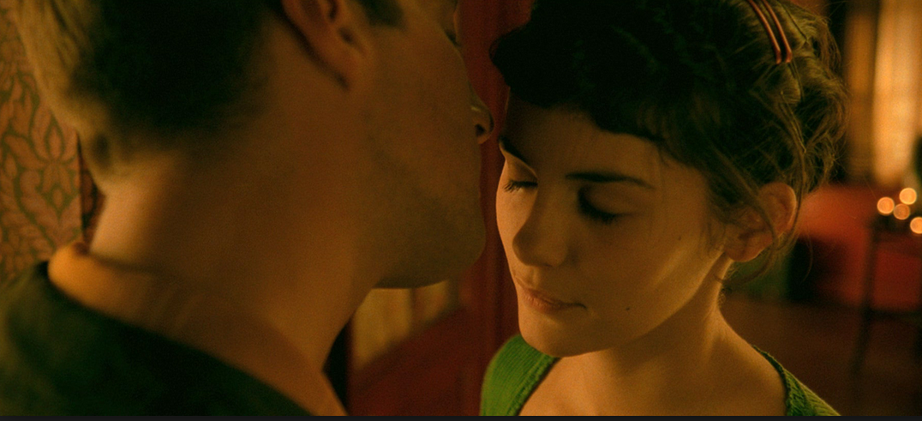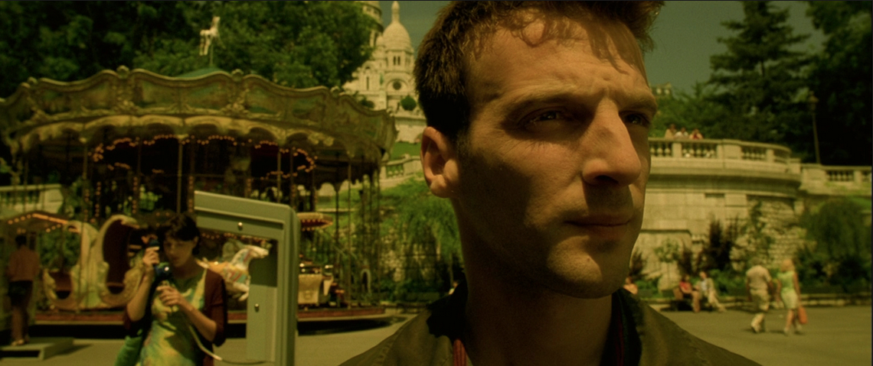

‘The end of the film […] brings the hitherto star-crossed lovers together, the sheer predictability of their union, the “fabulous”, storybook fulfilment of Amelie’s “destin”, recalls the ending of countless Hollywood films’ (Ezra, p.301).

Questions for discussion
- Do you agree with Kaganski’s critique of the film’s socially and ethnically cleansed vision of Paris?

- Do you agree with Moore that Amelie is a ‘borderline sociopath’ and the film’s ending constitutes ‘a series of seemingly incoherent (or irrational) images’ (pp. 16-17)

CLIP
- In what sense can we see Le Fabuleux destin d’Amélie Poulain as exploring female-specific experience of contemporary social reality? How is she presented as, and how does she represent, French women today?

Bibliography
Moore, R. C. 2006. ‘Ambivalence to Technology in Jeunet’s Le Fabuleux destin
d’Amélie Poulain.’ Bulletin of Science, Technology and Society 26, no.1
(February): 9-19.

Ezra, E, 2004. ‘The Death of an Icon: Le Fabuleux destin d’Amelie Poulain.’ French
Cultural Studies 15, no. 3: 301-10.

