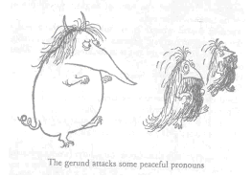

Picture: Ronald Searle, “The Private Life of the Gerund” from How to be Topp

