Sample blog post from student on AaC scheme (shared with school)

Having started university in Autumn 2014, the prospect of spending my third year abroad seemed quite surreal, never quite believing the day would actually come where I packed up my worldly belongings to start a new journey im Ausland! However, by Christmas of second year, it all began to feel quite real with the task of completing my British Council Application.
Warwick offers three different options for language students; the chance to study at an overseas university, find a work placement or work as an English teaching assistant at a school which is the route I have chosen. With the British Council having altered the application this year (I seem to belong to the year group who has been used as guinea pigs throughout my schooling!), I was able to whittle down my year abroad destination to the not so narrow ‘South Germany’ – yes, comprising the largest Bundesland of Bayern as well as Baden-Württemberg and Hessen, I really had no idea where I would be heading – just slightly scary! Preparatory meetings started to become a regular occurrence and in May this year, there was finally light at the end of the tunnel - my Bundesland is Hessen!

Having eagerly researched this region, I was very excited and then I realised I did not know anyone else also heading here – oh well, year abroad is for making contacts, right?! A month or so later I was then informed by post of my town and the school where I will be teaching (it really was a waiting game!) - Alsfeld. With baited breath I searched Alsfeld on Google Images and when old timber houses, fairy-tale tours and the cobbled market square starting appearing, I knew the wait had been worth it – this was the real German experience I was looking for!
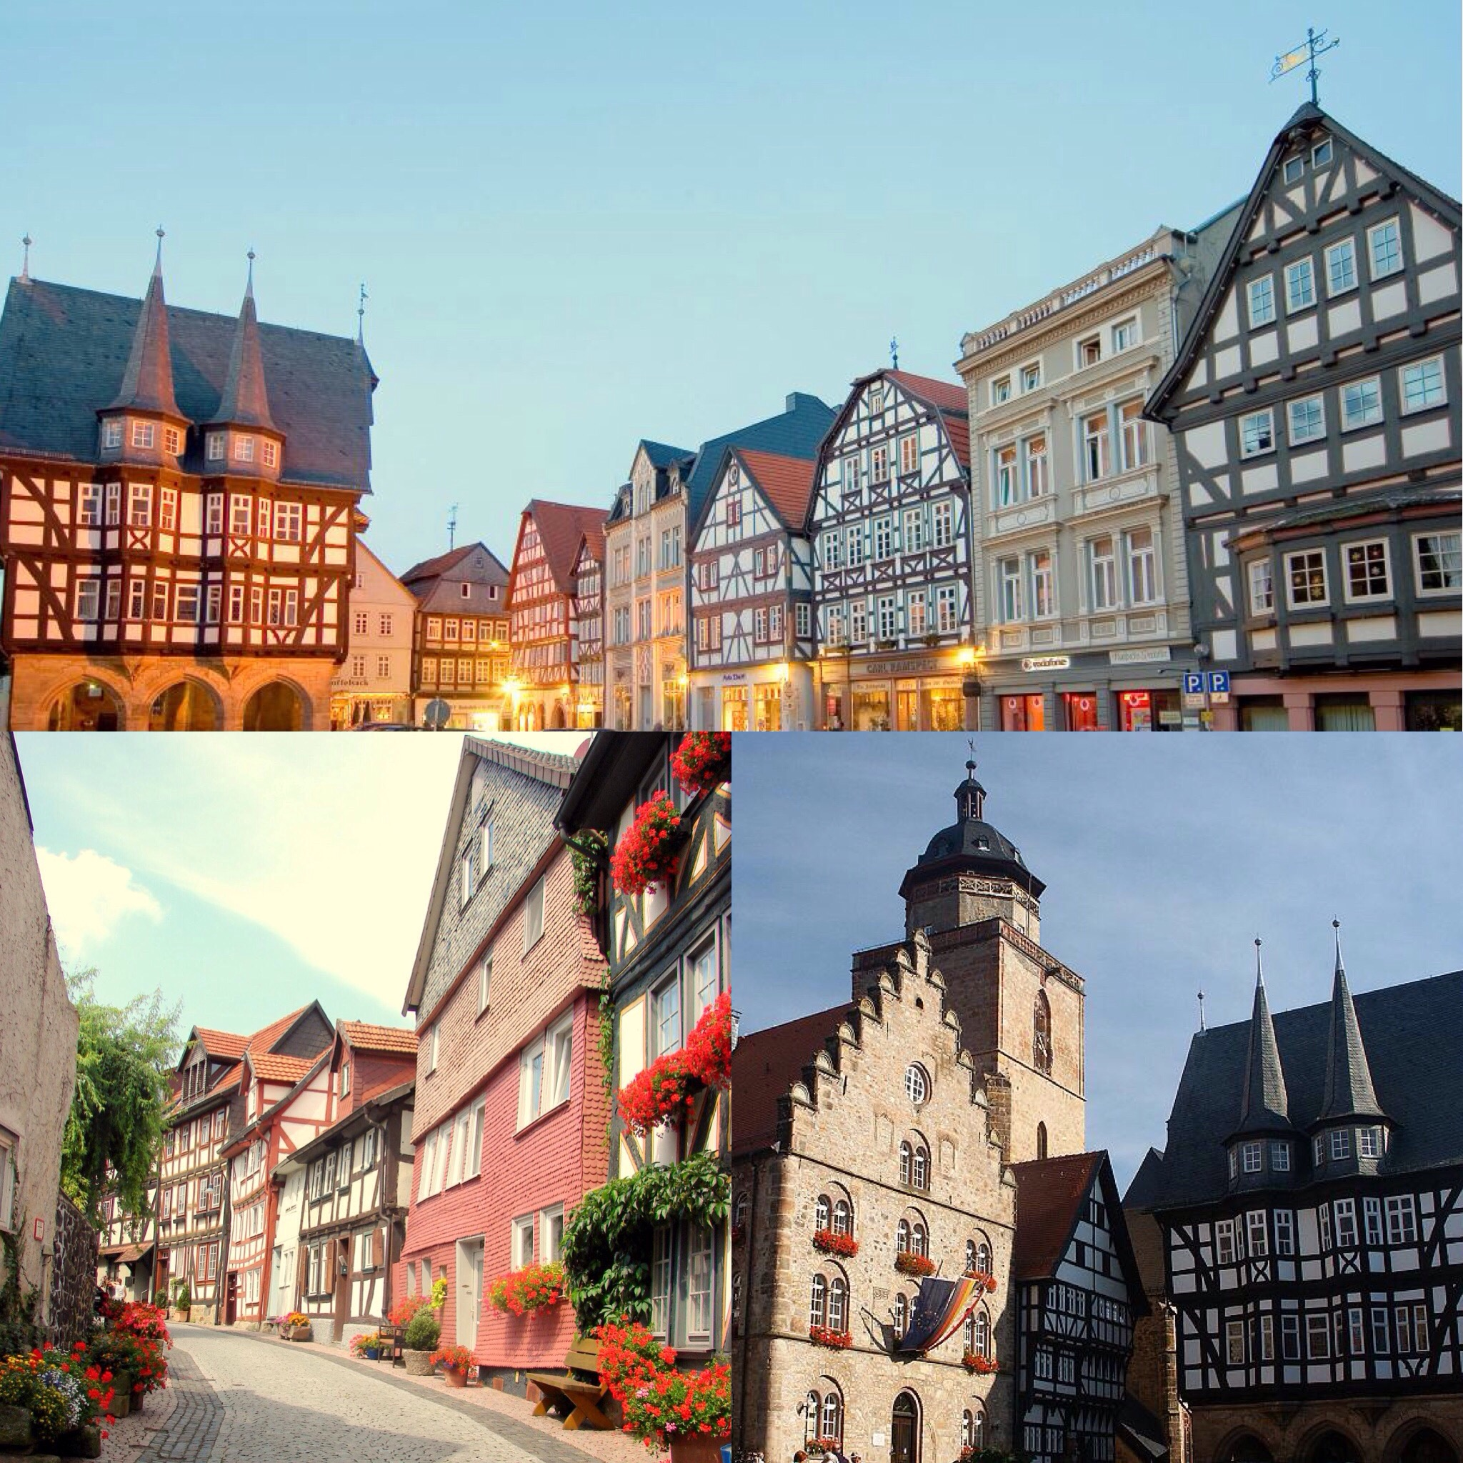

Once I found out my town, I then started making contact with my school – to receiving the first email back from my mentor teacher (initially unaware that they would even be having a Fremdsprachenassistentin this year…!) to meeting her in London to discussing topics from school life, tasks, working hours to the best places to stay and eat, I already felt part of the local community.

The next task was to find accommodation. I couldn’t have been more fortunate with all the praise going to my wonderful mentor teacher. Trying to look for WG’s (Wohngemeinschaft = flat share) or apartments by trawling the internet without being able to physically view them is quite a task yet I was blessed with my teacher’s help who visited a couple for me. Having now experienced the horrors of second year student accommodation and landlords, going through this process but in a foreign country without doubt seemed very daunting. Having found a flat at a reasonable price, centrally located within walking distance of the school and on the doorstep to the railway station - yet with no pictures - I had to put all my faith in humanity and hope for the best by securing the property and signing the contract!

Moving in…
This summer I spent a week in Germany, both visiting friends in the wonderful city of Stuttgart (found my love for the city on the German Exchange in year 10) and combining it with a trip to my soon-to-be new home! With my mum’s help, having packed 2 cases nearly full to bursting with homely items and utensils, seeing our cases appear in the Gepäckausgabe safe and sound – well, relief is an understatement! Arriving in Alsfeld, I was very much taken aback. Upon finding the apartment I then had to look for the Hausmeister (caretaker). Speaking rapidly in his strong Hessian dialect, I barely said a word as I accepted the keys for the apartment and thanked him - hopefully our conversations will improve over the coming year…! Overwhelmed with the apartment – the space, homeliness and even a coffee maker & TV - with the help of my parents, I unpacked the bits and bobs I brought from England. Home sweet home!

Registering…
Next job.. Anmeldung. Having to answer a series of questions from passport details to marital status ‘allein?’ (yes, alone but hopefully will make some friends!) I was now officially registered in Germany!

The Bank…
Setting up a German bank account was the next on the agenda. Having fears of not being able to communicate, my experience at the bank was really something quite extraordinary! From asking the first person I saw if I could open an account to then being escorted by the manager into his office and spending about an hour discussing the options, transferring money and setting up a Dauerauftrag (standing order) all in German as he did not speak a word of English to being asked if I would be prepared to give his daughter English lessons, it’s safe to say I left the bank smiling!

Getting around…
With the task of having taken four different trains from Alsfeld to Stuttgart, with the pressure of having to make every connection (I had booked the Sparpreis rather than Flexpreis), so far Deutsche Bahn has impressed me. All the trains were pünktlich - I don’t know what the Germans are complaining about??!

Top tip so far: Even when the locals realise you’re English and start speaking English to you, reply in German and keep replying in German (that’s what I keep telling myself) – that’s what we’re there for!

Until next time… Halina

(me enjoying the delights of Alsfeld’s local Bäckerei!)

