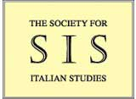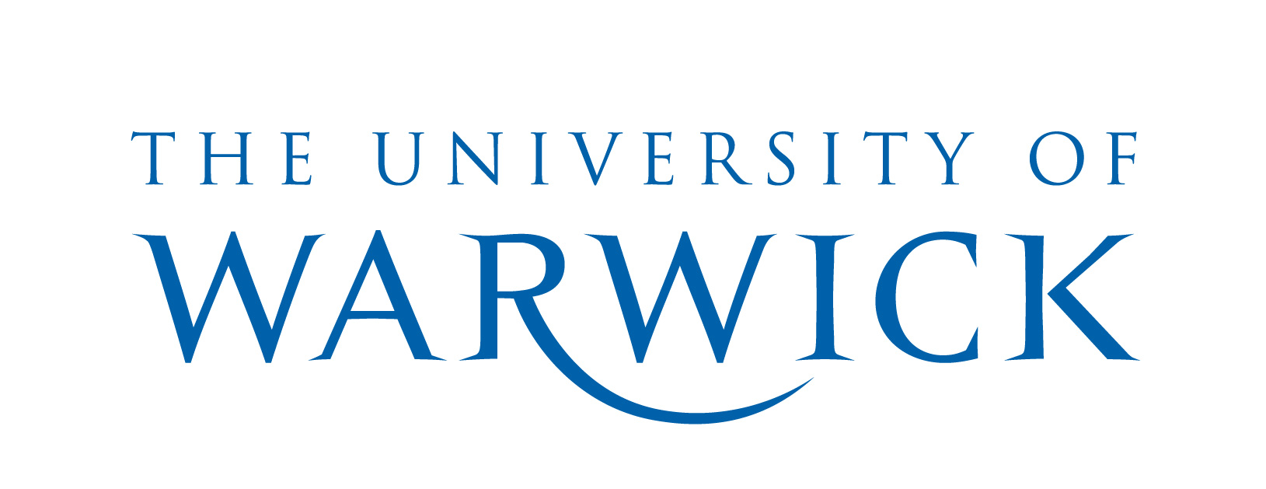

SIS INTERIM CONFERENCE 2014

INTERSTITIAL ITALY

REASSESSING GLOBAL QUESTIONS THROUGH THE ‘PECULIAR’ ITALIAN CASE

THE BRITISH SCHOOL AT ROME, 27TH-28TH MARCH 2014

PROGRAMME

THURSDAY 27TH MARCH

8.30-9.00: Registration and Welcome

9.00-10.30:
I. Parenthood: Legacies and Generational Positionings
Chair: Fabio Camilletti (Warwick)

Katrin Wehling-Giorgi (Warwick), ‘Come una lingua straniera mal nota’: Oblique Considerations on Mother-tongue and Generational Detachment in Ferrante and Sapienza
Saskia Ziolkowski (Duke), Parental Bonds: Kafka and the Family in Modern Italian Literature
Kate Willman (Warwick), The Death of the Father and Genna’s ‘Italia De Profundis’

10.30-11.00: Coffee break
11.00-12.30:
II. Italian ‘Difference’: Intellectual and Cultural Genealogies
Chair: Daragh O’Connell (Cork)

Sharon Hecker (independent scholar), Shifting Borders: What Art History Can Contribute to Rethinking Italian Studies
Laura Rorato (Bangor), Michelangelo Merisi da Caravaggio and The Commodification of High Art in a Globalized Society
Marina Spunta (Leicester), Luigi Ghirri, Giorgio Messori e l’esperienza del luogo

12.30-13.30: Lunch

13.30-16.00
III. Italian ‘Difference’: Intellectual and Cultural Genealogies (continued)
Chair: Caterina Sinibaldi (Manchester)

Daragh O’Connell (Cork), Interstitial Vico: Settecento Naples between Jurisdictionalism and Post-Humanism
Federico Casari (Durham), Benedetto Croce as a ‘civilisational centre’. Towards a network of Italian culture, 1903-1953
Giacomo Tagliani (Siena), ‘Actuality’ of Biopic Italian Style

IV. Italian ‘Difference’: Centrality and Ex-centricity
Chair: Laura Rorato (Bangor)

Francesca Billiani (Manchester), Dialettiche della modernità e arte di regime nell’Italia fascista
Damiano Benvegnù (Notre Dame), Una modernità animalesca: Italian Studies and Animal Studies

16.00-16.30: Coffee break

16.30-18.00:
V. Transnational Italy: Deterritorialization
Chair: Derek Duncan (St Andrews)

Emma Bond (St Andrews), Moving Beyond Borders: The Case for Trans-nationality in Contemporary Italian Writing
Renata Redford (Los Angeles), The Italian Case: Women's ‘Transnational’ Literature from East to West
Adalgisa Giorgio (Bath), Italian Difference Abroad: The New Zealand Case

18.00-19.00: Wine reception

19.00-20.00:
Roundtable: Intellectual Mobilities
Chair: Jennifer Burns (Warwick). Participants: Francesca Billiani (Manchester), Gianluca Briguglia (Vienna), Joanna Kostylo (BSR), Florian Mussgnug (University College London).

FRIDAY 28TH MARCH

09.00-10.30:
VI. Transnational Italy: Transcultural Memory
Chair: Adalgisa Giorgio (Bath)

Carlo Pirozzi (St Andrews), Traces of ‘Tally’s blood’ in Ancient Caledonia: Archival Materials, Photos, Letters and Family Memories
Margaret Hills de Zarate (Queen Margaret, Edinburgh), Embodied Objects in the Construction of Transcultural Memory
Derek Duncan (St Andrews), Human Cargo and the Possession of Transcultural Memory

10.30-11.00: Coffee break

11.00-13.00:
VII. Transnational Italy: Transnational Spaces
Chair: Emma Bond (St Andrews)

Daniele Salerno (Bologna), Cultural Responses to Migration by Boat: Kater I Rades case and the Memorialisation of Albanian Diaspora
Simone Brioni (London), Alternative Italian Colonial Histories in Enrico Brizzi’s ‘L’inattesa piega degli eventi’
Barbara Spadaro (Bristol), ‘Una casa normale’. Remembering Jewish Domesticity in Libya, Questioning ‘Italian’ Postcolonial Frameworks
Caterina Romeo (Rome), The Italian Postcolonial Condition in a Global Context

13.00-14.00: Lunch

14.00-15.30:
VIII. Italian Studies: Redefining the Limits of the Canon
Chair: Katrin Wehling-Giorgi (Warwick)

Florian Mussgnug (London), Against Genre: Mimicry and Microspection in Contemporary Italian Fiction
Caterina Sinibaldi (Manchester), Modernity’s Crimes: Writing and Translating Crime Fiction under Italian Fascism
Michael Jolliffe (Leicester), In Medias Res: Emanuel Carnevali’s Transnational Modernism

15.30-16.00: Coffee break
16.00-18.00:
IX. Italian Studies: Redefining the Limits of the Canon (continued)
Chair: Jennifer Burns (Warwick)

Giulia Iannuzzi (Trieste), Science Fiction in Italian Studies: in Search of Critical Citizenship from the Ghetto to the Internet
Cecilia Ghidotti (Bologna), Dieci cattive ragioni per non leggere la narrativa italiana contemporanea. Strategies to Evaluate Contemporary Italian Writers
Emanuela Piga (Cagliari), Cartografie della memoria nella narrativa italiana contemporanea
Ilaria Pinna (Exeter), Theatre Theory and Cultural Studies: an Interdisciplinary Approach to the Analysis of Political Theatre in Italy

18.00-19.00: Wine reception

19.00-20.00
Discussion: Sonnambulismo e barbarie: Rivoluzione, memoria, scrittura
Wu Ming 2 (Bologna) and Fabio Camilletti (Warwick) in conversation, with Kate Willman (Warwick)

