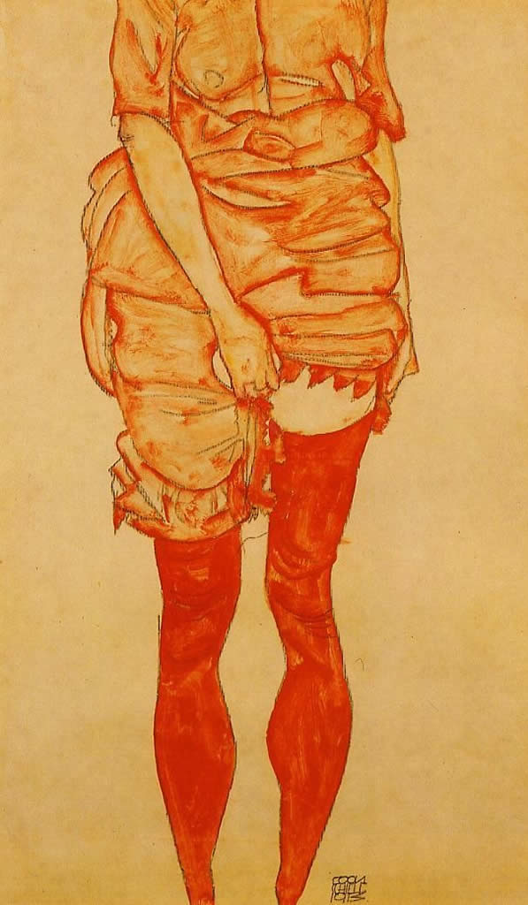
The Female ‘Other’: Subversive Women in 19th and 20th Century Literary and Cultural Production

A workshop hosted by the University of Warwick and the Institute of Advanced Study on Friday, 18 May 2012 (Wolfson Research Exchange, Library Building Floor 3)
Programme
10.00-10.30: Arrival and Coffee
10.30-12.00: PANEL 1: Writing the Female Body (Chair: Jenny Burns)
- Emma Bond (Italian, Oxford): ‘Transgenderism and Transnationalism: Exploring Binary Lines in Fernanda Farias de Albuquerque's Princesa and Elvira Dones' Vergine giurata’
- Simone Brioni (Italian, Warwick): ‘Cutting the Body: Cristina Ali Farah’s Female Writing’
- Susannah Wilson (French, Warwick): ‘Wasting Women: Anorexia Nervosa as a Subversive Discourse in Nineteenth-Century France’

12.00-12.15: Coffee break

12.15-1.15: Lecture

Lisa Downing (Exeter/Birmingham): ‘Aileen Wuornos: The Spectre of the Radical Feminist Serial Killer’ (Respondent: Douglas Morrey)

LUNCH: 1.15-2.15
2.15-3.45: PANEL 2: Female ‘Ex-centricity’: Italy’s Other Women (Chair: Sharon Wood)
- Danielle Hipkins (Italian, Exeter): 'Italy's Other Women: Prostitutes and Showgirls in Italian Cinema’
- Charlotte Ross (Italian, Birmingham): ‘Inverts, tribades and sapphists: subversive desires in Italian cultural texts, 1877-1908’
- Katrin Wehling-Giorgi (Italian, Warwick): ‘The Maternal Other: Subversive Mothers and the Fragmented Self in Elsa Morante’s Writings’

3.45-4.15: Coffee break
4.15-5.15: Lecture
Naomi Segal (Birkbeck), ‘The Senses of Ada’ (Respondent: Ann Hallamore Caesar)
5.15: Wine Reception
6.30/7: Dinner
The Female ‘Other’: Subversive Women in 19th and 20th Century Literary and Cultural Production
A workshop hosted by the University of Warwick and the Institute of Advanced Study on Friday, 18 May 2012.

This one-day interdisciplinary workshop will look at the representation of subversive women in nineteenth- and twentieth-century literature and cultural production. ‘Subversiveness’ in this context may refer to representations of women who subvert societal norms, representations which transgress conventional discourses of body, gender and sexuality, or to the stylistic techniques employed in the articulation of the marginalised female voice, space or subjectivity. The thematic investigation will focus on literary, cinematic and socio-historical representations and narratives of subversive women in nineteenth- and twentieth-century Western European cultural production.
In exemplary analyses and/or theoretical explorations, the papers will address questions such as the following:
* What role does female subversiveness play in the construction of discourses about and representations of subjectivity, body, gender and sexuality?
* What narrative and stylistic techniques are at play in the representation of female subversiveness in literature/film? What role does language play in the construction of the subversive female voice?
* How is the subversive female voice construed in a socio-historical context? What impact do socio-historical factors have on the creation of the female voice?

