
Our mission. The DeutschZusammen network aims to model new ways of working between secondary school teachers and university teachers and researchers. It provides non-hierarchical, mutually enriching meetings and dialogue between German practitioners in higher and secondary education. It aims to promote networking, resource and best practice sharing, and strategic planning, though also listening and mutual support, all with the aim of finding together ways of raising the profile of German language and culture in our education system and sustaining colleagues working in those environments.



Rundbrief, Sommer 2023/ Newsletter, Summer 2023.
Online Sessions: „Kölner Karneval“

Anfang Februar sind in Köln stets die Jecken los, man ruft „Kölle Alaaf“, und auch in anderen deutschen Städten erreicht die närrische Zeit ihren Höhepunkt. Dieses Jahr haben einige Schulklassen gemeinsam mit unserer DAAD-Lektorin Nora online Karneval gefeiert. Dabei haben sie geübt, auf Deutsch ein Video über den Karnevalsumzug zu beschreiben und dachten sich lustige Kostüme aus: „Ich verkleide mich als Bratwurst“ - na dann guten Appetit, and well done for practicing your reflexive verbs!

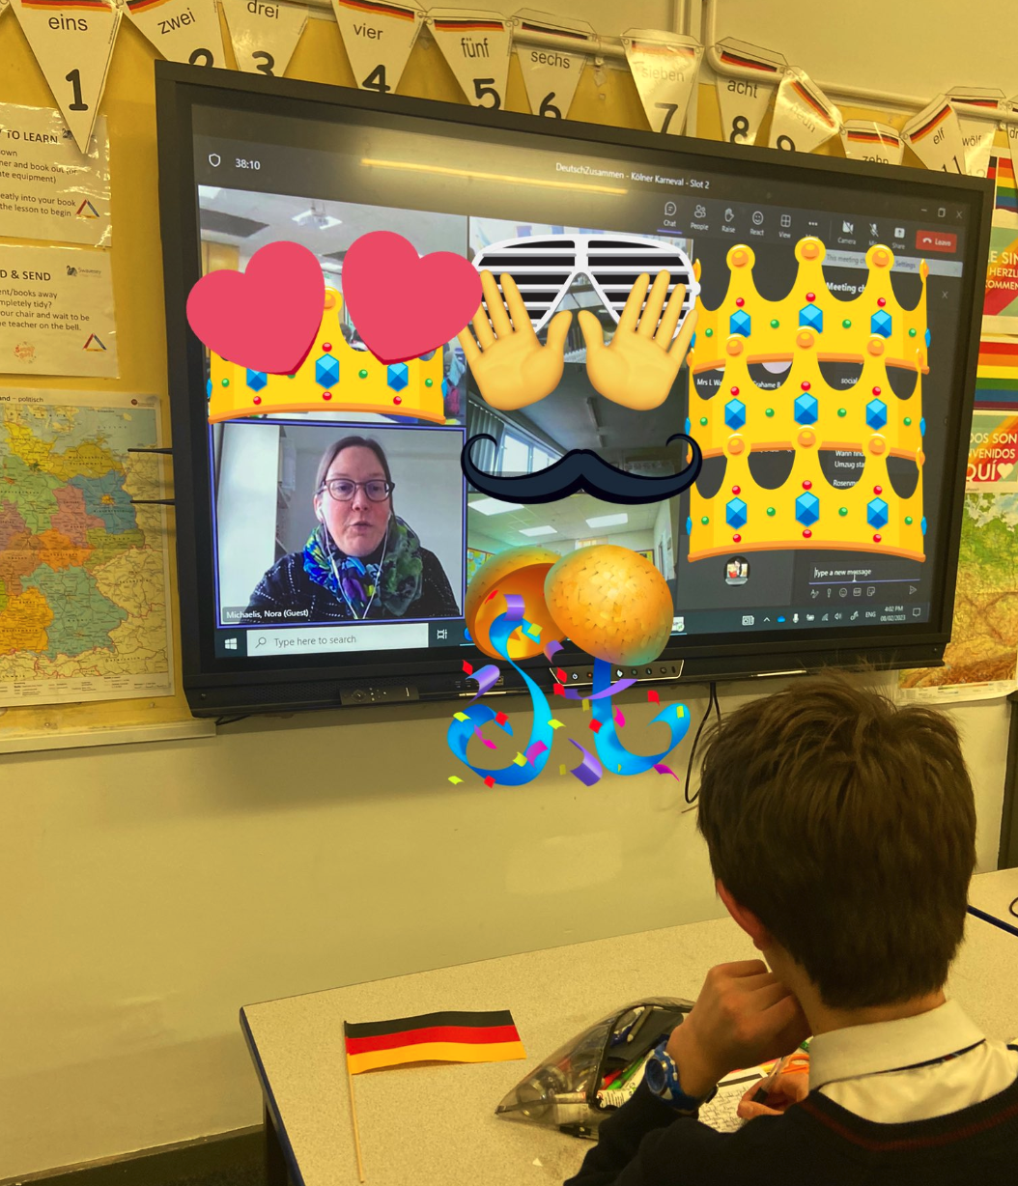

- Austausch der Uni Warwick mit der Uni Bonn: Der April macht, was er will! Zumindest für das Wetter traf das auch dieses Jahr zu, und so begrüßten wir im strömenden Regen 10 Studierende und ihre Dozentin aus Bonn, die nicht nur der Nässe, sondern auch noch massiven Streiks bei in Bahn- und Flugverkehr getrotzt hatten. Als sie dann auf dem Campus waren, kannte die Motivation keine Grenzen. Sofort wurden am ersten Pubabend lustige und skurrile Vokabeln getauscht sowie Pläne für den gemeinsamen Podcast geschmiedet. Nach einer ereignisreichen Woche dann der krönende, aber auch tränenreiche Abschlussabend mit gelungenen Podcasts und der Bitte aus Bonn: Besucht uns doch auch mal!

- School Visit to Campus! In May, about 40 motivated linguists from Blessed Edwards Catholic College in Worcester visited German at Warwick for an active day full of language, sports and university experience. The pupils met our student ambassadors and asked them all kinds of questions about life at uni, went on to practice saying the ü and the z (not without some very funny duckfaces and a lot of laughter) and were then tasked with designing an exercise programme in German which was performed on a meadow outside our new building. Who would have known before how to say „Mach fünf Liegestützen und wirf den Ball in die Schale“? - Everyone was very happy to be able to use their language skills to make other people do what they wanted them to – such is the power of language!

- Earlier in June, we hosted a Year 12 Languages Taster Day as part of our Widening Participation programme. German was represented by our colleague Prof Helmut Schmitz, who spoke about Brecht’s drama and its contemporary relevance for today’s society.

Forthcoming:

- Our own Dr James Hodkinson will be giving the keynote address at the KS3-KS5 German Teacher Day at the Greycoat Hospital, London on Sat 24th June, 2023. He will be talking about his research and reflecting on the problematic and shifting nature of so-called ‘multicultural’ topics in higher education German Studies curriculum – and how that discussion can be used to connect with secondary teaching practice.

- On Sat Sept 30th, 2023 DeutschZusammen will host its second German Teacher Day. Following on from the first successful event in summer 2022, attended by over forty colleagues from across the UK, we will invite colleagues back to our Faculty of Arts Building for a day of exchange, enrichment, planning and mutual support. The day will focus on building strategies and resources for language teaching across the curriculum and on the role of culture. Keep an eye on our website for more details and booking details in due course.

- In response to your request for support in showing how German can shape careers, DeutschZusammen will host the Goethe Institut’s German Careers Roadshow on Thursday November 9th in our FAB. Schools are invited to bring pupils to meet employers interested in German speaking employees here in the UK. Find out more and book tickets here: https://www.goethe.de/ins/gb/de/spr/unt/eng/cre.html

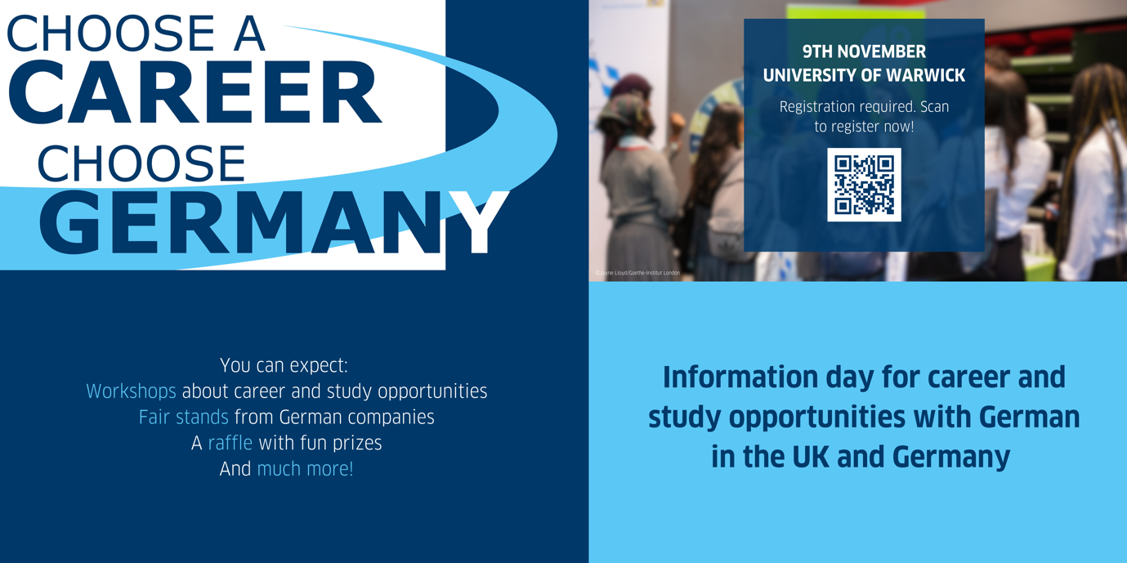

To find out more or join the DeutschZusammen network, click here.

Contact the DZ Team here:

- Ms Nora Michaelis ( Nora.Michaelis@warwick.ac.uk),
- Dr Dan Hall (D.Hall.3@warwick.ac.uk)
- Dr James Hodkinson (on sabbatical leave 23-24)

